

AutoWash Pro
Software Requirement Specification

Project Code: SU26SWP01
Document Code: SRS-AWP-v1.0
Group: Group 7
Prepared by: Le Doan Gia Hung - SE193449 - BA

Ho Chi Minh City, 16 June 2026

Record of change

*A - Added M - Modified D - Deleted
Effective Date | Changed Items | A*  M, D | Change Description | New Version
02/06/2026 | Project overview | A | Create initial SRS outline using the official template structure. | V0.1
04/06/2026 | Scope and assumptions | A | Add project scope, assumptions, constraints, and excluded items for frontend prototype. | V0.2
06/06/2026 | Overall description | A | Add product perspective, user characteristics, product functions, and core business data. | V0.3
08/06/2026 | Context diagram | A | Add system context diagram with Customer, Admin, Staff, and optional external interfaces. | V0.4
10/06/2026 | Functional requirements | A | Add main use case model and use case specification structure. | V0.5
12/06/2026 | CRUD use cases | M | Revise use case diagram to show CRUD-oriented use cases for each player. | V0.6
14/06/2026 | Non-functional requirements | A | Add usability, reliability, performance, supportability, constraints, interfaces, and standards. | V0.7
15/06/2026 | Template formatting | M | Align document layout with Software Requirement Specification Template 2016. | V0.9
16/06/2026 | Final SRS | M | Finalize official metadata, record of change, diagrams, and submission-ready SRS content. | V1.0

SIGNATURE PAGE

ORIGINATOR: Le Doan Gia Hung - SE193449 16/06/2026
Position: BA - Group 7

REVIEWERS: N/A

TABLE OF CONTENTS
1 Introduction 5
1.1 Purpose 5
1.2 Scope 5
1.3 Definitions, Acronyms, and Abbreviations 5
1.4 References 5
1.5 Overview 6
2 Overall Description 7
2.1 Product Perspective 7
2.2 System Context Diagram 7
2.3 Product Functions 8
2.4 User Characteristics 8
2.5 Constraints 8
2.6 Assumptions and Dependencies 8
3 FUNCTIONAL Requirements 9
3.1 Use Cases Diagram 9
3.2 Use Case Specifications 10
4 NON-FUNCTIONAL Requirements 13
4.1 Usability 13
4.2 Reliability 13
4.3 Performance 13
4.4 Supportability 14
4.5 Design Constraints 14
4.6 On-line User Documentation and Help System Requirements 14
4.7 Purchased Components 14
4.8 Interfaces 15
4.9 Licensing Requirements 15
4.10 Legal, Copyright, and Other Notices 15
4.11 Applicable Standards 15
5 Supporting Information 16

Introduction
This section provides an overview of the Software Requirements Specification (SRS) for AutoWash Pro. The document follows the provided SRS template structure and describes the purpose, scope, definitions, references, product perspective, functional requirements, non-functional requirements, interfaces, and supporting information for the SU26SWP01 prototype.

Purpose
The purpose of this SRS is to fully describe the externally observable behavior and requirements of AutoWash Pro: a smart automated car wash management system with advance booking and loyalty program. The SRS is intended for project stakeholders, instructors, developers, testers, and reviewers.

Scope
AutoWash Pro supports customer registration/login, vehicle and license plate management, advance booking, service package selection, simulated payment status, tiered loyalty, point/voucher redemption, staff check-in and wash processing, admin configuration, promotions, reports, notifications, and support chat. The current prototype is frontend-only and uses browser local storage plus mock state. Real online payment, refund management, real OTP delivery, backend database, real LPR hardware, and production AI personalization are outside the current implementation scope.

Definitions, Acronyms, and Abbreviations
Term | Definition
SRS | Software Requirements Specification
LPR | License Plate Recognition
CRM | Customer Relationship Management
OTP | One-Time Password
CRUD | Create, Read, Update, Delete
Tier | Customer loyalty level such as Member, Silver, Gold, Platinum/Diamond
Voucher | Discount or benefit applied through promotion or point redemption
Prototype | Frontend-only simulation using local storage and mock data

References
• Software Requirement Specification Template 2016.
• SU26SWP01 topic description: Smart Automated Car Wash Management System with Advance Booking & Loyalty Program.
• AutoWash Pro prototype repository and observable frontend behavior.
• Prototype README and local route/module behavior.

Overview
Section 2 describes the overall product and context. Section 3 defines functional requirements through a CRUD-oriented use case model. Section 4 defines non-functional requirements and interface requirements. Section 5 provides supporting information and prototype notes.

Overall Description

Product Perspective
AutoWash Pro is a web-based management system for motorbike/car wash businesses. It improves customer retention through loyalty tiers, point tracking, vouchers, and targeted promotions while supporting operations through scheduled booking, queue visibility, license plate verification, check-in, wash progress, and reporting. In the prototype, these functions are simulated in the browser rather than enforced by a backend service.

System Context Diagram
The diagram below presents the system boundary, primary actors, supporting components, and optional external interfaces. Solid flows represent current prototype UI/local-store behavior; optional integrations such as payment gateway, LPR, OTP delivery, and AI/CRM are modeled as future or simulated interfaces.
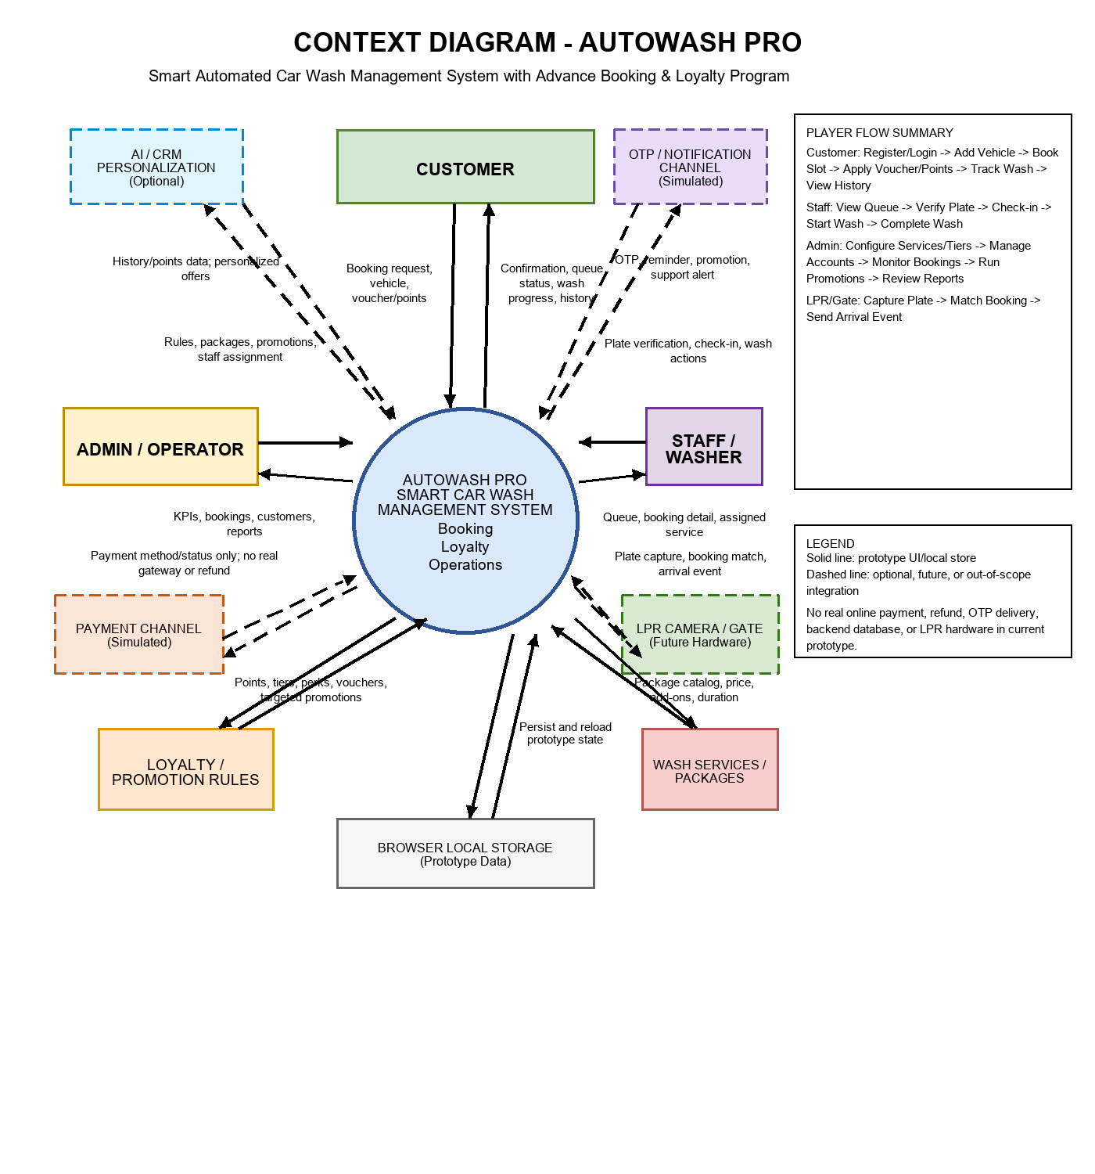
Figure 2-1. System Context Diagram for AutoWash Pro

Product Functions
• Customer account access, profile management, and vehicle/license plate management.
• Advance booking with service package/combo selection, slot selection, voucher/point usage, and simulated payment method.
• Loyalty engine for tier, points, spend, visits, vouchers, redemption, and expiry behavior.
• Staff workflow for queue reading, plate verification, check-in, wash start, wash completion, status update, and support response.
• Admin workflow for account, service package, loyalty rule, promotion, booking, staff assignment, report, and setting management.
• Notification, support chat, wash progress tracking, and booking/wash/point history views.

User Characteristics
User | Description | Main Goals
Customer | Vehicle owner using booking and loyalty features. | Book services, manage vehicles, redeem rewards, track wash status, view history.
Staff / Washer | Operational employee at the wash location. | Read queue, verify plate, check in, start/complete wash, update service status.
Admin / Operator | Business manager or wash operator. | Configure system data, manage accounts/promotions/services, monitor bookings and reports.

Constraints
• The prototype is frontend-only and stores data in browser localStorage and mock module state.
• Real online payment gateway and refund management are not implemented.
• Real OTP/SMS/email delivery, real backend APIs, and real database persistence are not implemented.
• LPR camera/gate integration and AI personalization are optional future interfaces.
• Some customer and admin/staff views use separate mock state models in the current prototype.

Assumptions and Dependencies
• Users access the system through a modern web browser.
• License plate data is the main vehicle identifier for booking/check-in matching.
• A production system would require backend persistence, authentication, authorization, API validation, and audit logging.
• External services such as payment, OTP, LPR, and AI/CRM require separate service providers and integration contracts.

FUNCTIONAL Requirements

Use Cases Diagram
The following use case diagram shows actor-visible CRUD-oriented use cases. CRUD labels express user goals at system boundary level; they do not represent internal database tables.
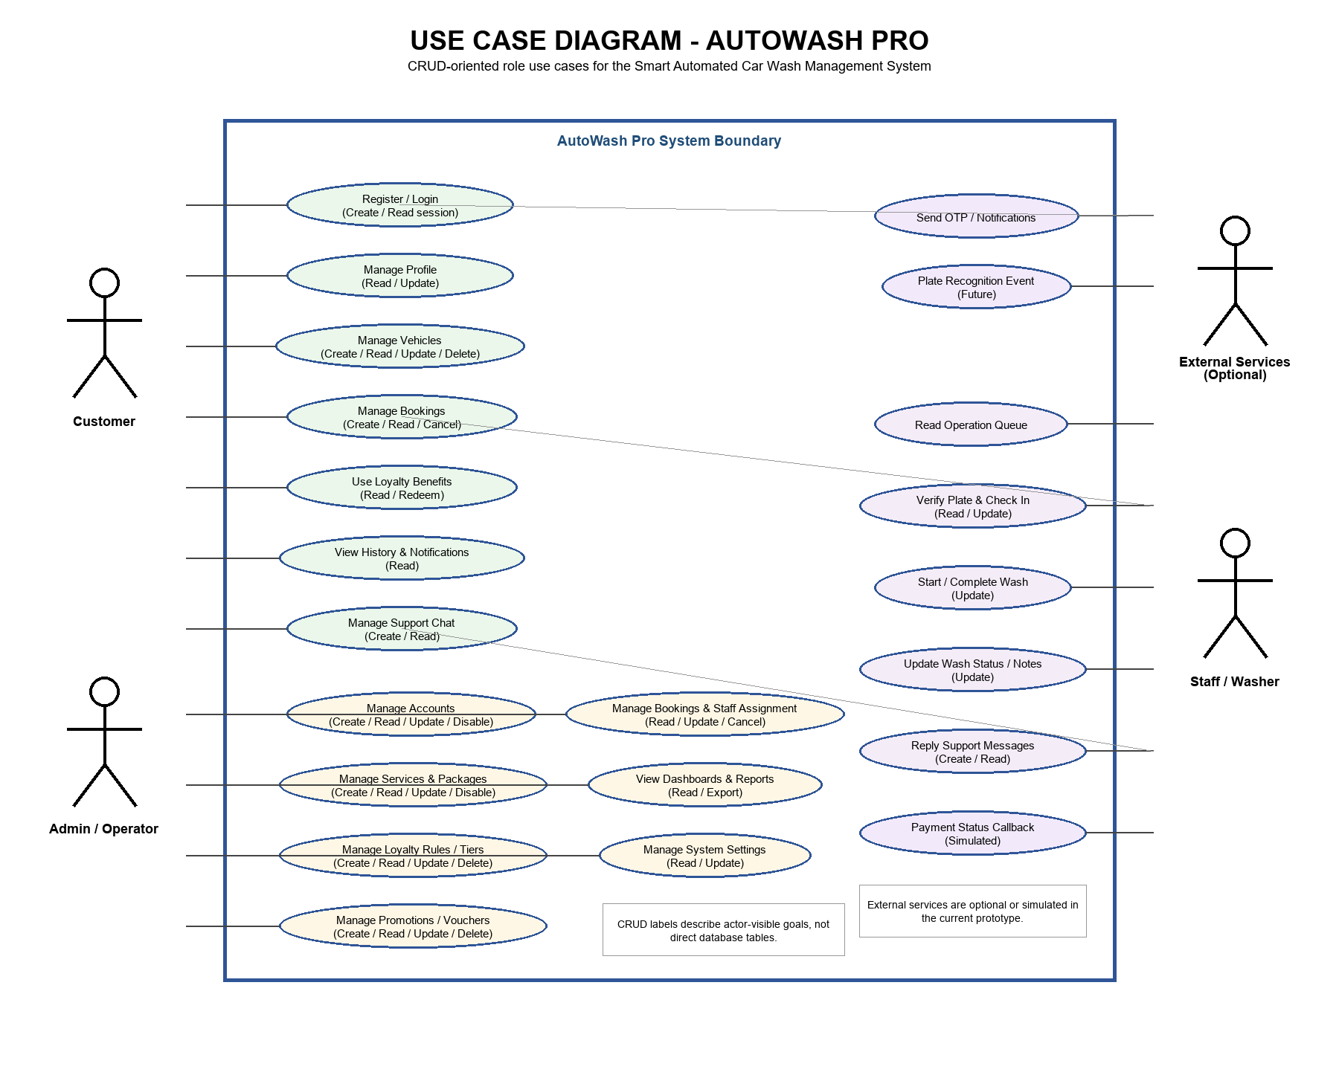
Figure 3-1. Main CRUD-oriented Use Case Diagram for AutoWash Pro

Use Case Specifications

UC001 Register / Login
USE CASE-n SPECIFICATION
Use-case No. | UC001 | Use-case Version | 1.0 | 1.0
Use-case Name | Register / Login | Actor(s) | Customer, Admin, Staff | Customer, Admin, Staff
Author | AutoWash Pro Project Team | Date | 16/06/2026 | 16/06/2026
Priority | High | Pre-condition | User opens public access page. | User opens public access page.
Summary | Create/read user session; OTP behavior is simulated. | Post-condition | Authenticated role workspace is opened or registration is completed. | Authenticated role workspace is opened or registration is completed.

UC002 Manage Profile and Vehicles
USE CASE-n SPECIFICATION
Use-case No. | UC002 | Use-case Version | 1.0 | 1.0
Use-case Name | Manage Profile and Vehicles | Actor(s) | Customer | Customer
Author | AutoWash Pro Project Team | Date | 16/06/2026 | 16/06/2026
Priority | High | Pre-condition | Customer is authenticated. | Customer is authenticated.
Summary | Read/update profile and create/read/update/delete vehicles/license plates. | Post-condition | Profile and vehicle data are saved for future booking and check-in. | Profile and vehicle data are saved for future booking and check-in.

UC003 Manage Bookings
USE CASE-n SPECIFICATION
Use-case No. | UC003 | Use-case Version | 1.0 | 1.0
Use-case Name | Manage Bookings | Actor(s) | Customer | Customer
Author | AutoWash Pro Project Team | Date | 16/06/2026 | 16/06/2026
Priority | High | Pre-condition | Customer has at least one vehicle. | Customer has at least one vehicle.
Summary | Create/read/cancel booking with vehicle, package, slot, voucher/points, and payment method. | Post-condition | Booking confirmation/status is stored and displayed. | Booking confirmation/status is stored and displayed.

UC004 Use Loyalty Benefits
USE CASE-n SPECIFICATION
Use-case No. | UC004 | Use-case Version | 1.0 | 1.0
Use-case Name | Use Loyalty Benefits | Actor(s) | Customer | Customer
Author | AutoWash Pro Project Team | Date | 16/06/2026 | 16/06/2026
Priority | High | Pre-condition | Customer has loyalty profile and eligible points/voucher. | Customer has loyalty profile and eligible points/voucher.
Summary | Read loyalty status and redeem points/vouchers/perks. | Post-condition | Point/voucher transaction is recorded and benefit is applied. | Point/voucher transaction is recorded and benefit is applied.

UC005 Manage Accounts
USE CASE-n SPECIFICATION
Use-case No. | UC005 | Use-case Version | 1.0 | 1.0
Use-case Name | Manage Accounts | Actor(s) | Admin | Admin
Author | AutoWash Pro Project Team | Date | 16/06/2026 | 16/06/2026
Priority | High | Pre-condition | Admin is authenticated. | Admin is authenticated.
Summary | Create/read/update/disable user accounts where supported by prototype screens. | Post-condition | Account directory/status information is updated or displayed. | Account directory/status information is updated or displayed.

UC006 Manage Services, Loyalty Rules, and Promotions
USE CASE-n SPECIFICATION
Use-case No. | UC006 | Use-case Version | 1.0 | 1.0
Use-case Name | Manage Services, Loyalty Rules, and Promotions | Actor(s) | Admin | Admin
Author | AutoWash Pro Project Team | Date | 16/06/2026 | 16/06/2026
Priority | High | Pre-condition | Admin is authenticated. | Admin is authenticated.
Summary | CRUD wash packages, loyalty tiers/rules, point rates, promotions, vouchers, and perks. | Post-condition | Configuration data is stored in prototype state and used by supported screens. | Configuration data is stored in prototype state and used by supported screens.

UC007 Manage Bookings and Staff Assignment
USE CASE-n SPECIFICATION
Use-case No. | UC007 | Use-case Version | 1.0 | 1.0
Use-case Name | Manage Bookings and Staff Assignment | Actor(s) | Admin | Admin
Author | AutoWash Pro Project Team | Date | 16/06/2026 | 16/06/2026
Priority | Medium | Pre-condition | Admin is authenticated; booking exists. | Admin is authenticated; booking exists.
Summary | Read/update/cancel bookings and update staff assignment where allowed. | Post-condition | Operational booking information is updated or reported. | Operational booking information is updated or reported.

UC008 Process Queue and Check-in
USE CASE-n SPECIFICATION
Use-case No. | UC008 | Use-case Version | 1.0 | 1.0
Use-case Name | Process Queue and Check-in | Actor(s) | Staff | Staff
Author | AutoWash Pro Project Team | Date | 16/06/2026 | 16/06/2026
Priority | High | Pre-condition | Staff is authenticated; booking exists. | Staff is authenticated; booking exists.
Summary | Read operation queue, verify license plate, and update check-in status. | Post-condition | Booking is checked in or handled according to queue/check-in rules. | Booking is checked in or handled according to queue/check-in rules.

UC009 Start / Complete Wash
USE CASE-n SPECIFICATION
Use-case No. | UC009 | Use-case Version | 1.0 | 1.0
Use-case Name | Start / Complete Wash | Actor(s) | Staff | Staff
Author | AutoWash Pro Project Team | Date | 16/06/2026 | 16/06/2026
Priority | High | Pre-condition | Booking is checked in. | Booking is checked in.
Summary | Update wash state, service notes, and completion status. | Post-condition | Wash progress or completion is updated. | Wash progress or completion is updated.

UC010 Send Notifications and Support Messages
USE CASE-n SPECIFICATION
Use-case No. | UC010 | Use-case Version | 1.0 | 1.0
Use-case Name | Send Notifications and Support Messages | Actor(s) | System, Customer, Staff, Admin | System, Customer, Staff, Admin
Author | AutoWash Pro Project Team | Date | 16/06/2026 | 16/06/2026
Priority | Medium | Pre-condition | A triggering event occurs. | A triggering event occurs.
Summary | Create/read notification and support chat messages; OTP/notification delivery is simulated. | Post-condition | Notification/chat state is visible to the relevant role. | Notification/chat state is visible to the relevant role.

NON-FUNCTIONAL Requirements

Usability
• The system shall present role-specific workspaces for Customer, Staff, and Admin.
• The booking and check-in flows shall provide clear validation messages and status feedback.
• Customer-facing screens should support English/Vietnamese labels where implemented by the prototype.
• Users should complete common tasks with minimal training during demonstration.

Reliability
• The prototype shall preserve supported state across reloads using browser localStorage.
• The system shall block invalid visible actions such as booking without vehicle or starting wash before check-in.
• Production implementation should provide backend validation, durable persistence, audit log, and backup.

Performance
• Local UI actions should respond within two seconds for demonstration data volume.
• Queue filtering, booking views, and dashboards should remain responsive in normal prototype scenarios.
• Production implementation should define transaction throughput, concurrent users, and notification capacity targets.

Supportability
• The system should keep role responsibilities separated by module/route.
• Admin-editable configuration should be maintainable without code changes in production.
• Production implementation should include logs, monitoring, and operational support procedures.

Design Constraints
• The prototype is implemented as a web frontend using React/TanStack/Vite patterns.
• The current implementation uses mock state/localStorage instead of a production database.
• Real online payment and refund management are excluded by the topic note.
• OTP, LPR, and AI/CRM are optional/future external integrations.

On-line User Documentation and Help System Requirements
• The system shall include visible labels, empty states, validation messages, and confirmations.
• Support chat is provided as an in-prototype support/help channel.
• Production system should include role-based user guides for Customer, Staff, and Admin.

Purchased Components
No purchased component is required for the academic frontend prototype. Future production deployment may require licensed or subscription components for SMS/OTP delivery, payment gateway, cloud hosting, LPR camera SDK, and AI/CRM services.

Interfaces

User Interfaces
• Public homepage, login, registration, and OTP verification screens.
• Customer dashboard, profile, vehicles, booking, loyalty, history, notifications, transactions, and support chat screens.
• Staff dashboard, check-in queue, operation board, wash progress, confirmation, and support inbox screens.
• Admin dashboard, bookings, accounts, customer detail, wash packages, loyalty, promotions, reports, and settings screens.

Hardware Interfaces
Optional future hardware interface: LPR camera/gate for license plate capture and automated arrival event. The current prototype uses manual plate verification and does not connect to real hardware.

Software Interfaces
• Browser localStorage for prototype persistence.
• Optional payment channel for payment status; real online payment and refund management are out of scope.
• Optional OTP/notification service for SMS/email/push delivery; current behavior is simulated locally.
• Optional AI/CRM personalization service for customer segmentation and promotion suggestions.

Communications Interfaces
The prototype runs as a browser-based web application. A production system would use HTTPS, backend APIs, authentication/session services, notification provider APIs, payment gateway APIs, and LPR integration APIs.

Licensing Requirements
No licensing enforcement is required for the academic prototype. Production deployment must comply with licenses for frameworks, hosting, payment gateway SDKs, notification providers, LPR hardware/software, and AI/CRM tools.

Legal, Copyright, and Other Notices
The FPT University logo is included for academic document presentation. Production use must protect customer phone numbers, license plates, booking records, payment status, and loyalty history under applicable privacy and data-protection rules.

Applicable Standards
• SRS organization follows the provided Software Requirement Specification Template 2016.
• Use case modeling is presented at system-boundary level with actors and oval use cases.
• Future production implementation should follow secure web application and privacy-by-design practices.

Supporting Information

Prototype Implementation Notes
• The repository is a frontend prototype and does not include production backend APIs.
• Data persistence is simulated through browser localStorage and module-local mock data.
• Customer booking and admin/staff operational views are not fully unified into one backend state model in the prototype.
• Payment, refund, OTP, LPR, and AI/CRM integrations are represented as context/interface requirements rather than implemented production services.

Core Business Data
Data Object | Purpose
Customer | Profile, phone, status, loyalty tier, points, vehicles, and history references.
Customer Vehicle | License plate, vehicle type/model, default marker, and ownership association.
Booking / Wash History | Scheduled slot, service package, vehicle, status, check-in, progress, and completion.
Promotion / Voucher | Discount eligibility, target tiers, active period, redemption state, and benefit.
Point Transaction | Earned, redeemed, adjusted, and expiring loyalty point records.
Wash Package | Service name, price, active status, add-ons, and duration.

Out-of-scope Items
• Real online payment processing and refund management.
• Real OTP/SMS/email/push delivery.
• Real backend database, backend APIs, and cloud deployment.
• Real LPR camera/gate hardware integration.
• Production AI personalization engine and automated campaign execution.

