

# **MOBILE CONTENT LTD**

**DOCUMENT INFORMATION**

|  |  |
| --- | --- |
| **Document Author:** | Lordgreat – Adri Emmanuel |
| **Document Owner:** | Mobile Content Ltd |
| **Date:** | 2021/02/17 |

**DESIGN LEAD SIGN-OFF**

|  |  |  |  |
| --- | --- | --- | --- |
| **Name:** | Ekow DesBordes | | |
| **Role:** | Head of IT Department | | |
| **Approved:** |  | **Date:** |  |

## **AIRTEL TIGO CREDIT MOMO API**

## **SERVICE OVERVIEW**

The credit or payments service would be used by the consuming application to initiate payment of consumers using the e-money account. It provides for payments from a Merchant’s wallet to a third-party’s wallet or between wallets. The service will be exposed on AirtelTigo middleware platform for it to be used by the consuming application.

## **DEFINITIONS AND ABBREVIATIONS**

|  |  |
| --- | --- |
| **SMS** | Short Message Service |
| **USSD** | Unstructured Supplementary Service Data |
| **MSISDN** | Mobile Station International Subscriber Directory Number |
| **SOA** | Service Oriented Architecture. |
| **API** | Application Program Interface |
| **MCC** | Mobile Content.Com |
| **OSB** | Oracle Service Bus |

## **API USAGE AND REQUIRED PARAMETERS**

To access and use the API successfully, few parameters must be provided.

|  |  |  |
| --- | --- | --- |
| **PARAMETERS** | **MANDATORY LEVEL** | **DESCRIPTION** |
| TargetNumber | Mandatory | Msisdn of the initiator of the service in a format (233546789364) |
| Amount | Mandatory | Amount payable for the service |
| Service | Mandatory | What the payment is for, and should be very short ei (bill-paid, fund-settlement) etc |
| PaymentReference | Mandatory | A unique code/id for each request submitted |
| AuthorizationCode | Mandatory | An access code for mcc users to be included in each request, this is a database define code. Details will be shared by head of the department. |
| Network | Mandatory | The value required is **AIRTEL-TIGO-GH** |

Ei

{

“TargetNumber”:”233546789876”,

“PaymentReference”:”239843940344343943434”,

“AuthorizationCode”:”lknskdnsowejnjsdhije”,

“Amount”:”1.0”,

“Service”:”Fund-Settlement”,

“Network”:”AIRTEL-TIGO-GH”

}

A **POST** request with the above parameters should be sent to the MOMO Credit url/endpoint below.

## **http://139.162.242.100/adri/payments/tigo/credit/payment_request_processor.php**

Example of postman request:

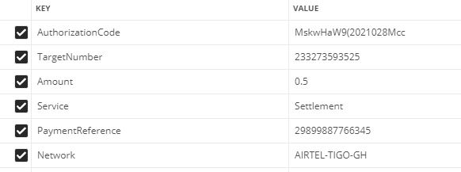

The consuming middleware would authenticate the calling application against the unwanted request from other sources.

The API will first check for the authorization for the incoming request and if all is good, it then process the request. Should the user not authorized to access the API or request coming from a wrong guest, the API will throw the below json response:

{

"Success":"Failed",

"Data":

{

"ResponseCode":"2001",

"Description":"Non authorized request"

}

}

Example of response from postman when authorization failed:

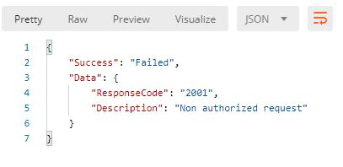

Should the request be processed successfully, a json response will be sent to the calling application to acknowledge the request as shown below:

{

"Success":true,

"ResponseCode":"payments-2005-0000-S",

"Data":

{

"Network": "AIRTEL-TIGO-GH",

"CorrelationId":"2334237965687202102151956024251734",

"TransactionId":"FtNQH5c1613418962344e40ece75c00531562ab3f4a6e97af",

"ExternalTransactionId":"f6dbafef-befd-407a-b900-31c45a87c3c2",

"Amount":"0.5",

"Status":"OK",

"Description":"The Payment Is Done successfully.",

"UtibaTransactionId":"BM210215.1954.C00819",

"PaymentReference":"350235001"

}

}

Example of success response from postman is request was initiated successfully:

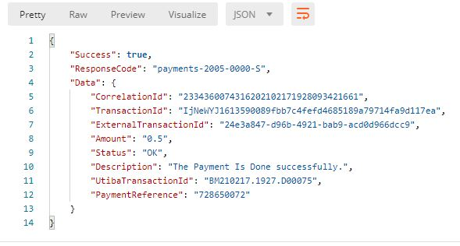

Sample error response from postman request:

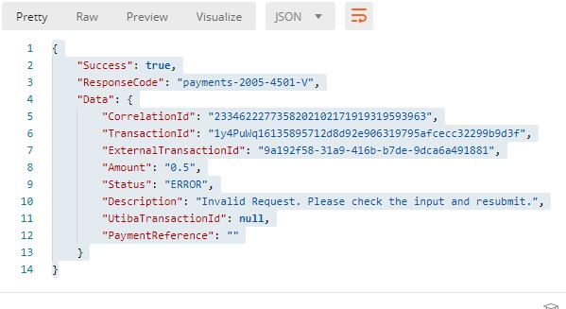

## **SUCCESS STATUS CODES**

|  |  |
| --- | --- |
| **Code** | **Description** |
| payments-2005-0000-S | The Payment Is Done successfully. |

On successful operation execution the API will return the success code below.

## **ERROR CODES**

This operation could return errors or failures in the process. The error codes and short descriptions are listed below.

|  |  |  |
| --- | --- | --- |
| **Error Code** | **Error Category** | **Error Description** |
| payments-2005-4501-V | OSB Validation Error | Invalid Request. Please check the input and resubmit. |
| payments-2005-3001-E | Backend Error. Any unmapped backend error would be returned under this error code. | <Backend error description>  or Request was not successful. Backend error has occurred. |
| payments-2005-2501-F | Connection Error | One or more back ends may be down. Please try again later. |
| payments-2005-2502-F | Timeout error. | Service call has timed out. Please resubmit your request later. |
| payments-2005-3602-E | OSB service error | Internal service error |
| payments-2005-3999-E | To be mapped in unknown section. The failure reason is not defined. | Unknown/Uncaught error has occurred. |
| payments-2005-4502-V | When an invalid ISD (Country) code is sent in the MSISDN. | Invalid ISD code passed in the MSISDN |
| payments-2005-4017-V | When an already used payment reference is passed in the request by the same Merchant. | Duplicate Paymentreference passed in the request |
| payments-2005-4516-V | When invalid amount passed in the request | Invalid Amount passed in the request. |

## **GENERAL RESPONSE STRUCTURE AND DESCRIPTION**

|  |  |  |
| --- | --- | --- |
| **Element Name** | **Element Type** | **Description** |
| ResponseCode | String | Code that is to identify the success or fail event in the transaction |
| CorrelationId | Integer | Unique identifier of the transaction by the calling application. |
| TransactionId | String | Transaction id is generated by the calling application to tigo. |
| ExternalTransactionId | String | Unique transaction id from tigo platform |
| Amount | Double | An amount to be deducted for the service/product |
| Status | String | State of the transaction Enumeration values ➢ OK  ➢ ERROR |
| Description | String | Technical and brief description of the error/success |
| UtibaTransactionId | String | Unique ID of the payment transaction from the MFS platform. |
| PaymentReference | Integer | This will the unique payment reference sent by the consuming application |

Sample success response description

|  |  |
| --- | --- |
| **Element Name** | **Description** |
| UtibaTransactionId | TransactionId from the Payment Platform (Comviva Mobiquity) |
| CorrelationId | The unique paymentreference passed in the payment request. |
| Status | OK |
| ResponseCode | payments-2005-0000-S |
| Description | The Payment Is Done successfully. |
| Amount | The amount of the Product/Item/Service provided in the request. |
| ClientReference | The unique paymentreference passed in the credit request. |
| ExternalTransactionId | Unique id (SoaTransactionId) generatedfrom tigo payment platform that previously came with the acknowledged response to the user’s request. |

Sample expected json response below:

{

"Success":true,

"ResponseCode":"payments-2005-0000-S",

"Data":

{

"Network": "AIRTEL-TIGO-GH",

"CorrelationId":"2334237965687202102151956024251734",

"TransactionId":"FtNQH5c1613418962344e40ece75c00531562ab3f4a6e97af",

"ExternalTransactionId":"f6dbafef-befd-407a-b900-31c45a87c3c2",

"Amount":"0.5",

"Status":"OK",

"Description":"The Payment Is Done successfully.",

"UtibaTransactionId":"BM210215.1954.C00819",

"PaymentReference":"350235001"

}

}