

# MOBILE CONTENT LTD

**DOCUMENT INFORMATION**

|  |  |
| --- | --- |
| **Document Author:** | Lordgreat – Adri Emmanuel |
| **Document Owner:** | Mobile Content Ltd |
| **Date:** | 2021/02/17 |

**DESIGN LEAD SIGN-OFF**

|  |  |  |  |
| --- | --- | --- | --- |
| **Name:** | Ekow DesBordes | | |
| **Role:** | Head of IT Department | | |
| **Approved:** |  | **Date:** |  |

## SERVICE OVERVIEW

The debit API service is used by a third-party Merchant’s applications to collect payment for goods and services by initiating a USSD push to the subscriber (mobile money user) to authorize the payment by entering his/her PIN or initiate an SMS push to the subscriber to follow steps in approving the payment for the service rendered. This service creates an entry of the transaction in the MCC database and respond to the calling application with an acknowledgment. It sends a request to the USSD push application which externally handles USSD push to the subscriber for transaction approval with PIN and fulfilment of payment on the payment platform (Mobiquity) MSF platform for MCC. In the event of no successful subscriber authorization with PIN, the service sends a SMS notification to the subscriber’s MSISDN with the USSD string to dial to approve/decline the pending transaction.

## DEFINITIONS AND ABBREVIATIONS

|  |  |
| --- | --- |
| **SMS** | Short Message Service |
| **USSD** | Unstructured Supplementary Service Data |
| **MSISDN** | Mobile Station International Subscriber Directory Number |
| **SOA** | Service Oriented Architecture. |
| **API** | Application Program Interface |
| **MCC** | Mobile Content.Com |
| **OSB** | Oracle Service Bus |

## API USAGE AND REQUIRED PARAMETERS

To access and use the API successfully, few parameters must be provided.

|  |  |  |
| --- | --- | --- |
| **PARAMETERS** | **MANDATORY LEVEL** | **DESCRIPTION** |
| CustomerMsisdn | Mandatory | Msisdn of the initiator of the service in a format (233546789364) |
| Amount | Mandatory | Amount to payable for the service |
| Product | Mandatory | What the payment is for, and should be very short ei (Vote, book, bill-paid) etc |
| PaymentReference | Optional | A unique code/id for each request submitted |
| AuthorizationCode | Mandatory | An access code for mcc users to be included in each request, this is a database define code. Details will be shared by head of the department. |
| Network | Mandatory | The value required is **AIRTEL-TIGO-GH** |

A **POST** request with the above parameters should be sent to the MOMO Debit url/endpoint below.

## <http://139.162.242.100/adri/payments/tigo/debit/process_initiate_request.php>

Example of postman request:

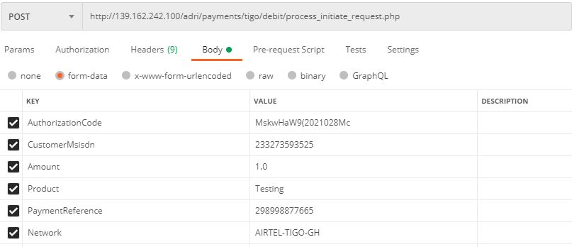

The API will first check for the authorization for the incoming request and if all is good, it then process the request. Should the user not authorized to access the API or request coming from a wrong guest, the API will throw the below json response:

{

"Success":"Failed",

"Data":

{

"ResponseCode":"2001",

"Description":"Non authorized request"

}

}

Example of response from postman when authorization failed:

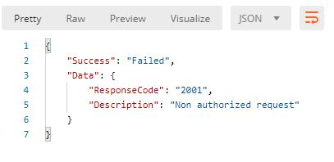

Should the request be processed successfully, a json response will be sent to the calling application to acknowledged the request as shown below:

{

"Success":true,

"ResponseCode":"purchaseinitiate-3022-0001-S",

"Data":

{

"Network": "AIRTEL-TIGO-GH",

"CorrelationId":"23324860299815202102161036192431294",

"TransactionId":"H4YhZ9v16134717794d5e9475ef11e1583dd79c914d2e24c3",

"ExternalTransactionId":"c3694618-ccc4-45ad-bf65-8cff4c1c8c2e",

"Amount":"1.0",

"Status":"OK",

"Description":"Your payment request has been initiated.",

"PaymentId":"6480551",

"PaymentReference":"123408989877855652413456"

}

}

Example of success response from postman is request was initiated successfully:

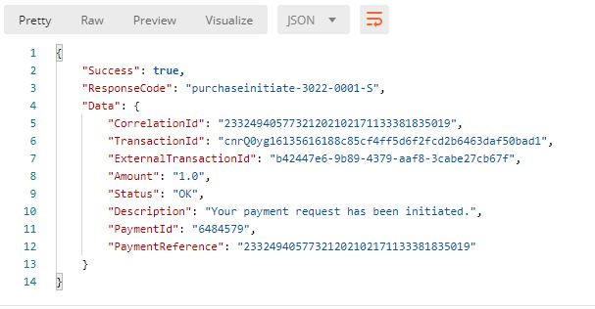

## SUCCESS STATUS CODES

|  |  |
| --- | --- |
| **Code** | **Description** |
| Purchaseinitiate-3022-0001-S | Your payment has been initiated. |

On successful operation execution the API will return the success code below.

## ERROR CODES

This operation could return errors or failures in the process. The error codes and short descriptions are listed below.

|  |  |  |
| --- | --- | --- |
| **Error Code** | **Error Category** | **Error Description** |
| purchaseinitiate-3022-3001-E | Any unmapped backend error would be returned under this error code. | <Backend error description> or  Request was not successful. Backend error has occurred. |
| purchaseinitiate-3022-4502-V | When an invalid ISD (Country) code is sent in the MSISDN. | Invalid ISD code passed in the MSISDN |
| purchaseinitiate-3022-4001-V | When the amount value in the request is not greater than zero (0). | Invalid amount value passed in the request. Amount should be a positive number. |
| purchaseinitiate-3022-2506-F | When a valid consumer is trying to access this API for whom there is no authorization | Consumer is not authorized to use the service. |
| purchaseinitiate-3022-3602-E | OSB service error | Internal service error |
| purchaseinitiate-3022-4507-V | When the payment reference id passed in the request has already been used by the same Merchant. | Duplicate payment reference id passed in the request |

## GENERAL RESPONSE STRUCTURE AND DESCRIPTION

|  |  |  |
| --- | --- | --- |
| **Element Name** | **Element Type** | **Description** |
| ResponseCode | String | Code number agreed to identify the success or fail event in the transaction |
| CorrelationId | Integer | Unique identifier of the transaction by the calling application. |
| TransactionId | String | Transaction id is generated by the calling application to tigo. |
| ExternalTransactionId | String | Unique transaction id from tigo platform |
| Amount | Double | An amount to be deducted for the service/product |
| Status | String | State of the transaction Enumeration values ➢ OK  ➢ ERROR |
| Description | String | Technical and brief description of the error/success |
| PaymentId | Integer | The unique ID that identifies the transaction in the MW platform |
| PaymentReference | Integer | This will the unique payment reference sent by the consuming application |

## CALLBACK REQUEST

On completion of the calling application’s debit transaction on Mobiquity (the payment platform) by Middleware, a callback response will be sent to the calling application with the results as updated in Middleware DB.

There is a need to store a unified callback url in BD (primary_callback_url) where all various momo debit callback response will be sent to.

A sample callback and description is below for reference.

|  |  |
| --- | --- |
| **Element Name** | **Description** |
| UtibaTransactionId | TransactionId from the Payment Platform (Comviva Mobiquity) |
| CorrelationId | The unique paymentreference passed in the PurchaseInitiate request. |
| Status | OK |
| ResponseCode | purchase-3008-0000-S |
| Description | The request has been processed successfully. |
| Product | Product/Item/Service provided in the request. |
| Amount | The amount of the Product/Item/Service provided in the request. |
| CustomerMsisdn | Momo msisdn provided in the request. |
| ClientReference | The unique paymentreference passed in the debit request. |
| ExternalTransactionId | Unique id (SoaTransactionId) generatedfrom tigo payment platform that previously came with the acknowledged response to the user’s request. |

Sample expected json response below:

{

"ResponseCode":"purchase-3008-0000-S",

"Data":

{

"Network": "AIRTEL-TIGO-GH",

" UtibaTransactionId ":" MM210217.1356.D04781 ",

"CorrelationId":"23324860299815202102161036192431294",

"ExternalTransactionId":"c3694618-ccc4-45ad-bf65-8cff4c1c8c2e",

"Amount":"1.0",

"Status":"OK",

"Description":"Your payment request has been initiated.",

"Product":"Testing",

" CustomerMsisdn ":"233569565608",

" ClientReference ":"123408989877855652413456"

}

}