

# **MOBILE CONTENT LTD**

**DOCUMENT INFORMATION**

|  |  |
| --- | --- |
| **Document Author:** | Lordgreat – Adri Emmanuel |
| **Document Owner:** | Mobile Content Ltd |
| **Date:** | 2021/02/19 |

**DESIGN LEAD SIGN-OFF**

|  |  |  |  |
| --- | --- | --- | --- |
| **Name:** | Ekow DesBordes | | |
| **Role:** | Head of IT Department | | |
| **Approved:** |  | **Date:** |  |

## **AIRTEL TIGO GET MOMO TRANSACTION DETAILS API**

## **SERVICE OVERVIEW**

GetPurchaseTransDetails is used by the consuming application to get the debit or credit transaction details (including the status) from the MW DB. Consuming application needs to pass the valid search criteria to get the transaction details. This service will retrieve the details from the MW DB based on the input. The service will return the success response. In case of any error in the flow, a fault would be returned in the response.

## **DEFINITIONS AND ABBREVIATIONS**

|  |  |
| --- | --- |
| **SMS** | Short Message Service |
| **USSD** | Unstructured Supplementary Service Data |
| **MSISDN** | Mobile Station International Subscriber Directory Number |
| **SOA** | Service Oriented Architecture. |
| **API** | Application Program Interface |
| **MCC** | Mobile Content.Com |
| **OSB** | Oracle Service Bus |

## **API USAGE AND REQUIRED PARAMETERS**

To access and use the API successfully, few parameters must be provided.

|  |  |  |
| --- | --- | --- |
| **PARAMETERS** | **MANDATORY LEVEL** | **DESCRIPTION** |
| ApiType | Mandatory | Identify the type of transaction being required for {purchase/payment} only |
| PaymentReference | Mandatory | Correlation ID of the required purchase or payment transaction. |
| AuthorizationCode | Mandatory | An access code for mcc users to be included in each request, this is a database define code. Details will be shared by head of the department. |
| Network | Mandatory | The value required is AIRTEL-TIGO-GH |

Ei

{

“ApiType”:”purchase”,

“PaymentReference”:”239843940344343943434”,

“AuthorizationCode”:”lknskdnsowejnjsdhije”,

“Network”:”AIRTEL-TIGO-GH”

}

A **POST** request with the above parameters should be sent to the MOMO Credit url/endpoint below.

**http://139.162.242.100/adri/payments/tigo/get_transactions/get_purchase_details_processor.php**

Example of postman request:

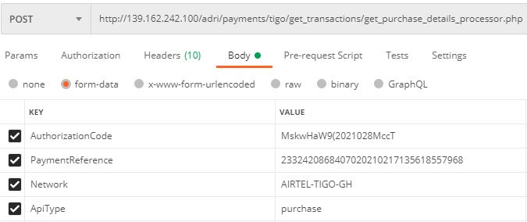

The consuming middleware would authenticate the calling application against the unwanted request from other sources.

The API will first check for the authorization for the incoming request and if all is good, it then process the request. Should the user not authorized to access the API or request coming from a wrong guest, the API will throw the below json response:

{

"Success":"Failed",

"Data":

{

"ResponseCode":"2001",

"Description":"Non authorized request"

}

}

Example of response from postman when authorization failed:

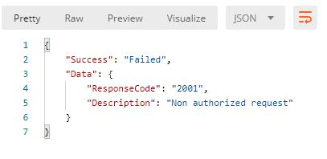

Should the request be processed successfully, a json response will be sent to the calling application to acknowledge the request as shown below for purchase (debit) and payment (credit):

**FOR PAYMENT**

{

"Success":true,

"ResponseCode":"getpurchasetransdetails-1162-0000-S",

"Data":

{

"Network": "AIRTEL-TIGO-GH",

"CorrelationId":"233244262394881202102152230228548107",

"TransactionId":"RhQ4GCs1613428222d181324d034c3b457d77c9b7cb82146d",

"ExternalTransactionId":"a3cc1d5c-fb7d-4657-8b7e-694d569c22fc",

"Amount":"0.50",

"ItemName":'payment',

"Status":"OK",

"PayerWallet":"233277231999",

"PayeeWallet":"233273593525",

"Description":"The request has been processed successfully.",

"UtibaTransactionId":"BM210215.1953.C00818",

"SoaTransactionId":"a74d3a42-2cb1-43b0-a135-807bcc52412e",

"PaymentReference":"818664819",

"PurchaseStatus":"Completed",

"AdditionalInfo":null,

"TransactionDate":"2021-02-15T19:54:24"

}

}

**FOR PURCHASE**

{

"Success": true,

"ResponseCode": "getpurchasetransdetails-1162-0000-S",

"Data": {

"Network": "AIRTEL-TIGO-GH",

"CorrelationId": "233244749322416202102182128283904469",

"TransactionId": "iUFpCMj1613683708ab4de5f72f1a5489dfd446b5ec1e2af1",

"ExternalTransactionId": "3a60e830-8845-4ec3-ac2f-a28bd17e80ae",

"Amount": "0.30",

"ItemName": "Book",

"Status": "OK",

"PayerWallet": "233273593525",

"PayeeWallet": "233277231999",

"Description": "The request has been processed successfully.",

"UtibaTransactionId": "MM210217.1356.D04781",

"SoaTransactionId": "5434cf4f-b4dc-47e8-8a3d-b4b5cc11ce83",

"PaymentReference": "23324208684070202102171356185579680",

"PurchaseStatus": "Completed",

"AdditionalInfo": null,

"TransactionDate": "2021-02-17T13:56:20.65"

}

}

Example of success response from postman is request was initiated successfully:

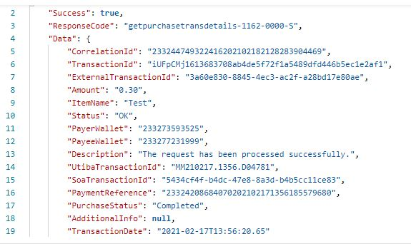

Sample error response from get transaction details request:

{

"Success": true,

"ResponseCode": "getpurchasetransdetails-1162-4110-V",

"Data": {

"Network": "AIRTEL-TIGO-GH",

"CorrelationId": "233244384613600202102182147162376052",

"TransactionId": "WHxrFTq16136848367b5af0b0a07642092b81c2362e52b818",

"ExternalTransactionId": "8dc1a7de-e2a6-4777-be19-2df2ba4abfc0",

"Amount": null,

"ItemName": null,

"Status": "ERROR",

"PayerWallet": null,

"PayeeWallet": null,

"Description": "Invalid paymentreference/authorizationcode passed in the request.",

"UtibaTransactionId": null,

"SoaTransactionId": null,

"PaymentReference": null,

"PurchaseStatus": null,

"AdditionalInfo": null,

"TransactionDate": null

}

}

## **SUCCESS STATUS CODES**

|  |  |
| --- | --- |
| **Code** | **Description** |
| getpurchasetransdetails-1162-0000-S | The request has been processed successfully |

On successful operation execution the API will return the success code below.

## **ERROR CODES**

This operation could return errors or failures in the process. The error codes and short descriptions are listed below.

|  |  |  |
| --- | --- | --- |
| **Error Code** | **Error Category** | **Error Description** |
| getpurchasetransdetails-1162- 4501-V | OSB Validation Error | Invalid Request. Please check the input and resubmit. |
| getpurchasetransdetails-1162-  4507-V | When PaymentReference passed is null/empty in the request. | PaymentReference passed is null/empty in the request |
| getpurchasetransdetails-1162- 2501-F | When backends are down | One or more back end services are not available at the moment. Please try again later. |
| getpurchasetransdetails-1162- 2502-F | OSB Timeout and backend timeout Error | Service call timed out. Please try again later. |
| getpurchasetransdetails-1162- 3603-E | OSB service error | Internal service error has occurred. |
| getpurchasetransdetails-1162- 3999-E | When the reason for failure is not defined/known in the service. | Unknown/Uncaught error has occurred. |
| getpurchasetransdetails-1162- 4502-V | When an invalid ISD (Country) code is sent in the MSISDN. | Invalid ISD code passed in the MSISDN |
| getpurchasetransdetails-1162- 4110-V | When Invalid paymentreference/correlation Id is passed in the request. | Invalid paymentreference/authorizationco de passed in the request. |
| getpurchasetransdetails-1162-  4107-V | Invalid apiType passed in the request, it should be purchase/payment. | Invalid apiType passed in the request, it should be purchase/payment. |

## **GENERAL RESPONSE STRUCTURE AND DESCRIPTION**

|  |  |  |
| --- | --- | --- |
| **Element Name** | **Element Type** | **Description** |
| ResponseCode | String | Code that is to identify the success or fail event in the transaction |
| CorrelationId | Integer | Unique identifier of the transaction by the calling application. |
| TransactionId | String | Transaction id is generated by the calling application to tigo. |
| ExternalTransactionId | String | Middleware Unique transaction Id generated by the API |
| Amount | Double | An amount to be deducted for the service/product |
| Status | String | State of the transaction Enumeration values ➢ OK  ➢ ERROR |
| Description | String | Technical and brief description of the error/success |
| UtibaTransactionId | String | Unique ID of the payment transaction from the MFS platform. |
| PaymentReference | Integer | This will the unique payment reference sent by the consuming application |
| AdditionalInfo | String | This element is used in case of backend error to return any additional information about the error. In this service, backend service name/response message would be returned in this element. |

Sample success response description

|  |  |
| --- | --- |
| **Element Name** | **Description** |
| UtibaTransactionId | TransactionId from the Payment Platform (Comviva Mobiquity) |
| CorrelationId | The unique paymentreference passed in the payment request. |
| Status | OK |
| ResponseCode | payments-2005-0000-S |
| Description | The request has been processed successfully. |
| Amount | The amount of the Item/Service provided in the request. |
| PaymentReference | Payment Reference ID for the purchase/payment transaction for which details are being requested. |
| ExternalTransactionId | Unique id (SoaTransactionId) generated from tigo payment platform that previously came with the acknowledged response to the user’s request. |
| AdditionalInfo | This element is used in case of backend error to return any additional information about the error. In this service, backend service name/response message would be returned in this element. |
| PayerWallet | Subscriber MSISDN. Payer wallet. |
| PayeeWallet | Subscriber/Merchant MSISDN who initiated the purchase/payment request. Payee wallet |
| Status | Status of the requested transaction, i.e:  Reversed  Expired  Initiated  Pending  Completed  Declined |
| TransactionDate | Purchase/Payment transaction date. |