

# **MOBILE CONTENT LTD**

**DOCUMENT INFORMATION**

|  |  |
| --- | --- |
| **Document Author:** | Lordgreat – Adri Emmanuel |
| **Document Owner:** | Mobile Content Ltd |
| **Date:** | 2021/02/19 |

**DESIGN LEAD SIGN-OFF**

|  |  |  |  |
| --- | --- | --- | --- |
| **Name:** | Ekow DesBordes | | |
| **Role:** | Head of IT Department | | |
| **Approved:** |  | **Date:** |  |

## **AIRTEL TIGO REVERSE MOMO TRANSACTION API**

## **SERVICE OVERVIEW**

The API ReverseTransaction_2_0 is used to rollback a previously successful purchase (debit) or payment (credit) transaction. The service will return the success response. This service is used by consuming applications to cancel a transaction which was previously carried out successfully by sending the Mobiquity Transaction ID hereby termed (UtibaTransactionId). In case of any error in the flow, a fault would be returned in the response.

## **DEFINITIONS AND ABBREVIATIONS**

|  |  |
| --- | --- |
| **TERMS** | **DEFINITIONS** |
| SMS | Short Message Service |
| MOBIQUITY | Mobile Financial Service Platform provided by Comviva |
| MSISDN | Mobile Station International Subscriber Directory Number |
| SOA | Service Oriented Architecture. |
| API | Application Program Interface |
| MCC | Mobile Content.Com |
| OSB | Oracle Service Bus |

## **API USAGE AND REQUIRED PARAMETERS**

To access and use the API successfully, few parameters must be provided.

|  |  |  |
| --- | --- | --- |
| **PARAMETERS** | **MANDATORY LEVEL** | **DESCRIPTION** |
| ApiType | Mandatory | Identify the type of transaction to be reversed {purchase/payment} only |
| PaymentReference | Mandatory | Correlation ID of the required purchase or payment transaction for the previous transaction that need to be reversed. |
| AuthorizationCode | Mandatory | An access code for mcc users to be included in each request, this is a database define code. Details will be shared by head of the department. |
| UtibaTransactionId | Mandatory | The Mobiquity (MFS) transactionId which has to be cancelled |
| RequestTransactionId | Mandatory | Previous transaction ID in purchase/payment that accompanied the response to acknowledge request initiated |
| RequestCorrelatorId | Mandatory | Correlation ID of the required purchase or payment transaction for the previous transaction that need to be reversed. |
| Network | Mandatory | The value required is AIRTEL-TIGO-GH |

Ei

{

“ApiType”:”purchase”,

“PaymentReference”:”239843940344343943434”,

“AuthorizationCode”:”lknskdnsowejnjsdhije”,

“UtibaTransactionId”:”MM210216.1045.D02408”,

“RequestCorrelatorId”:”239843940344343943434”,

“RequestTransactionId”:”H4YhZ9v16134717794d5e9475ef11e1583dd79c914d2e24c3”,

“Network”:”AIRTEL-TIGO-GH”

}

A **POST** request with the above parameters should be sent to the MOMO Credit url/endpoint below.

**http://139.162.242.100/adri/payments/tigo/reverse_payments/reverse_transaction_processor.php**

Example of postman request:

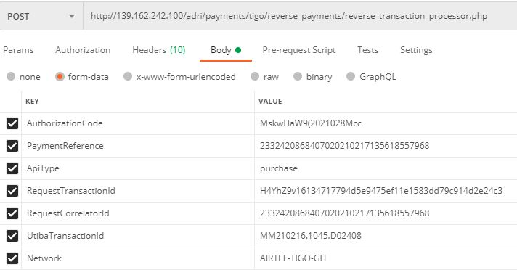

The consuming middleware would authenticate the calling application against the unwanted request from other sources.

The API will first check for the authorization for the incoming request and if all is good, it then process the request. Should the user not authorized to access the API or request coming from a wrong guest, the API will throw the below json response:

{

"Success":"Failed",

"Data":

{

"ResponseCode":"2001",

"Description":"Non authorized request"

}

}

Example of response from postman when authorization failed:

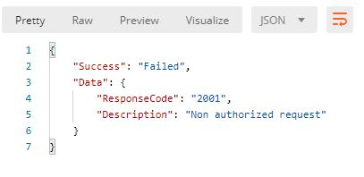

Should the request be processed successfully, a json response will be sent to the calling application to acknowledge the request as shown below for purchase (debit) and payment (credit):

**FOR PURCHASE**

{

"Success":true,

"ResponseCode":"reversetransaction-3020-0000-S",

"Data":

{

"Network": "AIRTEL-TIGO-GH",

"TransactionId":"pEOAib91613475191e1d45b4539e106a73bc7f6071770b898",

"RequestCorrelationId":"23324860299815202102161036192431294",

"RequestTransactionId":"H4YhZ9v16134717794d5e9475ef11e1583dd79c914d2e24c3",

"ExternalTransactionId":"c2cbc1d3-a79d-45e9-a6c6-342143b957f1",

"TransactionType":"CANCEL TRANSACTION",

"ReversedTransactionId":"XX210216.1132.D01930",

"Status":"OK",

"Description":"The request has been processed successfully.",

"ApiType":"purchase",

"PaymentReference":"123408989877855652413456"

}

}

Sample error response from get transaction details request:

{

"Success":true,

"ResponseCode":"reversetransaction-3020-4507-V",

"Data":

{

"Network": "AIRTEL-TIGO-GH",

"TransactionId":"iBVqPkE1613462351ad8a4273fa61090a2dd3cf6c9b2ccf54",

"RequestCorrelationId":"20210210112947",

"RequestTransactionId":"20210210112947",

"ExternalTransactionId":"4ae0369c-ebba-4b9e-ae57-3b8fc7659abd",

"TransactionType":"CANCEL TRANSACTION",

"Status":"ERROR",

"Description":"Invalid PaymentReferenceID\/AuthorizationCode passed in the request.",

"ApiType":"purchase",

"PaymentReference":"20210210112947"

}

}

## **SUCCESS STATUS CODES**

|  |  |
| --- | --- |
| **Code** | **Description** |
| reversetransaction-3020-0000-S | The request has been processed successfully. |

On successful operation execution the API will return the success code below.

## **ERROR CODES**

This operation could return errors or failures in the process. The error codes and short descriptions are listed below.

|  |  |  |
| --- | --- | --- |
| **Error Code** | **Error Category** | **Error Description** |
| reversetransaction-3020-4501-V | OSB Validation Error. Further details usually captured in additional information field. | Invalid Request. Please check the input and resubmit. |
| getpurchasetransdetails-1162-  4507-V | When PaymentReference passed is null/empty in the request. | PaymentReference passed is null/empty in the request |
| reversetransaction-3020-4507-V | Invalid PaymentReference/CorrelationId passed in the request. | Error when invalid PaymentReferenceID is passed in the request or the PaymentReferenceID is a mismatch to that of the Purchase or Payment transaction to be reversed. |
| reversetransaction-3020-2501-F | One or more back ends may be down. Please try again later. | When backends are down. Connection error message |
| reversetransaction-3020-2502-F | OSB Timeout and backend timeout Error. | Service call has timed out. Please resubmit your request later. |
| reversetransaction-3020-3602-E | OSB internal error | Internal service error has occurred. |
| reversetransaction-3020-3999-E | To be mapped in unknown section. The failure reason is not defined. | Unknown/Uncaught error has occurred. |
| reversetransaction-3020-4512-V | When Invalid apiType is passed in the request. Expected value is purchase or payment. | Invalid apiType passed in the request |
| reversetransaction-3020-4513-V | When an invalid Mobiquity (MFS) TransactionID is passed in the request | Invalid TransactionID passed in the request |
| reversetransaction-3020-3001-E | Any unmapped backend error would be returned under this error code. | <Backend description> or Request was not successful. Backend error has occurred. |

## **GENERAL RESPONSE STRUCTURE AND DESCRIPTION**

|  |  |  |
| --- | --- | --- |
| **Element Name** | **Element Type** | **Description** |
| ResponseCode | String | Code that is to identify the success or fail event in the transaction |
| CorrelationId | Integer | Unique identifier of the transaction by the calling application. |
| TransactionId | String | Transaction id is generated by the calling application to tigo. |
| ExternalTransactionId | String | Middleware Unique transaction Id generated by the API |
| Status | String | State of the transaction Enumeration values ➢ OK  ➢ ERROR |
| Description | String | Technical and brief description of the error/success |
| UtibaTransactionId | String | Unique ID of the payment transaction from the MFS platform. |
| PaymentReference | Integer | This will the unique payment reference sent by the consuming application |
| AdditionalInfo | String | This element is used in case of backend error to return any additional information about the error. In this service, backend service name/response message would be returned in this element. |
| additionalResults | String | AdditionalResults for this service returned are:  Generated  Consumed  NewBalance  SessionId |