ALGORITHM FullKnapsack(S)

INPUT: a set S containing n items (input.txt file containing first row Knapsack object data in format "<weight_cap> <size_cap>" and subsequent row Item object data in format "<name> <weight> <size> <value>").
OUTPUT: a set T containing the most optimal packing of set S items or no packing (update the console with process progress and results). The output should be consistent with the Liao-Knapsack Problem (two-dimensional, 0-1, full-Knapsack).

Step 1: Generate all subsets of possible Item packings with the SubMySet algorithm.
Step 2: Check each subset to see if its valid (matches weight and size caps exactly)
Step 3: Check the remaining valid entries for the one with the highest value entry (if multiple optimal packings are found, choose the first that appears with that value entry in your set of subsets).

ALGORITHM SubMySet(S)

INPUT: a set S containing n items.
OUTPUT: a set T containing all subsets of S (not including the null set)

For each i in S:
T’ -> set of saved sets.
T’ <- T //copy all previously found subsets to T’
for each s in T:
s.add(i) // add the next layer to all discovered sets.
T’.add(i) //add the set of just i.
T = T + T’ // doubles arr size during each iteration.

ANALYSIS
The output of the FullKnapSack Algorithm as seen in this implementation (FullKnapSack.java) follows the requirements very closely as seen by the following unix-CLI “diff” command output on the Project Required Output vs. the Real Implementation Output when run on the provided input file (input.txt).
--- sampleOutput.txt 2026-01-19 15:04:02
+++ realOutput.txt 2026-01-19 15:03:05
@@ -3,18 +3,18 @@
Knapsack weight: 15
Knapsack size: 20
Number of items: 4
-Item A (weight, size, value): 5 10 2.5
-Item B (weight, size, value): 10 10 10
-Item C (weight, size, value): 2 3 1
-Item D (weight, size, value): 3 7 2
+Item A (weight, size, value): 5.0 10.0 2.5
+Item B (weight, size, value): 10.0 10.0 10.0
+Item C (weight, size, value): 2.0 3.0 1.0
+Item D (weight, size, value): 3.0 7.0 2.0
Finding optimal packing ....
Found a packing!
-Total weight: 15
-Total size: 20
-Total value: [value]
-Packing: Item A, Item B, ..., etc.
-Total running time: [second] seconds
-or
+Total weight: 15.00
+Total size: 20.00
+Total value: 13.00
+Packing: Item B, Item C, Item D
+Total running time: 0.055963 seconds
+or
Finding optimal packing ....
No packing is found!
-Total running time: [second] seconds
+Total running time: 0.038951 seconds

The FullKnapSack Algorithm used in this study - which utilizes a brute force algorithm - follows a time and space complexity of O(k^{n}) (i.e. exponential time complexity) due to the process of generating all possible subsets from a set. When generating the set of all possible subsets, each Item in the input set must be iterated over all previously discovered subsets. This process effectively causes the number of possible subsets to be doubled with each subsequent Item object.
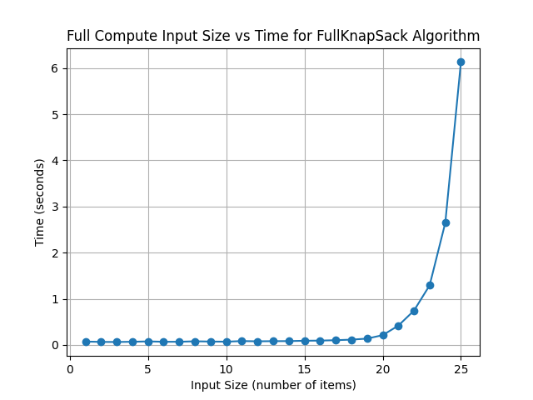
Figure 1.1: FullKnapSack Algorithm Implementation Appears to Follow Exponential Time Complexity for Increasing Magnitudes of Input Size. These values were collected using a bash script (gen_graph_from_algorithm.bash) to generate a relatively large test set of data - 30 trials sets (for stable means) of input sizes of 1-25 Item objects - which was subsequently pipelined into a modified FullKnapSack (FullKnapSack4Bash.java) script for processing and graphed with a python script (graph.py).
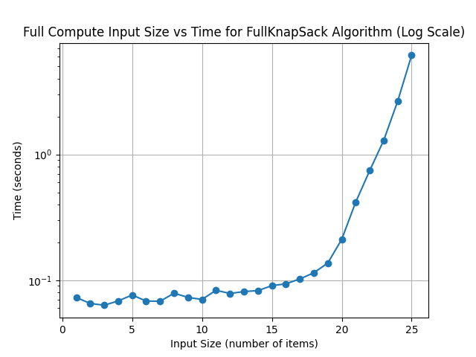Figure 1.2: FullKnapSack Algorithm Implementation Follows a Roughly Exponential Time as Seen with Logarithmic Time Scale. The logarithmic time scale version of the graph emphasizes a non-exponential pattern for lower Item data input quantities (likely due to the relatively large amount of compute resources being dedicated to non-exponential overhead). However, as input size increases and as other non-exponential processes become negligible, a strong exponential pattern emerges around input size of 19 (as seen by the relative linearity of the graph at higher input sizes).
This is not an ideal time complexity as it would not be practical to find optimal packings in real world scenarios. Much faster, so-called “greedy” algorithms exist for solving these problems more efficiently (although the optimal solution may not always be found). The actual running time on a set of Item objects begins to become impractical after about 25 items for the machine I used (macOS, Apple’s M2 ARM chip, 16 gigabytes of RAM, ~512 gigabytes of storage). The implementation regularly exceeded 50 seconds of compute time at input size of 26, with subsequent amounts of Item objects being far too impractical for real world applications of packing (such as in a pack and ship center). Running the same implementation on my system on 27 Item objects (instead of 26) gave the error java.lang.OutOfMemoryError (for java heap space overflow) and crashed the JVM. This is after using the -Xmx tag to dedicate more RAM to the process (My system-wide RAM caps out at 14gb of RAM, and the Java process only increased system-wide usage by 8gb of RAM, meaning the process likely only used 8gb of RAM at any given time).

DISCLAIMERS:
LLM output was used extensively throughout code implementations in this assignment in the form of in-line code autocomplete using the Microsoft Co-Pilot extension for VSCode. Such tools were for primarily utilized for simple, straight-forward implementations like constructors and helper methods (i.e. any method starting with calc, set, get, toString or like implementations, etc). The driving methods and implementations were primarily constructed by hand with some minor, straight-forward auto-completes.

Many skills utilized in the implementations (python and bash/zsh) were not taught directly in Computer Science courses but were learned through working closely with software that students in the meteorology department at CMU use (especially in the Data and Visualization course offered fall semester).

