

**DETAIL DESIGN DOCUMENT**

**iVOLUNTEER**

**Screen Design**

**Project Code: IVSN**

**Document Code: IVSN_ScreenDesign_v1.0_EN**

**Hanoi, Jun 02nd 2016**

# SIGNATURE PAGE

|  |  |  |
| --- | --- | --- |
| AUTHOR: | Võ Tôn Phúc  Team Member | 02/06/2016 |
| REVIEWERS: | Nguyễn Mình Đức  Project Manager | xx/06/2016 |
| APPROVAL: | Bùi Đình Chiến  Supervior |  |

# RECORD OF CHANGE

*A - Added M - Modified D – Deleted

|  |  |  |  |  |  |
| --- | --- | --- | --- | --- | --- |
| **Effective Date** | **Changed Item** | **A,M,D** | **Change Description** | **Reason for Change** | **Rev. Number** |
| 02/06/2016 | Create Screen Design | A |  |  | 1.0 |
|  |  |  |  |  |  |
|  |  |  |  |  |  |

Contents

SIGNATURE PAGE 2

RECORD OF CHANGE 3

1 INTRODUCTION 6

1.1 Purpose 6

1.2 Definition, Acronyms and Abbreviations 6

1.3 References 6

1.4 Overview 6

2 SCREEN FLOW 7

2.1 Register 8

2.1.1 Register 1/3 8

2.1.2 Register 2/3 9

2.2 Login 10

2.3 Forgot Password 10

2.4 Reset Password 10

2.5 Profile 10

2.5.1 Personal Information 10

2.5.2 Note 10

2.5.3 Group 10

2.5.4 Project 10

2.5.5 Friend 10

2.5.6 Gallery 10

2.5.7 Map 10

2.6 Group 10

2.6.1 Public 10

2.6.2 Dicussion 10

2.6.3 Member 11

2.6.4 Gallery 11

2.6.5 Information 11

2.7 Project 11

2.7.1 Public 11

2.7.2 Dicussion 11

2.7.3 Plan 11

2.7.4 Budget 11

2.7.5 Donator & Member 11

2.7.6 Information 11

2.8 Search 11

2.8.1 Project 11

2.8.2 Group 11

2.8.3 User 11

2.9 Create New Group 11

2.10 Create New Project 11

2.11 Popup Friend 12

2.12 Popup Notification 12

2.12.1 Notification 12

2.13 Popup message 12

2.13.1 Message 12

# INTRODUCTION

## Purpose

## Definition, Acronyms and Abbreviations

|  |  |  |
| --- | --- | --- |
| Abbreviations | Description | Comment |
| IVSN | iVolunteer Social Network |  |
| Q&A | Question and answer |  |

*Table 1-1: 1.2 Definition, Acronyms and Abbreviations*

## References

|  |  |
| --- | --- |
| Document Number | Title |
| 1 | JS_Templates - Template_Screen Design.dot |
|  |  |
|  |  |

*Table 1-2: References*

## Overview

# SCREEN FLOW



*Figure 2-1: Screen structure or transition between screens*

|  |  |  |
| --- | --- | --- |
| No | Screen Name | Description |
| 1 | Home | The first page will be displayed when user access IVSN website. |
| 2 | Login | Login into IVSN website |
| 3 | Forgot Password | The page allow user access when they forgot password to login into IVSN website. |
| 4 | Reset Password | The page allow user reset their password. |
| 5 | Profile | This is the page contain all object of user. |
| 6 | Profile Information | This is tab that user and their friend can see their personal information. |
| 7 | Note | That is tab that user and their friend or all user in system can see their note like an experiences or feeling when they join a volunteer activity. |
| 8 |  |  |
|  |  |  |

*Table 2-1: List of screen*

## Register

### Register 1/3

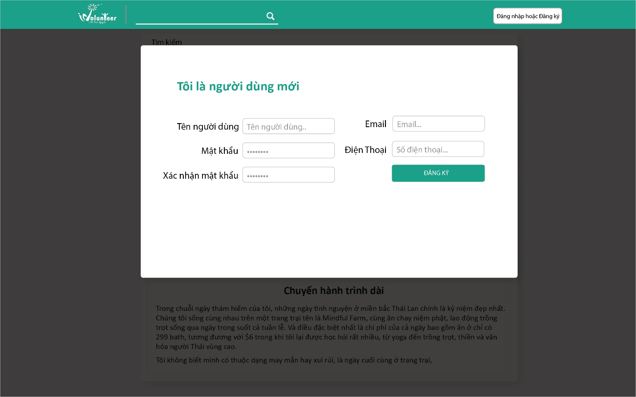

*Figure 2-2: Register (1/3) Screen*

|  |  |  |  |  |  |
| --- | --- | --- | --- | --- | --- |
| No | Component Name | Required | Format | Reference | Note |
|  |  |  |  | How to get data or save data from screen |  |
|  |  |  |  |  |  |
|  |  |  |  |  |  |
|  |  |  |  |  |  |

*Table 2-2: Register 1/3 Screen’s component list*

### Register 2/3

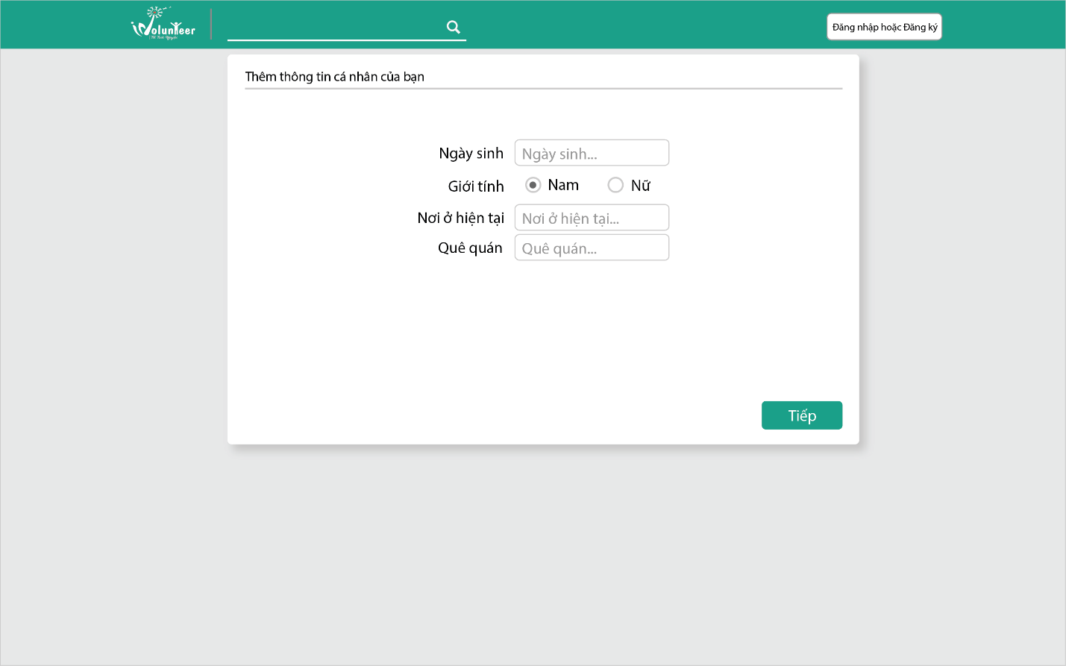

*Figure 2-3: Register 2/3 Screen*

|  |  |  |  |  |  |
| --- | --- | --- | --- | --- | --- |
| No | Component Name | Required | Format | Reference | Note |
|  |  |  |  | How to get data or save data from screen |  |
|  |  |  |  |  |  |
|  |  |  |  |  |  |
|  |  |  |  |  |  |

*Table 2-3: Register 1/3 Screen’s component list*

## Login

## Forgot Password

## Reset Password

## Profile

### Personal Information

### Note

### Group

### Project

### Friend

### Gallery

### Map

## Group

### Public

### Dicussion

### Member

### Gallery

### Information

## Project

### Public

### Dicussion

### Plan

### Budget

### Donator & Member

### Information

## Search

### Project

### Group

### User

## Create New Group

## Create New Project

## Popup Friend

## Popup Notification

### Notification

## Popup message

### Message