Import of existing Database

1) connect to phpmyadmin

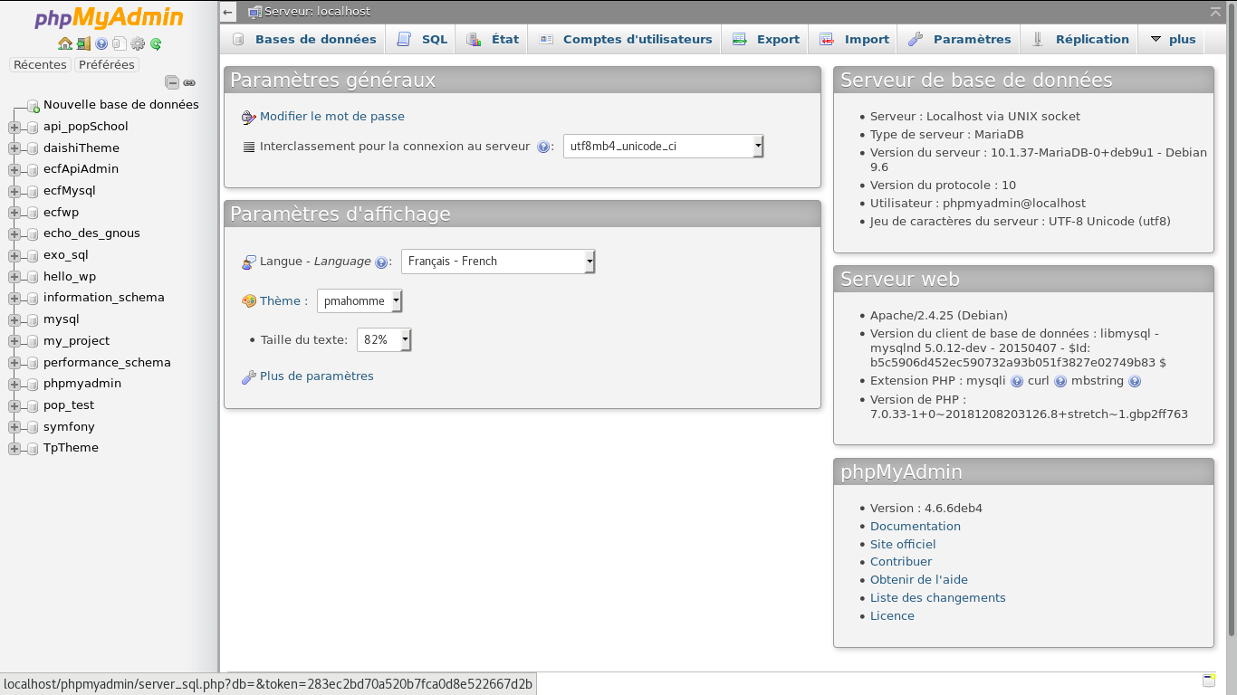
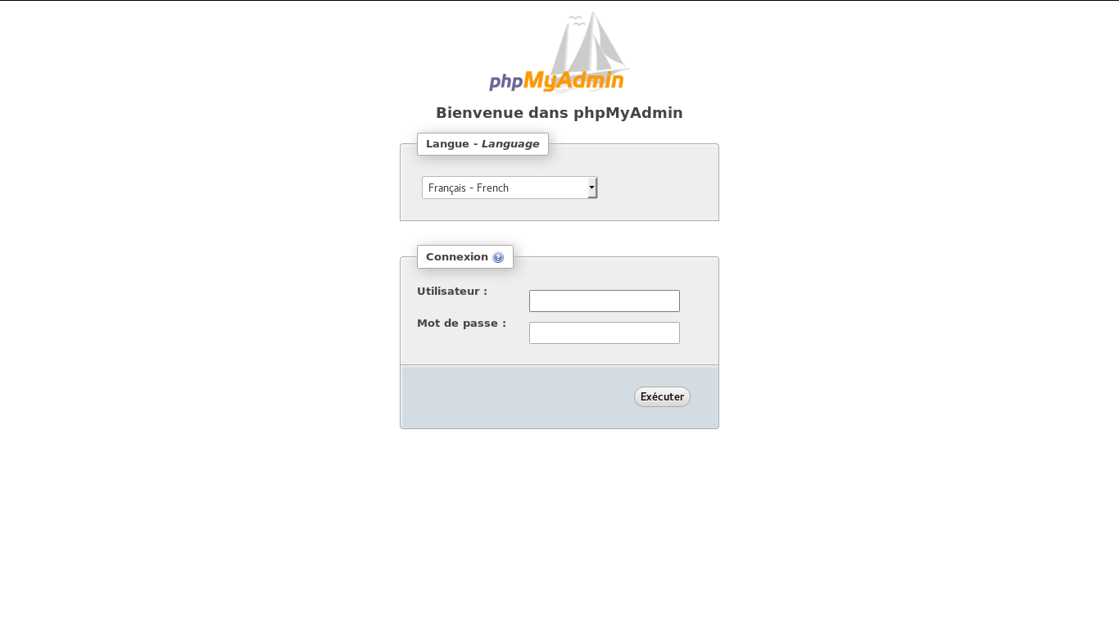
2) click on ‘create new database ‘

3) type the name of the existing database (for your project the name is : ‘ecfApiAdmin’)

4) click on create

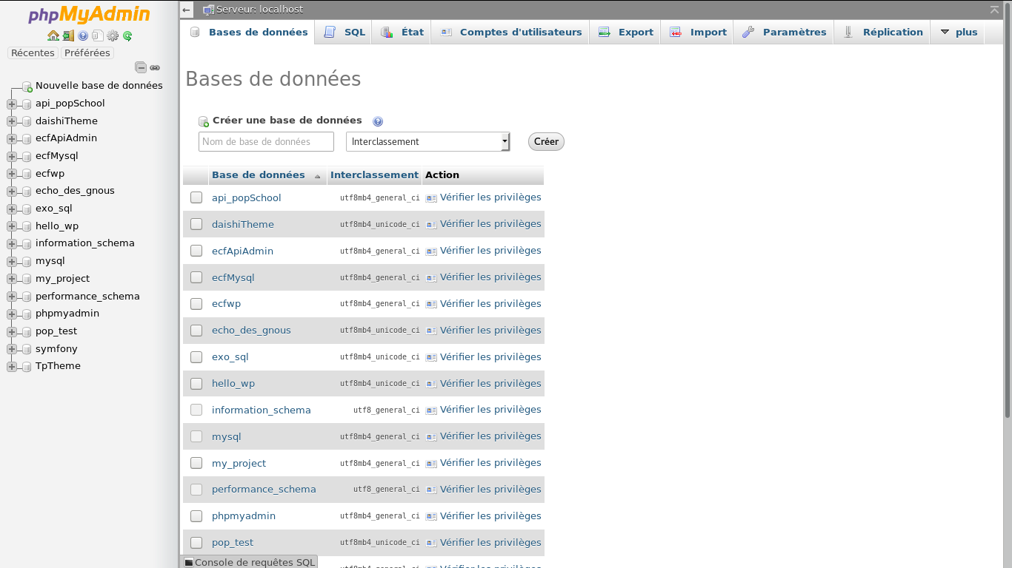

5) click on your database created

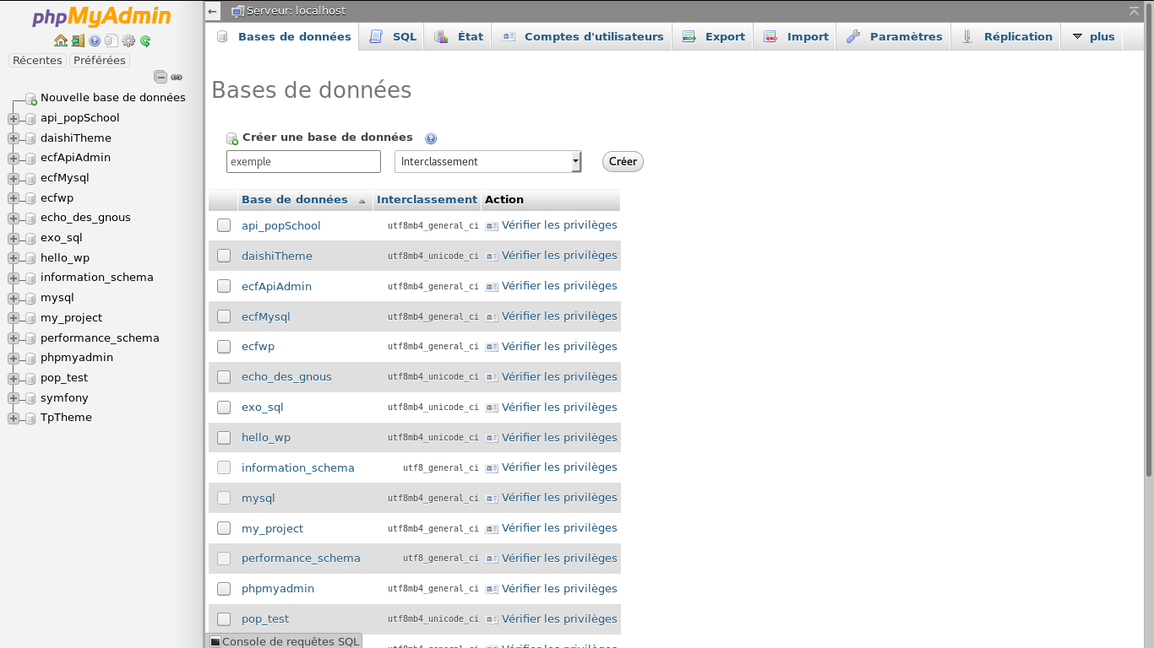

6) click on IMPORT

