user manual

to add a promotion:
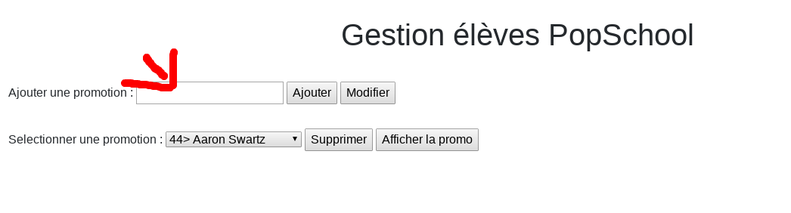
1- ADD name of promotion Here

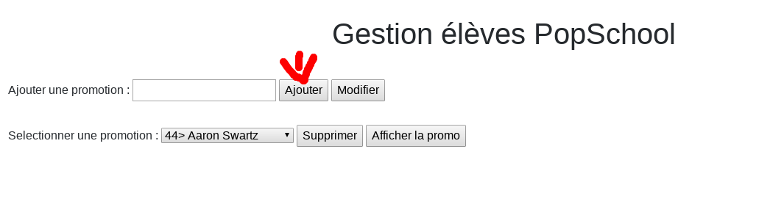
2- click on the buttons for add name of new promotion
For Delete promotion :

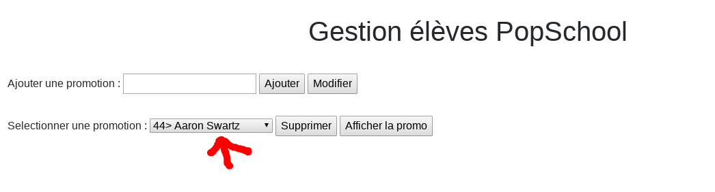
1- Select promotion
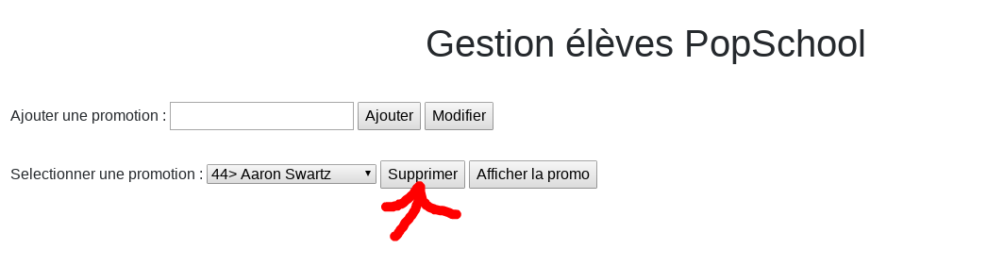
2- click on the button :

to display the promotion

1- click on the button

