Lords of Games Charter for Rocksmith
List of contents
How to start 2
File menu 2
Options 2
Creating a chart 3
Opening existing chart 3
Using separate audio file 4
Importing existing arrangement 4
Importing guitar pro file (experimental, not finished) 4
Graphic options 4
Edit menu 5
Special paste 5
Song options 5
Add silence to the beginning 5
Music menu 6
Arrangement menu 7
Tempo map 7
Vocals arrangement 7
New arrangement 8
Guitar arrangement 8
Notes menu 9
Guitar arrangement editing 10
Sections, phrases and events 10
Tone changes 10
Anchors 11
Hand shapes 11
Editing notes 12
Right click 12
Left click 12
Numeric buttons 12
Up and down 12
Shortcuts 12
Other buttons and actions 12
Copy and paste 13
Quick edit 13
3D Preview 15
Terminology 16

How to start
On Windows, you run the RS Charter.exe
On Mac and Linux you have to run the RS Charter.jar file
To use the program you need to have Java 16 or newer installed on your system, you can install newest version available from Oracle or any other distributor, for example OpenJDK, you don't need the same version of Java.

File menu

Options
After you start the program for the first time, you should go to File > Options and change settings as you see fit, in particular music and songs folders.
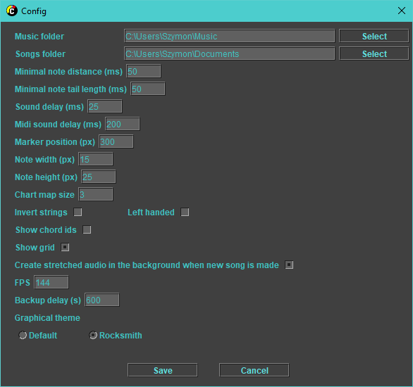
- Music folder – where the window for choosing music for new song will open (default value is user's Music folder)
- Songs folder – where the new songs will have folders created by default (default value is user's Documents folder)
- Minimal note distance – distance between end of one note and start of next note (doesn't apply to linked notes) (default value is 50 ms)
- Minimal note tail length – notes shorter than this will be reduced to length 0 (default value is 50 ms)
- Sound delay – delay of your audio system (default value is 25 ms)
- Midi sound delay – delay of your midi device (default value is 200 ms)
- Marker position – position of time marker on screen (default value is 300 px)
- Note width, Note height – size of notes on edit panel (default values are 15 x 25 px)
- Chart map size – multiplier for chart map height (default value is 3)
- Invert strings – whether strings should be inverted in the editor (default value is false)
- Left handed – whether 3D preview should be inverted left to right (default value is false)
- Show chord ids – debug option that shows chord numbers in the arrangement, helpful for finding similarly looking chords that are different (default value is false)
- Show grid – whether to show grid in the editor or not
- Create stretched audio... - If checked, editor will make slowed down versions of the song in the background when the song chart is made, if unchecked they will be created on demand (this takes few minutes though, so it's better to leave this checked unless you lack disk space)
- FPS – frames per second (default value taken from your screen's data)
- Backup delay – time between backups in the background (in seconds, 10 minutes by default)
- Graphical theme – choose editor's theme, which will change details on notes

Creating a chart
To create a chart, you click the File > New menu option, which will show music file chooser.
After selecting your desired music file in .ogg or .mp3 format, program will ask whether you want to make new folder in your songs directory, or use the folder where audio is stored. You can change name of the folder, by default the name is<artist> - <title>, taken from audio file's metadata.
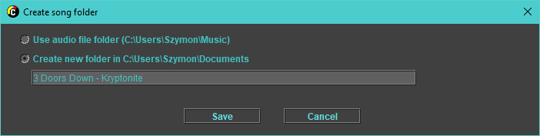
After clicking “Save”, chart files will be created.

Opening existing chart
If you want to open song that has arrangement already but wasn't made in this editor, you can create new song based on selected arrangement file in File > Open song from RS arrangement XML.
Program will ask you to select music file and then .xml file with arrangement, and will use folder where audio file is as project folder.
You should only use this option to make editor's project in existing chart folder.

Using separate audio file
You can open different audio file for playback fy using File > Open audio file option.
This will only change playback audio and not overwrite music file of the project.

Importing existing arrangement
You can import guitar/vocals arrangements to add them to existing project in the File > Import menu.

Importing guitar pro file
In the File > Import menu there is an option to import Guitar Pro file.
If tempo map is not set yet, it will be taken from GP file.
GP file import will add new arrangement(s) with auto generated hand shapes and anchors, and without tone changes, sections, phrases or events.
After import, you can select new arrangement in the Arrangement menu.
Currently only Guitar Pro 3, 4 and 5 files can be imported, newer formats coming soon.

Graphic options
You can set custom colors for the editor here (some color changes might need restart of the editor).

Edit menu

Special paste
By using ctrl + shift + V shortcut, you can paste more than just selected objects.
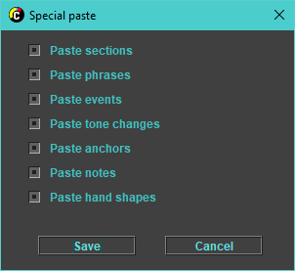
When pasting like this, all objects from start to end of your selection get copied, and can be pasted, including every option seen on the popup. You can use this to copy whole parts of the song.

Song options
Song options can be used to change title, artist, album and year of the song.

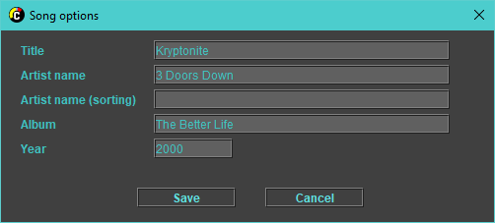
Add silence to the beginning
You can add seconds of silence to the beginning of the song or set first beat to be on given value.
Another menu position sets first beat at 10s and adds given amount of bars.
For now feature works only on Windows, you need to do it manually using eg. Audacity on other systems.

Music menu
You can set speed of slowed down audio there.

Arrangement menu
It contains all arrangements, levels and arrangement options.

Tempo map
Changes to tempo map edit mode, which is also default for new songs.
You can right click on a tempo to change the time signature.
In this mode you can change tempo by dragging beats around.
If you drag first beat, you move the whole chart.
For all other beats, after you drag the beat around, beats between dragged one and last anchored will get spread evenly, and same happens for dragged and next anchored beat, if there is no next anchored beat, editor takes BPM of last beat before dragged one and sets it as BPM for rest of the song.
Anchored beats will have little arrows at the top.
Moving beats will move positions on all arrangements accordingly, so you can fix the tempo after placing the notes if you need to, but you should start with getting it right because it helps in later stages.
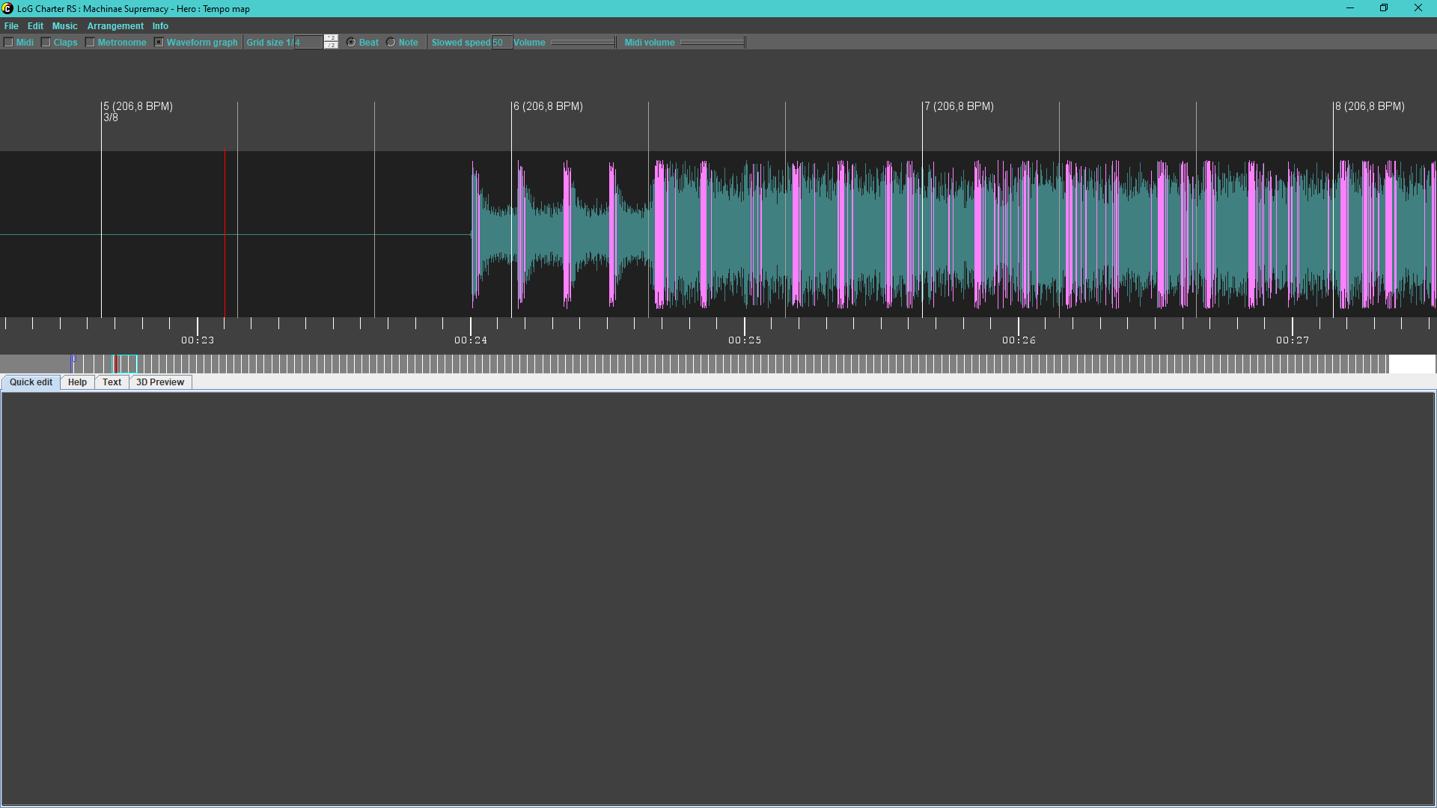
It is good to use Waveform graph and Metronome to confirm that the beats are placed correctly, you can toggle them with F5 and F4, or on the toolbar.
After you finish making tempo map, you should make or edit an arrangement.

Vocals arrangement
Changes to vocals edit mode.
You can right click to add/remove a vocal. When creating a vocal, you need to enter text that will show (- at the end will mark vocal as linked to next, + will mark it as phrase end). Saving with no text will delete a vocal.
Left click selects and moves vocals around.
When selected, vocals' lengths can be changed with scroll wheel, and quick edit on the bottom will show current values.
Double click or L can be used to open edit popup. If multiple vocals are selected when pressing L, they will be edited each after another.
W and E are shortcuts for toggling word part and phrase end flags.
Full phrases are shown above the edit area.
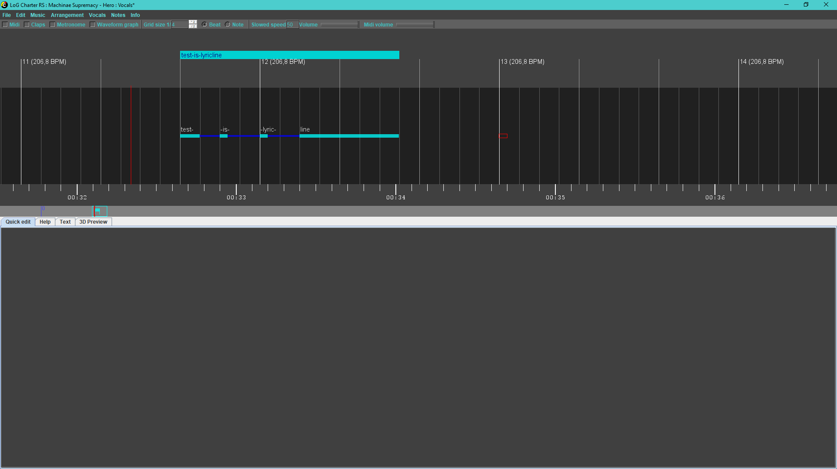

New arrangement
Adds new arrangement to the project.
You can set type of arrangement (Combo, Rhythm, Lead, Bass), subtype (Main, Bonus, Alternate),
base tone name, number of strings, capo and tuning. You can edit those later in Arrangement > Arrangement Options.
When changing tuning later, you will also have option to move frets on strings that changed values.
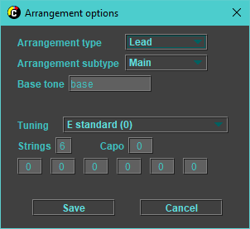
Changes to guitar edit mode.

Guitar arrangement
Selecting any of guitar arrangements will change editor to guitar editing mode.
Difficulty levels will show under the arrangements when guitar arrangement is selected.

Notes menu
Notes menu contains options for grid.
You can change size of the grid, unit it's based on (note or beat), and use , and . to double/halve the grid size.

Guitar arrangement editing
When editing guitar arrangement, you have main area where you can place notes, anchors, hand shapes, sections, phrases, events and tone changes.

Sections, phrases and events
To add, edit or remove sections, phrases and events, you right click the area above the beat line.
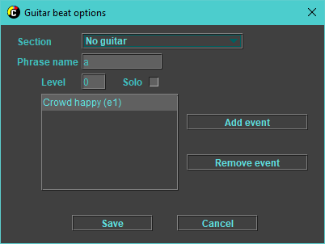
When you do, edit window will appear for that position that lets you edit these values.

Tone changes
Just below the beat you have tone change area, right clicking in it will let you add, edit or remove tone change. The input has autocomplete functionality that hints you already used tone names.
Remember that you can only use 4 tones per arrangement.
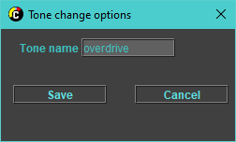

Anchors
Right clicking the area just above notes area will add or edit an anchor.
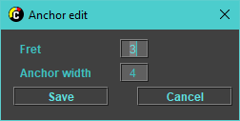
Fret is the fret that index finger should be put on, while width is the spread of what you should cover in this position.
If you use tapping, remember to make anchor reach the top note so it won't jump between high and low notes.

Hand shapes
Clicking just below the note area will let you add or remove a hand shape.
Hand shapes are automatically added for each chord when saving.
You can use hand shapes to mark arpeggios instead of chords too, you should then select the arpeggio flag on the hand shape edit popup.
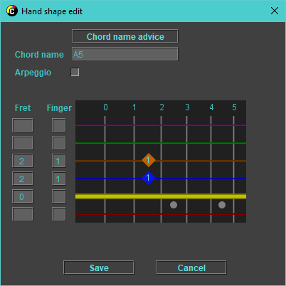

Editing notes

Right click
You can right click to add or remove notes, you can hold and drag to place multiple notes at the same time.

Left click
You can left click to select or drag notes.

Numeric buttons
You can use button 0-9 to input fret of all selected sounds.
All single notes will move to fret you typed.
Chords will put lowest fret in the shape at the typed fret.

Bookmarks
You can use ctrl + 0-9 to toggle bookmark at current position.
You can move to bookmark by pressing shift + 0-9.

Up and down
You can press up and down to move notes between strings, if you hold ctrl it will change strings but leave the sounds the same (it will change frets).

Shortcuts
You can use shortcuts described in the Guitar menu to quickly cycle note statuses of all selected notes:
- M – cycle mutes (None, Palm, Full)
- H – cycle HO/PO (None, Hammer On, Pull Off, Tap)
- O – cycle harmonic (None, Normal, Pinch)
- A – toggle accent
- V – toggle vibrato
- T – toggle tremolo
- L – toggle link next
- Shift + H – make a hand shape over selected sounds, with template from first selected chord
- F2 – toggle Midi
- F3 – toggle claps
- F4 – toggle metronome
- ./, - double/halve grid size
- G – open grid options popup

Other buttons and actions
- ctrl + left click – add to selection
- ctrl + shift – add to selection all objects from last selected to clicked
- scroll wheel – change length of selected notes/hand shapes
- shift + scroll wheel – change length faster
- ctrl + scroll wheel – change editor's zoom
- ctrl + shift + scroll wheel – change zoom faster
- left/right – move position
- ctrl + left/right – move position slower
- shift + left/right – move position faster
- alt + left/right – move between beats
- alt + ctrl + left/right – move between grid positions
- ctrl + shift + V – special paste

Copy and paste
Copied data is stored as a xml, so it can be saved as text for later.
You can use ctrl + shift + V to paste more than just selected copied values.

Chart map
Under the editor is chart map. You can click on it to move around the chart quickly, and it shows where you are and bookmarks, and also different other things based on mode:
- In tempo mode it will show bars
- In vocals mode it will show lyric lines

- In guitar mode it will show phrases, sections and notes

Quick edit
Below the edit area are tabs with Quick edit, Help, Text and 3D Preview.
Help just shows FPS for now.
Text can be used as temporary notepad or to hold lyrics as you edit them.
3D preview shows how the arrangement will approximately look like in the game.
The quick edit is made of few parts, changing depending on selected content. It allows you to change values of most objects, that is tone changes, anchors, notes, hand shapes and vocals.
Quick edit for tone changes, anchors and vocals looks just like the popup.
For notes and hand shapes there are few parts:
- note options
  - first there are strings that you want to edit (only notes on selected strings will have values changed, for chords you can change values of specific chord notes this way)
  - below are string and fret (only filled for single notes)
  - then Mute, HOPO, Bass picking, Harmonic and other statuses

- chord template editor
  - has chord name input that suggests already used chords if you start typing name or frets
  - has a button to suggest chord name based on its shape
  - below that is area where you can edit the shape via inputs or by clicking on the strings
  - you can press buttons for fingers (1, 2, 3, 4, T) while hovering over the strings to set the finger for that string
  - works the same way for both chords and hand shapes

- bend editor
  - you can use radio buttons to select strings
  - you can left click to add or move a bend point
  - you can right click to remove a bend point

3D Preview
Helpful to see if the chart isn't cluttered or if anchors and notes are placed right, you can press F11 to make it full screen.
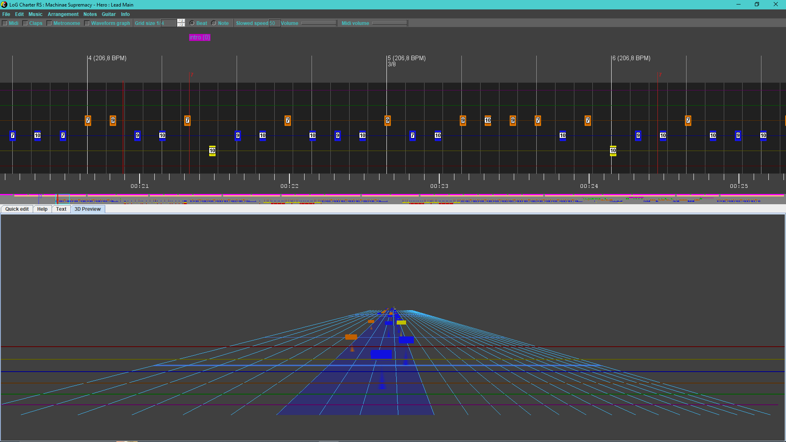

Terminology
- Accent – striking strings harder to make louder sound
- Anchor – also called fret hand position (FHP), in the game it tells where to place your left hand, has fret and width as values (default width is 4), should be placed on note that makes you move your hand
- Bass picking technique – special picking techniques for bass players, using fingers
  - Pop – pulling on the string before releasing it
  - Slap – slapping string with a thumb instead of plucking it
- Beat – horizontal line representing point in song time, it has time signature that marks every nth beat as primary, and can be anchored which means it has fixed position, beat is anchored after you drag it
- Bend point – position in note with defined bend value
- Chord – set of notes played together, each chord has a template assigned, if chord repeats, only the chord box is visible
- Chord template – shape of a chord with placement of fingers
- Chord note – note of a chord, each can be edited separately, if chord has different values on chord notes, it shows the notes.
- Claps – plays beep on every note in arrangement
- Crazy/Arpeggiato – allows you to place sustain passing other notes, can cause chart to be difficult to read
- Event – things like crowd cheering
- Hand shape – the duration for which you should hold a chord, can be marked as arpeggio
- Harmonic – sound created by multiplying base note
  - Normal harmonic – played by touching string with left hand exactly where it divides nicely, for example:
    - 12th fret for ½ → 2x higher pitch
    - 9th fret for 2/5 → 5x higher pitch
    - 7th fret for 1/3 → 3x higher pitch
    - 5th fret for ¼ → 4x higher pitch
    - 4th fret for 1/5 → 5x higher pitch
lower denominators are easier to play
  - Pinch harmonic – played by touching the string in a harmonic point with right hand while plucking the string, multiplies fretted note pitch instead of open note one
- HO/PO – technique of playing note without plucking the string
  - Hammer on (HO) – hitting the string on the fret with finger of the left hand
  - Pull off (PO) – releasing string with finger on left hand in a way that lets it ring out
  - Tap – you tap the string on a fret with finger of right hand
- Ignore – makes Rocksmith not check whether sound was played right for song score
- Link next – links note to next note, removing note head from note after
- Metronome – beeps on every beat
- Midi – plays midi notes based on current arrangement
- Mute – can be set to full (frethand), palm or none
  - Full mute – you mute the strings by touching them with fingers of left hand, but not holding them down to frets
  - Palm mute – you hold palm of your right hand on the strings
- Phrase – part of a section, could be repeated multiple times, has difficulty that show as a column in Rocksmith.
- Section – section of the song, shows as orange line under the phrases in Rocksmith
- Slide – changing frets by moving left hand between frets
  - pitched – moving it to new fret that should ring out
  - unpitched – moving it in a direction, then usually letting it go silent
- Split (chord) – forces splitting chord into normal notes placed on the same position
- Tremolo – technique where you pick the string/s repeatedly
- Vibrato – technique where you repeatedly slightly bend the string/s to make the pitch vibrate
- Vocal – part of lyrics, usually word or syllable, can be linked to next vocal or marked as end of phrase (lyric line)
- Waveform graph – visually represents song's audio, different color for audio parts with high RMS

