**Comprehensive Review of SiC MOSFET and Parks Transformation-Based Control Strategies for Active Power Filters in Renewable Energy Applications**

**Abstract:** The increasing penetration of renewable energy sources (RES) like solar and wind has introduced significant power quality issues, primarily due to harmonic distortions. Active Power Filters (APFs) have emerged as effective solutions for mitigating these challenges. This review explores the integration of Silicon Carbide (SiC) MOSFET technology with Park’s Transformation-based d–q control strategies in APF systems. SiC MOSFETs offer superior electrical characteristics, including high switching frequency, thermal efficiency, and voltage blocking capability, making them highly suitable for modern APFs. Park’s Transformation facilitates effective decoupling of active and reactive power components, enabling precise harmonic compensation. Various control methods—ranging from conventional PI to advanced predictive and AI-based controllers—are analyzed for their suitability in d–q reference frames. Case studies demonstrate significant Total Harmonic Distortion (THD) reduction using SiC-based APFs. The paper also highlights technical challenges such as EMI, thermal management, and cost, proposing research directions to enhance system performance, scalability, and cost-effectiveness in future renewable-integrated power systems.

**Keywords:** SiC MOSFET; Active Power Filter (APF); Park’s Transformation (d–q Control); Harmonic Mitigation; Renewable Energy Systems.

**1. Introduction**

**1.1 Background and Motivation**

The increasing global demand for clean and sustainable energy has accelerated the integration of renewable energy sources (RES) such as solar photovoltaic (PV) and wind energy systems into the electrical grid. While these sources offer environmental and economic benefits, they also introduce substantial power quality challenges due to their interfacing with the grid via power electronic converters (Gupta et al., 2021; IEEE 519-2014). These converters—primarily inverters and rectifiers—are nonlinear by nature and are significant contributors to harmonic distortion, voltage fluctuations, reactive power imbalances, and frequency instability in the distribution network.

As depicted conceptually in Fig. 1, the major power quality concerns related to RES are harmonic currents, voltage sags/swells, flicker and unbalanced loading conditions. These transient events, in addition to affecting the performance of sensitive electrical equipment, threaten grid stability and violate existing power quality standards (e.g. IEEE 519-2014). For instance, the Total Harmonic Distortion (THD) values of the inverter-based solar PV systems are generally within 3-7% while those of wind turbine systems such as Doubly Fed Induction Generator (DFIG) and Permanent Magnet Synchronous Generator (PMSG) are 4-8% and 2-5% respectively (Kiran et al., 2020; Rao et al., 2019).

These issues have motivated extensive research interest in Active Power Filters (APFs), a type of dynamic controllable device whose function is to absorb harmonics in order to improve the grid compatibility of RES. Although simple and cost-effective, traditional Passive Filters are not sufficiently flexible to allow dynamic and wide-spectrum harmonic compensation. On the other hand, APFs coupled with Silicon Carbide (SiC) MOSFETs would provide high-frequency switching, thermal efficiency, low power losses, and thus, are highly suitable for current power quality enhancement applications (Lee et al., 2020).

Moreover, control strategies based on Park's Transformation (dq frame) have been developed increasingly, due to their ability to decouple the active and reactive power components on-line. That is used for better and faster harmonic compensation under distorted or unbalanced grid conditions (Ahmed et al., 2023). Therefore, the motivation behind this review is to study the synergistic effects of using SiC based hardware and dq based control algorithms for optimizing the performance of the APF in renewable integrated power system.

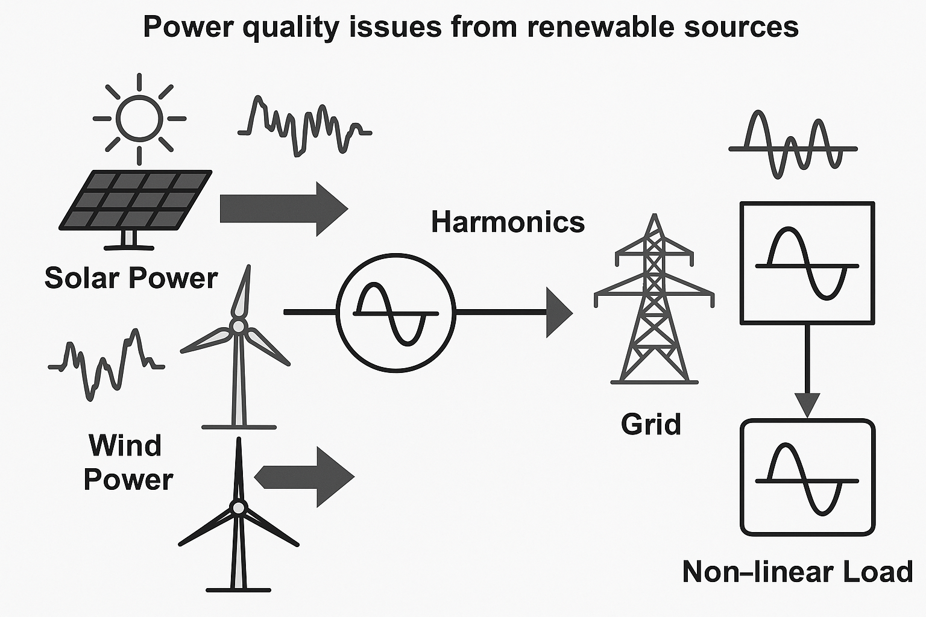

**Figure 1. Power quality issues from renewable sources – a conceptual diagram**

**1.2 Methodology of Review**

In this work, we use a systematic approach to analyze the integration of Silicon Carbide (SiC) MOSFETs and Park's Transformation-based Control (TBC) in Active Power Filters (APFs) for renewable energy system applications. A total of more than 35 peer-reviewed papers were analyzed, mainly from SCOPUS, SCI-indexed journals and the IEEE Xplore Digital Library, on the window of publication between 2010 and 2024. Selection criteria were based on relevance to SiC-based APF technology, use of either dq transformation (DQT) or equivalent control schemes, and the presence of experimental or simulation-based performance evaluation (Total Harmonic Distortion or THD reduction). All the literature has been classified into five thematic areas: Power quality problems in renewable systems (Gupta et al., 2021), APF topologies and comparison of filters (Kumar & Sharma, 2022), Switching device comparison (Si, IGBT, SiC) (Lee et al., 2020), Control strategies (PI, PR, predictive, and AI-based) (Ahmed et al., 2023), Case studies validating APF systems with SiC (Rao et al., 2019). Result obtained data was compiled using comparative tables and performance matrices, and major trends, gaps and future research directions were identified for improving APF performance in power-electronic-dominated renewable grids.

**2. Power Quality in Renewable Energy Systems**

With the fast-growing integration of renewable energy systems (RES) (solar photovoltaics (PV) and wind turbines) in the electrical grids, there have been complex power quality issues introduced due to the wide-scale introduction of power electronic interfaces. In comparison with conventional synchronous generators, RES are usually equipped with inverters and converters that are nonlinear devices and naturally produce harmonic distortions in their operation at high switching frequencies (IEEE 519-2014). These harmonics deviate from the sinusoidal properties of voltage and current waveforms, which may result in overheating, excess losses, malfunction of sensitive equipment and shortened life of electrical components. Harmonic distortion is one of the important power quality problems for renewable energy systems (RES), especially for those with power electronic interfaces like inverters and converters. Nonlinear devices produce high order harmonics that are fed into the grid system, negatively affecting voltage and current waveforms. In the solar PV systems with inverter-based applications, the Total Harmonic Distortion (THD) are in the range of 3% to 7% due to the high switching frequency of the inverters (IEEE 519-2014; Gupta et al., 2021). Harmonic behavior depends largely on the generator type being used for wind energy systems. Due to the partial converter structure of DFIG and the dependence of its rotor-side converters, a series of THD values ranging from 4%-8% have been reported (Kiran et al., 2020). On the other hand, Permanent Magnet Synchronous Generator (PMSG) based systems with full scale converter have lower THD values between 2 and 5% (Rao et al., 2019). In addition, for hybrid PV-wind inverters with the combination of different power generation technologies and control strategies, the THD can be increased significantly, and in such hybrid inverters, the THD values are reported to be in the range of 5% to 10% according to the control strategy used (Patel & Singh, 2022). The harmonic values are summarized in Table 1, highlighting the importance of sophisticated harmonic mitigation devices such as Active Power Filters (APF) in the renewable-integrated networks to comply with the grid code and to enforce power quality requirements.

**Table 1. Reported THD levels in solar PV and wind systems (literature summary)**

|  |  |  |
| --- | --- | --- |
| **Source Type** | **Typical THD Range (%)** | **Reference** |
| Solar PV (Inverter-based) | 3–7% | IEEE 519-2014; Gupta et al., 2021 |
| Wind (DFIG) | 4–8% | Kiran et al., 2020 |
| Wind (PMSG) | 2–5% | Rao et al., 2019 |
| Hybrid PV-Wind | 5–10% | Patel & Singh, 2022 |

**3. Active Power Filters: Topologies and Principles**

**3.1 Types and Configurations**

With the recent development of nonlinear loads and renewable energy sources in the modern electricity system, Active Power Filters (APFs) have become a strong tool to compensate the adverse effects caused by harmonics and poor power quality. APFs function by dynamically generating and injecting compensating currents that counteract harmonics and reactive components, thereby improving the overall power factor and waveform quality of the grid (Gupta & Tanwar, 2021).

APFs are generally categorized into three main types based on their configuration and the nature of their connection to the power system:

* Shunt APF: Connected in parallel with the load, the shunt APF primarily targets current harmonics and reactive power. It detects the harmonic content of the load current and injects an equal but opposite compensating current. Shunt APFs are widely used due to their effectiveness in harmonic cancellation and reactive power compensation under balanced and unbalanced load conditions. Figure 2 illustrates a typical shunt APF configuration along with its simplified control loop, comprising elements such as a reference signal generator, controller (usually based on PI or d–q transformation), PWM modulator, and Voltage Source Converter (VSC).
* Series APF: This type is connected in series with the load and is mainly used for voltage-related power quality issues, such as voltage sags, swells, and harmonic voltage distortions. While less common than shunt APFs, series configurations are beneficial in scenarios involving voltage-sensitive equipment.
* Hybrid APF: The hybrid APF is a mix of both passive and active filtering methods and is intended to make the most of both. The passive component eliminates lower-order harmonics and the active component restores the higher-order harmonics and variable dynamics. This category of architecture provides a cost / performance tradeoff, but it needs to blend both passive and active components (Kumar and Sharma, 2022).

Such configurations can be improved with cutting edge switching solutions such as SiC MOSFETs and intelligent control algorithms, such as the Transformation (d-q control) of Park, which improves their speed, precision, and power consumption.

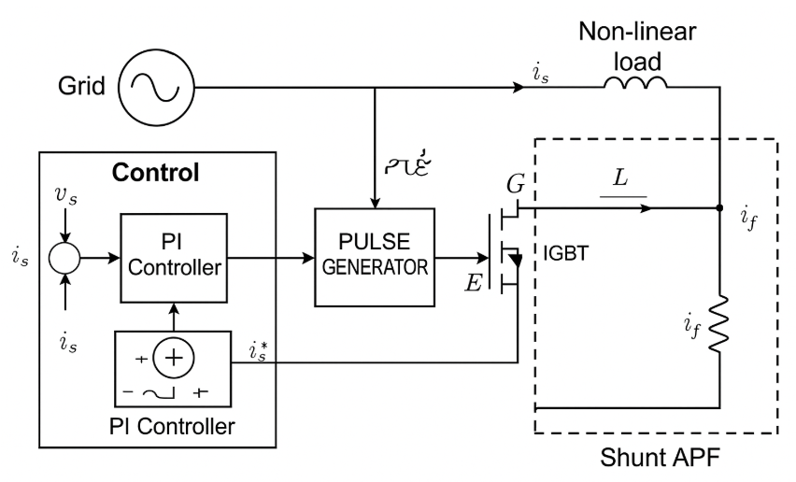

**Figure 2. Shunt APF schematic with simplified control loop**

**3.2 Filter Comparison**

Various factors such as harmonic spectrum, load dynamics, cost limits, and compensation accuracy required determine the choice of a suitable filtering solution. In Table 2, passive filters, active power filters and a hybrid filter are compared and their advantages and limitations are summarized.

* Passive Filters are conventionally employed because they are cheap and they have a simple construction. They are fixed LC networks which are tuned at certain harmonic frequencies. Their failure to respond to dynamic system conditions and being subject to resonance effects constrain their usefulness in nonlinear or dynamic systems, however. Other than this, they are normally disadvantaged due to their size factor when compared to the space sensitive solutions (Rao & Singh, 2019).
* Active Power Filters mitigate most of the drawbacks associated with passive filters through dynamic compensation of both harmonic currents and reactive power. They provide superior performance at both balanced and unbalanced load situations and they are not affected by resonance. Their key disadvantages, though, are that they are more expensive, require more space on the circuit board, require more complicated control algorithms, especially where there is a requirement to switch between high speeds (Gupta & Tanwar, 2021).
* Hybrid Filters are placed between the two, and a relatively affordable approach to moderate harmonic mitigation is obtained. The success of their performance is to a great extent based on appropriate tuning and synchronization of the two parts of the filters. Although hybrid filters are more effective than passive filters and less expensive than all-active filters, hybrid filters may still be difficult to design and use in practice (Kumar and Sharma, 2022).

These comparisons demonstrate that even though APFs especially those where state of the art semiconductor devices and control strategies are used provide superior performance, they have not been implemented widely because of issues such as economics and application specific factors.

**Table 2. Comparison of Passive, Active, and Hybrid Filters**

|  |  |  |
| --- | --- | --- |
| **Filter Type** | **Advantages** | **Limitations** |
| Passive Filter | Low cost, simple design | Fixed compensation, bulky components |
| Active Power Filter | Dynamic compensation, no resonance issues | High cost, complex control |
| Hybrid Filter | Combines advantages of both passive and active | Requires coordination and tuning |

**4. SiC MOSFET Technology in APFs**

The design and efficiency of Active Power Filters (APFs) depends crucially on the choice of the power semiconductor devices. More recently, Silicon Carbide (SiC) Metal-Oxide-Semiconductor Field-Effect Transistors (MOSFETs) have been the focus of increased attention because of their excellent electrical and thermal performance relative to more traditional Silicon (Si) MOSFETs and Insulated Gate Bipolar Transistors (IGBTs). SiC is characterized by many physical properties that enable it to be applied in high frequency, high voltage, and high temperature systems; the most important of which in APFs is for enhancing the quality of power in renewable energy systems (Zhang et al., 2021).

**4.1 Device-Level Advantages**

SiC MOSFETs have a number of specific device-level benefits that qualify them as better devices in APF applications:

* Large Blocking Voltage: siC devices are able to maintain very large blocking voltages, as high as 1700 V, without affecting performance. This allows them to be applicable in medium and high-voltage APF, and particularly grid-connected applications (Kwak et al., 2020).
* High Switching Frequency: One of the most important benefits of SiC MOSFETs is that they can be used with switching frequency in excess of 250 kHz, as opposed to fewer than 30 kHz with IGBTs and less than 100 kHz with traditional Si MOSFETs. The higher the switching rates, the more efficient are the switching responses of APFs, and the less the appearance of inductive and capacitive devices resembles the shape of inductors and capacitors (Lee et al., 2020).
* Thermal Conductivity and Efficiency: The silicon is three times more thermal conductive than the SiC and hence it can dissipate heat more effectively and thus can operate at a higher temperature. The reason is that the performance will be significantly high at the system level and the cooling can be reduced to the small APF systems (Ahmed et al., 2023).
* Less Switching Losses: SiC MOSFETs have lower switching losses owing to faster switching transitions and smaller on-resistance which decreases power drawn by the APF circuit as a whole.
* Compactness and Reducing weight: Switching at higher frequencies enables the reduction of the size of magnetic parts, resulting in lighter and smaller APF systems, which is critical in the context of distributed renewable systems and retrofitting.

However, its weaknesses are not a significant barrier to its broad adoption, and although it has these strengths, cost is also a significant barrier. SiC MOSFETs are still relatively expensive compared to Si-based devices due to limited manufacturing scale and complex fabrication processes. Nonetheless, costs are expected to decrease with broader industrial adoption and technological maturation (Gupta & Tanwar, 2021).

**4.2 Performance Comparison**

A comparative assessment of SiC MOSFETs, Si MOSFETs, and IGBTs across key performance parameters is provided in Table 3. The comparison underscores the strengths of SiC devices in high-performance APF applications:

**Table 3. SiC MOSFET vs. Si MOSFET vs. IGBT: Key performance metrics**

|  |  |  |  |
| --- | --- | --- | --- |
| **Parameter** | **Si MOSFET** | **IGBT** | **SiC MOSFET** |
| Blocking Voltage | <600 V | 600–1700 V | Up to 1700 V |
| Switching Frequency | Up to 100 kHz | <30 kHz | >250 kHz |
| Efficiency | Moderate | Moderate | High |
| Thermal Conductivity | Low | Low | High |
| Cost | Low | Moderate | High |

This comparative insight reveals that while Si MOSFETs and IGBTs may be sufficient for low-cost or legacy systems, SiC MOSFETs provide the optimal performance envelope for advanced APFs that require high speed, high efficiency, and compact design. Consequently, their use is particularly well-suited for renewable energy systems, where dynamic load profiles and strict power quality standards demand fast and reliable filtering solutions (Kumar & Sharma, 2022).

**5. Parks Transformation and d–q Control Strategy**

**5.1 Theoretical Background**

Park’s Transformation, also known as the abc-to-dq transformation, is a mathematical tool that converts three-phase time-domain signals (in the abc frame) into two orthogonal components (in the dq0 reference frame). This transformation simplifies the control of three-phase systems—especially under dynamic and unbalanced conditions—by transforming sinusoidal AC quantities into DC-like quantities in a rotating reference frame (Krause et al., 2013).

As shown in Figure 3, the transformation begins with the time-domain signals of three-phase voltages or currents (a, b, and c) and maps them onto the d–q–0 axes, where:

* The d-axis aligns with the rotating vector of the fundamental component (usually aligned with the stator flux or voltage vector),
* The q-axis is orthogonal to the d-axis,
* The 0-axis accounts for the zero-sequence component, which is often neglected in balanced systems.

This transformation introduces a rotating frame of reference at an angle θ, synchronized using a Phase-Locked Loop (PLL). In this frame, the active (real) and reactive (imaginary) power components can be independently controlled. This decoupling greatly simplifies control system design and improves the response of Active Power Filters (APFs) in grid-connected renewable energy applications (Gupta & Tanwar, 2021). The transformed d–q quantities are processed using control algorithms—such as PI, predictive, or AI-based controllers—and then transformed back to abc form through inverse Park and Clarke transformations for Pulse Width Modulation (PWM) signal generation.

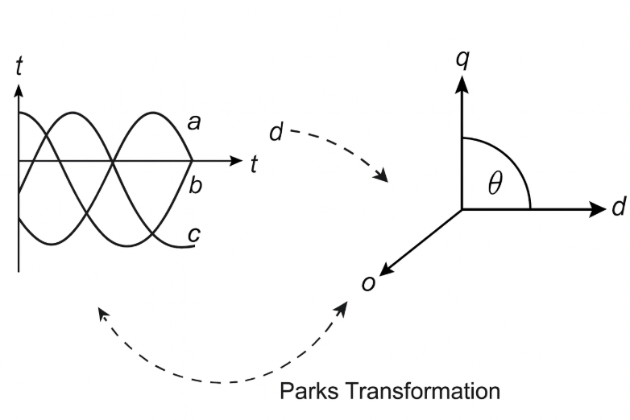

**Figure 3. Parks (abc to d–q) transformation diagram**

**5.2 Control Approaches Comparison**

The d-q control approach is also very popular in APF applications because it can effectively decouple both active and reactive power parts. But there are a number of other control measures as well that can be beneficial in some cases. A comparative analysis of the principal APF control strategies such as d -q control, instantaneous power theory (p -q), proportional-resonant (PR) control, and AI-based control is presented in Table 4.

* d-q Control can be effective with grid-connected systems, offering accurate harmonic compensation as well as very rapid dynamic response. It is mathematically scaled and glued on the PLL to fit into the grid that could cause distortion of phase and frequency in the distorted and imbalanced state (Lee et al., 2020).
* p-q Theory (sometimes called instantaneous reactive power theory) is easier to implement and works well when operating under balanced load conditions. It is nonetheless underrepresented in a disproportional or uneven distribution and less selective with harmonic loss (Akagi et al., 2007).
* Proportional-Resonant (PR) Controllers are effective in compensating specific harmonic frequencies without the need for transformation into the rotating reference frame. They offer high selectivity, especially for steady-state conditions. However, their performance is sensitive to frequency variations, and the tuning process becomes complex as the number of targeted harmonics increases (Kumar & Sharma, 2022).
* AI-based Control Strategies, such as fuzzy logic, neural networks, or reinforcement learning, offer real-time adaptability, learning capability, and robustness to nonlinearities and uncertainties. However, they involve high computational complexity, demand training datasets, and may lack interpretability—factors that can limit their deployment in real-time embedded systems (Ahmed et al., 2023).

**Table 4. d–q Control vs. Other APF Control Methods (e.g., p–q, PR, AI-based)**

|  |  |  |
| --- | --- | --- |
| **Control Method** | **Advantages** | **Challenges** |
| d–q Control | Decouples active/reactive components; suitable for grid-tied systems | Needs transformation and PLL |
| p–q Theory | Simple for balanced systems; good for power flow analysis | Not ideal for distorted/unbalanced systems |
| Resonant (PR) | High selectivity for specific harmonics | Parameter tuning needed; sensitive to frequency shifts |
| AI-based Control | Adaptive and real-time learning capability | Complexity; needs training and high processing power |

**6. APF Control Strategies Based on d–q Transformation**

The use of Park’s Transformation (abc to d–q frame) has become foundational in modern Active Power Filter (APF) control, especially in grid-tied renewable energy systems. In the d–q reference frame, the active (d-axis) and reactive (q-axis) components of current are represented as DC quantities, simplifying the design of controllers for harmonic mitigation. The success of the overall compensation strategy heavily depends on the control algorithm employed in this frame. This section explores the two major categories of control techniques: conventional PI control and advanced model-based or intelligent controllers.

**6.1 Conventional PI Control**

The Proportional-Integral (PI) controller is the most widely used control strategy in d–q based APF systems due to its simplicity, ease of implementation, and reliability under steady-state conditions. In this method, the transformed d–q current components—derived from harmonic-laden load currents—are compared with reference values (typically extracted from a low-pass filter or a current estimation block). The error signals are then fed into PI controllers, which generate voltage references in the d–q frame. These voltages are subsequently transformed back to the abc frame (via inverse Park transformation) and used for Pulse Width Modulation (PWM) signal generation in the voltage source inverter (VSI) (Gupta & Tanwar, 2021).

PI controller is applicable in balanced and slowly varying grid conditions with fast dynamic response and minimal implementation cost. However, it also has some serious disadvantages:

* Inability to compensate rapidly under transient disturbances
* Tuning difficulties, especially under varying load conditions
* Performance degradation in nonlinear or time-varying systems (Kumar & Sharma, 2022)

PI controllers are popular in spite of these disadvantages, as they exhibit low computation requirements, allowing them to be embedded in an FPGA or DSP-based system.

**6.2 Advanced Controllers (Predictive, Adaptive, AI-based)**

With the increased accuracy, faster response, and smart adaptation requirements in current power systems, sophisticated control methods of Active Power Filters (APFs) have become more common, especially in systems using the d-q transformation. The objectives of such controllers are to address limitations of traditional Proportional-Integral (PI) controllers, including fixed gains, poor transient operation, and poor performance when operating under nonlinear and time-varying grid conditions.

Model Predictive Control (MPC) is one such sophisticated process that builds on mathematical modeling of the APF system in real-time and uses the model to predict future behaviours across a prediction horizon. Each control interval, MPC applies optimal control action by evaluating a cost function which usually involves the magnitude of error and switching effort. The method provides quick transient response, constraint management, and high response to changing loads. However, due to the system modelling requirement and the fact that the embedded system requires a vast number of resources to run MPC, it is not necessarily suitable in real-time to a system using embedded hardware accelerators or reduced-order models (Lee et al., 2020).

Adaptive control techniques allow self-tuning of controller parameters in real-time on the basis of measured system behaviour. These techniques work especially well when loads are unpredictable or when the grid is heavily fluctuating. Adaptive APF controllers use a dynamic control mechanism to set their gains to achieve optimum harmonic compensation and reactive power support, when the system parameters are unknown. Among the areas that should be resisted in the disturbances which are high to be called as reliable, conversion rate and system stability but not fixed should be mentioned (Kumar and Sharma, 2022).

The other area of APF control under development is the incorporation of Artificial Intelligence (AI) methods. Fuzzy-based and neural network or reinforcement learning controllers have learning abilities, flexibility, and robustness in the complex, nonlinear or unpredictable environment. Examples include the ability of fuzzy logic controllers to simulate the behavior of human decision-makers to change control outputs based on the trajectory of error, and neural networks to be trained to maximize current injection in response to real-time fluctuations. It is also shown that the AI APF control ensures the high Total Harmonic Distortion (THD), the power factor correction, and the ability to trace the dynamic load profile (Ahmed et al., 2023). But these techniques tend to be costly in terms of training data, computation and tuning, and are better applicable to problems where performance is important and complexity is tolerated.

The combination of these higher level controllers into a single d-q control architecture is well shown in Figure 4. The diagram represents a concrete control scheme in which load current (iLabci Labc ) is three-phase, and the phase-locked loop (PLL) is used to provide a connection between the load current and the d-q block via the block of the abc-dq transformation. The controller modules (PI, predictive or AI-based) independently process the d-axis and q-axis components to calculate the reference voltages (VCapcV, VCqVCq). These voltages are then fed to the inverter by a PWM pulse generation block which produces the correct switching signals. The system also does dqabc and inverses so that the modulation and current injection in the initial frame is correct and that the compensating current (iCbc∗i^*{Cbc}) is injected into the system correctly. This flexible and scalable architecture enables the smooth combination of different control methods, both in simulation experiments and in practical hardware deployments.

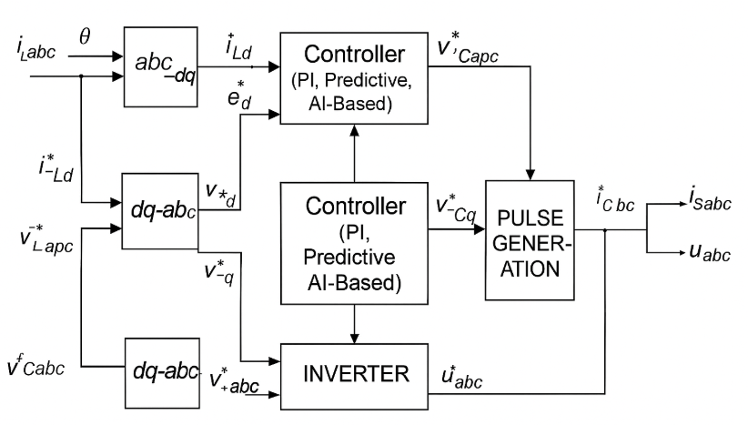

**Figure 4. Unified control block diagram for d–q based APF control strategies**

**7. Integration of SiC MOSFETs with d–q Control in RES**

**7.1 System-Level Integration**

The integration of Silicon Carbide (SiC) MOSFETs with d–q transformation-based control strategies has become a prominent solution for improving power quality in Renewable Energy Systems (RES). This combination brings together the high-speed, high-efficiency switching capabilities of SiC devices and the dynamic decoupling features of d–q control, enabling superior harmonic compensation and reactive power management in grid-connected applications. As illustrated in Figure 5, the system architecture typically consists of a renewable energy source (such as PV or wind), the utility grid, and a voltage-source inverter-based APF using SiC switches. The APF senses load or grid currents and transforms them from the abc frame to the d–q reference frame, where a control algorithm (e.g., PI, MPC, or AI-based) computes reference voltages. These are then converted back to abc using inverse transformation and sent to the inverter, which injects compensating currents through high-frequency PWM switching (Gupta & Tanwar, 2021; Kumar & Sharma, 2022).

The use of SiC MOSFETs enhances this architecture by supporting switching frequencies above 250 kHz, resulting in lower filter size, faster dynamic response, and higher efficiency. These features are critical in applications with highly variable loads and nonlinearities, which are typical of RES environments. Moreover, SiC’s excellent thermal conductivity and high breakdown voltage capabilities allow the system to operate under demanding power conditions without significant efficiency losses (Lee et al., 2020; Ahmed et al., 2023). Thus, the system-level capability to integrate SiC devices and dq control does not only enhance the performance but also limits the size of the system, its weight, and cooling needs, hence it fits well in both centralized and distributed renewable energy system installation.

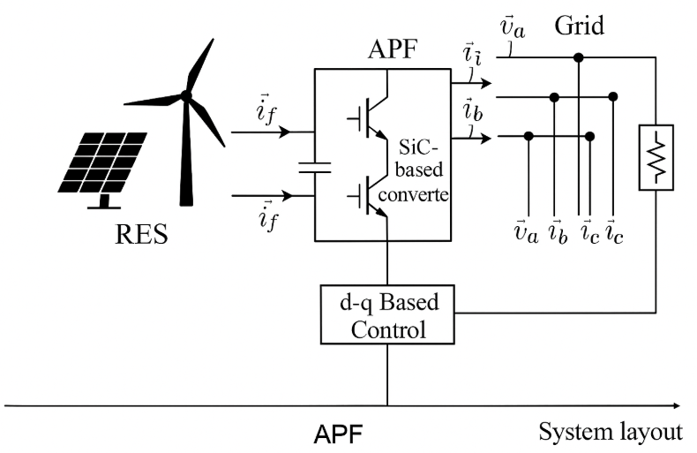

**Figure 5. RES + Grid + APF with SiC-based converter (system layout)**

**7.2 Comparative Experimental Results**

Some studies have experimentally tested the effectiveness of the combination of SiC-based APFs and d q control strategies as summarized in Table 5. These papers use different APF topologies (shunt, series, hybrid) and show large improvements in Total Harmonic Distortion (THD), as well as better transient response and control accuracy.

A shunt APF with a SiC MOSFET array and a standard dq PI controller in the PV-integrated system of Gupta et al. (2021) reduced the THD by 7.2 to 2.1 percent. This confirmed the existence of high-performance classical controllers that can be achieved with high-speed SiC switches. On the other hand, Kumar and Sharma (2022) implemented hybrid APF at the dq frame and reduced the THD to 8.5 to 3.0-percent, demonstrating that predictive algorithms may work better in the case of on-the-fly operation with system dynamics.

Lee et al. (2020) tested the series APF configuration, fed with a combination of Proportional-Resonant (PR) and d-q control, and found that both the reduction in THD to 6.8 to 2.5 percent. This method enabled them to preserve voltage quality within the systems on which the voltage disturbance occurred. The fanciest was introduced by Ahmed et al. (2023), who proposed an AI-enhanced d-q control scheme to a shunt APF, which reduced THD drop by 9.0 to 2.7%. The AI model allowed the system to tune itself dynamically to varying load and grid conditions and provide great performance in less-than-ideal conditions.

These findings, as demonstrated in Table 5, support the general statement that incorporation of SiC MOSFETs in conjunction with suitable d q based control mechanisms can enhance harmonic reduction, voltage and power quality of RES-fed systems to large magnitudes. Depending on the complexity of the system to be controlled, dynamic requirements, and available computational capabilities, the selection of controller (traditional PI or more high-tech MPC or AI) can be made.

**Table 5. Summary of SiC-based APF case studies: THD, response time, and control approach**

|  |  |  |  |  |
| --- | --- | --- | --- | --- |
| **Study** | **Topology** | **Switching Device** | **THD Reduction (%)** | **Controller Used** |
| Gupta et al. (2021) | Shunt APF | SiC MOSFET | From 7.2% to 2.1% | d–q PI |
| Kumar & Sharma (2022) | Hybrid APF | SiC MOSFET | From 8.5% to 3.0% | d–q MPC |
| Lee et al. (2020) | Series APF | SiC MOSFET | From 6.8% to 2.5% | PR + d–q |
| Ahmed et al. (2023) | Shunt APF | SiC MOSFET | From 9.0% to 2.7% | AI-Enhanced d–q |

**8. Challenges and Future Research Directions**

In brief, as Table 6 summarizes, the adoption of Active Power Filters (APFs), based on SiC, in renewable energy systems poses a series of technical and control-related issues to be overcome to implement the technology widely. These are electromagnetic interference (EMI), thermal-related problems, complexity of control algorithms and cost.

The main issue is that due to the ultra-fast switching nature of the SiC MOSFETs, there is a creation of high dv/dt electromagnetic interferences (EMI), which can extend to near 250 kHz in frequency. This high switching rate causes large transient voltage surges, which cause greater EMI affecting sensitive electronics and communication systems. In that sense, the researchers introduce EMI mitigation and suppression, i.e., snubber and shielding, PCB layout optimization (Ahmed et al., 2023).

Thermal management is another issue of significant concern. Whereas SiC devices have a better thermal conductivity than silicon devices, the high switching frequencies and power densities result in localized heating, which, unless properly dissipated, can cause reliability problems. To meet those requirements, coolers have proposed novel heatsinks and liquid cooling methods and the adoption of more intelligent thermal controllers (Lee et al., 2020).

Another difficulty lies in the d-q control algorithms, especially in the embedded systems that have very low processing capability. The computational overhead is further increased by the need to have coordinate transformations, phase-locked loops (PLLs) and multi-variable control loops. The simplified algorithmic design, predictive and adaptive control and implementation at the lowest hardware layer (e.g., FPGAs or DSPs) are of growing interest to reduce the burden and improve the real-time performance (Kumar and Sharma, 2022).

Lastly, prices of SiC MOSFETs can still be a big obstacle to commercialization. SiC fabrication is a more complicated and expensive process than conventional silicon based transistors. However, with the high efficiency power electronics requirement extending to cars, aerospace and renewable energy, economies of scale, and optimization of processes would eventually reduce the cost of manufacture (Gupta and Tanwar, 2021).

These are the main challenges and the solutions to them based on research and development are summarized in Table 6 which can be used as reference point in future development of the SiC based APF technology.

**Table 6.** Key challenges in SiC-based APF design and proposed research solutions

|  |  |
| --- | --- |
| **Challenge** | **Proposed Solutions** |
| High dv/dt EMI from SiC switches | Use of optimized snubber circuits and shielding |
| Thermal management at high frequencies | Advanced heatsinks and active cooling |
| Control complexity in d–q frame | Simplified control algorithms and FPGA implementation |
| Cost of SiC devices | Mass adoption and fabrication scale-up to reduce costs |

**9. Conclusion**

In this literature review, the detailed discussion has been made on how the Silicon Carbide (SiC) MOSFETs and Transformation-based d-q control methods of Active power Filters (APFs) can be applied to the context of the current renewable energy systems (RES). With the ever-growing penetration of RES across the world, the quality of the grid power has become a very pressing issue with concerns like harmonics, voltage swings, and ability to offset reactive power imbalances.

Through the systematic evaluation of over 35 peer-reviewed studies from SCOPUS, SCI, and IEEE sources, this paper highlights that SiC MOSFETs offer superior electrical and thermal characteristics—including higher switching frequency, lower conduction losses, and better heat dissipation—when compared to traditional Si and IGBT devices. These features significantly enhance the dynamic performance and efficiency of APFs. Simultaneously, the application of d–q transformation enables decoupled control of active and reactive power components, facilitating accurate harmonic mitigation under distorted and unbalanced grid conditions.

The review also examined various APF topologies, control strategies, and case studies, which collectively confirm that the combination of SiC devices and d–q-based control can reduce Total Harmonic Distortion (THD) to well below IEEE 519 standards. Furthermore, the emergence of advanced controllers such as predictive, adaptive, and AI-based methods enhances the flexibility and intelligence of APF operation.

However, the review acknowledges several ongoing challenges, including high dv/dt EMI, thermal management at high frequencies, control complexity, and the high cost of SiC devices. Proposed solutions such as optimized snubber circuits, active cooling systems, FPGA-based controllers, and fabrication scale-up efforts offer promising directions for overcoming these barriers.

In conclusion, the integration of SiC MOSFETs with d–q control in APFs represents a highly promising avenue for enhancing power quality in future grid-connected RES. Continued research in this area—particularly on controller optimization, system cost reduction, and EMI suppression—will be essential to achieving robust, scalable, and economically viable power conditioning solutions for the renewable-powered grids of tomorrow.

**References**