Ishuno Goods — Final Project Report
Author: Marvelours Ojeyemi
Project: Inventory and Sales Management System
Language: Python 3
GUI Framework: Tkinter

1. Project Overview
Ishuno Goods is an Inventory and Sales Management System designed for a small retail business. The application provides a graphical interface for managing products, monitoring stock quantities, and recording sales transactions.

2. System Design
The system uses object-oriented programming and four main classes:
- Product: Stores product ID, name, price, quantity, and category.
- Inventory: Manages products using a dictionary and supports inventory operations.
- Sale: Stores sale items, calculates totals, and generates receipts.
- StoreSystem: Coordinates inventory management and records sales.
The IshunoGoodsApp class provides the Tkinter graphical user interface. Lists, tuples, and dictionaries are used to organize application data.

3. Implemented Features
- Add products to inventory.
- Update and remove products.
- Search for products.
- Display product information and stock status.
- Record sales and calculate totals.
- Automatically decrease inventory after a sale.
- Display receipts and sales history.
- Reject sales when available stock is insufficient.

4. Testing and Results
The application launched successfully, and the following tests were completed.
Test 1: Add a product
A product with ID P001, name Ishuno T-Shirt, price $24.99, quantity 10, and category Clothing was added successfully.
Test 2: Record a sale
Two T-shirts were sold at $24.99 each.
Calculation: 2 × $24.99 = $49.98
The receipt displayed the correct total of $49.98.
Test 3: Update inventory
After the sale, the product quantity decreased from 10 to 8.
Test 4: Sales history
The completed sale appeared in Sales History with the correct item description and total.
Test 5: Insufficient stock
An attempt to sell 99 T-shirts was rejected with an insufficient-stock error message.
These tests confirmed that the application launches, records a sale, calculates the total, updates inventory, records sales history, and prevents overselling.

5. Sample Output
The following screenshots show the application interface and results from the completed tests.
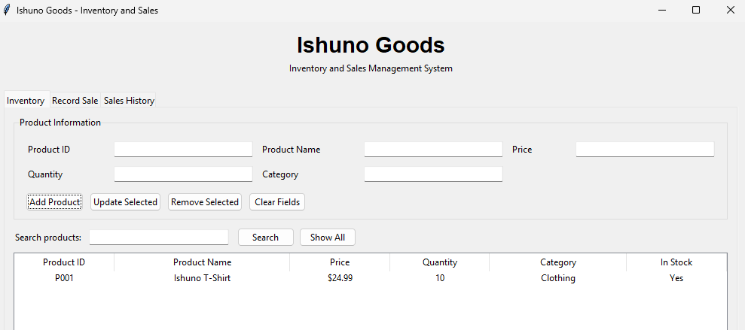
Figure 1: Inventory display showing the sample product.
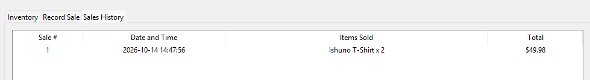
Figure 2: Sales history showing the completed sale.
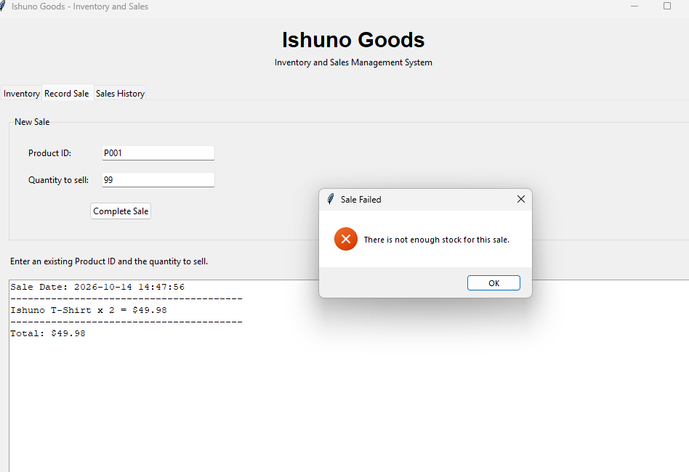
Figure 3: Error message preventing a sale that exceeds available stock.

6. Conclusion
The project provides a working foundation for inventory and sales management at Ishuno Goods. The implemented features demonstrate object-oriented programming, collection usage, graphical user interface development, and basic transaction processing.

7. Supporting Documentation
The project proposal and UML class diagram were prepared during earlier project milestones. The source code and README are maintained in the GitHub repository:
https://github.com/LordxxShadow/Ishuno-Goods

