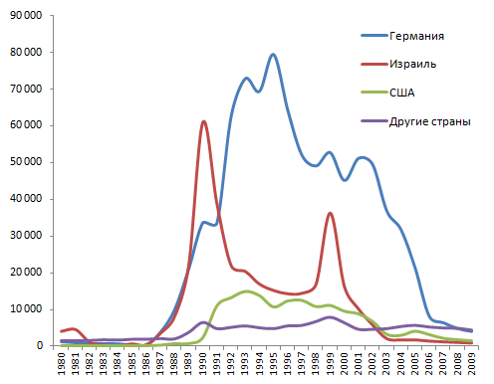
The graph below shows statistics on emigration to various countries in the period from 1980 to 2009.
The first significant date is 1986. This year, the mass repatriation of Jews to Israel began. We can observe the peak in 1991, when about 60,000 people left the country.
A new wave of emigration to Israel began in 1998, peaking in 1999, when about 40,000 people left the country. In the early noughties, emigration to Israel greatly decreased.
The emigration schedule to Germany began to grow strongly in 1986, stopped slightly in 1990-1991 and reached its peak in 1997. About 80,000 ethical Germans left the country that year.
Then you can observe a relatively smooth, with rare jumps, decrease in emigration to Germany.
The growth of the emigration schedule in the USA can be observed in the year of the collapse of the USSR and the fall of this schedule in the early noughties.

