

**PowerEnjoy**

**P**roject **P**lan

Version 1.0

**Software Engineering 2 (A.A. 2016/2017)**

* Simone Boglio (mat. 772263)
* Lorenzo Croce (mat. 807833)

Summary

1. Introduction 4

1.1. Purpose and Scope 4

1.2. Definitions, Acronyms and Abbreviations 4

1.3. Reference Documents 4

2. Function Point Analysis 5

2.1. Internal Logical Files 7

2.2. External Input 8

2.3. External Output 9

2.4. External Inquiry 9

2.5. External Interface Files 10

2.6. Total of Function Point 10

3. Cocomo II Analysis 11

3.1. Scale Factors 11

3.2. Cost Drivers 13

**3.2.1.** **Product Factors** 13

**3.2.2.** **Platform Factors** 15

**3.2.3.** **Personnel Factors** 16

**3.2.4.** **Project Factors** 18

**3.2.5.** **Total Cost Drivers** 19

3.3. Effort Equation 20

3.4. Schedule Estimation 21

**3.4.1.** **Approach 1: Estimate Size of the Team** 21

**3.4.2.** **Approach 2: Estimate Duration with Team of 2 People** 21

**3.4.3.** **Approach 3: Analysis with COCOMOII Automated Tool** 22

4. Task Identification 24

5. Task Schedule 25

6. Resource Allocation 26

7. Risks Planning and Management 27

8. Appendix 28

8.1. External References 28

8.2. Software and Tools Used 28

8.3. Hours of Work 28

1. **Introduction**
   1. **Purpose and Scope**

The main purpose of the project plan document is the analysis of the complexity and risks of the PowerEnjoy and create an estimate of the budget, the efforts, the time, and the resources allocation to define a plan to develop the entire project.

The project plan in general consists in:

* Identification of the feature;
* Identification of the activities needed to complete these feature;
* Estimate a budget;
* Estimate the effort and the time of the activities;
* Estimate the resource allocation for the activities;
* Develop a schedule;
* Identification of the risks;

For this scope, we use two method of analysis: Functional Point analysis and the COCOMOII analysis.

* 1. **Definitions, Acronyms and Abbreviations**

The following are used in this document:

* FP: Function Point
* JEE: Java Enterprise Edition
* SLOC: Source Lines of Code
* KSLOC: Thousands of SLOC
* EAF: Effort Adjustment Factor
* API: Application Programming Interface
* COCOMO: COnstructive COst MOdel
* RASD: Requirements Analysis and Specification Document
* DD: Design Document
* ITPD: Integrated Test Planning Document
* CMM: (Capability Maturity Model)
* EAF: Effort Adjustment Factor
  1. **Reference Documents**
* The COCOMOII Model Definition Manual
* The Function Points complexity evaluation tables
* Requirement Analysis and Specification Document (RASD) of PowerEnjoy
* Design Document (DD) of PowerEnjoy

1. **Function Point Analysis**

The Function Point analysis allows to estimate the size of the project by analyzing the set functionalities provided by the software.

The effort for the project development grows with the growth of the number of data structures, inputs and outputs, inquiries and external interfaces. A weight is associated with each of these functionalities and the total effort is obtained adding weights of partial values.

There are five User Function types and they are represented on the table below.

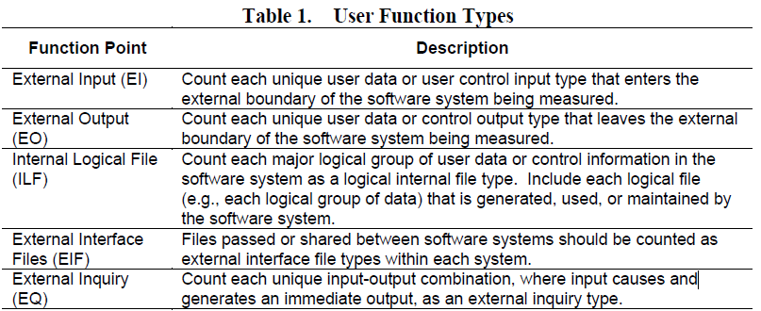

Each of these function types is characterized by a complexity levels and these levels are associated to a set of weights. The table below shows the complexity levels and their weights.

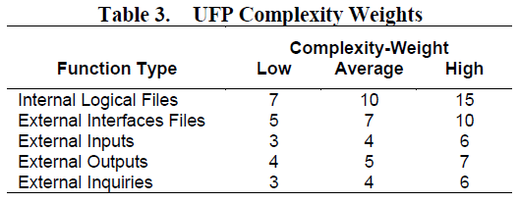

The function classification into the complexity level depending on the number of Data Elements, File Types and recorder Elements. The tables below explain this classification.

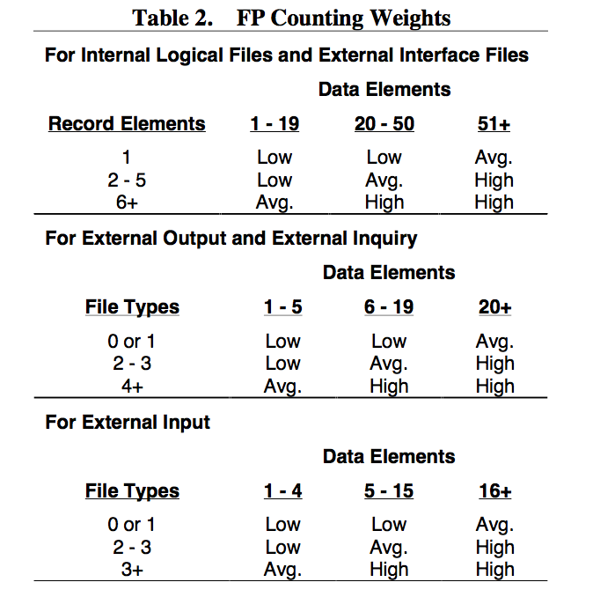

* 1. **Internal Logical Files**

The Internal Logical Files that we have identified are:

* **Users:** the system saves information about the users like ID, E-Mail, username, password, telephone number and credit card number.
* **Reservations:** the system saves information about each reservation like ID, IDUser, IDCar time of reservation, status, fee.
* **Rides:** the system saves information about the rides like ID, IDReservation, IDPayment, time of start, time of end, current charge.
* **Areas:** the system saves information about the safe areas like ID and position. The system must save also information about special areas that are a subset of safe areas. For each special area system saves information like number of power grid station and how many of these are available.
* **Cars:** the system saves information about the cars like ID, status, position and a flag that identify if it is plugged into a power grid.
* **Payments:** the system saves information about the payment like ID, the amount.
* **API pemrmission:** the system saves information about the API permission that allows developer to implement other user experience.

|  |  |  |
| --- | --- | --- |
| **Internal Logical File** | **Complexity** | **FP weight** |
| Users | Low | 7 |
| Reservations | Low | 7 |
| Rides | Low | 7 |
| Areas | Low | 7 |
| Cars | Low | 7 |
| Payments | Low | 7 |
| API information | Average | 10 |
| **Total:** | | 52 |

* 1. **External Input**

The External Inputs that we have identified are:

* **Signin:** this is an average operation that uses the Request Manager and the Account Manager and for this reason it has an average complexity level and it contributes 4FPs.
* **Login/Logout:** these are average operation like the signin and they have an average complexity level and they contribute 2x4FPs.
* **Search Car:** this is a complex operation because it involves in many components and for this reason it has a high complexity level and it contributes 6FPs.
* **Reserve Car:** like the search car operation also this functionality has a high complexity level and it contributes 6FPs.
* **Send Unlock:** this functionality involves in many components and it has a high complexity level and it contributes 6FPs.
* **Edit Profile:** this is a simple operation and it has a low complexity level and it contributes 3FPs.
* **Retrieve profile info:** this is a simple operation and it has a low complexity level and it contributes 3FPs.
* **Retrieve reservation info:** this is a simple operation and it has a low complexity level and it contributes 3FPs.

|  |  |  |
| --- | --- | --- |
| **External Input** | **Complexity** | **FP weight** |
| Signin | Average | 4 |
| Login/Logout | Average | 2x4 |
| Search car | High | 6 |
| Reserve car | High | 6 |
| Send unlock | High | 6 |
| Edit profile | Low | 3 |
| Retrieve profile info | Low | 3 |
| Retrieve reservation info | Low | 3 |
| **Total** | | 39 |

* 1. **External Output**

The External Outputs that we have identified are:

* **Email/SMS:** this functionality allows to send back to user his password at the registration moment (if the user chose this method to receive the password) and it has a low level of complexity and it contributes 2x4FPs.
* **Send ride information:** this functionality allows to send to the cars the information about the ride and it has an average complexity level and it contributes 5FPs.
* **Send safe areas:** this functionality allows to send to the cars the information about the safe area and it has an average complexity level and it contributes 5FPs.

|  |  |  |
| --- | --- | --- |
| **External Output** | **Complexity** | **FP weight** |
| SMS | Low | 4 |
| Email | Low | 4 |
| Send ride information | Average | 5 |
| Send safe areas | Average | 5 |
| **Total** | | 18 |

* 1. **External Inquiry**

The External Inquiries that we have identified are:

* **Reservation/profile info:** these are directly operations and for this reason they have a low complexity level and they contribute 2x3FPs.
* **Database query:** this functionality allows to query the database and it has an average complexity level and it contributes 4FPs.

|  |  |  |
| --- | --- | --- |
| **External Inquiry** | **Complexity** | **FP weight** |
| Reservation info | Low | 3 |
| Profile info | Low | 3 |
| Database query | Average | 4 |
| **Total** | | 10 |

* 1. **External Interface Files**

The External Interface Files that we have identified are:

* **Google Maps:** the interaction with map service implies the exchange of a high number of information and their computation is enough complex, for these reasons it has a high complexity level and it contributes 10FPs.
* **Payment service:** the interaction with the payment service has an average complexity level and it contributes 7FPs.
* **Green e-box:** the interaction with all the green e-box needs many calculations and it has a high complexity level and it contributes 10FPs.

|  |  |  |
| --- | --- | --- |
| **External Input File** | **Complexity** | **FP weight** |
| Google Maps | High | 10 |
| Payment Service | Average | 7 |
| Green e-box | High | 10 |
| **Total** | | 27 |

* 1. **Total of Function Point**

|  |  |
| --- | --- |
| **Type** | **FP weight** |
| Internal Logical File | 52 |
| External Input | 39 |
| External Output | 18 |
| External Inquiry | 10 |
| External Interface File | 27 |
| **Total** | 146 |

Considering that the platform used for this project is Java Enterprise Edition, we can use the as conversion factor 46 and 67 (lower bound and upper bound) to estimate the value of the lines of code needed for the development of the application.

These conversion factor can be found at:

http://www.qsm.com/resources/function-point-languages-table

The estimation is:

* **Lower bound:** 146FPs x 46 = 6716 SLOC
* **Upper bound:** 146FPs x 67 = 9782 SLOC

1. **Cocomo II Analysis**

In this section, we are going to use the COCOMO II model to estimate the cost and the effort needed to develop PowerEnjoy service.

* 1. **Scale Factors**

To evaluate the scale factor values we refer to the following official COCOMO II table:

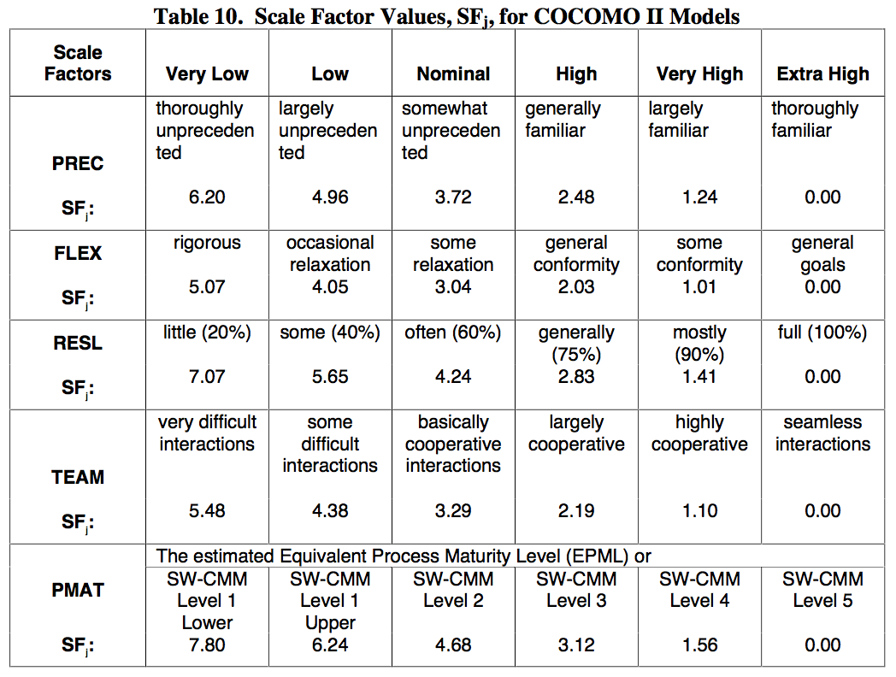

A brief description for each scale driver (for more details about each scale factor and how estimate it refer to tables from 11 to 15 in the official COCOMOII document):

* Precedentedness (PREC): it reflects the previous experience of our team with the development of large scale projects. Since we are not expert in the field, this value will be low.
* Development flexibility (FLEX): it reflects the degree of flexibility in the development process with respect to the external specification and requirements. Since there are very strict requirements on the functionalities but nothing specific is request for the technology to be used, this value will be low.
* Risk resolution (RESL): it reflects the level of awareness and reactiveness with respect to risks. We perform a good risks analysis, so the value will be set to very high.
* Team cohesion (TEAM): it is an indicator of how well the team members know each other and work together in a cooperative way. For our team, the value is set to high.
* Process maturity (PMAT): we use the CMM (Capability Maturity Model) scale for determining this value. We estimate that our process reflects the Level 3 of the CMM scale, so the value for PMAT is set to high.

The total result of our evaluation is the following:

|  |  |  |
| --- | --- | --- |
| **Scale Driver** | **Factor** | **Value** |
| PREP | Low | 4.96 |
| FLEX | Low | 4.05 |
| RESL | Very High | 1.41 |
| TEAM | High | 2.19 |
| PMAT | High | 3.12 |
| **Total** | | 15.73 |

* 1. **Cost Drivers**
     1. **Product Factors**
        1. **Required Software Reliability (RELY)**

Since all the PowerEnjoy car service need the software to work and all the cars depend from the central system, a failure of the software determines a high financial loss for the company. Also, there is not risk to human life in case of software failure since the car CU and engine are independent from the central system.

|  |  |
| --- | --- |
| **RELY** | |
| Rating Level | High |
| Effort Multiplier | 1.10 |

* + - 1. **Database Size (DATA)**

The database size is not easy evaluable; we estimate this value considering the SLOC value and a reasonable byte dimension value for the DB (2<GB<5).

The D/P (TestingDBbytes/SLOC) is between 100 and 1000, from this we can evaluate the DATA values.

|  |  |
| --- | --- |
| **DATA** | |
| Rating Level | High |
| Effort Multiplier | 1.14 |

* + - 1. **Product Complexity (CPLX)**

The application need to manage lot of thing such: the reservations for the car, the current rides, the remote communication with all the cars of the car sharing service PowerEnjoy.

These things involve in a lot of concurrent task, callbacks and others; in according with the Component Complexity Rating Levels table of COCOMOII we estimate CPLX as very high.

|  |  |
| --- | --- |
| **CPLX** | |
| Rating Level | Very High |
| Effort Multiplier | 1.34 |

* + - 1. **Developed for Reusability (RUSE)**

The reusability requirements are limited in scope to the project itself, so the RUSE cost is set to nominal.

|  |  |
| --- | --- |
| **RUSE** | |
| Rating Level | Nominal |
| Effort Multiplier | 1.00 |

* + - 1. **Documentation Match to Life-Cycle Needs (DOCU)**

The documentation for this project is right-sized to life-cycle needs.

|  |  |
| --- | --- |
| **DOCU** | |
| Rating Level | Nominal |
| Effort Multiplier | 1.00 |

* + 1. **Platform Factors**
       1. **Execution Time Constraint (TIME)**

Since we need to monitor continually the cars ant the actual rides we expect a high use of available execution time (between 50% and 70%).

|  |  |
| --- | --- |
| **TIME** | |
| Rating Level | High |
| Effort Multiplier | 1.11 |

* + - 1. **Main Storage Constraints (STOR)**

Since a normal hard disk can contain TB of data and our system don’t continue to expand its data in a relevant way we set this value low as possible.

|  |  |
| --- | --- |
| **STOR** | |
| Rating Level | Nominal |
| Effort Multiplier | 1.00 |

* + - 1. **Platform Volatility (PVOL)**

About the hardware system we don’t expect change very often.

The software doesn’t need continuous change, maybe just the client’s application can request software update to be aligned with the update or new release of the OS system where it runs (Android and iOS).

|  |  |
| --- | --- |
| **PVOL** | |
| Rating Level | Nominal |
| Effort Multiplier | 1.00 |

* + 1. **Personnel Factors**
       1. **Analyst Capability (ACAP)**

We think our team had been conducted a good analysis and design analysis so we set this parameter to high.

|  |  |
| --- | --- |
| **ACAP** | |
| Rating Level | High |
| Effort Multiplier | 0.85 |

* + - 1. **Programmer Capability (PCAP)**

We don’t have implemented this project, so we just estimate this value.

We have already developed some little project with different technologies but we never develop high real level project so we set this parameter to nominal.

|  |  |
| --- | --- |
| **PCAP** | |
| Rating Level | Nominal |
| Effort Multiplier | 1.00 |

* + - 1. **Personnel Continuity (PCON)**

Not relevant in our case since there is not personnel turnover. We set this value to nominal.

|  |  |
| --- | --- |
| **PCON** | |
| Rating Level | Nominal |
| Effort Multiplier | 1.00 |

* + - 1. **Applications Experience (APEX)**

We have some experience with development of little Java applications but we never develop a complex system of this kind. We set this value to low.

|  |  |
| --- | --- |
| **APEX** | |
| Rating Level | Low |
| Effort Multiplier | 1.10 |

* + - 1. **Platform Experience (PLEX)**

We don’t have any previous experience with JEE so this can be problematic at the start, also we don’t have experience with distributed middleware.

We have some little experience with DB, server side development and graphic user interfaces.

|  |  |
| --- | --- |
| **PLEX** | |
| Rating Level | Low |
| Effort Multiplier | 1.09 |

* + - 1. **Language and Tool Experience (LTEX)**

We have some experience with JSE but no experience with JEE.

We have some little experience with DB, server side development and graphic user interfaces.

|  |  |
| --- | --- |
| **LTEX** | |
| Rating Level | Low |
| Effort Multiplier | 1.09 |

* + 1. **Project Factors**
       1. **Use of Software Tools (TOOL)**

Our application environment is well integrated, complete and mature.

|  |  |
| --- | --- |
| **TOOL** | |
| Rating Level | High |
| Effort Multiplier | 0.90 |

* + - 1. **Multisite Development (SITE)**

We live in two different cities but we communicate with VOIP calls, email and chat so we set this value to high.

|  |  |
| --- | --- |
| **SITE** | |
| Rating Level | High |
| Effort Multiplier | 0.93 |

* + - 1. **Required Development Schedule (SCED)**

Although our efforts were well distributed over the available time, the definition of the RASD and DD require a consistent amount of time (more than we expected), for this reason we set this parameter to high.

|  |  |
| --- | --- |
| **SCED** | |
| Rating Level | High |
| Effort Multiplier | 1.00 |

* + 1. **Total Cost Drivers**

In the following table, there are all the cost driver that we discuss above with the assigned value:

|  |  |  |
| --- | --- | --- |
| **Cost Driver** | **Factor** | **Value** |
| RELY | High | 1.10 |
| DATA | High | 1.14 |
| CPLX | Very High | 1.34 |
| RUSE | Nominal | 1.00 |
| DOCU | Nominal | 1.00 |
| TIME | High | 1.11 |
| STOR | Nominal | 1.00 |
| PVOL | Nominal | 1.00 |
| ACAP | High | 0.85 |
| PCAP | Nominal | 1.00 |
| PCON | Nominal | 1.00 |
| APEX | Low | 1.10 |
| PLEX | Low | 1.09 |
| LTEX | Low | 1.09 |
| TOOL | High | 0.90 |
| SITE | High | 0.93 |
| SCED | High | 1.00 |
| **EAF** | | 1.7342 |

* 1. **Effort Equation**

The following equation give us the effort estimation in Person-Months (PM):

*Effort = A * EAF * KSLOCE*

Where:

*A = 2.94 = constant for COCOMOII*

*EAF = 1.7342 = product of all cost drivers (without SCED)*

*KSLOC = SLOC * 0.001*

*E = 1.0673 = B + 0.01 * ∑(SF) = 0.91 + 0.01 * 15.73*

*B = 0.91 = constant for COCOMOII*

*∑(SF) = 15.73 = summation of all Scale Factors*

The effort value has a lower bound of:

*EffortL = A * EAF * KSLOCE = 2.94 * 1.7342 * 6.7161.0673 = 38.92 ≈ 39 PM*

And an upper bound of:

*EffortU = A * EAF * KSLOCE = 2.94 * 1.7342 * 9.7821.0673 = 58.15 ≈ 59 PM*

* 1. **Schedule Estimation**
     1. **Approach 1: Estimate Size of the Team**

The following equation give us an estimation of the duration for the time schedule:

*Duration = 3.67 * EffortF * (SCED%/100)*

Where:

*F = 0.28 + 0.2 (E - B) = 0.28 + 0.2 * (E - B) = 0.31146*

*SCED% = 130% (High value)*

The duration (Upper and Lower bound) is:

*DurationL = 3.67 * EffortLF * (SCED%/100) = 14.91 months*

*DurationB = 3.67 * EffortUF * (SCED%/100) = 16.91 months*

The size of the team (Upper and Lower bound) is:

*Npeople = Effort / Duration*

*Npeople-L = EffortL / DurationL = 2.61 ≈ 3*

*Npeople-U = EffortU / DurationU = 3.44 ≈ 4*

* + 1. **Approach 2: Estimate Duration with Team of 2 People**

If we consider our team composed by 2 people, the duration (Upper and Lower bound) is:

*Duration = Effort / Npeople  
DurationL = EffortL / 2 = 19.46 months  
DurationU = EffortU / 2 = 29.07 months*

* + 1. **Approach 3: Analysis with COCOMOII Automated Tool**

A second analysis is here presented; it has been done with the help of an online tool (http://csse.usc.edu/tools/COCOMOII.php), where it is easier and immediate to evaluate the difference in effort and scheduling.

The setting of the analysis tool:

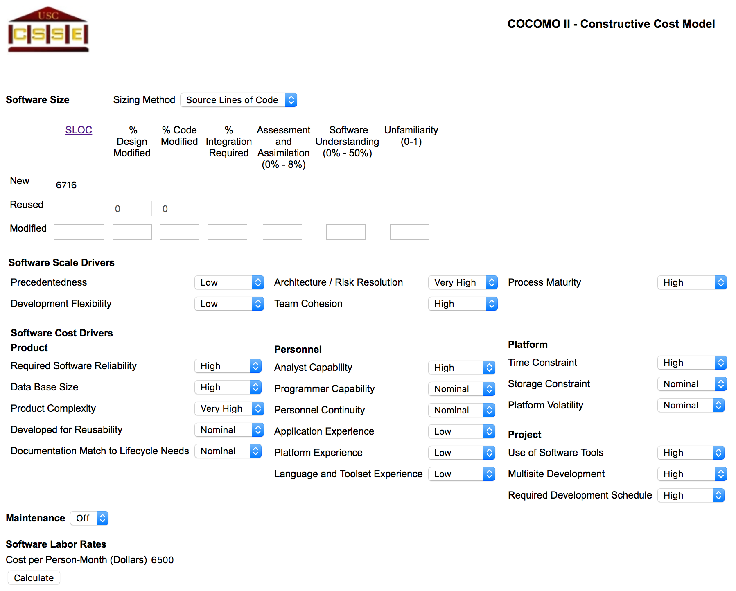

The output of the analysis tool:

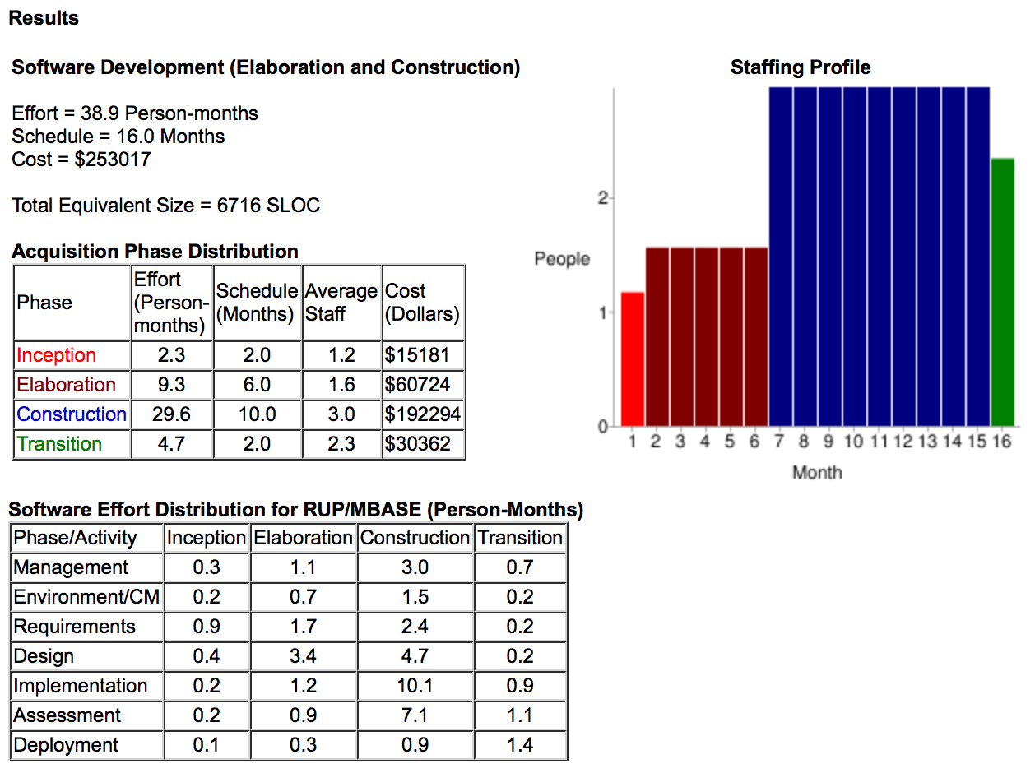

The estimated size of the team is:

*Npeople = Effort / TimeSchedule = 2.43 ≈ 3*

1. **Task Identification**

The tasks are the activities which must be developed to reach the project goals.

These tasks are the same that are represented in the RASD, DD and ITPD.

Some tasks need to be developed before other and the table below shows the dependencies between the tasks and their development time.

|  |  |  |  |  |
| --- | --- | --- | --- | --- |
| ID | Task | Effort (person-days) | Duration  (days) | Dependencies |
| T1 | Stakeholders identification | 5 | 3 |  |
| T2 | Actors identification | 4 | 2 | T1 |
| T3 | Goals identification | 10 | 5 | T2 |
| T4 | Requirements identification | 25 | 13 | T3 |
| T5 | Use Case and scenarios | 20 | 10 | T4 |
| T6 | Class diagrams | 15 | 8 | T5 |
| T7 | Alloy model | 25 | 13 | T6 |
| T8 | Components and interfaces | 28 | 14 | T7 |
| T9 | Deployment architecture | 23 | 23 | T8 |
| T10 | Runtime units | 20 | 20 | T9 |
| T11 | Sequence diagrams | 25 | 13 | T8 |
| T12 | Algorithm design | 36 | 18 | T8 |
| T13 | Mock-up and UX diagrams | 20 | 10 | T5 |
| T14 | View Client development | 38 | 19 | T10, T11, T12, T13 |
| T15 | Request manager development | 57 | 29 | T10, T11, T12 |
| T16 | Account manager development | 30 | 15 | T10, T11, T12 |
| T17 | Reservation manager development | 64 | 32 | T10, T11, T12 |
| T18 | Ride manager development | 67 | 34 | T10, T11, T12 |
| T19 | Car manager development | 60 | 30 | T10, T11, T12 |
| T20 | Area manager development | 40 | 40 | T10, T11, T12 |
| T21 | Payment manager development | 30 | 30 | T10, T11, T12 |
| T22 | Integration testing strategy | 43 | 22 | T14 – T21 |
| T23 | Integration testing execution | 55 | 28 | T22 |

The effort person-days can be calculated using a factor that represent the number of working day in a month and it is equal to 19. So, the 38.9 person-months calculated by COCOMOII is equal to 740 person-days.

If we sum all the effort values represented in the table above, we obtain 740 person-days.

The duration is calculated dividing the effort by the number of workers. Our group’s worker is composed by only 2 people.

The assignment of the workers to each task is done keeping in mind the dependencies, when two activities can be developed concurrently and its effort isn’t very high the workers can work in a parallel way.

1. **Task Schedule**

The image below shows an example of the possible high level project schedule.

The activities and their duration are the same we can found at the previous task identification table. They are grouped into four main groups: RASD, DD, DEVELOPMENT and ITPD.

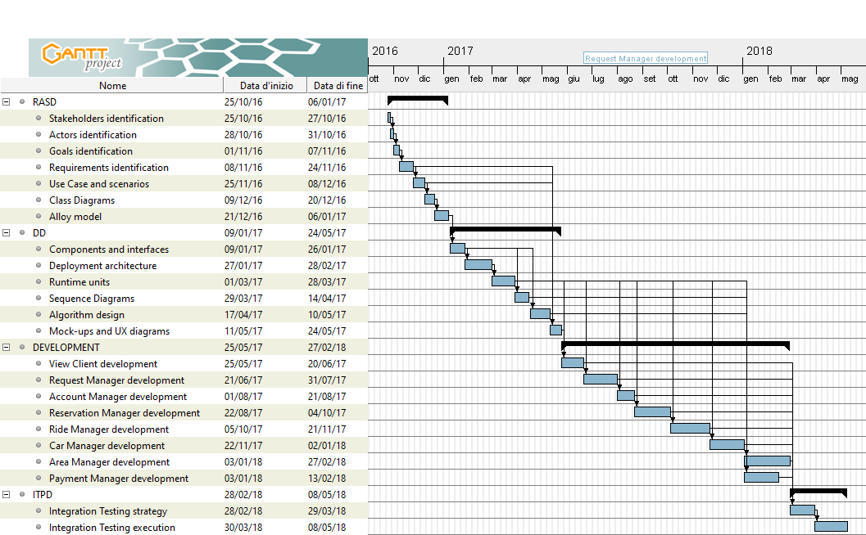

1. **Resource Allocation**

The image below shows how the activities indicated in the previous tasks schedule plan are assigned to the workers.

The development team is composed by two developers (Boglio and Croce).

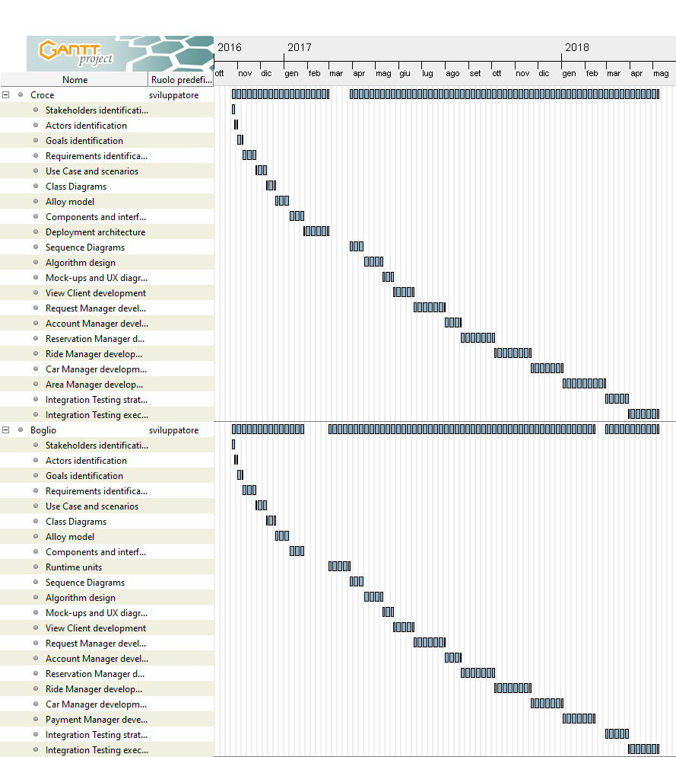

1. **Risks Planning and Management**

Our project during its development can run into some trouble and in this section, we try to find these possible problems (risks) and the way to manage them.

To manage a risk there are four ways:

* **Avoid:** it’s the prevention of the risk before it happening
* **Mitigate:** if you can’t avoid the risk, you can take some prevention measures to contain the damage
* **Transfer:** pay someone else to accept the risk for you
* **Accept:** if you can’t do none of the previous strategy, you must accept the risk

Some risks of PowerEnjoy project can be the following:

* **Project delays** during development of the project  
  To manage this risk, we can apply an avoid strategy. We can make a project schedule considering more days of the necessary.
* **Stakeholders bankrupt**  
  To manage this risk, we can apply a mitigate strategy. We can request a part of the total cost of the whole project when we reach each milestone.
* **Wrong functionalities/user interfaces**  
  To manage this risk, we can apply an avoid strategy. We can schedule more than one meeting with stakeholder to inform them of the current result and in case of mistakes or other we can easily fix the problem. Also, we can let the stakeholders to have an active role in the RASD and DD develop to avoid all possible misunderstand and problems in future parts of the project develop. Wrong user interface problems can be avoided with the use of mock-ups in early phase of the project.
* **Project team problem**: some members can quit or ill; we can also underestimate the quality and capability of a person in our team.  
  To manage this risk we can split works and responsibilities to multiple people in the team and try to hire people with knowledgeable and flexible capability.
* **External component failure**: PowerEnjoy use as external services Google Maps, email provider, mobile provider and payment service.   
  To manage this risk, we can apply a mitigate strategy. We can build our components in a modular way to substitute these external service, in case of their failure, with others that have the same functionalities.
* **Loss of work**To manage this risk, we can apply a mitigate strategy. We can plan daily backups to recover data in case of problems. We must be able to store these backups in a secure place, also in another physical place to avoid losses in case of fire, flooding etc.

1. **Appendix**
   1. **External References**

* CMM model: <https://en.wikipedia.org/wiki/Capability_Maturity_Model>
* FP model: <http://www.functionpointmodeler.com/fpm-infocenter/index.jsp?topic=%2Fcom.functionpointmodeler.fpm.help%2Fditafiles%2Fconcepts%2Fcon-86.html>
* Risk management: <https://opentextbc.ca/projectmanagement/chapter/chapter-16-risk-management-planning-project-management/>
  1. **Software and Tools Used**
* Microsoft Office Word to redact and format this document.
* GanttProject for the Gantt chart of the project schedule.
  1. **Hours of Work**
* Simone Boglio 21 hours of work
* Lorenzo Croce 21 hours of work