Methods synthesis tables

Overview
Population
population | n | Proportion (n/N) | Percent
adults | 20 | 20/37 | 54.1%
mixed | 11 | 11/37 | 29.7%
children | 4 | 4/37 | 10.8%
adolescents | 1 | 1/37 | 2.7%
indeterminable | 1 | 1/37 | 2.7%

Overarching domain
overarching_domain | n | percent
psychological_condition | 16 | 43.2%
transdiagnostic_feature | 11 | 29.7%
other | 6 | 16.2%
medical_condition | 4 | 10.8%

Administration mode
administration_mode | n | Proportion (n/N) | Percent
self_report | 23 | 23/37 | 62.2%
mixed | 7 | 7/37 | 18.9%
indeterminable | 2 | 2/37 | 5.4%
parent_report | 2 | 2/37 | 5.4%
structured_interview | 2 | 2/37 | 5.4%
observer_report | 1 | 1/37 | 2.7%

Scale search and selection transparency
Reported databases/search sources
database | n | percent
psycinfo | 13 | 35.1%
pubmed | 11 | 29.7%
indeterminable | 9 | 24.3%
google_scholar | 8 | 21.6%
web_of_science | 7 | 18.9%
embase | 6 | 16.2%
medline | 5 | 13.5%
cinahl | 3 | 8.1%
eric | 3 | 8.1%
scopus | 3 | 8.1%
sociological_abstracts | 2 | 5.4%
cosmin | 1 | 2.7%
eprovide | 1 | 2.7%
proquest | 1 | 2.7%
psycarticles | 1 | 2.7%
ptsdpubs | 1 | 2.7%
sciencedirect | 1 | 2.7%

Number of Databases Used
n_sources | n_studies | percent
1 | 8 | 34.8%
2 | 4 | 17.4%
3 | 2 | 8.7%
4 | 5 | 21.7%
6 | 3 | 13.0%
7 | 1 | 4.3%

Selection criteria format
Selection criteria format | n | Proportion (n/N) | Percent
Both inclusion & exclusion | 21 | 21/32 | 65.6%
Inclusion only | 7 | 7/32 | 21.9%
Neither inclusion nor exclusion | 3 | 3/32 | 9.4%
Exclusions only | 1 | 1/32 | 3.1%

Specific inclusion criteria
Inclusion criteria | n | Proportion (n/N) | Percent
language | 17 | 17/28 | 60.7%
frequency | 14 | 14/28 | 50.0%
availability | 8 | 8/28 | 28.6%
release date/recency | 8 | 8/28 | 28.6%
clinical relevance | 6 | 6/28 | 21.4%
minimum citation threshold | 4 | 4/28 | 14.3%

Unit of comparison and transformations
Unit of comparison across analyses
unit_token | n | percent
symptom_level | 28 | 63.6%
category_level | 12 | 27.3%
criterion_level | 2 | 4.5%
item_level | 1 | 2.3%
semantic_level | 1 | 2.3%

Percentage reduction by unit type
unit_token | n | mean | sd | median | iqr | min | max | q25 | q75
symptom_level | 27 | 68.38 | 18.95 | 68.75 | 26.81 | 32.0 | 96.7 | 56.7 | 83.5
category_level | 11 | 92.15 | 7.13 | 90.95 | 9.41 | 75.8 | 99.6 | 89.1 | 98.5
criterion_level | 2 | 88.30 | 9.28 | 88.30 | 6.56 | 81.7 | 94.9 | 85.0 | 91.6
item_level | 1 | 0.00 |  | 0.00 | 0.00 | 0.0 | 0.0 | 0.0 | 0.0
semantic_level | 1 | 36.62 |  | 36.62 | 0.00 | 36.6 | 36.6 | 36.6 | 36.6

Categorization approach
categorization_approach | n | percent
bottom_up | 27 | 73.0%
mixed | 5 | 13.5%
top_down | 5 | 13.5%

Diagnostic frameworks referenced
diagnostic_framework | n | percent
none | 18 | 48.6%
dsm | 13 | 35.1%
other | 4 | 10.8%
icd | 2 | 5.4%
who_definition | 2 | 5.4%
guideline | 1 | 2.7%

Item preprocessing and transformation decisions
Decision | n | Proportion (n/N) | Percent
Within-scale item collapsing | 16 | 16/37 | 43.2%
Reverse-worded items collapsed | 7 | 7/37 | 18.9%
Item exclusions reported | 13 | 13/37 | 35.1%
Idiosyncratic/unique items discussed | 26 | 26/37 | 70.3%
Compound items discussed | 24 | 24/37 | 64.9%
↳ Compound handling: multi-coded | 20 | 20/24 | 83.3%
↳ Compound handling: mono-coded | 2 | 2/24 | 8.3%
↳ Compound handling: other | 2 | 2/24 | 8.3%

Coding workflow and reproducibility

Coding team and rater counts
metric | n | mean | sd | median | iqr | min | max
Initial coding team size | 28 | 2.29 | 1.56 | 2 | 1 | 1 | 7
Number of raters | 28 | 3.25 | 1.76 | 3 | 2 | 1 | 8

Initial team distribution
initial_coding_team_size | n | percent
1 | 8 | 28.6
2 | 14 | 50.0
3 | 3 | 10.7
6 | 2 | 7.1
7 | 1 | 3.6

Rater team distribution
n_rater | n | percent
1 | 2 | 7.1
2 | 10 | 35.7
3 | 7 | 25.0
4 | 4 | 14.3
5 | 1 | 3.6
6 | 2 | 7.1
7 | 1 | 3.6
8 | 1 | 3.6

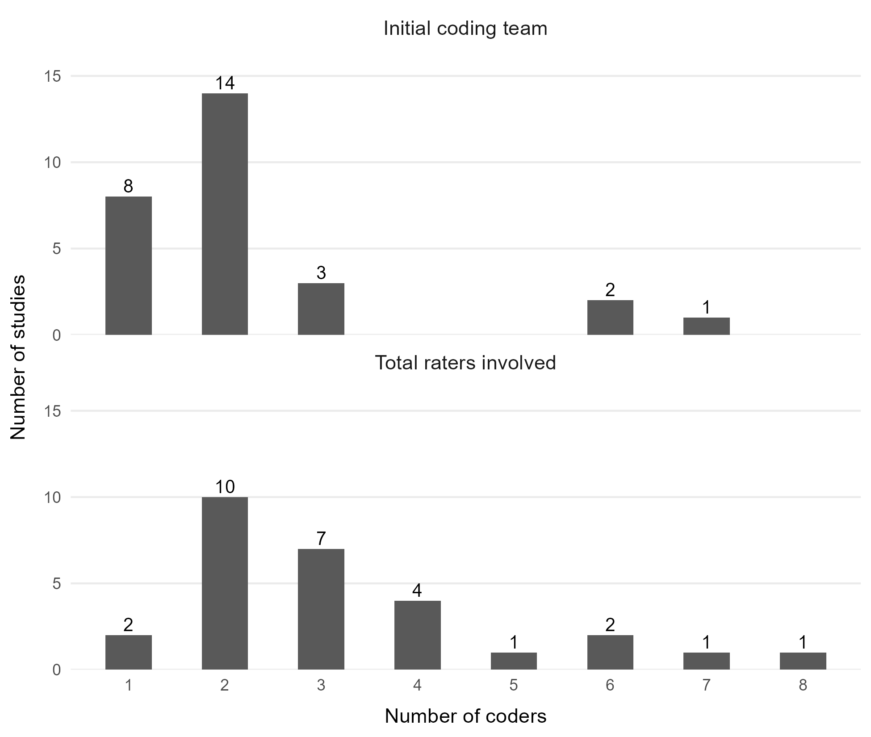

Coding team expansion
expanded | n | percent
false | 13 | 46.4
true | 15 | 53.6

Additional Coding Descriptives
Indicator | n | denominator | report
Rater expertise mentioned | 8 | 37 | 8/37 (21.6%)
Blinded | 2 | 37 | 2/37 (5.4%)

Coding reliability indicators
Indicator | n (Studies) | Proportion (n/N) | Percent
Independent coding scheme mentioned | 14 | 14/37 | 37.8%
Interrater reliability reported | 10 | 10/37 | 27%
Disagreement resolved mentioned | 23 | 23/37 | 62.2%
Documentation indicators
Indicator | n (Studies) | Proportion (n/N) | Percent
Codebook reported | 15 | 15/37 | 40.5%
Software mentioned | 29 | 29/37 | 78.4%
Preregistered rules reported | 1 | 1/37 | 2.7%

Software used
Software used | n (Studies) | Proportion (n/N) | Percent
R | 25 | 25/29 | 86.2%
Python | 3 | 3/29 | 10.3%
No code | 1 | 1/29 | 3.4%

Overlap reporting and scale length correlation
Indicator | n (Studies) | Proportion (n/N) | Percent
Mean overlap reported | 26 | 26/37 | 70.3%
Minimum overlap reported | 26 | 26/37 | 70.3%
Maximum overlap reported | 30 | 30/37 | 81.1%
Length × mean-overlap relation noted | 17 | 17/37 | 45.9%

Location of overlap matrix
Matrix source | n (Studies) | Proportion (n/N) | Percent
Main text | 28 | 28/37 | 75.7%
Supplement | 1 | 1/37 | 2.7%
Not available despite overlap reporting | 3 | 3/37 | 8.1%
 | 5 | 5/37 | 13.5%

Summary of Overlap Values
metric | n | mean | median | min | max
Mean overlap | 26 | 0.27 | 0.26 | 0.07 | 0.44
Minimum overlap | 26 | 0.09 | 0.07 | 0.00 | 0.30
Maximum overlap | 30 | 0.56 | 0.50 | 0.13 | 1.00

Types of reported length correlations
correlation_lengthxmeanoverlap_type | n (Studies) | Proportion (n/N) | Percent
positive_numeric | 9 | 9/17 | 52.9%
positive_text_only | 3 | 3/17 | 17.6%
null_numeric | 2 | 2/17 | 11.8%
other_unclear | 2 | 2/17 | 11.8%
null_text_only | 1 | 1/17 | 5.9%

Interpretive claims and recommendations
Indicator | n (Studies) | Proportion (n/N) | Percent
Heterogeneity emphasized | 35 | 35/37 | 94.6%
Noninterchangeability emphasized | 21 | 21/37 | 56.8%
Careful measure selection recommended | 26 | 26/37 | 70.3%
Measure development recommended | 25 | 25/37 | 67.6%
ICA methods problems/research needs noted | 19 | 19/37 | 51.4%

How authors described overlap strength
Overlap reported | n (Studies) | Proportion (n/N) | Percent
Very weak overlap | 5 | 5/37 | 13.5%
Weak overlap | 22 | 22/37 | 59.5%
Moderate overlap | 5 | 5/37 | 13.5%
Not specified | 5 | 5/37 | 13.5%

