Banking Data Pipeline — Reporting Layer
Power BI Case Study: Data-Quality Root Causes & Financial Impact
Ana Lorena Ortiz Loyola Solana · Data Science, Tecnológico de Monterrey

1. Business Question
This dashboard extends a personal data pipeline project (150 simulated bank accounts, synthetic transactions, a normalized SQLite database with a full audit log) into a reporting layer built in Power BI. It is designed to answer one stakeholder-facing question:
What are the main root causes of data-quality errors in the pipeline, and what is their financial impact in terms of transactions that had to be dropped?
The underlying data comes from a Python/SQL cleaning pipeline that logs every correction and removal to a cleaning_log audit table (table, column, original value, new value, action, reason, timestamp) — mirroring the reconciliation and audit-trail work performed during a regulatory-reporting internship at Deutsche Bundesbank (AnaCredit).

2. Data Model
The Power BI model is built on the pipeline's SQLite output plus several DAX-derived tables:
- cleaning_log — the fact table: every cleaning action, with table, column, reason, and action type (corrected / removed).
- transactions, transactions_invalid_date, transactions_future_date — the clean table plus the two quarantine tables produced when a transaction fails a date-validity check.
- ErrorCategories / CategorySummary — groups raw reason codes into readable categories (Date Formatting, Invalid Date, Categorical Correction) and computes each category's share of total errors.
- ErrorsByTable — error rate per source table, computed against the true row count of accounts and transactions (not just the error count in isolation).
- RemovedRowsByReason — removed rows grouped by table and root-cause category, isolating exactly which cleaning rule triggered each deletion.
- AllMonthlyErrors_2025 / MonthlyErrorAmounts_2025 (and matching 2024 tables) — monthly aggregates of error count, amount lost, and average error amount, used for the trend and KPI pages.
Two DAX patterns carry most of the analytical weight: (1) SWITCH(TRUE()) blocks that classify reason codes into categories without a manual mapping table, and (2) GROUPBY / GENERATE combinations that compute per-table, per-category statistics without flattening everything into one wide table.

3. Dashboard Walkthrough
3.1 Root-Cause & Error-Composition View
The first page answers "where do errors come from, and how much money do they touch?" Date-related issues (formatting and invalid/future dates) account for the large majority of flagged rows, while the amount-by-transaction-type breakdown shows that roughly 13% of total transaction value sits in transactions ultimately dropped as invalid- or future-dated.
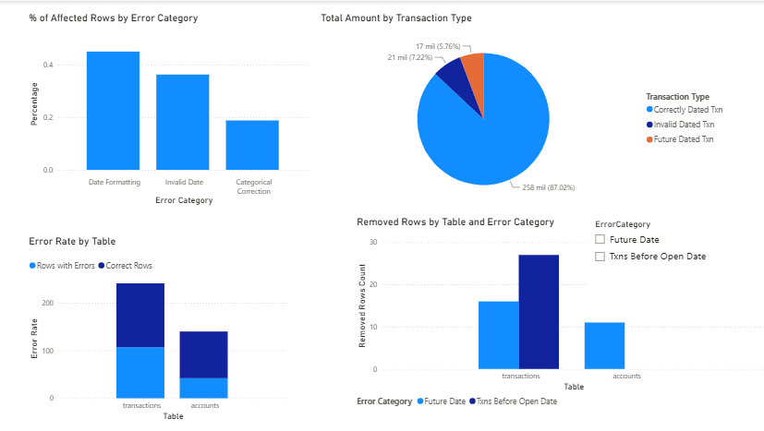
Figure 1 — Error category composition, transaction value by status, error rate by table, and removed rows by root cause.
3.2 Reconciliation & Column-Level Detail
The second page drills into where errors concentrate geographically and structurally. The timezone breakdown — a direct analogue of the cross-jurisdiction reconciliation work performed on AnaCredit reporting data — shows Europe/Berlin accounts for the large majority of removed-transaction value, largely because it is the dominant timezone in the underlying account population rather than a higher error propensity per se. The column-level panel shows transactions carries a materially higher average error count per column than accounts, pointing cleanup effort toward the transaction ingestion path first.
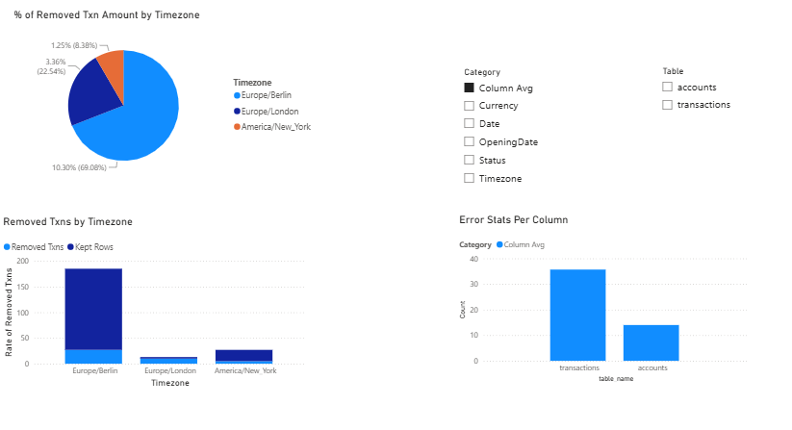
Figure 2 — Removed transaction value by timezone, removed-vs-kept rate by timezone, and average errors per column by table.
3.3 Trend View
The third page adds the time dimension: total errors by year, by quarter, and a monthly series plotted against a rolling 30-day baseline. The baseline — computed with a custom DAX window function rather than a built-in time-intelligence call — lets a spike in any given month (e.g., July) read as a deviation from recent normal rather than an isolated number.
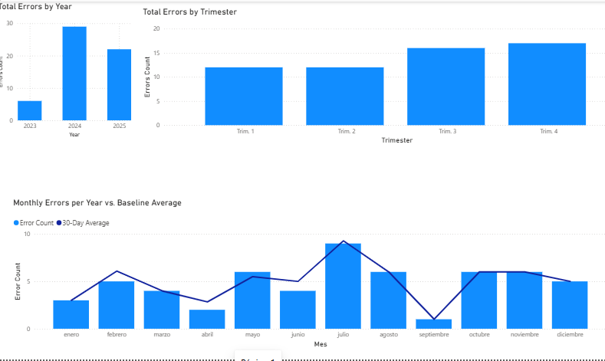
Figure 3 — Errors by year, by quarter, and monthly error count against a 30-day rolling baseline.
3.4 KPI Scorecard: Year-over-Year Comparison
The fourth page adds four KPI cards comparing each month of 2025 against the same month in 2024, using dedicated DAX measures rather than a raw prior-year column — this was a deliberate fix during development: an earlier version compared a single month's value against the full prior-year total, producing distorted percentages. The corrected measures use SELECTEDVALUE plus CALCULATE to look up the matching month, with an AVERAGEX fallback to the prior year's average when no directly comparable month exists (e.g., where the synthetic dataset has gaps).
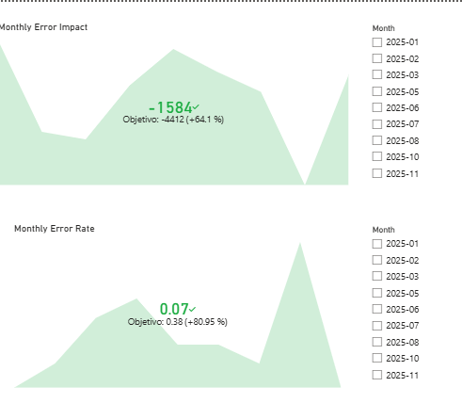
Figure 4 — Monthly Error Impact and Monthly Error Rate vs. same-month-prior-year goal.
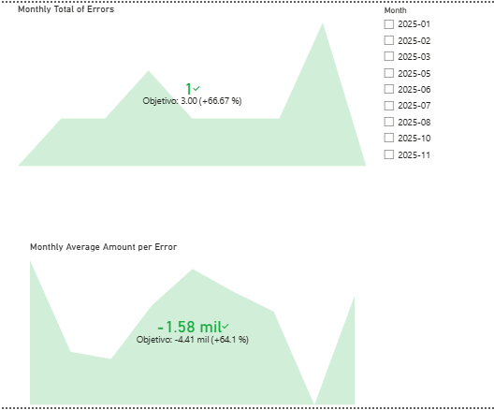
Figure 5 — Monthly Total of Errors and Monthly Average Amount per Error vs. same-month-prior-year goal.
KPI | Value vs. same month, prior year
Monthly Error Impact | −1,584 vs. goal −4,412 (+64.1%)
Monthly Error Rate | 0.07 vs. goal 0.38 (+80.95%)
Monthly Total of Errors | 1 vs. goal 3.00 (+66.67%)
Monthly Average Amount per Error | −1.58 mil vs. goal −4.41 mil (+64.1%)

4. Data-Quality Layer
This is treated as a first-class part of the model rather than an afterthought, reflecting the reconciliation discipline required in regulatory reporting:
- Completeness / reconciliation — ErrorsByTable computes valid rows as (true table row count − errors), rather than assuming the post-cleaning row count is the denominator.
- Root-cause taxonomy — RemovedRowsByReason and ErrorCategories classify every removal, so "we removed rows" becomes "we removed rows because of X, Y, or Z," a distinction that matters when explaining data loss to a stakeholder.
- Auditability — every action traces back to a single row in cleaning_log with a timestamp, original value, and new value, so any number on the dashboard can be traced to the exact rows that produced it.

5. Limitations & What I'd Add for Production
This is a proof-of-concept built on synthetic data, and it's scoped that way on purpose. In a production setting, I would add:
- Row-level security by reporting entity, so different teams only see their own accounts/transactions.
- Incremental refresh instead of a full reload, since the cleaning_log and transaction tables would grow indefinitely.
- Automated data-quality alerting (e.g., a scheduled check that flags when the monthly error rate exceeds the rolling baseline by a defined threshold) instead of manual dashboard review.
- A proper shared date/calendar table relating the 2024 and 2025 aggregates, replacing the current pattern of separate per-year tables joined via text-matched YearMonth keys — workable at this scale, but not how I'd model it with a longer time horizon.

6. Tools
Python (pandas, sqlite3) for data generation and cleaning · SQLite for storage and referential integrity (foreign keys, triggers for balance recalculation) · Power BI Desktop for modeling and reporting · DAX for all derived tables and measures (SWITCH, GROUPBY, GENERATE, ADDCOLUMNS, CALCULATE, custom rolling-window and prior-year-comparison logic).

