Finite-element simulation of AFM nanoindentation of a thin elastic film adsorbed to a rigid substrate
Materials and Methods (Biophysical Journal style)

Finite-element model
Force–indentation curves and the internal stress distribution of the sample were computed with a custom, open-source finite-element (FE) solver (nanoindent, implemented in Python on the scikit-fem/FEniCSx framework), reproducing the numerical experiment usually carried out in commercial FE software (COMSOL Multiphysics; COMSOL AB, Stockholm, Sweden). The atomic force microscopy (AFM) indentation of a probe (MSNL-BIO-DC) into a thin elastic film adsorbed to a rigid substrate is an axisymmetric problem; exploiting the rotational symmetry about the indentation axis, the three-dimensional geometry was reduced to a two-dimensional cross-section in cylindrical coordinates (r, z). All fields, boundary conditions, and the contact constraint are independent of the azimuthal angle, and every domain integral carries the axisymmetric weight 2πr.

Geometry and material models
The indenter was modeled as a rigid paraboloid of apex radius R = 20 nm, matching the nominal end radius of the MSNL-BIO-DC tip. Although the probe is a silicon-nitride cantilever with Young's modulus E_tip = 170 GPa, its stiffness exceeds that of the sample by more than three orders of magnitude (E_tip/E_sample ≈ 3.4×10³); the tip deformation is therefore negligible and the indenter was treated as perfectly rigid, entering the formulation solely through its gap (indentation) function. The exact paraboloidal profile, z_tip(r) = r²/(2R), was used rather than a small-slope linearization.
The sample was represented as a linear, isotropic, homogeneous elastic solid with Young's modulus E = 50 MPa. Because the Poisson's ratio of the sample was not independently determined, it was fixed at ν = 0.5 (fully incompressible), the value conventionally assumed for soft, hydrated biological material; a compressible case (ν = 0.3) was also computed for comparison. Small-strain (infinitesimal) kinematics were assumed throughout. The sample was an axisymmetric disc of radius L = 500 nm and thickness h = 6.2 nm; the lateral extent was large compared with the contact radius, so that lateral boundary effects were negligible.

Boundary and contact conditions
The following boundary conditions were imposed. Bottom surface (z = 0): the film is adsorbed to the rigid substrate but not clamped, so it cannot detach or penetrate the substrate yet is free to slide along it; this was modeled as a frictionless (unbonded) support with the normal displacement constrained, u_z = 0, and the tangential (radial) displacement u_r left free. Symmetry axis (r = 0): u_r = 0 (axisymmetry). Lateral edge (r = L): traction-free. Top surface (z = h): frictionless (normal-only) unilateral contact against the rigid tip, traction-free outside the contact region.
Contact was enforced with a penalty formulation. The signed gap between the deformed sample surface and the rigid paraboloid, g(r) = z_tip(r) − [h + u_z(r)], defines the interpenetration [−g]₊ = max(−g, 0); a contact pressure p_c = k_pen[−g]₊ was applied over the top surface, with the penalty stiffness k_pen scaled to the local element size to remain consistent under mesh refinement. Only the normal component of the contact traction was retained (frictionless contact); no tangential constraint was imposed.
Because the incompressible sample (ν = 0.5) would cause volumetric locking of a single-field displacement discretization, the elasticity was solved with a mixed displacement–pressure (Taylor–Hood) formulation, using quadratic (P2) displacement and linear (P1) pressure fields; the pressure enforces the incompressibility constraint. For the compressible comparison (ν = 0.3) the standard single-field P2 displacement formulation was used.

Loading and solution
Indentation was displacement-controlled: the rigid tip was advanced normal to the sample surface in 30 equal increments up to a maximum indentation of δ = 5 nm. At each increment the nonlinear contact problem — nonlinear only through the activation of the contact set — was solved by a Newton iteration, using the converged solution of the previous step as the initial guess; the linear systems were solved with a direct sparse solver. The reaction force on the indenter was computed by integrating the contact pressure over the top surface, F = ∫ k_pen[−g]₊ 2πr dr, and, independently, by integrating the axial stress over the bottom boundary; the two estimates agreed to within 1.0%, confirming global equilibrium. Forces are reported in piconewtons, using the consistent unit system (length in nm, stress in MPa), for which 1 MPa·nm² = 1 pN.

Mesh and convergence
The cross-section was discretized with quadratic triangular elements on a graded mesh, strongly refined at the contact point (r = 0, z = h) and coarsening toward the outer boundaries. Mesh independence was established by successively reducing the near-contact element size (down to 0.01 nm) while holding the graded coarsening toward the edges fixed; the reaction force at maximum indentation varied by only a few percent over the finest refinements. The reported results use the 0.01 nm near-contact mesh. Several element layers were resolved across the 6.2 nm film thickness.
Near-contact element size (nm) | Degrees of freedom | F(δ = 5 nm) (pN)
0.04 | 17298 | 17177
0.02 | 19950 | 17085
0.01 | 23862 | 17133

Outputs
Two quantities were extracted from the converged solution: (i) the force–indentation curve F(δ) over 0 ≤ δ ≤ 5 nm; and (ii) the spatial distribution of the von Mises (equivalent) stress, σ_vM = sqrt{ ½[(σ_rr−σ_zz)² + (σ_zz−σ_θθ)² + (σ_θθ−σ_rr)²] + 3σ_rz² }, recovered by L² projection onto the mesh nodes and displayed on the axisymmetric cross-section (mirrored about the symmetry axis). The evolution of σ_vM through the loading history was additionally rendered as a video.
For interpretation, the simulated F(δ) was compared with the analytical Hertz model for a paraboloid on an elastic half-space, F = (4/3)[E/(1−ν²)]√R δ^{3/2}; with the Chadwick (2002) asymptotic solution for a thin incompressible layer, F = (2π/3) E R² δ³/h³; and with the finite-thickness correction of Dimitriadis et al. (2002) for a film with a free (frictionless) base.

Representative results
For the incompressible sample (E = 50 MPa, ν = 0.5, R = 20 nm, h = 6.2 nm) adsorbed to but free to slide on the rigid substrate, the converged model gave a reaction force of F ≈ 17.1 nN at the maximum indentation δ = 5 nm, with a peak von Mises stress of ≈ 45 MPa. Because the film is unbonded, the incompressible material relieves confinement by sliding laterally along the substrate rather than by large in-plane stretching, so the high-stress region extends down to the sliding base beneath the tip apex. At equal indentation the compressible sample (ν = 0.3) is more compliant, F ≈ 14.1 nN. The strongly nonlinear rise of F(δ) at this large indentation-to-thickness ratio (δ/h ≈ 0.8) reflects the finite-thickness (bottom-effect) stiffening of the thin film; the FE curve is bracketed by the Hertz half-space and thin-layer analytical limits.

Figures
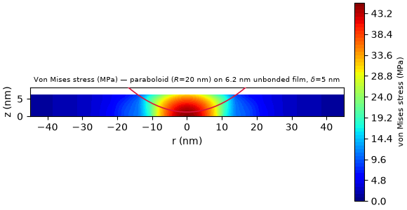
Figure 1. Cross-section of the FE simulation of the AFM tip (rigid paraboloid, R = 20 nm) indenting a 6.2 nm elastic film adsorbed to a rigid substrate, at the maximum indentation δ = 5 nm. The color map shows the simulated von Mises stress within the sample (red: high stress; blue: low stress) produced by the vertical force applied by the tip; the red curve marks the rigid tip surface, and the domain is mirrored about the symmetry axis r = 0.

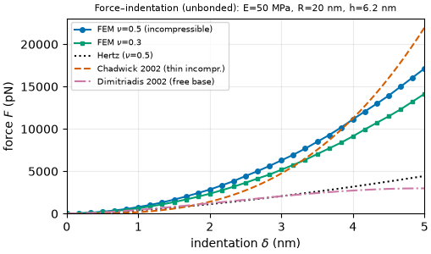
Figure 2. Simulated force–indentation curve F(δ) for the same sample (E = 50 MPa, h = 6.2 nm, unbonded base), for ν = 0.5 (incompressible, primary) and ν = 0.3, compared with the Hertz half-space, Chadwick thin-incompressible-layer, and Dimitriadis (2002) free-base models.
Supplementary Video 1. Evolution of the von Mises stress field over the axisymmetric cross-section as the tip indents from δ = 0 to 5 nm (file: von_mises_indentation.mp4).

References
Hertz, H. (1882). Über die Berührung fester elastischer Körper. J. Reine Angew. Math. 92, 156–171.
Sneddon, I. N. (1965). The relation between load and penetration in the axisymmetric Boussinesq problem for a punch of arbitrary profile. Int. J. Eng. Sci. 3, 47–57.
Dimitriadis, E. K., F. Horkay, J. Maresca, B. Kachar, and R. S. Chadwick (2002). Determination of elastic moduli of thin layers of soft material using the atomic force microscope. Biophys. J. 82, 2798–2810.
Chadwick, R. S. (2002). Axisymmetric indentation of a thin incompressible elastic layer. SIAM J. Appl. Math. 62, 1520–1530.
Garcia, P. D., and R. Garcia (2018). Determination of the elastic moduli of a single cell cultured on a rigid support by force microscopy. Biophys. J. 114, 2923–2932.

