

DESIGN DOCUMENT: Platform for Connecting Agricultural Cooperatives and Farmers

GROUP MEMBERS:
- DJANI Paule Lorene
- NDINGA Prince Raoul
- TAKAM Ismael Ulrich
- TCHUENTE TEUKAM Fleur-Doline Merveille
- YIMGAIN PONTU Marie-Paule Yvana

Supervisor:
M.PESSA Arthur

Academic year 2025-2026

Table of Contents
1. INTRODUCTION 3
2. PROJECT PRESENTATION 3
2.1 System Objectives 3
2.2 System Interfaces 7
2.3 General Design Constraints 11
3. REFERENCE DOCUMENTS 14
4. STANDARDS, NORMS, AND TOOLS 15
4.1 Design Methods 15
4.2.1 Hardware and Tools 17
4.2.2 Programming Standards 25
4.3 Quality Plan 34
5. GENERAL DESIGN 38
5.1 Module Identification and Description 38
5.2. Component Diagram 52
5.3. Deployment Diagram 52
6. Detailed Design 53
6.1. Design Class Diagram 53
6.2. Algorithms 53
6.3. Application Theme 93

1. INTRODUCTION
This document outlines the technical design for our agricultural platform that connects farmers, cooperatives, and government agencies. After completing the analysis phase where we identified all functional requirements and use cases, we now need to translate those findings into practical technical specifications that our development team can implement.
The main purpose of this design document is to provide clear technical direction for building the system. We're documenting our architectural decisions, technology choices, and implementation strategies to ensure we develop software that actually works within our project timeline and constraints. This isn't just theoretical - these specifications need to be practical enough that we can build a functional system.
We're following IEEE 1016 standards for software design documentation to ensure we cover all essential technical aspects systematically. This document will guide our development team members who will write the code, help our supervisor validate our technical approach, and assist future maintenance teams who might work with this system.
The document is organized to progress from general concepts to specific technical details. We start with project objectives and constraints, then move to standards and tools, followed by general architecture, and finally detailed design specifications for key system components.

2. PROJECT PRESENTATION

2.1 System Objectives
Based on our analysis work, we've identified six core technical objectives that translate our functional requirements into implementable architecture. Each objective directly addresses requirements from our analysis document while providing measurable success criteria.
Objective 1: Offline-First Mobile Application (Addresses UFR-003, NFR-001)
Implement a mobile application using React Native that operates primarily offline with SQLite local storage. The app must cache 30 days of essential data including debt status (UFR-005), market prices (UFR-004), weather information (UFR-006), and cooperative announcements (UFR-007).
Technical Implementation:
- SQLite database for local persistence
- Redux Persist for state management across app restarts
- Automatic synchronization when connectivity detected
- Conflict resolution prioritizing server data for financial transactions
Success Metrics:
- App launches in under 10 seconds on Android 6.0 devices with 2GB RAM (NFR-001)
- Core functions accessible with zero network connectivity
- Data synchronization completes within 5 minutes when online
- Zero data loss during offline/online transitions
Objective 2: Multilingual Audio Interface (Addresses UFR-002, NFR-002)
Develop an audio-first user interface supporting French, English, Fulfulde, Ewondo, and Duala that is main native languages of all the country with icon-based navigation requiring minimal literacy.
Technical Implementation:
- Native speaker audio recordings for all interface elements
- Adaptive audio compression (16-32 kbps) based on network speed
- Icon library following universal agricultural symbols
- Audio playback with speed adjustment (0.75x to 1.5x)
Success Metrics:
- All core functions operable without reading text (NFR-002)
- Audio files under 500KB per minute of content
- Language switching completed within 2 seconds
- Successful operation on 2G networks (64 kbps minimum)
Objective 3: Microservices Architecture (Addresses SFR-001 through SFR-012, NFR-006)
Build a distributed system using the seven modules identified in our analysis: Farmer Core Experience, Cooperative Management, Communication Hub, Market & Weather Data, Plant Health & Advisory, Government Dashboard, and Core Platform Services.
Technical Implementation:
- RESTful APIs for inter-service communication
- Docker containerization for consistent deployment
- MySQL 8.0 database with master-slave replication
- API Gateway for centralized authentication and routing
Success Metrics:
- System supports 100,000+ concurrent users (NFR-004)
- 99.5% uptime excluding scheduled maintenance (NFR-004)
- Individual services deployable independently
- API response times under 2 seconds for 95% of requests
Objective 4: Government Monitoring Dashboard (Addresses SFR-002)
Create a web-based analytics dashboard providing agricultural statistics aggregated by region, department, and district with Excel/PDF export capabilities.
Technical Implementation:
- React.js with data visualization libraries
- Aggregation queries on replicated read database
- Real-time alerts for production anomalies
- Export generation for datasets up to 100,000 records
Success Metrics:
- Dashboard loads within 15 seconds on 1 Mbps connections (NFR-001)
- Statistics updated daily with zero aggregation errors
- Alerts triggered within 5 minutes of threshold breaches
- Year-over-year comparisons accurate within 0.1%
Objective 5: Cooperative Management Portal (Addresses SFR-001, SFR-004, SFR-005)
Implement a web application for cooperative managers to handle member management, inventory tracking, and microcredit administration with transaction integrity.
Technical Implementation:
- Progressive Web App (PWA) for offline capability
- Transaction management ensuring ACID properties
- Bulk communication system (SMS, audio messages)
- Integration with mobile money APIs for payment validation
Success Metrics:
- Transaction processing under 3 seconds response time
- Bulk operations (1,000 SMS) complete within 10 minutes
- Member search/filter results returned in under 2 seconds
- Zero financial transaction inconsistencies
Objective 6: Secure Data Management (Addresses SFR-012, NFR-003)
Establish secure, encrypted data synchronization with geographic replication within Cameroon borders, complying with GDPR and local data protection laws.
Technical Implementation:
- TLS 1.3 for all data transmission
- AES-256 encryption at rest for sensitive data
- MySQL replication across multiple Cameroon data centers
- Automated daily backups with 30-day retention
Success Metrics:
- Zero data breaches verified through quarterly audits
- Recovery Point Objective (RPO) of 1 hour maximum
- Recovery Time Objective (RTO) of 4 hours for full restoration
- Compliance verified by legal review against Cameroon Law No. 2010/012

2.2 System Interfaces
These are external software systems our platform must integrate with to deliver required functionality. Each interface represents a dependency that affects our architecture.
Interface 1: Meteorological Data Service
Purpose: Retrieve location-specific weather forecasts and severe weather alerts (UFR-006, SFR-007)
Technical Specifications:
- Protocol: REST over HTTPS
- Data Format: JSON with 7-day forecast data
- Authentication: API key authentication
- Update Frequency: Twice daily (6 AM, 6 PM) for forecasts, real-time for alerts
- Data Points: Temperature (min/max), precipitation probability, humidity, wind speed
- Geographic Coverage: Administrative regions of Cameroon
Integration Requirements:
- Caching: 24-hour local cache to reduce API costs
- Fallback: Display last known forecast if API unavailable
- Error Handling: Retry with exponential backoff (1s, 2s, 4s, manual)
- Rate Limits: 10,000 requests per day system-wide
Interface 2: Mobile Money Payment APIs
Purpose: Validate microcredit payments made through MTN Mobile Money and Orange Money (SFR-005)
Technical Specifications:
- Protocol: REST/HTTPS (newer) or SOAP/XML (legacy systems)
- Authentication: OAuth 2.0 with merchant credentials
- Transaction Flow: Query payment status by transaction ID
- Data Format: JSON for REST, XML for SOAP responses
- Response Time: Typically 2-5 seconds per query
Integration Requirements:
- Security: No storage of payment credentials, transaction IDs only
- Error Handling: Failed validations queued for manual review, retry after 1 hour
- Compliance: CEMAC (Central African Economic and Monetary Community) regulations
- Abstraction: Wrapper layer to handle different provider APIs uniformly
Interface 3: SMS Gateway Service
Purpose: Send notifications for payment confirmations, weather alerts, and cooperative announcements (SFR-006, UFR-005, UFR-006, UFR-007)
Technical Specifications:
- Protocol: REST over HTTPS
- Authentication: API token with IP whitelist
- Message Types: Transactional (payment), promotional (announcements), alerts (weather/disease)
- Rate Limits: 100 SMS per second, burst to 500 for emergencies
- Delivery Confirmation: Webhook callbacks for status tracking
Integration Requirements:
- Cost Management: Estimated 10,000-50,000 monthly messages at ~50 CFA each
- Fallback: Secondary gateway if primary fails (60-second failover)
- Retry Logic: 3 attempts for failed deliveries over 24 hours
- Delivery Tracking: Log all attempts and confirmations for audit
Interface 4: Government Agricultural Database
Purpose: Submit aggregated production statistics and receive policy alerts (SFR-002)
Technical Specifications:
- Protocol: REST over HTTPS
- Authentication: JWT tokens issued by Ministry of Agriculture, rotated monthly
- Data Flow: Bidirectional (push statistics, receive alerts)
- Update Frequency: Daily statistics at midnight, real-time policy alerts
- Data Format: Standardized JSON schema defined by government
Integration Requirements:
- Security: Government-issued TLS certificates, data encrypted at rest and in transit
- Queuing: Offline queue for failed submissions, retry when connection restored
- Compliance: Government data classification (public, internal, confidential)
- Availability: Design for government system downtime (cache and retry)
Interface 5: Market Price Data Aggregators
Purpose: Retrieve current market prices for agricultural commodities (UFR-004)
Technical Specifications:
- Protocol: REST over HTTPS
- Authentication: API key authentication
- Data Sources: Major markets (Yaoundé, Douala, Bamenda, Garoua, Maroua)
- Update Frequency: Daily during market hours
- Data Format: JSON with FAO commodity classification codes
Integration Requirements:
- Caching: 24-hour local cache to minimize API costs
- Error Handling: Display last known prices with timestamp if unavailable
- Data Gaps: Interpolation logic for crops/regions without direct data
- Historical Data: Store for trend analysis and price comparison
Cross-Interface Integration Principles:
All external API integrations follow consistent patterns:
- 10-second maximum timeout for all requests
- Exponential backoff retry strategy (1s, 2s, 4s intervals)
- Environment-variable storage for all credentials (never hardcoded)
- Comprehensive logging for debugging and audit trails
- Graceful degradation using cached data when services unavailable

2.3 General Design Constraints
These constraints fundamentally shape our architectural decisions and technology choices. They represent non-negotiable limitations we must design around.
Technical Constraints
Hardware Limitations (NFR-001):
- Android 6.0 minimum compatibility (released 2015)
- Target devices: 2GB RAM, 16GB storage, entry-level processors
- App installation size: Maximum 50MB
- Cached offline data: Maximum 500MB
- Battery efficiency: Minimal background processing
Network Connectivity (NFR-001):
- 2G network support (64 kbps theoretical, often slower)
- Frequent connection drops and interruptions
- High data costs for end users
- Unreliable connectivity in rural areas
- Design consequence: Offline-first architecture mandatory
Performance Requirements:
- Mobile app launch: Under 10 seconds on target hardware
- Web dashboard load: Within 15 seconds on 1 Mbps connection
- Database queries: Results within 3 seconds for standard operations
- API responses: 95th percentile under 2 seconds
Regulatory Constraints
Data Protection (NFR-003):
- GDPR compliance for any EU-related data subjects
- Cameroon Law No. 2010/012 on Cybersecurity compliance
- Explicit consent required before data collection
- Right to access, correction, and deletion
- Breach notification to authorities required
Data Sovereignty:
- All data storage physically within Cameroon borders
- No cloud hosting in foreign regions (limits AWS, Google Cloud options)
- Requires local data center partnerships or on-premises infrastructure
- Geographic replication must remain within national boundaries
Financial Regulations:
- CEMAC financial transaction regulations
- Not licensed as financial institution - record-keeping only
- Actual money movement through licensed mobile money providers
- Audit trail requirements for all financial data
Cultural and Social Constraints
Low Literacy Accommodation (NFR-002):
- Text-heavy interfaces unsuitable for target users
- Icon-based navigation required for all core functions
- Audio alternatives mandatory for every text element
- Someone unable to read must accomplish all core tasks
Multilingual Requirements (UFR-002, NFR-002):
- Minimum five languages: French, English, Fulfulde, Ewondo, Duala
- Native speaker recordings required (not text-to-speech)
- Regional variations in agricultural terminology
- Different primary languages by geographic region
Audio Design Constraints:
- Native speaker quality required for comprehension
- Low-bandwidth compression necessary (16-32 kbps)
- Balancing audio quality with file size
- Cultural communication norms (timing, formality, authority)
Operational Constraints
Maintenance Limitations (NFR-005):
- Cooperatives lack dedicated IT staff
- Government offices have limited technical resources
- System maintainable by staff with standard IT training only
- Remote administration required (no guaranteed physical access)
- Stability prioritized over latest framework versions
Support Constraints:
- End users call from areas with poor connectivity
- Users may struggle to articulate technical problems
- Support required in local languages
- SMS-based support options necessary (not just web/email)
Long-term Viability:
- Must run for years with minimal intervention
- Cannot require constant framework updates
- Dependencies must remain stable
- Breaking changes must be rare and well-documented
These constraints eliminate many potential technical approaches and guide us toward solutions that actually work in the target environment. Every subsequent design decision must be evaluated against these limitations.

3. REFERENCE DOCUMENTS
- Analysis Document: Platform for Connecting Agricultural Cooperatives and Farmers - Our complete functional analysis including use cases (UFR-001 through UFR-009, SFR-001 through SFR-012, NFR-001 through NFR-007), class diagrams, sequence diagrams, and seven-module system architecture.
- Project Brief ING4178: ISI Transversal Project - Original project specification from Institut Saint Jean defining scope, target users (farmers, cooperatives, government), main features, constraints, and deliverables.
- IEEE 1016-2009: Standard for Software Design Descriptions - Industry standard governing structure and content of software design documentation.
- UML 2.5 Specification (OMG) - Standard for Unified Modeling Language notation used in our component diagrams, deployment diagrams, and class diagrams.
- Regulation (EU) 2016/679: General Data Protection Regulation (GDPR) - European Union data protection law affecting personal data handling.
- Cameroon Law No. 2010/012 on Cybersecurity and Cybercriminality - National legislation governing data protection, electronic transactions, and information system security.
- ISO/IEC 27005:2018: Information Security Risk Management - International standard guiding risk assessment and management procedures.
- IEEE 730-2014: Software Quality Assurance Processes - Standard defining quality assurance procedures and testing strategies.
- OpenAPI Specification 3.0 - Standard for REST API documentation ensuring properly specified microservices interfaces.
- WCAG 2.1 (Web Content Accessibility Guidelines) - W3C accessibility standard relevant for low-literacy user interface design.

4. STANDARDS, NORMS, AND TOOLS

4.1 Design Methods
Modeling Methodology: Agile (Scrum Framework)
We're using Agile methodology with Scrum for practical reasons aligned with our project context. Iterative development is essential given our target users - we need farmer and cooperative feedback early and often to validate usability assumptions around low-literacy interfaces and offline functionality. We cannot build in isolation for six months and hope the result works for users with limited technology experience and poor connectivity.
Our Scrum implementation uses 2-week sprints matching our academic timeline. Sprint reviews force demonstration of working software to our supervisor, enabling course corrections before significant effort is wasted. The user story format aligns directly with our use case analysis from the previous document - scenarios like "As a farmer, I want to check my debt status offline" translate naturally into sprint backlog items with acceptance criteria.
However, we're pragmatic about Agile's limitations in our context. True continuous deployment isn't feasible - testing with real farmers in rural areas requires coordination and time. Major architectural decisions must remain stable - we cannot pivot dramatically mid-project. We're using Agile principles to guide our process, not following them dogmatically.
Modeling Language: UML 2.5
UML provides the standardized notation we need for technical communication. Specifically, we require component diagrams for microservices architecture visualization, deployment diagrams for infrastructure design, detailed class diagrams with typed attributes and method signatures, and sequence diagrams for interaction flows.
We're using UML 2.5 (not older versions) because it has improved support for component-based architectures. The interface notation (provided/required interfaces shown as lollipops and sockets) perfectly documents our microservices API dependencies.
Our UML tooling includes PlantUML for version-controlled text-based diagrams integrating with Git workflow, supplemented by visual editing tools (draw.io or Visual Paradigm) for complex diagrams where graphical manipulation is more efficient.
Quality Approach: Test-Driven Development with User Acceptance Testing
Test-Driven Development (TDD) applies to our core algorithms: offline synchronization with conflict resolution, credit eligibility scoring, and disease pattern detection. Writing tests before implementation forces us to think through edge cases and define clear success criteria. For a system handling financial microcredit data, this rigor is necessary.
However, pure TDD doesn't work for everything. User interface development doesn't fit TDD well - visual design requires iterative refinement. Integration with external APIs (weather services, mobile money) requires different testing approaches using mocks and stubs. We apply TDD where it strengthens design, use integration tests for API boundaries, and conduct manual testing for user experience.
User Acceptance Testing (UAT) is critical and irreplaceable. We need farmers using the mobile app on their actual devices in areas with genuine connectivity issues. We need cooperative managers processing real member data. Simulated testing cannot reveal the assumptions we don't know we're making about literacy, technology comfort, or workflow expectations.

4.2.1 Hardware and Tools
Mobile Application Layer
Frontend: React Native 0.72+ with Expo
- Cross-platform framework targeting Android specifically (iOS not required per project brief)
- Expo managed workflow for team members who cannot run Android Studio, providing pre-built native modules
- Single JavaScript/TypeScript codebase reduces development time and maintenance
- Native module access for QR scanning, audio playback, and offline storage through Expo libraries
- Large community and ecosystem for troubleshooting support and regular updates
- Justification: Team has JavaScript/TypeScript experience, Expo simplifies development setup and testing, cross-platform foundation reduces long-term maintenance
Backend Services for Mobile: Node.js 18 LTS with Express.js
- JavaScript runtime for mobile-specific backend services
- Non-blocking I/O handles concurrent mobile requests efficiently
- Consistent language with frontend reduces context switching for full-stack developers
- LTS version ensures stability and long-term support (NFR-005)
- Lightweight and fast for handling mobile-specific features like audio processing and push notifications
- Justification: Optimal for I/O-heavy mobile operations, team expertise, seamless integration with React Native frontend
Mobile Data Persistence: SQLite 3.x
- Embedded relational database for offline storage in mobile app
- Lightweight footprint (~700KB), works efficiently on low-end target devices
- ACID compliance ensures data integrity during app crashes or unexpected closures
- Handles 30-day data caching requirement (UFR-003) with optimal performance
- Justification: Industry standard for mobile offline storage, mature and stable, proven reliability in similar applications
Mobile State Management: Redux Toolkit with Redux Persist
- Predictable state management with modern Redux patterns
- Automatic persistence maintains application state across app restarts
- Handles offline/online transitions gracefully with middleware support
- Optimized performance with built-in immutability and serializability checks
- Justification: Solves complex state persistence problems cleanly, excellent debugging capabilities, strong React Native integration
Mobile Audio Handling: Expo AV API
- Native audio playback for multilingual interface (UFR-002)
- Supports compressed audio formats (MP3, AAC) optimized for low bandwidth
- Background playback and audio interruption handling
- Low battery consumption with hardware-accelerated decoding
- Built-in recording capabilities for future voice note features
- Justification: Part of Expo ecosystem, well-maintained, handles audio compression for 2G networks
QR Code Scanning: Expo Camera with Barcode Scanner
- Camera integration for QR code registration (UFR-001)
- Hardware-accelerated on supported devices
- Works on Android 6.0+ with consistent performance
- No native build requirement with Expo managed workflow
- Justification: Reliable and maintained, fits Expo ecosystem, meets minimum Android version requirement
Web Application Layer
Frontend: Angular 16+ with TypeScript
- Component-based frontend framework with strong typing
- Virtual DOM and change detection provides good performance on slower government computers
- Large ecosystem and community support with extensive material design components
- Reusable components between cooperative and government portals
- Built-in dependency injection and modular architecture
- Justification: Enterprise-ready framework, excellent for complex dashboards, strong type safety reduces runtime errors
Backend Services: Spring Boot 3.x with Java 17
- Enterprise-grade framework for robust backend services
- Comprehensive ecosystem with Spring Security, Spring Data, Spring Cloud
- Strong typing and performance for financial transactions and data processing
- Mature security features essential for GDPR and financial compliance
- Microservices ready with Spring Cloud for service discovery and configuration
- Justification: Proven reliability for enterprise applications, excellent support for complex business logic, strong security features
Progressive Web App (PWA) Features
- Service workers enable offline functionality for cooperative managers
- Web app manifest allows desktop installation and app-like experience
- Push notifications for real-time alerts and updates
- Background sync for automatic data synchronization when online
- Justification: Addresses cooperative connectivity issues (NFR-001), reduces dependency on constant internet access
Database Layer
Primary Database: MySQL 8.0
- Relational database as specified in project requirements
- ACID compliance for transaction integrity in financial operations
- InnoDB engine with row-level locking for concurrent access
- Master-slave replication for redundancy and read scalability (SFR-012)
- JSON column support for flexible schema where needed
- Geospatial support for location-based queries
- Justification: Project specification alignment, proven reliability for financial data, team familiarity, strong replication capabilities
Caching & Session Storage: Redis 7.x
- In-memory data store for session management and caching
- Frequently accessed data caching (market prices, weather forecasts, user sessions)
- Pub/sub system for real-time notifications and event distribution
- Reduces database load significantly for read-heavy operations
- Persistence options for critical cache data
- Justification: Industry standard for caching, dramatic performance improvement, essential for real-time features
API and Microservices Layer
API Architecture: RESTful with OpenAPI 3.0
- Stateless HTTP/HTTPS using JSON for data exchange
- Simple and widely understood by all team members and future maintainers
- OpenAPI 3.0 specification for automated documentation and client generation
- Versioning strategy with URI path versioning (/api/v1/)
- Justification: Standard approach that works well with both Angular and React Native clients, excellent tooling support
Authentication & Authorization: Spring Security with JWT
- Spring Security for comprehensive security framework
- JWT tokens for stateless authentication
- Cryptographically signed tokens with configurable expiration
- Role-based access control for farmers, cooperative managers, and government officials
- Refresh token mechanism for extended sessions
- Justification: Industry standard security practices, scales well, integrates perfectly with Spring Boot ecosystem
Service Communication: Spring Cloud for Microservices
- Spring Cloud Gateway for API routing and rate limiting
- Netflix Eureka for service discovery and registration
- Spring Cloud Config for centralized configuration management
- Resilience4j for circuit breaker and retry patterns
- Justification: Comprehensive microservices support, integrates seamlessly with Spring Boot, production-ready patterns
Containerization: Docker 24+ with Docker Compose
- Containerization for consistent development and production environments
- Each microservice in isolated container with defined resource limits
- Eliminates environment-specific issues across development, testing, and production
- Simplifies deployment and scaling operations
- Docker Compose for local development and testing
- Justification: Industry standard, essential for microservices architecture, simplifies DevOps processes
Web Server & Load Balancer: Nginx
- Reverse proxy and load balancer for routing requests to appropriate services
- SSL/TLS termination for secure communications
- Static file serving for Angular applications and uploaded content
- Request distribution across multiple application server instances
- Compression and caching for performance optimization
- Justification: Proven reliability, excellent performance characteristics, free and open-source
Version Control & CI/CD: Git + GitLab
- Git version control with feature branch workflow
- Merge request reviews with mandatory approvals before integration
- CI/CD pipeline integration for automated testing and deployment
- Issue tracking and project management within single platform
- Container registry for Docker image management
- Justification: Industry standard, comprehensive DevOps platform, essential for team collaboration
Development Tools
IDEs and Code Editors
- IntelliJ IDEA Ultimate for Spring Boot/Java development (primary backend IDE)
- Visual Studio Code for Angular and React Native development (primary frontend editor)
- Justification: Professional-grade tools with excellent framework support, team familiarity, comprehensive debugging capabilities
API Development and Testing
- Postman for API endpoint testing and documentation
- Spring Boot Test for comprehensive backend testing
- JUnit 5 & Mockito for unit and integration testing
- Justification: Standard tooling for API development, comprehensive testing frameworks
Database Tools
- MySQL Workbench for database schema design and management
- Redis Insight for Redis monitoring and debugging
- Justification: Official tools with comprehensive feature sets, essential for database operations
Mobile Development Tools
- Expo Go for rapid mobile app testing and development
- Android Studio for team members who need native debugging capabilities
- React Native Debugger for comprehensive React Native debugging
- Justification: Expo enables rapid development without native setup, professional tools available when needed
Build and Dependency Management
- Maven for Spring Boot/Java dependency management
- npm/yarn for Angular and React Native dependency management
- Gradle for Android build configuration (when needed)
- Justification: Standard build tools for respective technology stacks, reliable dependency resolution

4.2.2 Programming Standards
- Frontend Standards
Angular/TypeScript Standards
- TypeScript strict mode enabled for all projects with comprehensive type checking
- Component-based architecture following Angular style guide conventions
- Naming conventions:
  - PascalCase(each word in an identifier starts with an uppercase letter, and there are no spaces or underscores between words) for classes, components, interfaces, and decorators
  - camelCase for variables, properties, and methods
  - UPPER_CASE for constants
- File naming: Feature-based organization with descriptive names (farmer-registration.component.ts)
- Enforced via ESLint(analysis tool—meaning it checks your code without running it—to enforce coding standards, catch bugs early, and maintain consistency across your project) & Angular CLI with automated code formatting using Prettier
Angular-specific standards:
- Smart vs Presentational components separation for maintainable architecture
- Reactive programming with RxJS for state management and data streams
- OnPush change detection strategy for performance optimization
- Lazy loading of feature modules to reduce initial bundle size
- Interface definitions for all data models and API contracts
- Dependency injection with providedIn root for singleton services
React Native/TypeScript Standards
- Functional components with hooks exclusively (no class components)
- TypeScript interfaces for all component props and state
- Custom hooks for reusable business logic and side effects
- One component per file with descriptive file names
- Error boundaries at route level for graceful failure handling
Frontend Error Handling:
- Global error handlers in Angular and React Native for uncaught exceptions
- User-friendly error messages in local languages with audio support
- Loading states and retry mechanisms for all async operations
- Never expose technical details or stack traces to end users
- Comprehensive error logging with user context for debugging
- Backend Standards
Spring Boot/Java Standards
- Java 17 features utilization with records for DTOs where appropriate
- Spring Boot conventions following official style guide
- Package structure: Layer-based organization (controller, service, repository, model)
- Naming conventions:
  - PascalCase for classes and interfaces
  - camelCase for methods and variables
  - Constants in UPPER_SNAKE_CASE
Spring Boot-specific standards:
- Controller-service-repository pattern for clear separation of concerns
- DTO pattern for API request/response objects separate from entity models
- Constructor injection for dependency management
- Spring Data JPA for repository abstraction with custom query methods
- Spring Security for comprehensive authentication and authorization
Node.js/Express.js Standards
- TypeScript for all backend services with strict type checking
- Middleware pattern for cross-cutting concerns (logging, auth, validation)
- Async/await pattern with comprehensive error handling
- Environment-based configuration using environment variables
- API Design Standards
REST API Standards (Spring Boot & Node.js)
- REST Maturity Level 2 compliance across all endpoints
- Resource-oriented design with clear URI patterns
- HTTP semantics: Proper use of verbs and status codes:
  - 200 OK for successful GET requests
  - 201 Created for successful resource creation
  - 204 No Content for successful deletions
  - 400 Bad Request for client input errors
  - 401 Unauthorized for authentication failures
  - 403 Forbidden for authorization failures
  - 404 Not Found for non-existent resources
  - 409 Conflict for resource state conflicts
  - 500 Internal Server Error for server-side errors
API Versioning & Evolution:
- URI path versioning (/api/v1/farmers, /api/v2/farmers)
- Backward compatibility maintained for at least one major version
- Deprecation policy: 6 months notice before version removal
- Content negotiation support for different response formats
Consistent Naming Conventions:
- Plural nouns for collections (/farmers, /cooperatives)
- Kebab-case for multi-word resources (/market-prices, /weather-alerts)
- Query parameters for filtering and sorting (?region=west&crop=maize&sort=date)
- Nested resources for related entities (/cooperatives/{id}/members)
Request/Response Standards:
- JSON for all payloads with consistent casing (camelCase)
- Pagination for large collections using page, size parameters
- Standardized error response format:
json
{
"error": {
"code": "VALIDATION_ERROR",
"message": "Invalid input data",
"details": [...],
"timestamp": "2024-01-15T10:30:00Z"
}
}
- Database Standards
MySQL Design Standards
- Third Normal Form (3NF) compliance for all core tables
- Referential integrity enforced with foreign key constraints
- Denormalization only for proven performance requirements with documentation
- Consistent data types across similar fields (e.g., DECIMAL(10,2) for monetary values)
Naming Conventions:
- snake_case for all database objects (tables, columns, indexes)
- Singular table names (farmer, cooperative, production_record)
- Primary keys named id with AUTO_INCREMENT
- Foreign keys named {referenced_table}_id
- Index names descriptive and consistent (idx_{table}_{columns})
Indexing Strategy:
- All foreign keys automatically indexed
- Composite indexes for frequently queried column combinations
- Covering indexes for common read queries
- Regular query analysis using EXPLAIN and performance monitoring
- Index maintenance with regular optimization and monitoring
Data Integrity:
- Constraints for data validation (NOT NULL, CHECK, UNIQUE)
- Default values for appropriate columns
- Triggers for complex business rules with documentation
- Temporal data handling with created_at and updated_at timestamps
- Security Standards
OWASP(Open Worldwide Application Security Project) Top 10 Compliance:
- Injection prevention: Parameterized queries exclusively, input validation
- Authentication security: Spring Security with BCrypt (cost 12+), JWT with short expiration
- Sensitive data protection: Encryption at rest (AES-256) and in transit (TLS 1.3+)
- XXE prevention: Disabled XML external entity processing
- Access control: Role-based authorization with principle of least privilege
- Security configuration: Secure defaults, minimal exposed services
- XSS prevention: Input sanitization, Content Security Policy headers
- Deserialization protection: Type checking, signature verification
- Dependency management: Regular vulnerability scanning and updates
- Logging and monitoring: Comprehensive audit trails with alerting
Authentication & Authorization:
- JWT tokens with 24-hour expiration for access tokens
- Refresh tokens with 7-day expiration for session continuity
- Rate limiting on authentication endpoints to prevent brute force
- Role-based access control: FARMER, COOPERATIVE_MANAGER, GOVERNMENT_OFFICIAL
- Contextual authorization based on cooperative membership and regional access
Input Validation:
- Server-side validation using Spring Validation and custom validators
- Input sanitization for all user-provided data
- Type conversion with proper error handling
- Business rule validation in service layer
- File upload validation for type, size, and content checking
- Code Documentation
Java/Spring Boot Documentation:
- Javadoc comments for all public classes and methods
- Spring REST Docs for API documentation generation
- Method documentation including parameters, return values, and exceptions
- Business logic documentation for complex algorithms and rules
TypeScript Documentation:
- JSDoc comments for all functions and components
- Interface documentation for data models and contracts
- Usage examples for complex components and services
- Architecture decisions documented in ADR (Architecture Decision Records)
Repository Documentation:
- Comprehensive README.md in each microservice repository
- Setup instructions with environment prerequisites
- API documentation with examples and testing instructions
- Environment variables with descriptions and example values
- Deployment guides for different environments
API Documentation:
- OpenAPI(It allows both humans and machines to understand the structure and capabilities of an API without needing access to its source code or network traffic) 3.0 specifications automatically generated from code
- Request/response examples for all endpoints
- Authentication requirements clearly specified
- Error scenarios with resolution steps
- Interactive documentation using Swagger UI
Testing Standards
Spring Boot Testing:
- JUnit 5(It helps developers check if their code works correctly by running small, automated tests.) for unit and integration testing
- Testcontainers(a tool that helps you run real databases inside Docker containers while testing your code) for database integration tests
- Mockito for mocking dependencies
- Spring Boot Test for application context testing
- Test coverage minimum of 70% for all services
Frontend Testing:
- Jest for React Native unit testing
- Jasmine/Karma for Angular unit testing
- Cypress for end-to-end testing of web applications
- React Native Testing Library for component testing
- Test coverage minimum of 70% for critical components
API Testing:
- Postman collections for API endpoint testing
- Integration tests for all external service integrations
- Performance testing for high-traffic endpoints
- Security testing for authentication and authorization flows
Performance Standards
Backend Performance:
- Database query optimization with regular performance reviews
- Caching strategy using Redis for frequently accessed data
- Connection pooling for database and external service connections
- Asynchronous processing for long-running operations
- Response time targets: < 2 seconds for 95% of API requests
Frontend Performance:
- Bundle optimization with code splitting and lazy loading
- Image optimization and responsive image delivery
- Caching strategies for static assets and API responses
- Progressive enhancement for offline functionality
- Performance budgets: < 50MB mobile app, < 15s dashboard load on 1Mbps
These standards ensure consistent, maintainable, and secure code across all layers of the application while meeting the specific requirements of our agricultural platform context.

4.3 Quality Plan
Our quality assurance follows international standards systematically integrated into our development process.
ISO 12207 - Software Lifecycle Processes
Provides our overall quality management framework covering development, operation, and maintenance. Ensures quality considerations at every project stage, not just during testing phases.
IEEE 730 - Software Quality Assurance
Our SQA implementation includes:
Code Reviews:
- Every merge request requires approval from one other team member
- Review checklist: logic correctness, security vulnerabilities, coding standards adherence, test coverage adequacy
- Reviews completed within 24 hours to avoid blocking development
- Reviewer rotates to spread knowledge across team
Automated Testing:
- Unit tests run on every commit via CI/CD pipeline
- Build fails if tests don't pass
- Code coverage target: 70% minimum, 85% goal
- Integration tests run nightly
- Performance tests run weekly
Testing Strategy:
- Unit tests: Individual functions and components
- Integration tests: API endpoints with various inputs and error scenarios
- System tests: End-to-end workflows (farmer registration through debt tracking)
- Performance tests: Load testing with simulated user counts
- Security tests: Automated vulnerability scanning with OWASP ZAP
IEEE 1059 - Verification and Validation
Verification (building it right):
- Technical correctness through automated tests
- Code reviews by peers
- Static analysis tools (ESLint, SonarQube)
- Architecture reviews before major implementations
Validation (building the right thing):
- User needs validated through UAT with actual farmers
- Feedback from cooperative managers on portal usability
- Government official testing of dashboard functionality
- Iterative refinement based on real user input
IEEE 1028 - Reviews and Audits
Design Reviews:
- Architectural decisions reviewed by supervisor before implementation
- Major technical changes require team consensus
- Design review meetings documented with decisions and rationale
Code Audits:
- Quarterly security audits using automated vulnerability scanning
- Manual code review for critical financial transaction logic
- Database audit logs reviewed monthly for suspicious patterns
- Third-party security assessment before production deployment
Configuration Management
Version Control:
- Git with feature branch workflow
- Main branch always in deployable state
- No direct commits to main - all changes through merge requests
- Semantic versioning (MAJOR.MINOR.PATCH)
Environment Management:
- Separate development, staging, and production environments
- Configuration differences managed through environment variables
- No credentials in code repository
- Infrastructure as Code where possible
Dependency Management:
- npm for JavaScript packages, versions locked in package-lock.json
- Security audits run monthly (npm audit)
- Automated pull requests for dependency updates
- Review security advisories before updating
Risk Management (ISO 27005)
Identified risks with mitigation strategies:
Risk | Likelihood | Impact | Mitigation
External API unavailability | High | Medium | Caching, fallback data sources, graceful degradation
Data loss during synchronization | Medium | High | Transaction logging, conflict resolution, automated backups
Security breach | Low | Critical | Encryption, access controls, security audits, penetration testing
Performance degradation | Medium | Medium | Load testing, monitoring, horizontal scaling capability
Scope creep | High | Medium | Strict requirements traceability, change control process
Quality Metrics
We track concrete measurable quality indicators:
- Code coverage: minimum 70%, target 85%
- Bug density: target <5 bugs per 1000 lines of code
- API response times: 95th percentile under 2 seconds
- Mobile app crash rate: target <1% of sessions
- Security vulnerabilities: zero critical or high severity in production
- Test pass rate: 100% required for deployment
- Code review completion: within 24 hours
- Build success rate: target >90%
Continuous Improvement
- Weekly retrospectives to identify process improvements
- Monthly quality metrics review
- Quarterly stakeholder feedback sessions
- Lessons learned documentation
- Process adjustments based on data and feedback
This quality plan isn't documentation theater - it's our actual working process. Quality is everyone's responsibility throughout development, not something added at the end or assigned to one person.

5. GENERAL DESIGN

5.1 Module Identification and Description
To effectively build and maintain the platform using a microservices architecture, we've broken down the functional and non-functional requirements into cohesive modules. Each module represents a distinct business capability and will be developed as an independent service. What's crucial here is that we're not just grouping features randomly - each module has clear boundaries, owns its data, and can be deployed independently.
Module 1: Farmer Core Experience Module
This module encapsulates the entire mobile application experience for the farmer, designed around offline-first access and audio-based interaction. We're building this as a self-contained React Native application that can function completely offline.

Purpose: Provide farmers with offline-first access to essential information through an audio-enabled, icon-based interface requiring minimal literacy.

Core Services:

Farmer Registration Service
- Handles QR code scanning and registration number validation
- Creates farmer profiles linked to cooperatives
- Manages initial onboarding flow with language selection

Farmer Profile Service
- Maintains farmer personal information, crop types, and farm details
- Handles profile updates and preferences
- Syncs profile changes with central database

Offline Sync Service
- Manages local SQLite database operations
- Handles conflict resolution when connectivity returns
- Implements intelligent caching strategies (30-day retention)
- Queues offline transactions for server synchronization

Audio Playback Service
- Manages multilingual audio content playback
- Controls playback speed and repeat functions
- Handles audio caching for offline access
- Integrates text-to-speech for dynamic content

Debt Tracking Client Service
- Displays current debt status with visual indicators
- Shows payment history and upcoming deadlines
- Calculates payment scenarios (early vs late)
- Receives payment confirmations from cooperative

Key Technologies:
- React Native 0.71+ for cross-platform mobile development
- SQLite for local offline data persistence
- Redux Persist for state management
- React Native Sound for audio playback
- React Native QRCode Scanner

Data Storage:
- Local SQLite: farmer_profile, cached_announcements, offline_transaction_queue, weather_cache, market_price_cache
- Remote MySQL: Users table (farmer records), Farmers table (agricultural details)

APIs Exposed:
- POST /api/v1/farmer/register
- POST /api/v1/farmer/sync
- GET /api/v1/farmer/profile
- GET /api/v1/farmer/debt-status

APIs Consumed:
- Communication Hub: /api/v1/communications/audio
- Market Data: /api/v1/market/prices
- Weather Service: /api/v1/weather/forecast
- Core Platform: /api/v1/auth/login

Fulfills Requirements: UFR-001, UFR-002, UFR-003, UFR-005, UFR-007, UFR-008, UFR-009
Module 2: Cooperative Management & Operations Module

This web-based module gives cooperative managers the tools to replace their manual paper-based processes. It's the administrative backbone for cooperative operations. We've designed this with Progressive Web App features so managers can work offline when needed.

Purpose: Enable cooperative managers to efficiently manage member farmers, track production and inventory, administer microcredits, and connect with markets.

Core Services:

Member Management Service
- CRUD operations for farmer members
- Advanced search and filtering by location, crop type, status
- Member activity tracking and reporting
- Bulk member operations and data import/export

Production Recording Service
- Records farmer deliveries with quantities and quality grades
- Tracks production by season and crop type
- Generates production forecasts based on historical data
- Links production to individual farmer accounts

Inventory Management Service
- Manages seeds, fertilizers, and equipment stock
- Tracks inventory movements (in/out transactions)
- Automated low-stock alerts
- Supplier management and reorder tracking

Microcredit Service
- Handles loan disbursement workflows
- Tracks repayment schedules and payment processing
- Calculates interest, penalties, and outstanding balances
- Manages credit eligibility assessment for bank referrals
- Generates automated payment reminders

Contract Management Service
- Creates and manages buyer contracts
- Tracks contract terms, delivery schedules, and milestones
- Monitors contract performance and compliance
- Handles contract renewals and modifications with audit trails

Sales Management Service
- Manages product listings with quality grades and pricing
- Connects cooperatives with potential buyers
- Tracks sales transactions from agreement to delivery
- Calculates commissions and fees

Resource Request Service
- Publishes resource needs (seeds, fertilizers, equipment)
- Manages supplier connections and quotations
- Tracks request fulfillment from order to delivery
- Coordinates bulk purchasing between cooperatives

Report Generation Service
- Generates production reports by farmer, crop, and period
- Financial reports for microcredit performance
- Member activity and participation reports
- Exports to Excel and PDF formats

Key Technologies:
- React.js 18 for web frontend
- Node.js 18 LTS with Express.js for backend API
- MySQL 8.0 for relational data storage
- PWA features for offline capability
- Redis for session management

Data Storage:
- MySQL tables: Cooperatives, Farmers, ProductionRecords, Microcredits, Payments, InventoryItems, Contracts, Sales, ResourceRequests
- Redis cache: Session data, frequently accessed member lists

APIs Exposed:
- GET/POST/PUT/DELETE /api/v1/cooperative/members
- POST /api/v1/cooperative/production/record
- GET/POST/PUT /api/v1/cooperative/inventory
- POST /api/v1/cooperative/microcredit/disbursement
- PUT /api/v1/cooperative/microcredit/payment
- GET /api/v1/cooperative/microcredit/eligibility/{farmerId}
- POST /api/v1/cooperative/sales/contract
- POST /api/v1/cooperative/resources/request
- GET /api/v1/cooperative/reports/{reportType}

APIs Consumed:
- Communication Hub: /api/v1/communications/bulk-sms
- Communication Hub: /api/v1/communications/audio/publish
- Core Platform: /api/v1/auth/login
- Market Data: /api/v1/market/buyers

Fulfills Requirements: SFR-001, SFR-004, SFR-005, SFR-009, SFR-010, SFR-011

Module 3: Communication Hub Module

This module is the nervous system of our platform - responsible for getting information to users through multiple reliable channels. We've built this with redundancy and fallback mechanisms because in rural areas, communication reliability is critical.

Purpose: Centralized service handling all outbound communications (SMS, audio messages, push notifications) with delivery tracking and fallback mechanisms.

Core Services:

SMS Gateway Service
- Sends bulk SMS to multiple recipients
- Integrates with external SMS providers (Nexmo/Twilio)
- Implements automatic failover to secondary gateway
- Handles delivery confirmations via webhooks

Audio Distribution Service
- Manages multilingual audio announcement creation
- Compresses audio files (AMR-NB format) for low-bandwidth
- Distributes audio to farmer mobile apps
- Handles audio file storage and retrieval

Push Notification Service
- Sends push notifications to mobile apps
- Integrates with Firebase Cloud Messaging
- Manages notification tokens and device registration
- Handles notification scheduling and batching

Message Queue Service
- Queues outbound messages for processing
- Implements retry logic with exponential backoff
- Prioritizes urgent messages (weather alerts, critical announcements)
- Schedules messages for optimal delivery times

Delivery Tracking Service
- Monitors message delivery status across all channels
- Logs delivery confirmations and failures
- Generates delivery statistics and reports
- Triggers fallback mechanisms for failed deliveries

Key Technologies:
- Node.js 18 LTS with Express.js
- Redis for message queuing
- WebSocket for real-time push notifications
- SMS gateway API integrations
- Audio file storage and CDN

Data Storage:
- MySQL tables: Announcements, Notifications, DeliveryLogs, MessageQueue
- Redis queue: Pending messages, retry queue, scheduled messages
- File storage: Audio files (AMR-NB compressed)

APIs Exposed:
- POST /api/v1/communications/bulk-sms
- POST /api/v1/communications/audio/publish
- POST /api/v1/communications/push-notification
- GET /api/v1/communications/audio/{announcementId}
- GET /api/v1/communications/delivery-status/{messageId}
- POST /api/v1/communications/schedule

APIs Consumed:
- External SMS Gateway (Nexmo/Twilio)
- Firebase Cloud Messaging API
- Core Platform: /api/v1/users (for contact information)

Fulfills Requirements: SFR-006, UFR-007 (system-level support)
Module 4: Market & Weather Data Module

This module acts as the bridge between our platform and external data sources that farmers need for decision-making. We're implementing aggressive caching here because external API calls can be expensive, and we need this data available even when external services are down.

Purpose: Aggregate, cache, and distribute real-time market prices and weather information from external services with intelligent caching to minimize API costs.

Core Services:

Market Price Aggregation Service
- Collects commodity prices from multiple market sources
- Normalizes price data across different formats
- Updates prices on scheduled intervals (daily)
- Validates price accuracy against historical data

Weather Forecast Service
- Retrieves weather forecasts from meteorological services
- Caches forecasts by region (6-hour TTL)
- Provides 7-day forecasts with temperature, rainfall, humidity
- Handles API rate limiting and quota management

Weather Alert Service
- Detects severe weather conditions from forecast data
- Generates automated alerts for affected regions
- Distributes alerts through Communication Hub
- Maintains alert history for pattern analysis

Price Trend Analysis Service
- Analyzes historical price data for trends
- Generates price comparison reports (30-day, year-over-year)
- Detects significant price changes (>15% threshold)
- Provides visualization data for charts

External API Integration Service
- Manages connections to external data providers
- Implements retry logic with exponential backoff
- Handles API authentication and token refresh
- Provides fallback to cached data when APIs unavailable

Key Technologies:
- Node.js 18 LTS with Express.js
- Redis for aggressive data caching
- Scheduled cron jobs for data fetching
- HTTP client libraries for external API integration

Data Storage:
- MySQL tables: MarketPrices, WeatherForecasts, WeatherAlerts, PriceHistory
- Redis cache: Current prices (24-hour TTL), weather forecasts (6-hour TTL)

APIs Exposed:
- GET /api/v1/market/prices
- GET /api/v1/market/prices/trends
- GET /api/v1/weather/forecast/{region}
- GET /api/v1/weather/alerts/{region}
- POST /api/v1/weather/subscribe

APIs Consumed:
- Cameroon Meteorological Service API
- Market price aggregator APIs
- Agricultural commodity databases

Fulfills Requirements: UFR-004, UFR-006, SFR-007
Module 5: Plant Health & Advisory Module

This module connects farmer observations of crop problems with agricultural expertise and tracks disease patterns across regions. The key challenge here is pattern detection - we need to identify when individual disease reports indicate a larger outbreak.

Purpose: Facilitate disease reporting, provide agricultural advice, detect outbreak patterns, and trigger alerts to farmers and extension services.

Core Services:

Disease Report Service
- Processes disease reports submitted by farmers
- Manages photo uploads of affected crops
- Links reports to farmer locations and crop types
- Tracks report status (pending, diagnosed, resolved)

Image Analysis Service
- Performs basic image recognition for common diseases
- Identifies disease candidates from photo analysis
- Integrates with machine learning models
- Provides confidence scores for identifications

Advisory Content Service
- Manages agricultural advisory content library
- Provides treatment recommendations by disease type
- Delivers advice in multilingual formats
- Links to local extension officer expertise

Pattern Detection Service
- Analyzes disease reports across geographic regions
- Detects outbreak patterns using threshold algorithms
- Identifies disease spread trends and hotspots
- Generates outbreak predictions based on historical data

Extension Service Integration
- Connects reports with agricultural extension officers
- Notifies experts when outbreaks exceed thresholds
- Facilitates expert consultations for complex cases
- Integrates veterinary services for livestock health

Key Technologies:
- Node.js 18 LTS with Express.js
- Image storage and processing (cloud storage)
- Pattern detection algorithms
- MySQL for disease report data
- Machine learning integration (TensorFlow/PyTorch)

Data Storage:
- MySQL tables: DiseaseReports, AdvisoryContent, OutbreakAlerts, ExtensionOfficers
- File storage: Disease photos uploaded by farmers

APIs Exposed:
- POST /api/v1/plant-health/report
- GET /api/v1/plant-health/report/{reportId}
- GET /api/v1/plant-health/advisory/{cropType}
- GET /api/v1/plant-health/outbreaks
- POST /api/v1/plant-health/analyze

APIs Consumed:
- Communication Hub: /api/v1/communications/push-notification
- Core Platform: /api/v1/users/extension-officers

Fulfills Requirements: SFR-003, SFR-008
Module 6: Government Dashboard & Analytics Module

This module provides government officials with the macro-level visibility they need for policy decisions and resource allocation. The challenge here is aggregating data from multiple sources while maintaining good query performance - that's why we're using read replicas and pre-calculated views.

Purpose: Aggregate and visualize agricultural statistics across administrative regions with drill-down capabilities and data export for official reporting.

Core Services:

Analytics Aggregation Service
- Compiles statistics from all platform modules
- Performs scheduled data aggregation jobs
- Calculates key performance indicators (KPIs)
- Maintains pre-calculated aggregated views for performance

Dashboard Service
- Serves interactive dashboard data to government officials
- Provides drill-down by region, department, district
- Delivers visualization data (charts, maps, graphs)
- Implements role-based data access controls

Report Export Service
- Generates Excel reports with formatted data
- Creates PDF reports with charts and tables
- Handles custom date range selections
- Manages large dataset exports with pagination

Alert Configuration Service
- Allows officials to set threshold-based alerts
- Monitors production anomalies and trends
- Triggers notifications for significant events
- Manages alert rules and recipient lists

Regional Drill-Down Service
- Provides hierarchical data navigation
- Compares statistics across regions
- Shows year-over-year production trends
- Delivers detailed cooperative performance metrics

Key Technologies:
- React.js 18 for web frontend
- Node.js 18 LTS with Express.js for backend
- MySQL with read replicas for analytics queries
- Data visualization libraries (D3.js, Recharts)
- PDF/Excel generation libraries

Data Storage:
- MySQL read replica: Optimized for analytical queries
- Aggregated views: Pre-calculated statistics for performance
- Export cache: Temporary storage for generated reports

APIs Exposed:
- GET /api/v1/analytics/dashboard
- GET /api/v1/analytics/region/{regionId}
- GET /api/v1/analytics/production
- GET /api/v1/analytics/cooperatives
- GET /api/v1/analytics/export/excel
- GET /api/v1/analytics/export/pdf
- POST /api/v1/analytics/alerts/configure

APIs Consumed:
- Cooperative Management: Production data aggregation
- Market & Weather Data: Agricultural context information
- Plant Health: Disease outbreak statistics
- Core Platform: User authentication and authorization

Fulfills Requirements: SFR-002
Module 7: Core Platform Services Module

This is our foundational infrastructure module providing cross-cutting services required by all other modules. Think of this as the backbone that holds everything together - without these services, the other modules can't function properly.

Purpose: Provide authentication, authorization, data synchronization, system monitoring, and infrastructure services supporting the entire platform.

Core Services:
- Authentication Service
- Handles user registration and login workflows
- Generates and validates JWT tokens
- Manages password reset and account recovery
- Implements token refresh mechanisms

Authorization Service
- Enforces role-based access control (RBAC)
- Validates user permissions for operations
- Manages roles (farmer, cooperative manager, government official)
- Implements fine-grained permission checks

User Management Service
- Maintains user profiles across all actor types
- Handles profile updates and preferences
- Manages user contact information
- Provides user search and lookup capabilities

Session Management Service
- Tracks active user sessions
- Manages session timeouts and renewals
- Implements concurrent session controls
- Stores session data in Redis for fast access

Sync Coordination Service
- Coordinates data synchronization across modules
- Manages synchronization schedules and priorities
- Tracks sync status and progress
- Optimizes sync operations to minimize bandwidth

Conflict Resolution Service
- Detects synchronization conflicts
- Applies resolution strategies (server-wins, last-write-wins)
- Logs conflict resolutions for audit
- Notifies users of significant conflicts

Database Replication Service
- Manages master-slave database replication
- Monitors replication lag and health
- Handles failover to replicas during outages
- Ensures data consistency across replicas

Backup Service
- Performs automated daily backups
- Maintains 30-day backup retention policy
- Tests backup integrity regularly
- Implements disaster recovery procedures

Monitoring Service
- Collects system health metrics (CPU, memory, disk)
- Monitors service availability and response times
- Tracks API usage and error rates
- Integrates with Prometheus for metrics collection

Logging Service
- Centralizes logs from all modules
- Implements structured logging standards
- Provides log search and analysis capabilities
- Maintains audit trails for compliance

API Gateway Service
- Routes external requests to appropriate modules
- Implements rate limiting and throttling
- Handles API versioning and backward compatibility
- Provides service-to-service authentication

Key Technologies:
- Node.js 18 LTS with Express.js
- MySQL 8.0 with master-slave replication
- Redis for caching and session management
- JWT for authentication tokens
- Prometheus for metrics collection
- ELK stack (Elasticsearch, Logstash, Kibana) for centralized logging

Data Storage:
- MySQL tables: Users, Roles, Permissions, AuditLogs, SyncMetadata
- Redis: Session storage, authentication tokens, distributed locks

APIs Exposed:
- POST /api/v1/auth/register
- POST /api/v1/auth/login
- POST /api/v1/auth/refresh
- POST /api/v1/auth/logout
- GET /api/v1/system/health
- POST /api/v1/sync/conflict-resolution
- GET /api/v1/users/{userId}

APIs Consumed:
- None (foundational service consumed by all other modules)

Fulfills Requirements: NFR-003, SFR-012, NFR-001, NFR-004, NFR-005, NFR-006
Inter-Module Communication

These modules communicate through well-defined RESTful APIs using JSON over HTTPS. All inter-service communication is authenticated using service-to-service JWT tokens. We're implementing circuit breakers to handle service failures gracefully - if one module is unavailable, dependent modules use cached data and queue requests for retry.

Communication Patterns:

Synchronous Communication (REST APIs):
- Direct HTTP requests for real-time operations
- Used when immediate response is required
- Example: Authentication requests, profile lookups, real-time data queries

Asynchronous Communication (Message Queues):
- Redis-based message queuing for decoupled operations
- Used for background processing and non-urgent tasks
- Example: Notification delivery, data aggregation, scheduled reports

Example Interaction Flow:

When a cooperative manager records a payment (Module 2), this triggers a series of events:

Cooperative Management Module updates the payment record in MySQL

Calls Communication Hub (Module 3) to send SMS confirmation to farmer

Communication Hub queues the SMS and returns immediately (async)

Farmer's mobile app (Module 1) receives push notification when online

Government Dashboard (Module 6) analytics updated through scheduled aggregation

Core Platform (Module 7) logs the transaction for audit

This architecture allows us to:
- Scale individual modules independently based on load
- Deploy updates to one module without affecting others
- Maintain the system even when some components are temporarily unavailable
- Replace or upgrade individual services without full system rewrites
Data Sovereignty and Compliance:
All data processing and storage remains within Cameroon borders as required by NFR-003. Inter-module communication uses TLS 1.3 encryption, and all services implement proper authentication and authorization checks through the Core Platform Services module.
Summary: Complete Service Inventory
Total Services Identified: 51 services across 7 modules
- Farmer Core Experience: 5 services
- Cooperative Management: 8 services
- Communication Hub: 5 services
- Market & Weather Data: 5 services
- Plant Health & Advisory: 5 services
- Government Dashboard: 5 services
- Core Platform Services: 11 services
- External Systems: 7 integrations
This modular architecture with clearly defined service boundaries ensures our platform is maintainable, scalable, and resilient - exactly what's needed for a system serving rural agricultural communities where reliability is paramount.

5.2. Component Diagram

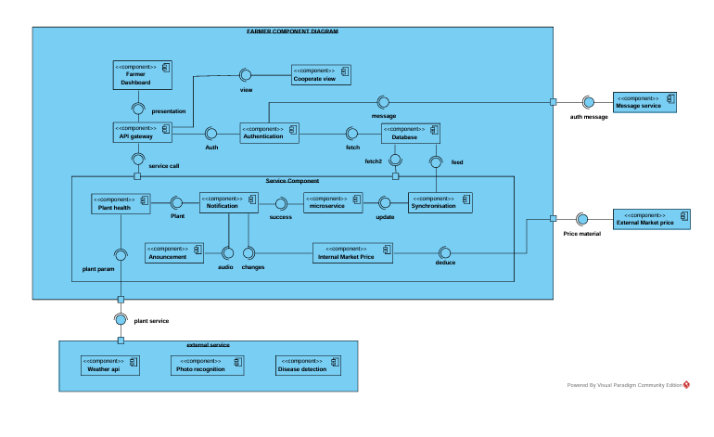

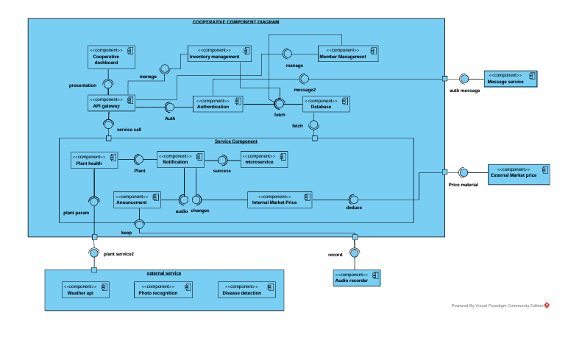

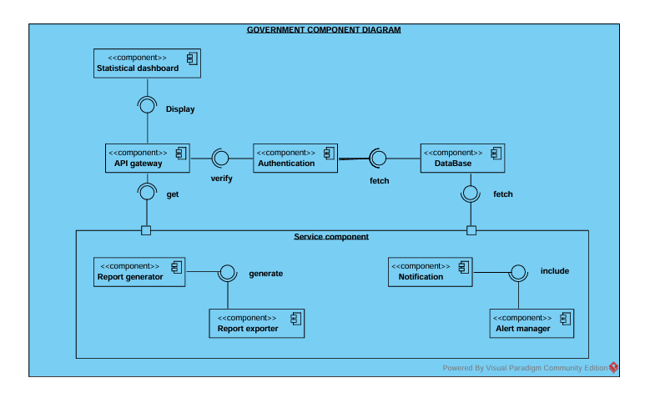

5.3. Deployment Diagram
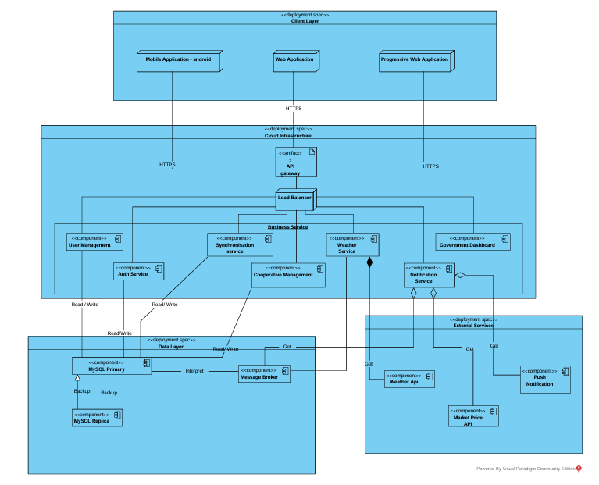

6. Detailed Design

6.1. Design Class Diagram

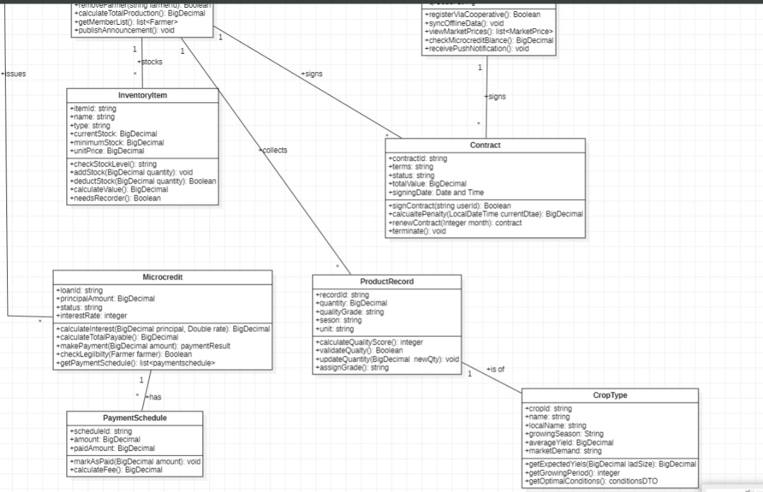6.2. Algorithms
Algorithm 1: Farmer Registration with QR Code & Offline Support
FUNCTION registerFarmer(registrationMethod, registrationData, preferredLanguage)
INPUT:
registrationMethod: String ["QR_SCAN", "MANUAL_CODE", "MANUAL_FORM"]
registrationData: Object [qrData or registrationCode or formData]
preferredLanguage: String [FR, EN, FUL, EWE, DUA]

OUTPUT: RegistrationResult {success: Boolean, farmerId: String, errorMessage: String}

BEGIN:
1. // Validate input parameters
2. IF registrationMethod NOT IN ["QR_SCAN", "MANUAL_CODE", "MANUAL_FORM"] THEN
3. RETURN {success: false, errorMessage: "Invalid registration method"}
4. END IF
5.
6. // Handle different registration methods
7. SWITCH (registrationMethod)
8. CASE "QR_SCAN":
9. qrResult = decodeQRCode(registrationData.qrData)
10. IF qrResult.status = "INVALID" THEN
11. playAudio("invalid_qr", preferredLanguage)
12. RETURN {success: false, errorMessage: "Invalid QR code format"}
13. END IF
14. registrationInfo = qrResult.data
15.
16. CASE "MANUAL_CODE":
17. IF registrationData.registrationCode.length < 6 OR
18. registrationData.registrationCode.length > 8 THEN
19. playAudio("invalid_code_length", preferredLanguage)
20. RETURN {success: false, errorMessage: "Registration code must be 6-8 digits"}
21. END IF
22. registrationInfo = {registrationNumber: registrationData.registrationCode}
23.
24. CASE "MANUAL_FORM":
25. IF validateFormData(registrationData.formData) = false THEN
26. RETURN {success: false, errorMessage: "Missing required form fields"}
27. END IF
28. registrationInfo = registrationData.formData
29. END SWITCH
30.
31. // Check network connectivity
32. IF isOnline() = true THEN
33. // Immediate server validation
34. validationResponse = POST /api/v1/cooperatives/validate-registration
35. WITH registrationInfo
36.
37. IF validationResponse.status = 200 THEN
38. cooperativeTemplate = validationResponse.data
39. farmerProfile = createFarmerProfile(registrationInfo, cooperativeTemplate)
40. saveToLocalDB(farmerProfile)
41. playAudio("registration_success", preferredLanguage)
42. RETURN {success: true, farmerId: farmerProfile.farmerId}
43. ELSE
44. playAudio("registration_failed", preferredLanguage)
45. RETURN {success: false, errorMessage: validationResponse.error}
46. END IF
47. ELSE
48. // Offline registration - queue for later sync
49. pendingRegistration = {
50. clientOutboxId: generateUUID(),
51. type: "FARMER_REGISTRATION",
52. payload: registrationInfo,
53. createdAt: currentTimestamp(),
54. attempts: 0
55. }
56. saveToOutbox(pendingRegistration)
57. playAudio("registration_queued", preferredLanguage)
58. RETURN {success: true, farmerId: "PENDING_" + pendingRegistration.clientOutboxId}
59. END IF
END FUNCTION
Algorithm 2: Offline Data Synchronization with Conflict Resolution
FUNCTION synchronizeOfflineData()
INPUT: None
OUTPUT: SyncResult {syncedItems: Integer, conflicts: Integer, errors: Integer}

BEGIN:
1. // Check prerequisites
2. IF isOnline() = false THEN
3. RETURN {syncedItems: 0, conflicts: 0, errors: 1,
4. error: "No network connectivity"}
5. END IF
6.
7. // Get pending actions from local outbox
8. pendingActions = SQLiteDB.outbox.getAllOrderedBy("createdAt", "ASC")
9. syncedItems = 0
10. conflicts = 0
11. errors = 0
12.
13. FOR EACH action IN pendingActions DO:
14. TRY:
15. // Prepare sync request
16. syncRequest = {
17. clientOutboxId: action.clientOutboxId,
18. actionType: action.type,
19. payload: action.payload,
20. deviceId: getDeviceId(),
21. timestamp: action.createdAt
22. }
23.
24. // Send to server
25. response = POST /api/v1/sync WITH syncRequest
26. TIMEOUT: 30000 // 30 seconds
27.
28. IF response.status = 200 THEN
29. // Success - remove from outbox and update local data
30. SQLiteDB.outbox.delete(action.clientOutboxId)
31. updateLocalData(response.data.updatedEntities)
32. syncedItems = syncedItems + 1
33.
34. ELSE IF response.status = 409 THEN
35. // Conflict detected - apply resolution rules
36. resolvedData = resolveDataConflict(
37. action.payload,
38. response.data.serverVersion,
39. action.type
40. )
41.
42. // Update server with resolved data
43. conflictResponse = POST /api/v1/sync/conflict-resolution
44. WITH resolvedData
45.
46. IF conflictResponse.status = 200 THEN
47. SQLiteDB.outbox.delete(action.clientOutboxId)
48. updateLocalData(conflictResponse.data)
49. conflicts = conflicts + 1
50. ELSE
51. THROW "Conflict resolution failed"
52. END IF
53.
54. ELSE
55. // Other error - increment attempt count
56. action.attempts = action.attempts + 1
57. action.lastError = response.error
58. action.lastAttempt = currentTimestamp()
59. SQLiteDB.outbox.update(action)
60.
61. IF action.attempts >= MAX_SYNC_ATTEMPTS THEN
62. moveToDeadLetterQueue(action)
63. END IF
64.
65. errors = errors + 1
66. END IF
67.
68. CATCH Exception AS e:
69. logError("Sync failed for " + action.clientOutboxId + ": " + e.message)
70. action.attempts = action.attempts + 1
71. action.lastError = e.message
72. SQLiteDB.outbox.update(action)
73. errors = errors + 1
74. END TRY
75. END FOR
76.
77. // Download latest server updates
78. IF syncedItems > 0 OR conflicts > 0 THEN
79. lastSyncTimestamp = getLastSyncTimestamp()
80. updates = GET /api/v1/sync/updates?since=lastSyncTimestamp
81.
82. IF updates.status = 200 THEN
83. FOR EACH entity IN updates.data DO:
84. saveOrUpdateLocalEntity(entity)
85. END FOR
86. setLastSyncTimestamp(currentTimestamp())
87. END IF
88. END IF
89.
90. RETURN {syncedItems: syncedItems, conflicts: conflicts, errors: errors}
END FUNCTION

FUNCTION resolveDataConflict(localData, serverData, dataType)
INPUT:
localData: Object - Local version of the data
serverData: Object - Server version of the data
dataType: String - Type of data for conflict resolution rules

OUTPUT: Object - Resolved data for server update

BEGIN:
1. SWITCH (dataType)
2. CASE "FINANCIAL_TRANSACTION":
3. CASE "LOAN_PAYMENT":
4. // Financial data: server always wins for audit integrity
5. RETURN serverData
6.
7. CASE "PRODUCTION_RECORD":
8. CASE "INVENTORY_UPDATE":
9. // Production data: merge and keep both with metadata
10. mergedData = {
11. ...serverData,
12. localVersion: localData,
13. conflictResolvedAt: currentTimestamp(),
14. resolutionMethod: "MERGE"
15. }
16. RETURN mergedData
17.
18. CASE "FARMER_PROFILE_UPDATE":
19. // Profile data: use most recent timestamp
20. IF localData.lastModified > serverData.lastModified THEN
21. resolvedData = {
22. ...localData,
23. conflictResolved: true,
24. previousServerVersion: serverData
25. }
26. ELSE
27. resolvedData = {
28. ...serverData,
29. conflictResolved: true,
30. previousLocalVersion: localData
31. }
32. END IF
33. RETURN resolvedData
34.
35. DEFAULT:
36. // Default: server wins
37. RETURN serverData
38. END SWITCH
END FUNCTION
Algorithm 3: Microcredit Eligibility Assessment & Loan Processing
FUNCTION assessCreditEligibility(farmerId, requestedLoanAmount)
INPUT:
farmerId: String - Unique farmer identifier
requestedLoanAmount: BigDecimal - Amount farmer wants to borrow

OUTPUT: EligibilityResult {
isEligible: Boolean,
creditScore: Integer (0-100),
maxLoanAmount: BigDecimal,
reasons: String[],
conditions: String[]
}

BEGIN:
1. // Initialize result structure
2. result = {
3. isEligible: false,
4. creditScore: 0,
5. maxLoanAmount: 0.00,
6. reasons: [],
7. conditions: []
8. }
9.
10. // 1. Check repayment history (40% of score)
11. repaymentHistory = getRepaymentHistory(farmerId, 12) // Last 12 months
12. totalPayments = length(repaymentHistory)
13. onTimePayments = countWhere(repaymentHistory, "status = 'ON_TIME'")
14. latePayments = countWhere(repaymentHistory, "status = 'LATE'")
15. defaultedPayments = countWhere(repaymentHistory, "status = 'DEFAULTED'")
16.
17. IF totalPayments = 0 THEN
18. repaymentRate = 1.0 // New farmer - assume good faith
19. ELSE
20. repaymentRate = (onTimePayments + (latePayments * 0.5)) / totalPayments
21. END IF
22.
23. repaymentScore = repaymentRate * 40
24.
25. // 2. Check production consistency (30% of score)
26. productionData = getProductionHistory(farmerId, 4) // Last 4 seasons
27. IF length(productionData) >= 2 THEN
28. avgProduction = average(productionData, "quantity")
29. productionVariance = variance(productionData, "quantity")
30. maxVariance = getMaxAllowedVariance(farmerId.cropType)
31.
32. IF productionVariance <= maxVariance THEN
33. productionScore = 30
34. ELSE IF productionVariance <= maxVariance * 1.5 THEN
35. productionScore = 20
36. ELSE
37. productionScore = 10
38. result.reasons.append("High production variance detected")
39. END IF
40. ELSE
41. productionScore = 15 // Insufficient data penalty
42. result.reasons.append("Insufficient production history")
43. END IF
44.
45. // 3. Check debt burden (30% of score)
46. currentDebt = getTotalOutstandingDebt(farmerId)
47. avgSeasonalIncome = calculateAverageIncome(farmerId, 2) // Last 2 seasons
48.
49. IF avgSeasonalIncome > 0 THEN
50. debtToIncomeRatio = currentDebt / avgSeasonalIncome
51. ELSE
52. debtToIncomeRatio = 999 // High penalty for no income
53. END IF
54.
55. IF debtToIncomeRatio <= 0.3 THEN
56. debtScore = 30
57. ELSE IF debtToIncomeRatio <= 0.5 THEN
58. debtScore = 20
59. ELSE IF debtToIncomeRatio <= 0.7 THEN
60. debtScore = 10
61. result.reasons.append("High existing debt burden")
62. ELSE
63. debtScore = 0
64. result.reasons.append("Debt-to-income ratio too high")
65. END IF
66.
67. // Calculate final score
68. result.creditScore = round(repaymentScore + productionScore + debtScore)
69.
70. // Determine eligibility
71. IF result.creditScore >= 70 THEN
72. result.isEligible = true
73.
74. // Calculate maximum loan amount based on score and income
75. baseMultiplier = 1.0
76. IF result.creditScore >= 90 THEN baseMultiplier = 1.5
77. ELSE IF result.creditScore >= 80 THEN baseMultiplier = 1.2
78. ELSE baseMultiplier = 1.0
79.
80. result.maxLoanAmount = min(
81. avgSeasonalIncome * 0.5 * baseMultiplier, // 50% of seasonal income
82. getCooperativeMaxLoanLimit(farmerId.cooperativeId)
83. )
84.
85. // Add conditions for high-risk borrowers
86. IF result.creditScore < 80 THEN
87. result.conditions.append("Requires co-signer from cooperative")
88. END IF
89. IF debtToIncomeRatio > 0.4 THEN
90. result.conditions.append("Staggered disbursement required")
91. END IF
92.
93. ELSE
94. result.isEligible = false
95. result.maxLoanAmount = 0.00
96. END IF
97.
98. RETURN result
END FUNCTION

FUNCTION generateRepaymentSchedule(principal, annualInterestRate, termMonths, disbursementDate)
INPUT:
principal: BigDecimal - Loan amount
annualInterestRate: BigDecimal - Annual interest rate (e.g., 0.12 for 12%)
termMonths: Integer - Loan duration in months
disbursementDate: Date - When loan is given to farmer

OUTPUT: List<RepaymentInstallment> - Monthly repayment schedule

BEGIN:
1. schedule = []
2. monthlyRate = annualInterestRate / 12.0
3. currentBalance = principal
4.
5. // Calculate monthly payment using amortization formula
6. IF monthlyRate = 0 THEN
7. monthlyPayment = principal / termMonths
8. ELSE
9. monthlyPayment = principal *
10. (monthlyRate * power(1 + monthlyRate, termMonths)) /
11. (power(1 + monthlyRate, termMonths) - 1)
12. END IF
13.
14. monthlyPayment = round(monthlyPayment, 2) // Round to 2 decimal places
15.
16. // Generate each installment
17. FOR month FROM 1 TO termMonths DO:
18. dueDate = addMonths(disbursementDate, month)
19.
20. // Skip if due date falls on weekend (move to next Monday)
21. WHILE isWeekend(dueDate) = true DO:
22. dueDate = addDays(dueDate, 1)
23. END WHILE
24.
25. interestAmount = round(currentBalance * monthlyRate, 2)
26. principalAmount = monthlyPayment - interestAmount
27.
28. // Ensure last payment adjusts for rounding errors
29. IF month = termMonths THEN
30. principalAmount = currentBalance
31. monthlyPayment = principalAmount + interestAmount
32. END IF
33.
34. currentBalance = round(currentBalance - principalAmount, 2)
35.
36. installment = {
37. installmentNumber: month,
38. dueDate: dueDate,
39. totalAmount: monthlyPayment,
40. principalAmount: principalAmount,
41. interestAmount: interestAmount,
42. remainingBalance: currentBalance,
43. status: "PENDING"
44. }
45.
46. schedule.append(installment)
47. END FOR
48.
49. RETURN schedule
END FUNCTION
Algorithm 4: Multilingual Audio Announcement Distribution System
FUNCTION distributeAudioAnnouncement(announcementId, targetCriteria)
INPUT:
announcementId: String - ID of the announcement to distribute
targetCriteria: Object - Filter criteria for target recipients
{
cooperativeIds: String[],
regions: String[],
cropTypes: String[],
farmerStatus: String[] // ["ACTIVE", "INACTIVE", "OVERDUE"]
}

OUTPUT: DistributionResult {
totalRecipients: Integer,
audioDeliveries: Integer,
smsFallbacks: Integer,
failedDeliveries: Integer,
deliveryId: String
}

BEGIN:
1. // Initialize result counters
2. result = {
3. totalRecipients: 0,
4. audioDeliveries: 0,
5. smsFallbacks: 0,
6. failedDeliveries: 0,
7. deliveryId: generateUUID()
8. }
9.
10. // 1. Retrieve announcement details
11. announcement = getAnnouncementById(announcementId)
12. IF announcement = null OR announcement.status != "APPROVED" THEN
13. THROW "Announcement not found or not approved"
14. END IF
15.
16. // 2. Identify target farmers based on criteria
17. targetFarmers = getFarmersByCriteria(targetCriteria)
18. result.totalRecipients = length(targetFarmers)
19.
20. // 3. Process each farmer
21. FOR EACH farmer IN targetFarmers DO:
22. TRY:
23. // Determine best available content for farmer's language
24. content = findBestContentForFarmer(announcement, farmer)
25.
26. IF content.audioUrl != null THEN
27. // Prefer audio delivery for app users
28. notification = {
29. farmerId: farmer.farmerId,
30. type: "AUDIO_ANNOUNCEMENT",
31. content: content.audioUrl,
32. language: farmer.preferredLanguage,
33. priority: announcement.priority,
34. deliveryChannel: "PUSH_NOTIFICATION",
35. expiresAt: addHours(currentTimestamp(), 24)
36. }
37.
38. queueNotification(notification)
39. result.audioDeliveries = result.audioDeliveries + 1
40.
41. ELSE IF content.text != null THEN
42. // Fallback to SMS for non-audio content
43. smsMessage = formatSMSMessage(content.text, farmer.preferredLanguage)
44.
45. IF length(smsMessage) <= 160 THEN
46. notification = {
47. farmerId: farmer.farmerId,
48. type: "TEXT_ANNOUNCEMENT",
49. content: smsMessage,
50. language: farmer.preferredLanguage,
51. priority: announcement.priority,
52. deliveryChannel: "SMS",
53. phoneNumber: farmer.phoneNumber
54. }
55.
56. queueNotification(notification)
57. result.smsFallbacks = result.smsFallbacks + 1
58. ELSE
59. // Message too long for SMS
60. logWarning("SMS too long for farmer: " + farmer.farmerId)
61. result.failedDeliveries = result.failedDeliveries + 1
62. END IF
63.
64. ELSE
65. // No content available for this farmer
66. logWarning("No content available for farmer: " + farmer.farmerId)
67. result.failedDeliveries = result.failedDeliveries + 1
68. END IF
69.
70. CATCH Exception AS e:
71. logError("Failed to queue notification for farmer: " + farmer.farmerId)
72. result.failedDeliveries = result.failedDeliveries + 1
73. END TRY
74. END FOR
75.
76. // 4. Log distribution results
77. distributionRecord = {
78. deliveryId: result.deliveryId,
79. announcementId: announcementId,
80. distributedAt: currentTimestamp(),
81. totalRecipients: result.totalRecipients,
82. audioDeliveries: result.audioDeliveries,
83. smsFallbacks: result.smsFallbacks,
84. failedDeliveries: result.failedDeliveries
85. }
86.
87. saveDistributionRecord(distributionRecord)
88. RETURN result
END FUNCTION

FUNCTION findBestContentForFarmer(announcement, farmer)
INPUT:
announcement: Object - Announcement with available translations
farmer: Object - Farmer details including preferred language

OUTPUT: ContentResult {audioUrl: String, text: String, language: String}

BEGIN:
1. preferredLanguage = farmer.preferredLanguage
2.
3. // 1. Try exact language match with audio
4. FOR EACH translation IN announcement.translations DO:
5. IF translation.language = preferredLanguage AND
6. translation.audioUrl != null AND
7. translation.status = "APPROVED" THEN
8. RETURN {
9. audioUrl: translation.audioUrl,
10. text: translation.text,
11. language: preferredLanguage
12. }
13. END IF
14. END FOR
15.
16. // 2. Try exact language match with text only
17. FOR EACH translation IN announcement.translations DO:
18. IF translation.language = preferredLanguage AND
19. translation.status = "APPROVED" THEN
20. RETURN {
21. audioUrl: null,
22. text: translation.text,
23. language: preferredLanguage
24. }
25. END IF
26. END FOR
27.
28. // 3. Fallback to cooperative default language with audio
29. defaultLanguage = getCooperativeDefaultLanguage(farmer.cooperativeId)
30. FOR EACH translation IN announcement.translations DO:
31. IF translation.language = defaultLanguage AND
32. translation.audioUrl != null AND
33. translation.status = "APPROVED" THEN
34. RETURN {
35. audioUrl: translation.audioUrl,
36. text: translation.text,
37. language: defaultLanguage
38. }
39. END IF
40. END FOR
41.
42. // 4. Fallback to announcement base language
43. FOR EACH translation IN announcement.translations DO:
44. IF translation.language = announcement.baseLanguage AND
45. translation.status = "APPROVED" THEN
46. RETURN {
47. audioUrl: translation.audioUrl,
48. text: translation.text,
49. language: announcement.baseLanguage
50. }
51. END IF
52. END FOR
53.
54. // 5. No suitable content found
55. RETURN {audioUrl: null, text: null, language: null}
END FUNCTION
Algorithm 5: Weather Data Processing & Alert System
FUNCTION processWeatherDataAndAlerts(weatherData, regions)
INPUT:
weatherData: Object - Raw weather data from meteorological service
regions: String[] - Affected regions

OUTPUT: AlertResult {alertsGenerated: Integer, farmersNotified: Integer}

BEGIN:
1. // Parse and validate incoming weather data
2. validatedData = validateWeatherData(weatherData)
3. IF validatedData.status = "INVALID" THEN
4. RETURN {alertsGenerated: 0, farmersNotified: 0, error: "Invalid weather data"}
5. END IF
6.
7. // Store weather data with timestamp
8. weatherRecord = {
9. data: validatedData,
10. receivedAt: currentTimestamp(),
11. regions: regions,
12. source: "METEO_SERVICE"
13. }
14. saveWeatherRecord(weatherRecord)
15.
16. // Analyze for severe conditions
17. alerts = []
18. FOR EACH region IN regions DO:
19. severity = analyzeWeatherSeverity(validatedData, region)
20. IF severity > "LOW" THEN
21. alert = createWeatherAlert(region, severity, validatedData)
22. alerts.append(alert)
23. END IF
24. END FOR
25.
26. // Notify affected farmers
27. totalNotified = 0
28. FOR EACH alert IN alerts DO:
29. farmers = getFarmersInRegion(alert.region)
30. FOR EACH farmer IN farmers DO:
31. notification = createWeatherNotification(farmer, alert)
32. queueNotification(notification)
33. totalNotified = totalNotified + 1
34. END FOR
35. END FOR
36.
37. RETURN {alertsGenerated: length(alerts), farmersNotified: totalNotified}
END FUNCTION
Algorithm 6: Market Price Analysis & Trend Detection
FUNCTION analyzeMarketPricesAndTrends(marketData, historicalDays)
INPUT:
marketData: Object[] - Current market prices
historicalDays: Integer - Days of history to analyze

OUTPUT: PriceAnalysisResult {trends: Object[], alerts: Object[]}

BEGIN:
1. trends = []
2. alerts = []
3.
4. FOR EACH commodity IN marketData DO:
5. // Get historical data for this commodity
6. history = getPriceHistory(commodity.id, historicalDays)
7.
8. // Calculate price trend
9. currentPrice = commodity.currentPrice
10. avgPrice7d = calculateAveragePrice(history, 7)
11. avgPrice30d = calculateAveragePrice(history, 30)
12.
13. // Detect significant changes
14. changeVs7d = ((currentPrice - avgPrice7d) / avgPrice7d) * 100
15. changeVs30d = ((currentPrice - avgPrice30d) / avgPrice30d) * 100
16.
17. trend = {
18. commodityId: commodity.id,
19. commodityName: commodity.name,
20. currentPrice: currentPrice,
21. change7d: changeVs7d,
22. change30d: changeVs30d,
23. trend: calculateTrendDirection(history),
24. confidence: calculateTrendConfidence(history)
25. }
26. trends.append(trend)
27.
28. // Generate alerts for significant changes
29. IF abs(changeVs7d) >= PRICE_CHANGE_THRESHOLD THEN
30. alert = {
31. type: "PRICE_ALERT",
32. commodity: commodity.name,
33. changePercentage: changeVs7d,
34. severity: calculateAlertSeverity(changeVs7d),
35. timestamp: currentTimestamp()
36. }
37. alerts.append(alert)
38. END IF
39. END FOR
40.
41. RETURN {trends: trends, alerts: alerts}
END FUNCTION
Algorithm 7: Disease Report Processing & Pattern Detection
FUNCTION processDiseaseReportAndDetectPatterns(reportData, farmerId)
INPUT:
reportData: Object - Disease report from farmer
farmerId: String - Reporting farmer ID

OUTPUT: ProcessingResult {reportId: String, patternsDetected: Integer}

BEGIN:
1. // Validate and store report
2. IF validateDiseaseReport(reportData) = false THEN
3. RETURN {reportId: null, patternsDetected: 0, error: "Invalid report data"}
4. END IF
5.
6. reportId = generateReportId()
7. diseaseReport = {
8. reportId: reportId,
9. farmerId: farmerId,
10. symptoms: reportData.symptoms,
11. cropType: reportData.cropType,
12. location: reportData.location,
13. photos: reportData.photos,
14. reportedAt: currentTimestamp(),
15. status: "PENDING_ANALYSIS"
16. }
17. saveDiseaseReport(diseaseReport)
18.
19. // Initial automated analysis
20. preliminaryDiagnosis = analyzeSymptoms(reportData.symptoms, reportData.cropType)
21. IF preliminaryDiagnosis.confidence > 0.7 THEN
22. updateReportDiagnosis(reportId, preliminaryDiagnosis)
23. END IF
24.
25. // Check for regional patterns
26. similarReports = findSimilarReportsInRegion(
27. reportData.location,
28. reportData.cropType,
29. reportData.symptoms,
30. 50 // km radius
31. )
32.
33. patternsDetected = 0
34. IF length(similarReports) >= OUTBREAK_THRESHOLD THEN
35. // Potential outbreak detected
36. createOutbreakAlert(reportData.location, reportData.cropType, similarReports)
37. patternsDetected = length(similarReports)
38.
39. // Notify agricultural extension officers
40. officers = getExtensionOfficersInRegion(reportData.location)
41. FOR EACH officer IN officers DO:
42. sendOfficerAlert(officer, diseaseReport, similarReports)
43. END FOR
44. END IF
45.
46. // Notify cooperative managers
47. cooperativeId = getFarmerCooperative(farmerId)
48. managers = getCooperativeManagers(cooperativeId)
49. FOR EACH manager IN managers DO:
50. sendManagerNotification(manager, diseaseReport)
51. END FOR
52.
53. RETURN {reportId: reportId, patternsDetected: patternsDetected}
END FUNCTION
Algorithm 8: Inventory Management & Reorder System
FUNCTION manageInventoryAndReorder(inventoryItemId, adjustment)
INPUT:
inventoryItemId: String - ID of inventory item
adjustment: Object {quantity: Double, unit: String, reason: String}

OUTPUT: InventoryResult {newStock: Double, reorderSuggested: Boolean}

BEGIN:
1. // Get current inventory item
2. item = getInventoryItem(inventoryItemId)
3. IF item = null THEN
4. RETURN {error: "Inventory item not found"}
5. END IF
6.
7. // Convert adjustment to standard units
8. adjustedQuantity = convertToStandardUnits(adjustment.quantity, adjustment.unit, item)
9.
10. // Update stock level
11. oldStock = item.currentStock
12. item.currentStock = oldStock + adjustedQuantity
13. item.lastUpdated = currentTimestamp()
14.
15. // Record movement for audit
16. movementRecord = {
17. itemId: inventoryItemId,
18. oldStock: oldStock,
19. adjustment: adjustedQuantity,
20. newStock: item.currentStock,
21. reason: adjustment.reason,
22. timestamp: currentTimestamp()
23. }
24. saveStockMovement(movementRecord)
25.
26. // Check stock levels and trigger alerts
27. reorderSuggested = false
28. IF item.currentStock <= item.reorderPoint THEN
29. severity = calculateStockSeverity(item)
30. triggerLowStockAlert(item, severity)
31.
32. IF item.currentStock <= item.criticalStock THEN
33. triggerCriticalStockAlert(item)
34. END IF
35.
36. reorderSuggested = true
37. END IF
38.
39. // Calculate and suggest reorder quantity if needed
40. IF reorderSuggested = true THEN
41. suggestion = calculateReorderSuggestion(item)
42. saveReorderSuggestion(item.id, suggestion)
43. END IF
44.
45. // Update inventory record
46. updateInventoryItem(item)
47.
48. RETURN {
49. newStock: item.currentStock,
50. reorderSuggested: reorderSuggested,
51. suggestion: suggestion
52. }
END FUNCTION
Algorithm 9: Government Statistics Aggregation
text
FUNCTION aggregateGovernmentStatistics(timePeriod, regions, aggregationLevel)
INPUT:
timePeriod: Object {startDate: Date, endDate: Date}
regions: String[] - Regions to include
aggregationLevel: String ["NATIONAL", "REGIONAL", "DISTRICT"]

OUTPUT: StatisticsReport {summary: Object, details: Object[], exports: Object}

BEGIN:
1. report = initializeReport(timePeriod, regions, aggregationLevel)
2.
3. // Aggregate production data
4. productionData = aggregateProductionData(timePeriod, regions, aggregationLevel)
5. report.summary.totalProduction = productionData.total
6. report.summary.productionByCrop = productionData.byCrop
7. report.summary.averageYield = productionData.averageYield
8.
9. // Aggregate farmer data
10. farmerData = aggregateFarmerData(timePeriod, regions)
11. report.summary.activeFarmers = farmerData.activeCount
12. report.summary.farmerGrowth = farmerData.growthRate
13. report.summary.cooperativeCount = farmerData.cooperativeCount
14.
15. // Aggregate financial data
16. financialData = aggregateFinancialData(timePeriod, regions)
17. report.summary.totalLoansDisbursed = financialData.loansDisbursed
18. report.summary.repaymentRate = financialData.repaymentRate
19. report.summary.defaultRate = financialData.defaultRate
20.
21. // Calculate trends and comparisons
22. previousPeriod = getPreviousPeriod(timePeriod)
23. previousData = aggregateDataForPeriod(previousPeriod, regions, aggregationLevel)
24. report.summary.periodComparison = comparePeriods(report.summary, previousData)
25.
26. // Generate detailed breakdowns
27. report.details = generateDetailedBreakdowns(productionData, farmerData, financialData)
28.
29. // Prepare export files
30. report.exports = {
31. excelFile: generateExcelExport(report),
32. pdfReport: generatePDFReport(report),
33. jsonData: generateJSONData(report)
34. }
35.
36. // Store report for historical reference
37. saveStatisticsReport(report)
38.
39. RETURN report
END FUNCTION
Algorithm 10: Data Backup & Recovery System
FUNCTION executeScheduledBackup(backupType, retentionPolicy)
INPUT:
backupType: String ["FULL", "INCREMENTAL", "DIFFERENTIAL"]
retentionPolicy: Object {keepDays: Integer, maxBackups: Integer}

OUTPUT: BackupResult {success: Boolean, backupId: String, size: Long}

BEGIN:
1. backupId = generateBackupId()
2. timestamp = currentTimestamp()
3.
4. TRY:
5. // 1. Database backup
6. dbBackup = executeDatabaseBackup(backupType)
7. IF dbBackup.status != "SUCCESS" THEN
8. THROW "Database backup failed: " + dbBackup.error
9. END IF
10.
11. // 2. File storage backup (audio files, photos)
12. fileBackup = executeFileStorageBackup()
13. IF fileBackup.status != "SUCCESS" THEN
14. THROW "File backup failed: " + fileBackup.error
15. END IF
16.
17. // 3. Configuration backup
18. configBackup = backupSystemConfigurations()
19.
20. // 4. Create backup manifest
21. manifest = {
22. backupId: backupId,
23. timestamp: timestamp,
24. type: backupType,
25. components: {
26. database: dbBackup,
27. files: fileBackup,
28. config: configBackup
29. },
30. checksum: calculateBackupChecksum(dbBackup, fileBackup, configBackup)
31. }
32.
33. // 5. Store backup metadata
34. saveBackupManifest(manifest)
35.
36. // 6. Apply retention policy
37. cleanupOldBackups(retentionPolicy)
38.
39. RETURN {
40. success: true,
41. backupId: backupId,
42. size: dbBackup.size + fileBackup.size,
43. timestamp: timestamp
44. }
45.
46. CATCH Exception AS e:
47. logError("Backup failed: " + e.message)
48. sendBackupFailureAlert(e.message)
49. RETURN {
50. success: false,
51. backupId: backupId,
52. error: e.message
53. }
54. END TRY
END FUNCTION

6.3. Application Theme
This section defines the core visual identity for the platform's user interfaces. The design is built for utility and clarity, directly supporting the operational workflows of cooperative managers and government officials. Every visual choice is justified by the need to present complex agricultural data efficiently and without ambiguity.
Logo
The platform identity is built around the AgriBind wordmark. The name reflects the system's core function of binding together farmers, cooperatives, and government agencies into a single, coordinated network. For application headers and navigation bars, a compact version of the wordmark is used to conserve space for critical data and controls.
Main Colors
The color scheme is selected for functional communication first, with a secondary role in branding. It ensures WCAG 2.1 AA compliance for accessibility and uses semantic coloring to convey status and priority at a glance.
- Primary Colors:
  - #2A6D38 (Agri-Green): The primary brand color. Applied to primary action buttons, active navigation states, and key positive metrics. It signifies affirmation, growth, and active processes.
  - #4CAF50 (Success Green): Used exclusively for positive indicators: upward trends (MoM growth), successful completion states, and high-quality statuses.
- Neutral & Structural Colors:
  - #333333 (Text Primary): The default color for all body text and data points, ensuring maximum legibility.
  - #666666 (Text Secondary): Used for labels, captions, placeholder text, and non-critical information.
  - #E0E0E0 (UI Border): The standard color for borders, table rules, and component strokes.
  - #F5F5F5 (App Background): The main canvas color for the application, reducing eye strain.
  - #FFFFFF (Surface): Used for the background of cards, input fields, and modal dialogs.
- Semantic Feedback Colors:
  - #FF9800 (Warning): Indicates medium-priority issues requiring attention, such as "Low Stock" alerts or "Medium Risk" loans.
  - #D32F2F (Critical): Reserved for high-priority alerts, errors, "High Risk" statuses, and critical system warnings that demand immediate action.
  - #2196F3 (Interactive): Applied to hyperlinks, interactive icons, and secondary information accents to distinguish them from primary actions.
  - #388E3C (System OK): Confirms positive system status, such as "Online" indicators and successful operational checks.
Design of UI Components
The component library is engineered for consistency and efficiency across the dashboard and management portals.
- Application Framework:
  - A fixed, vertical sidebar provides persistent access to the seven core modules (Members, Production, Inventory, etc.).
  - A top app bar contains the global search function, contextual user info (Emmanuel Njoya Manager), and the language selector (Français).
  - Content is organized into discrete cards with subtle shadows or borders, grouping related data and functions.
- Data Presentation:
  - KPI Cards: Display a large, bold value (e.g., 245 Active Members) with a concise label and a trend indicator (e.g., + 1,358 MoM colored semantically).
  - Charts: Utilize a minimal style with clear axis labels. The color palette is applied consistently across chart types—line graphs for trends, bar charts for comparisons, and donut charts for composition (e.g., "Stock Composition Analysis").
  - Progress Indicators: Horizontal bars visually represent completion, such as loan repayment. The filled portion uses #4CAF50.
- Interactive Controls:
  - Primary Button: Solid #2A6D38 background, white text, rounded corners. Used for principal actions like "Generate Full Report" and "New Audio Announcement."
  - Secondary Button: Outlined with a #2A6D38 border and same-colored text. Used for alternative actions.
  - Table Design: Features a clean, zebra-striped layout for scannability. Status badges (e.g., "Low Risk," "High Risk") are color-coded pills for instant recognition.
  - Filters & Search: Dropdown filters ("Loan Status," "Risk Level") and the search input ("Search by loan ID, member...") use a standard, minimal form control style.

Mockups of main interfaces
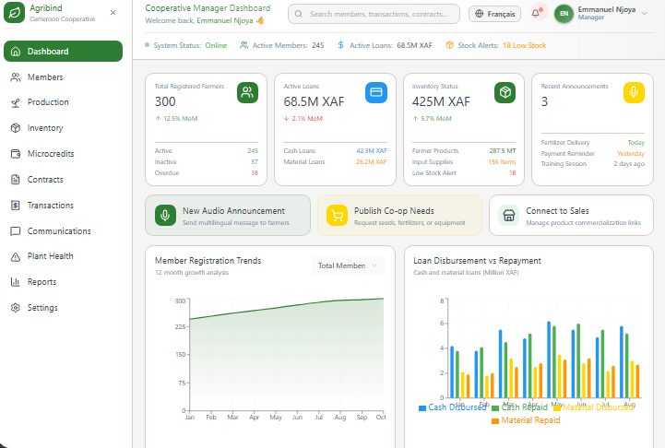
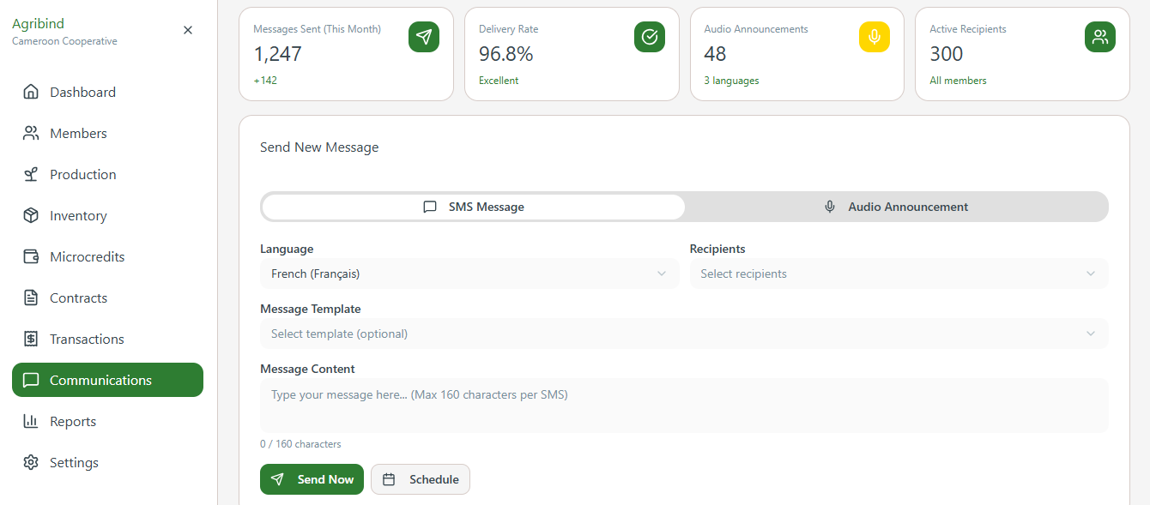

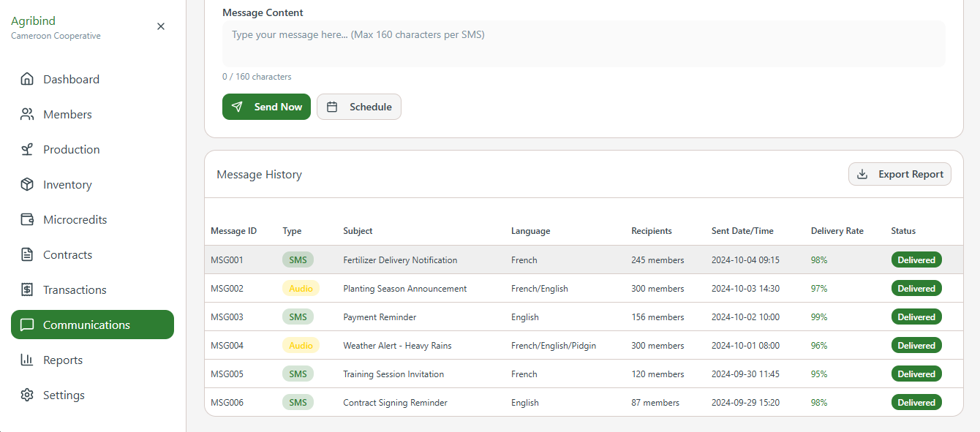

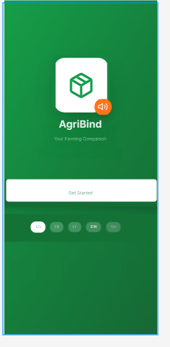


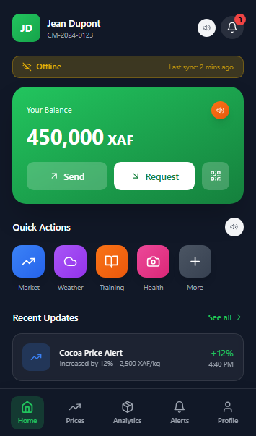
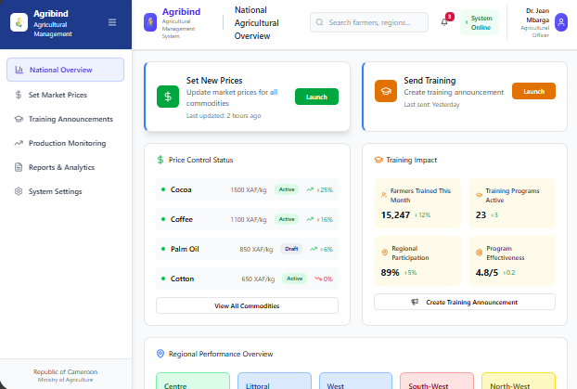
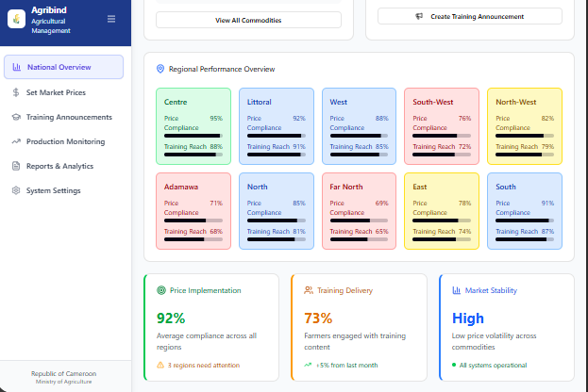

7.Conclusion
This document provides a complete technical blueprint for the agricultural platform, translating our analysis into a practical, implementable design. The chosen architecture—an offline-first mobile application supported by a microservices backend—directly addresses our core constraints of limited connectivity, low-literacy users, and regulatory requirements.
The detailed specifications for the seven modules, key algorithms, and technology stack offer a clear roadmap for development. By adhering to established engineering standards, we ensure the resulting system will be robust, secure, and maintainable. This design document thus serves as the definitive foundation for building a functional and impactful platform for our target users.

