Lorenz Allen M. Biscocho
IT2B
CLASS DIAGRAM
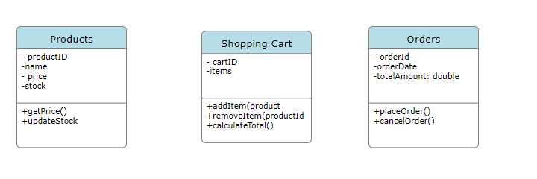

Relationships
