**Microprocessor Lab**

Laboratory Activity No. 1

**Familiarization with TinkerCAD**

|  |
| --- |
|  |

Score

*Submitted by:*

**Magnabihon,Michael Lorenz.**

**<10:00 AM – 1:00 PM (Saturday)> / <20231 – CPE 0412.1-1>**

*Date Submitted*

**16-09-2023**

*Submitted to:*

**Engr. Maria Rizette H. Sayo**

1. Exercise

a. A process in Tinkercad where we can develop electronic circuits that can be quickly updated, modified and tested is called **SIMULATING/SIMULATION**.

b. In Tinkercad, **DESIGN AND SIMULATION** tests the working of the circuits and the components.

c. The device used to assemble and connect the various components is known as **BREADBOARD**.

d. In an electronic circuit with LED, the positive end of the circuit should be connected to

**ANODE** and negative end should be connected to **CATHODE** of the LED.

e. A **RESISTOR** is used to restrict the flow of current to electrical components

2. Label the following:



1. Anode and Cathode in a LED **ANODE**
2. Different parts of breadboard

**CATHODE**

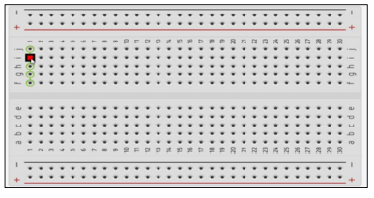

**EDGE**

**MAIN**

**AREA**

**EDGE**

1. List the electronic components used in a circuit assembly
2. Crystal Oscillator
3. Sensor
4. Fuse
5. Switching Power Supply
6. Reliable Wire and Cables
7. Integrated Circuit (IC) package
8. Relay
9. Resistor Network
10. Potentiometer
11. Switch
12. Connector
13. Battery
14. Voltage Regulator
15. Transformer
16. Resistor
17. Capacitor
18. Inductor
19. Diode
20. Transistor
21. LED (Light Emitting Diode)