**Microprocessor Lab**

Laboratory Activity No. 2

**Arduino and Tinkercad Interface**

|  |
| --- |
|  |

Score

*Submitted by:*

**Magnabihon, Michael Lorenz M.**

**Saturday 10:00am-1:00pm / CPE 0412.1-1**

*Date Submitted*

**30-09-2023**

*Submitted to:*

**Engr. Maria Rizette H. Sayo**

I. Objectives

This laboratory activity aims to implement the principles and techniques of hardware programming using Arduino through:

- creating an Arduino programming and circuit diagram.

II. Method/s

- Perform a task problem given in the presentation.

- Write a code and perform an Arduino circuit diagram of a ring counter that display

eight (8)LEDs starting from left.

III. Results

**TinkerCad**

**Exercise 1: Write a code that does a ring counter display for eight (8) LEDs starting from left.**

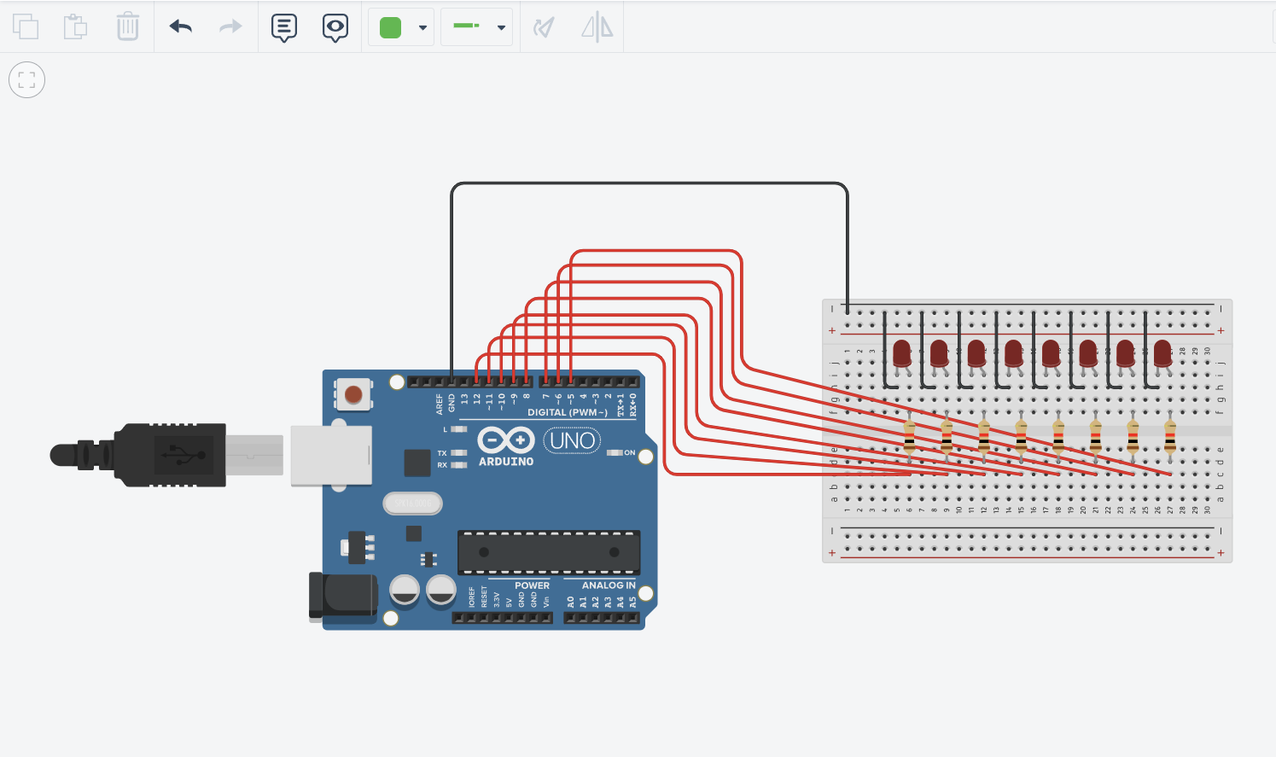

Figure No.1 Ring Counter Display Circuit Diagram

**Components Used**

1. 8 LEDs
2. Resistor
3. Breadboard

**CODE:**

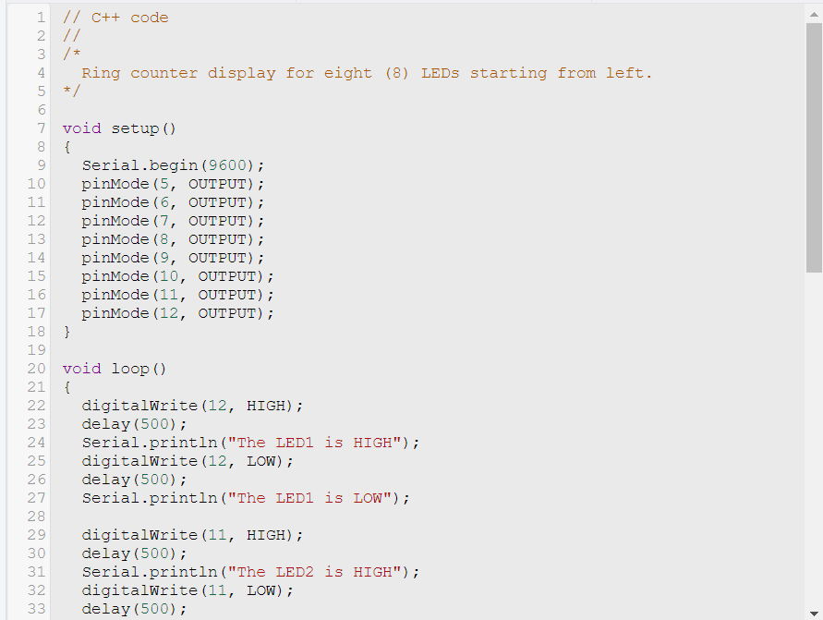

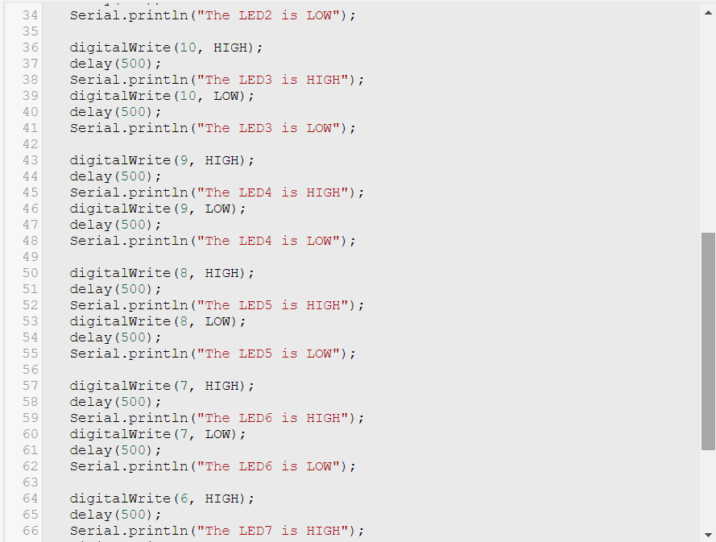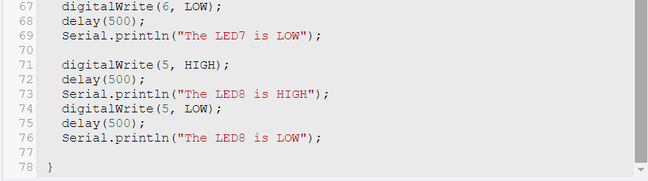

IV. Conclusion

In conclusion, this activity thought us how to make a circuit diagram that displays Ring Counter. We wrote Arduino code to control the LEDs in a ring counter pattern. The program turned off all LEDs, then sequentially turned on each LED from left to right, creating a continuous looping effect. A delay was included to control the speed of the display, making it visually appealing.

This project served as an excellent demonstration of hardware programming principles using Arduino. It showcased how to interface with hardware components, manipulate digital pins, and create dynamic lighting patterns. It's a fundamental example for beginners in electronics and programming, providing a solid foundation for more advanced projects in the future.

By successfully implementing this ring counter display, we have gained hands-on experience in combining hardware and software to achieve a specific objective, which is a crucial skill in the field of electronics and embedded systems development. This project can be a starting point for exploring more complex applications and innovations in the world of Arduino-based projects.

**References**

[1] D.J.D. Sayo. “University of the City of Manila Computer Engineering Department Honor Code,” PLM-CpE Departmental Policies, 2020.

*<This is in a separate page>*