**Initial project pitch**

prepared for CLIENT XXX (let us know who your client is!)  
prepared by TEAM NAME

|  |  |
| --- | --- |
| Team members | Lorenzo Yizhou Lu |
|  |  |
|  |  |

**Problem description**  
Brief description of the problem setup. What is the problem you are trying to solve? Give an overview of the background of the problem and the question you are trying to answer.

[](https://www.medicalnewstoday.com/articles/234614#1)

The live capture of tumor tissues remains a very important question to cancer surgery, where surgeons are still looking for safe and high-resolution approaches. The Fluorescence Lifetime Hyper-spectrum would be a powerful candidate tool helping the surgeons decide if there is a tumor. However, capturing this 5-D spectrum could be very time-consuming and we would only concern the location and size of a tumor. Or in the other word, we don’t need to see if it is smooth or not at its surface. So, the question is if there is a way to capture an image with fewer measurements but can still tell us the size and location of a tumor. Our answer is yes if we use Compressed Sensing.

What is the decision you are trying to make? What are the decision variables, what is your objective and what are your constraints? You can describe this in words, but you can also use mathematical symbols and equations if that is useful.



The decision is to reconstruct an image with 20% of measurements (for example). If you have 100*100 pixels, you may have to measure 10000 times by Raster Scan. But we just want to measure 2000 times and make the image. This figure shows exactly how compressed sensing works. The **decision variable** is α, the coefficients vector in DCT (discrete cosine transformation domain). The Ψ is the vectors in DCT domain, and Φ is the measurement matrix, and y is the measured values.

The **constraint** is, Φ only has 0 and 1 as elements. It describes the process where we collect the data from part of an image. If the element is 1, it means we measure the pixel at corresponding location.

The objective is to minimize:

We choose L1 norm to make the decision variable as sparse as possible.

The reconstructed image can be expressed as Ψα.

How large is this problem? What is the approximate count of decision variables and constraints?

The number of decision variables is about the number of pixels you want to reconstruct, or how many elements in the measurement matrix. We just have one constraint.

Your problem will likely require that you gather some data. Where will your data come from? How much data do you need?

This data can be a medical image, or any other images. Also, I am trying to set up a digital mirror device and photon counter in my lab. We may be able to analyze real life images soon.

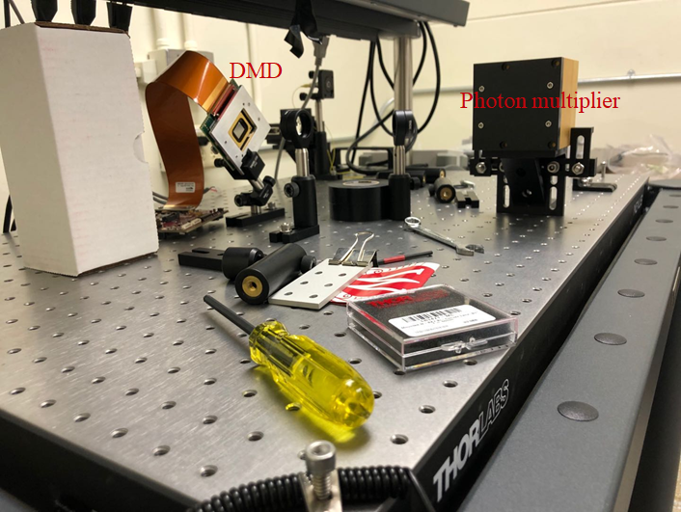

SOME THINGS TO CONSIDER:

1. Your problem does not have to be a linear program (LP). It can also include non-linear constraints or integer variables. However, try to avoid BOTH non-linear constraints and integer variables, as such problems are often very, very hard to solve computationally (we will learn more about this!). There is no bonus for complicated mathematical models – an interesting problem that can be modelled as an LP is the best kind of problem!
2. When you are thinking about analyzing and interpreting the solutions, try to think about how you can utilize concepts from class such as duality (for example for sensitivity analysis).