Manuel Peracci 10824742

Lorenzo Poletti 10825663

Project: Smart Bracelets

**Introduction**

We developed the Smart Bracelets project using TinyOs and Cooja.

**Assumptions**

* The keys used are statics and they are embedded, so we supposed that these bracelets are sold only in couples.
* We assumed that the alarms are printfs that may be triggered by different mechanisms and they are printed only on the parents’ bracelets.
* The alarm for MISSING child is repeated every minute in which the child is missing.
* The key is passed in clear.

**Approaches**

Our team decided that to divide the work in three different files:

1. BraceletAPP.nc, containing the components
2. BraceletC.nc, containing the implementation
3. Bracelet.h, which is the header file

We also decided to develop the code for all the 4 devices in the file BraceletC.nc.

First of all, the pairing phase which is entirely developed inside the receive event and it works in the following way:

* All the devices send a broadcast packet to the other nearby bracelets, specifying the packet type BROADCAST_PAIRING, its key and its ID;
* The bracelets receive the packets and check the type of packets, which must be BROADCAST_PAIRING;
* If the previous check is done successfully, then the receiver bracelet also checks the key.

If the key is the same, then the receiver bracelet will save the received key and the ID of the sender, then it will send a unicast packet to the sender, specifying the type UNICAST_PAIRING, its key and its ID. Otherwise, the receiver bracelet won’t do anything.

If it is the CHILD, it will start the CHILDTIMER for the future INFO packets. While if it is the PARENT, it will start the PARENTTIMER for the eventual MISSING CHILD alarm.

* If the previous unicast packet is correctly sent, then the first sender will receive the packet and it will check the key. If it is the same, it will save the received key and the ID of the sender.

If it is the CHILD, it will start the CHILDTIMER for the future INFO packets. While if it is the PARENT, it will start the PARENTTIMER for the eventual MISSING CHILD alarm.

* Starting from now they are paired on both sides.

About the INFO:

* The CHILDTIMER will fire every 10 seconds and it compute the status of the child and its position (posX and posY) according to the instructions;
* When the timer fires, a unicast packet is sent to the PARENT with all the previous information.

Notice that a different struct is used. Check Bracelet.h for more details. The idea behind using different structs is that we want to have the least amount of fields.

About the Alarms:

* The MISSING CHILD alarm is printed when the PARENTTIMER fires. This timer fires every 60 seconds, but it is restarted every time the PARENT receives an INFO message from the CHILD.
* The FALLING alarm is printed after receiving the INFO message with status “FALLING”.

**Other**

In the log.txt file at 04:20:00 (more or less), we moved the CHILD far away from the PARENT on Cooja.

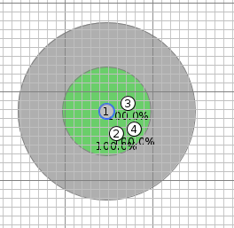

Figure Initial situation

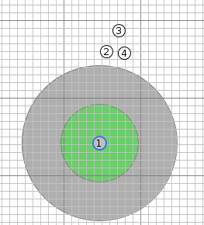

Figure MISSING CHILD case