Fund FactSheet

[Fondo Crescita Futura]

Brief Description: A diversified fund aimed at maximizing returns by investing in sectors with high growth potential, taking into account future market trends.

Investment Strategy: The fund will adopt a growth-oriented investment strategy, focusing on companies and sectors expected to grow at a higher-than-average rate compared to other market assets. The fund will primarily invest in equities, with a particular focus on the technology and renewable energy sectors.

Ideal Investor Profile: This fund is ideal for investors with a high tolerance for risk who are seeking long-term capital appreciation. Investors should be comfortable with market volatility and willing to invest for a period of 5+ years.

Fund Details:

Manager: Team Crescita Futura

Launch Date: July 27, 2023

Size: €30.0 million

Benchmark:

The MSCI World Growth Index is the benchmark for this fund. The MSCI World Growth Index is a free float-adjusted market capitalization weighted index that is designed to measure the equity market performance of developed markets. The index is made up of stocks from the MSCI World Index that have high growth characteristics, based on long-term forward EPS growth rate, short-term forward EPS growth rate, current internal growth rate, and long-term historical EPS growth trend.

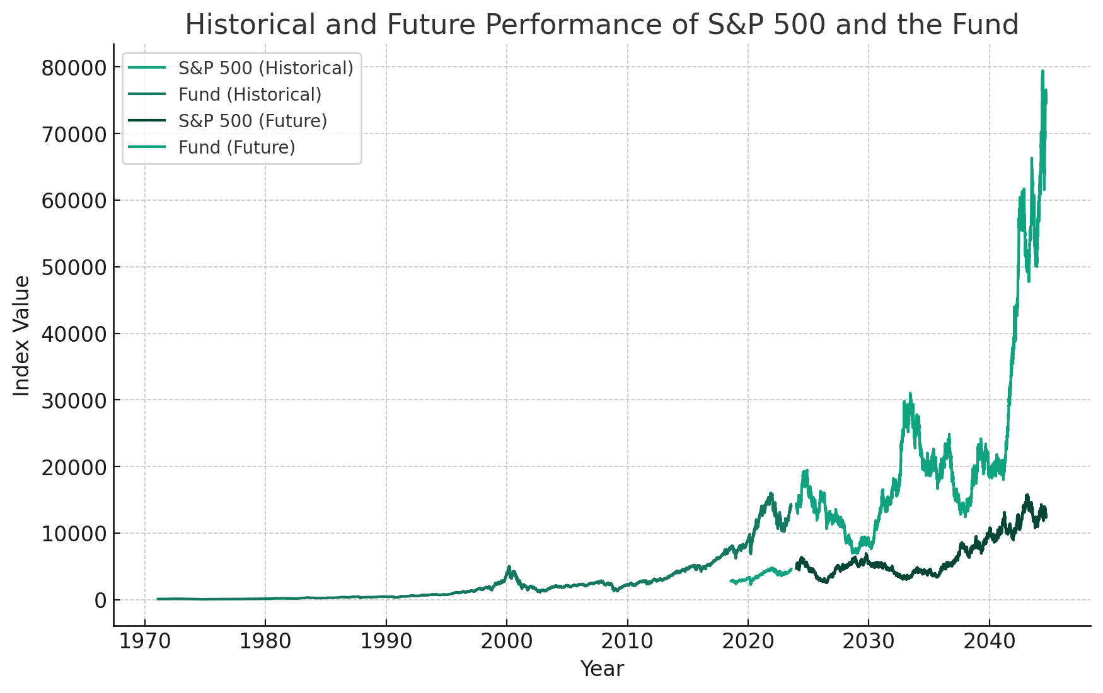

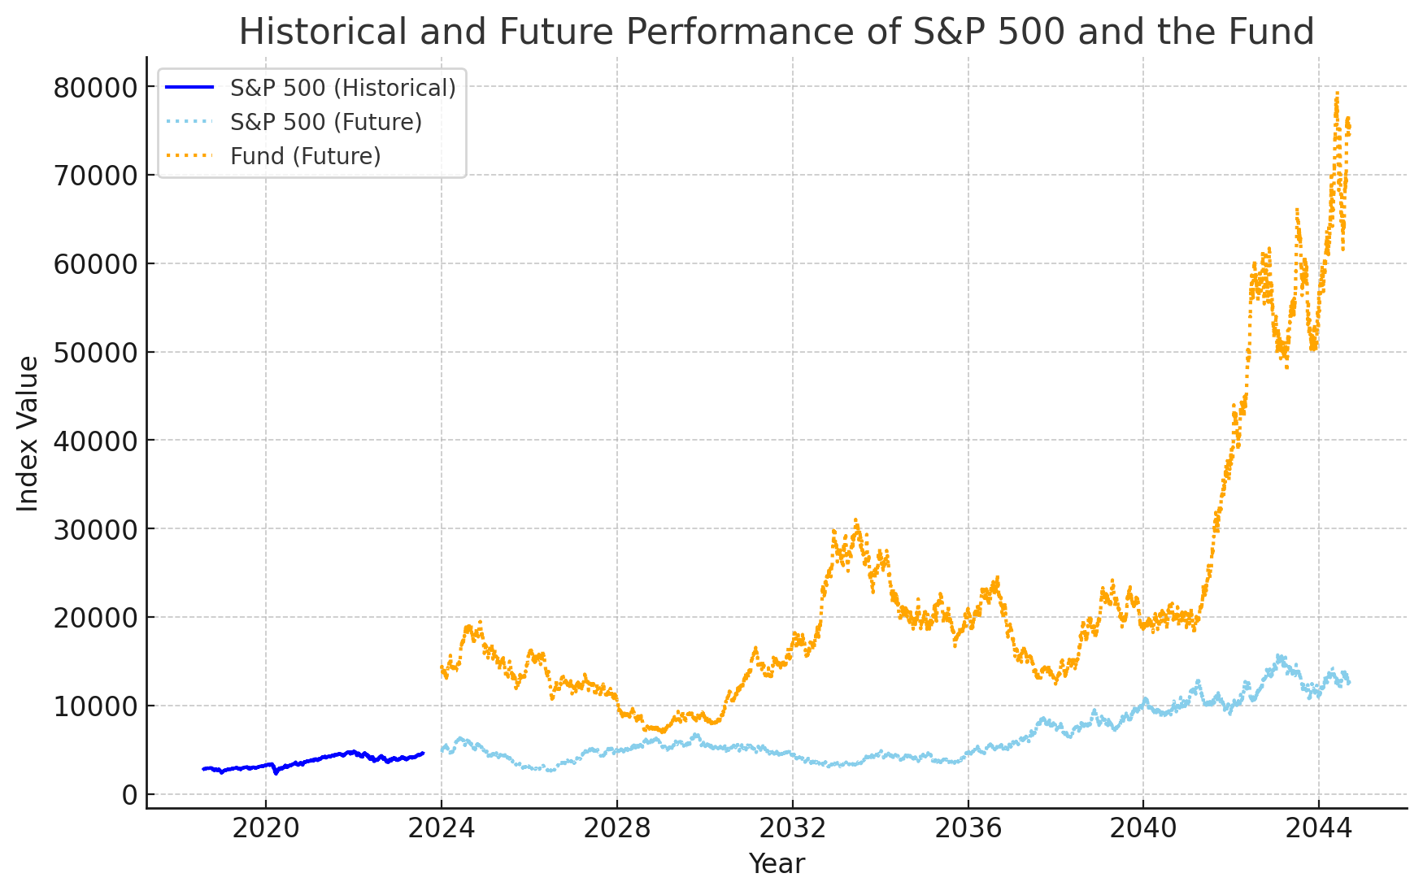

Annual Fees: 1.5%

Fund Composition:

Geographic Allocation: 50% North America, 30% Europe, 20% Asia

Sector Allocation: 40% Technology, 30% Renewable Energy, 20% Healthcare, 10% Other

Key Investments: TechGrow Inc., SolarWind Ltd., HealthRise Corp.

Performance Analysis: The historical performance of key investments shows steady growth over the past five years. The fund aims to capitalize on this growth trend.

Manager Comments:

Investment Ideas: The fund's investment decisions are based on the belief in the continued growth of the technology and renewable energy sectors, driven by digital transformation and the global shift towards sustainable energy.

Asset Allocation and Selection: The fund's asset allocation strategy is designed to maximize growth potential while managing risk. Asset selection is based on rigorous analysis of company fundamentals, sector trends, and macroeconomic factors.

Market Facts: In the past six months, significant events such as advancements in AI technology and the increased global emphasis on climate change have reinforced our investment strategy.

Forecasts: We anticipate continued growth in chosen sectors due to ongoing technological innovation and increasing demand for renewable energy.

ESG Factors: The fund considers ESG factors in its investment decisions, with a focus on companies that demonstrate strong environmental practices and good corporate governance.

Other Considerations: The fund's strategy may involve higher volatility and risk compared to market averages. However, it offers the potential for significant long-term returns for patient investors.