Scenario 1
Backbones | Baseline | Split | threshold
Omnivore | V1: MLP | step | 0.6

python -m core.evaluate --variant MLP --backbone omnivore --modality video --ckpt data/checkpoints/omnivore/MLP/error_recognition_MLP_omnivore_step_epoch_43.pt --split step --threshold 0.6

Result:
test Sub Step Level Metrics:
{
'precision': 0.4096162736939436,
'recall': 0.2989708115404083,
'f1': 0.3456549302643129,
'accuracy': 0.6831416629277163,
'auc': 0.6541560462689701,
'pr_auc': tensor(0.3187)
}

test Step Level Metrics:
{
'precision': 0.6607142857142857,
'recall': 0.14859437751004015,
'f1': 0.24262295081967214,
'accuracy': 0.7105263157894737,
'auc': 0.7573902166041213,
'pr_auc': tensor(0.3638)
}
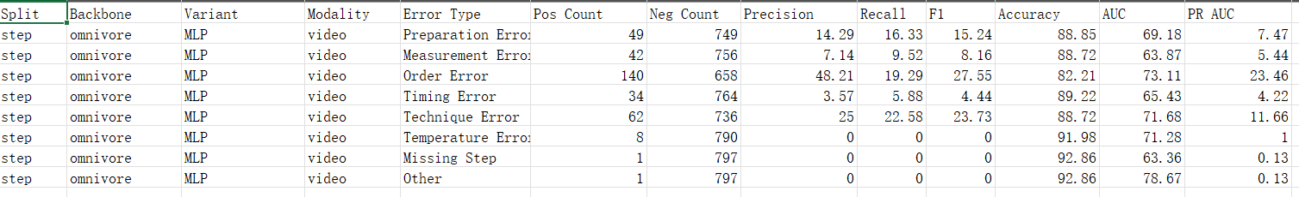

Scenario 2
Backbones | Baseline | Split | threshold
Omnivore | V1: MLP | recordings | 0.4

python -m core.evaluate --variant MLP --backbone omnivore --modality video --ckpt data/checkpoints/omnivore/MLP/error_recognition_MLP_omnivore_recordings_epoch_33.pt --split recordings --threshold 0.4

test Sub Step Level Metrics:
{
'precision': 0.3964945261528254,
'recall': 0.5688109780280797,
'f1': 0.46727266803505685,
'accuracy': 0.5735263432446531,
'auc': 0.5988330671714146,
'pr_auc': tensor(0.3673)
}
test Step Level Metrics:
{
'precision': 0.4090909090909091,
'recall': 0.8589211618257261,
'f1': 0.5542168674698795,
'accuracy': 0.503725782414307,
'auc': 0.6302808067162018,
'pr_auc': tensor(0.4020)
}
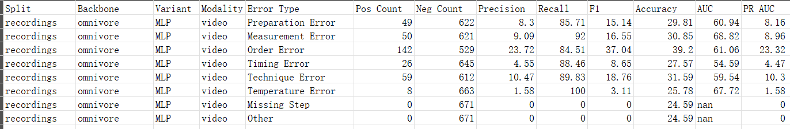
Scenario 3
Backbones | Baseline | Split | threshold
Omnivore | V2: Transf | step | 0.6

python -m core.evaluate --variant Transformer --backbone omnivore --modality video --ckpt data/checkpoints/omnivore/Transformer/error_recognition_Transformer_omnivore_step_epoch_9.pt --split step --threshold 0.6

test Sub Step Level Metrics:
{
'precision': 0.4445452483556362,
'recall': 0.6613801248523705,
'f1': 0.5317056629365887,
'accuracy': 0.6738848088412402,
'auc': 0.7461755197865861,
'pr_auc': tensor(0.3888)
}
test Step Level Metrics:
{
'precision': 0.5155709342560554,
'recall': 0.5983935742971888,
'f1': 0.5539033457249071,
'accuracy': 0.6992481203007519,
'auc': 0.7561832027563805,
'pr_auc': tensor(0.4338)
}
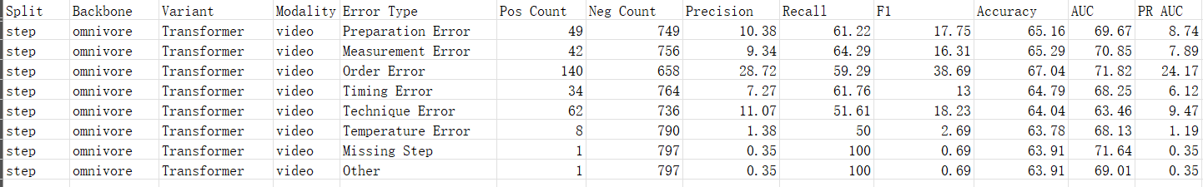
Scenario 4
Backbones | Baseline | Split | threshold
Omnivore | V2: Transf | recordings | 0.4
python -m core.evaluate --variant Transformer --backbone omnivore --modality video --ckpt data/checkpoints/omnivore/Transformer/omnivore/error_recognition_Transformer_omnivore_recordings_epoch_31.pt --split recordings --threshold 0.4

test Sub Step Level Metrics:
{
'precision': 0.4491327720864185,
'recall': 0.35123344173871657,
'f1': 0.39419567346212053,
'accuracy': 0.645018257694314,
'auc': 0.6254427052165943,
'pr_auc': tensor(0.3711)
}
test Step Level Metrics:
{
'precision': 0.45408163265306123,
'recall': 0.36929460580912865,
'f1': 0.4073226544622426,
'accuracy': 0.6140089418777943,
'auc': 0.6226768310334846,
'pr_auc': tensor(0.3942)
}
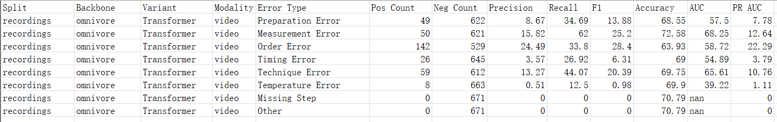

New baseline: Scenario 5-should use CaptainCookSubStepDataset.py to train the checkpoint
Backbones | Baseline | Split | threshold
Omnivore | V3: LSTM | step | 0.6

Generate checkpoint: python train_er.py --backbone omnivore --variant LSTM

python -m core.evaluate --variant LSTM --backbone omnivore --modality video --ckpt data/checkpoints/omnivore/LSTM/error_recognition_recordings_omnivore_LSTM_video_epoch_1.pt --split step --threshold 0.6
test Sub Step Level Metrics:
{
'precision': 0.45546774882528834,
'recall': 0.7195883246161633,
'f1': 0.5578444836832124,
'accuracy': 0.6806857628639573,
'auc': 0.7649622844068281,
'pr_auc': tensor(0.4062)
}
test Step Level Metrics:
{
'precision': 0.6816143497757847,
'recall': 0.6104417670682731,
'f1': 0.6440677966101694,
'accuracy': 0.7894736842105263,
'auc': 0.8272433998288234,
'pr_auc': tensor(0.5376)
}

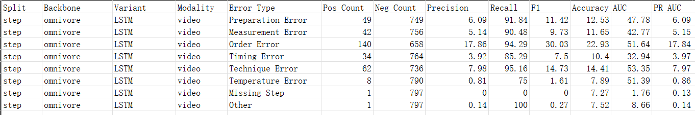

New baseline: Scenario 6-should use CaptainCookSubStepDataset.py to train the checkpoint
Backbones | Baseline | Split | threshold
Omnivore | V3: LSTM | recordings | 0.4

python -m core.evaluate --variant LSTM --backbone omnivore --modality video --ckpt data/checkpoints/omnivore/LSTM/error_recognition_recordings_omnivore_LSTM_video_epoch_1.pt --split recordings --threshold 0.4

test Sub Step Level Metrics:
{
'precision': 0.5645161290322581,
'recall': 0.7967795669072737,
'f1': 0.6608335252129864,
'accuracy': 0.7310641627543036,
'auc': 0.8346234112652131,
'pr_auc': tensor(0.5166)
}
test Step Level Metrics:
{
'precision': 0.5644768856447688,
'recall': 0.9626556016597511,
'f1': 0.7116564417177914,
'accuracy': 0.7198211624441133,
'auc': 0.8734343336871562,
'pr_auc': tensor(0.5568)
}
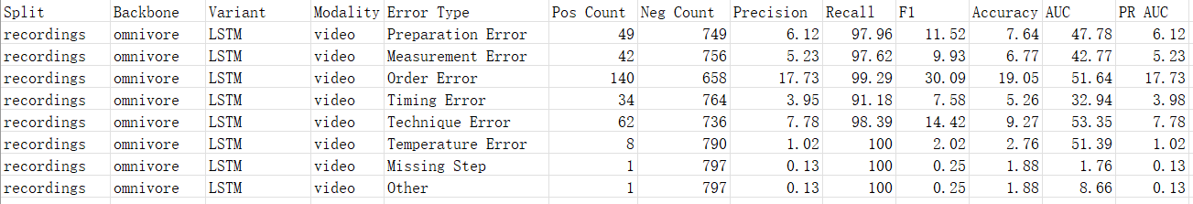

New backbone: Scenario 7
Backbones
PerceptionEncoder (PE-Core)
Generate feature:
python core/setup/PerceptionEncoder_feature_extractor.py --backbone pe_core --pe_core_model_id hf-hub:timm/PE-Core-B-16
--video_dir data/goprovideos
--output_dir data/features
--pe_core_num_frames 4
--segment_seconds 1
--num_workers 1

Backbones | Baseline | Split | threshold
PerceptionEncoder (PE-Core) | V1: MLP | step | 0.6
Generate checkpoint:
python train_er.py --backbone perception_encoder --variant MLP

python -m core.evaluate --variant MLP --backbone perception_encoder --modality video --ckpt data/checkpoints/pe_core/MLP/error_recognition_recordings_perception_encoder_MLP_video_epoch_2.pt --split step --threshold 0.6

test Sub Step Level Metrics:
{
'precision': 0.4774528025041573,
'recall': 0.4117597435464822,
'f1': 0.44217964397336595,
'accuracy': 0.7091815047466112,
'auc': 0.7139814043112891,
'pr_auc': tensor(0.3613)
}
test Step Level Metrics:
{
'precision': 0.5368852459016393,
'recall': 0.5261044176706827,
'f1': 0.5314401622718052,
'accuracy': 0.7105263157894737,
'auc': 0.7380853102757111,
'pr_auc': tensor(0.4303)
}
Extension:
{
'accuracy': 0.5370370370370371,
'precision': 0.4827586206896552,
'recall': 0.5833333333333334,
'f1': 0.5283018867924529,
'auc': 0.5888888888888889,
'pr_auc': 0.5811502899224296
}

- High Recall means the model catches most real errors .
Low Recall means it misses many real errors (false negatives).
- High Precision means when the model says “error,” it’s usually correct .
Low Precision means it often flags normal steps as errors (false positives).
- High F1 means a good overall balance between catching errors (recall) and avoiding false alarms (precision).
Low F1 usually means the model is either missing lots of errors or producing lots of false alarms.
- High Accuracy means the model is correct on a large fraction of all samples.
Low Accuracy means it makes many mistakes overall.
- High AUC means the model’s scores rank error samples above normal samples well across all thresholds.
AUC ≈ 0.5 means near-random separation.
AUC < 0.5 often suggests the score direction is flipped or the model is performing worse than random.

