Multi-Agent Deep Reinforcement Learning for Coordinated Scheduling of Battery Energy Storage Fleets Providing Stacked Services Across Sequential Electricity Markets
Lorenzo Giannuzzo^{1,2} [0009-0006-8420-3906], Daniele Salvatore Schiera^{1,2} [0000-0002-8692-2238], Francesco Demetrio Minuto^{1,2} [0000-0003-0813-7880], Andrea Lanzini^{1,2} [0000-0003-4688-8212]
¹ Energy Center Lab, Polytechnic of Turin, via Paolo Borsellino 38/16, 10152, Turin, Italy
² Department of Energy (DENERG), Polytechnic of Turin, Corso Duca degli Abruzzi 24, 10129, Turin, Italy
lorenzo.giannuzzo@polito.it
Abstract. Although battery energy storage can capture value across sequential electricity markets, scheduling a heterogeneous fleet that provides energy and reserve services is a tightly coupled control problem. Mixed-integer optimization can solve this problem, but it is computationally expensive and must be re-solved whenever conditions change. This study presents the coordinated scheduling of fifty heterogeneous storage units operated by a single balancing service provider across the Italian day-ahead and balancing markets as a Multi-Agent Reinforcement Learning (MARL) task, showing that a learned policy captures a large share of the optimizer's revenue at a fraction of the computational cost. A Mixed-Integer Linear Programming (MILP) model provides a realizable discrete benchmark, and a behavioral clone of the MILP model warm-starts a multi-agent Proximal Policy Optimization (PPO) agent. The warm-started agent, which outperforms its randomly initialized counterpart, captures approximately 80% of the optimizer's profit while generating a full set of fleet bids in a single forward pass, so that a full day of fleet scheduling costs about 0.24 milliseconds against 341 milliseconds for the MILP. A sensitivity analysis over fleet size (N = 3, 10, 50 BESS) shows that this speedup approaches three orders of magnitude at the largest fleet and widens as the fleet grows, since the MILP solve time rises with size while the DRL inference cost barely changes. The learned scheduler and the optimizer are compared under matched information, both receiving the same 24-hour price path, so that the reported gap isolates the scheduling mechanism rather than the quality of a forecast. The policy requires no online optimization, thereby trading a portion of realized profit for real-time, fleet-scalable dispatch, precisely the regime in which repeated optimization becomes impractical.
Keywords: Battery Energy Storage Systems · Multi-Agent Deep Reinforcement Learning · Electricity markets.
- Introduction
  - Context and Motivation
The decarbonization of power systems is changing how electricity is generated, traded, and balanced. As wind and solar power replace synchronous generation, the reliability of the grid decreases while price volatility and imbalance events increase. In this setting, Battery Energy Storage Systems (BESS) are among the most flexible assets available: they are fast and bidirectional, shifting energy through arbitrage, relieving congestion, and supplying frequency and balancing reserves to support renewable integration, all while creating value for their owners. Italy is an instructive setting in this regard. Its wholesale market, run through the power exchange (GME) and the transmission system operator (TERNA), consists of a zonal day-ahead market (MGP), whose zonal prices settle generation and storage while the single national price (PUN) is the reference price for consumers, intraday sessions, and the Dispatching Services Market (MSD), through which TERNA procures real-time balancing reserves [5, 6]. Recent reforms that opened system services to storage and shifted to fifteen-minute balancing make Italy one of the most active European arenas for BESS deployment [7]. For a balancing service provider (BSP) operating a fleet, revenues must be stacked across markets that clear sequentially and at different resolutions. These markets are linked by coupling constraints that tie present actions to future opportunities and are constrained by each unit's state of charge (SOC) and degradation [2, 8, 9]. Operating many heterogeneous units jointly and coupling them through shared portfolio limits yields a high-dimensional, partially observable, strongly coupled control problem. The dominant paradigm is mixed-integer linear programming (MILP), which encodes constraints, losses, and linearized degradation and returns provably optimal schedules for a given price scenario [9, 12, 13, 14]. However, its optimality depends on perfect foresight: under uncertainty, it requires either deterministic forecasts, which introduce forecast error into the schedule, or stochastic and robust extensions [15, 16], which become intractable across many markets, assets, and fine time steps. Moreover, its schedules do not adapt online. Deep reinforcement learning (DRL) offers an alternative: a policy learned through interaction acts in milliseconds without solving an optimization problem online [17, 18], adapts to outcomes that a fixed plan cannot anticipate, and captures nonlinear couplings such as degradation and sequential clearing. This work grants both schedulers the same foresight over the daily horizon, so that the comparison isolates the scheduling mechanism rather than the quality of a forecast; the forecast-free regime is left to future work. This work investigates whether DRL, in a multi-agent form, can match or exceed MILP-based scheduling when storage fleets aggregate revenues across sequential markets while remaining tractable and deployable at scale.

  - Literature Review
Advances in algorithmic techniques have led to the development of DRL for energy management [3]. Value-based methods, such as the Deep Q-Network, have achieved human-level control in high-dimensional discrete settings [1, 17]. Meanwhile, Deep Deterministic Policy Gradient (DDPG), Soft Actor-Critic (SAC), and Proximal Policy Optimization (PPO) have extended these ideas to continuous actions, offering greater stability and sample efficiency [18-21]. PPO has become the default for energy applications, handling discrete and continuous control alike. Single-agent DRL has been widely applied to storage scheduling and bidding. For example, Huang and Wang used a PPO agent for photovoltaic-battery scheduling with stacked services, achieving better results than discrete value-based methods [22]. Li et al. developed a bidding strategy for co-located wind-battery systems in spot and ancillary markets that outperformed optimization benchmarks under uncertainty [23]. Related work includes temporal-aware architectures [24], forecast-free day-ahead arbitrage [25], and degradation-aware integrated scheduling [8]. Model-free policies usually trade a small optimality gap for robustness and online speed. Multi-agent reinforcement learning (MARL) is required when several decision makers interact, a setting that introduces non-stationarity, partial observability, credit assignment, and joint-action scalability issues [10, 11], which are usually addressed through centralized training with decentralized execution. In power systems, Xu et al. cast price-maker bidding as a decentralized partially observable Markov decision process (POMDP), which they solved using multi-task MARL [26]. Other work has coordinated electric vehicle charging, photovoltaics, and storage [27] and managed multi-market procurement risk [28], but typically for a single asset class or market interface. Two topics directly relate to multi-market storage. The first is revenue stacking: Paredes et al. formulated the multi-market participation of distributed resources as a three-level optimization that raises attainable revenue, as well as the computational burden [4]. Hybrid plants benefit from multi-timescale coordination when stochastic programs become intractable [29]. The second is storage as a strategic participant: inverse reinforcement learning has revealed the objectives behind multi-market bidding, exposing strong time and market coupling [30]. Finally, behavioral cloning (BC) warms up DRL using expert demonstrations, which in the storage domain can be generated by an offline optimizer [31, 32], thereby providing a natural bridge in which optimal schedules seed a policy that is later refined through interaction. Despite this progress, a gap remains. Single-agent studies rarely consider heterogeneous fleets, and multi-agent studies seldom address the full stack of sequential markets faced by a BSP. Controlled comparisons between learned policies and MILP under matched assumptions are scarce, and BC as a warm start for multi-agent storage policies and its effect on the gap to the optimization-based benchmark has received little attention.

  - Novelty and Paper Organization
This paper investigates the coordinated scheduling of a heterogeneous BESS fleet stacking revenues across sequential Italian markets as a BSP, framed as a multi-agent system in which each unit is governed by an agent. The MILP serves as a discrete, realizable, perfect-foresight benchmark. Behavioral cloning is used only to support learning: an offline clone of the MILP warm-starts the multi-agent PPO agent, and comparison against a randomly initialized counterpart shows that the warm start improves the learned policy. A sensitivity analysis over fleet size (N = 3, 10, 50 BESS) is further conducted to quantify the DRL inference speed against the reference MILP. To our knowledge, this is one of the first studies to evaluate a warm-started multi-agent DRL scheduler against a MILP benchmark for multi-market revenue stacking of a storage fleet under matched assumptions on the Italian day-ahead and balancing markets. The main contributions are as follows:

- Problem formulation – A formulation of the multi-market, multi-asset BSP scheduling of a heterogeneous BESS fleet as a multi-agent decision problem coupling sequential market clearing, SOC dynamics, and lifecycle-aware degradation;
- Unified benchmark environment – A unified evaluation environment that compares the learned policy against the optimizer on identical data, constraints, and information, so that the reported gap reflects the scheduler rather than the setup;
- Warm start from the optimizer – Evidence that behavioral cloning of the MILP provides an effective warm start for the multi-agent DRL policy, together with a characterization of the operating regimes that govern the residual gap;
- Scalability of inference – A sensitivity analysis over fleet size showing that the DRL inference cost remains nearly constant while the MILP solve time grows, so that the speed advantage widens with the fleet.
- Methodology
This study compares two scheduling approaches using real-market data in one common environment to examine the trade-off between optimality and deployability when coordinating a heterogeneous BESS fleet, and the overall simulation framework is described in Fig.1. As shown, in this controlled comparison, all tested optimization algorithms use the same battery fleet, Italian day-ahead and balancing data, physical and regulatory constraints, and degradation costs. The chosen reference algorithm is a MILP that schedules the fleet with perfect foresight and is executed in the same environment as the learned policies, which makes it a realizable reference rather than an unattainable ceiling. The other tested optimizer is a multi-agent PPO policy that acts based on observations alone. Behavioral cloning of the MILP is used only as a supporting step to project the expert schedule onto the discrete action grid and warm-start the PPO agent. The PPO agent is also trained from scratch for comparison purposes. Market occurrences, awards, and activations are stochastic events whose probabilities are evaluated according to Section 2.2. In this environment, the optimizer prices these probabilities in expectation while the environment draws them at execution.
  - Italian Electricity Market Setup & Data Sources
As mentioned, all the simulations use real data from Italian markets from 2023 to 2024. Historical rather than synthetic series preserve the diurnal shape, weekly seasonality, and heavy tails important for storage scheduling. The data is collected by the two
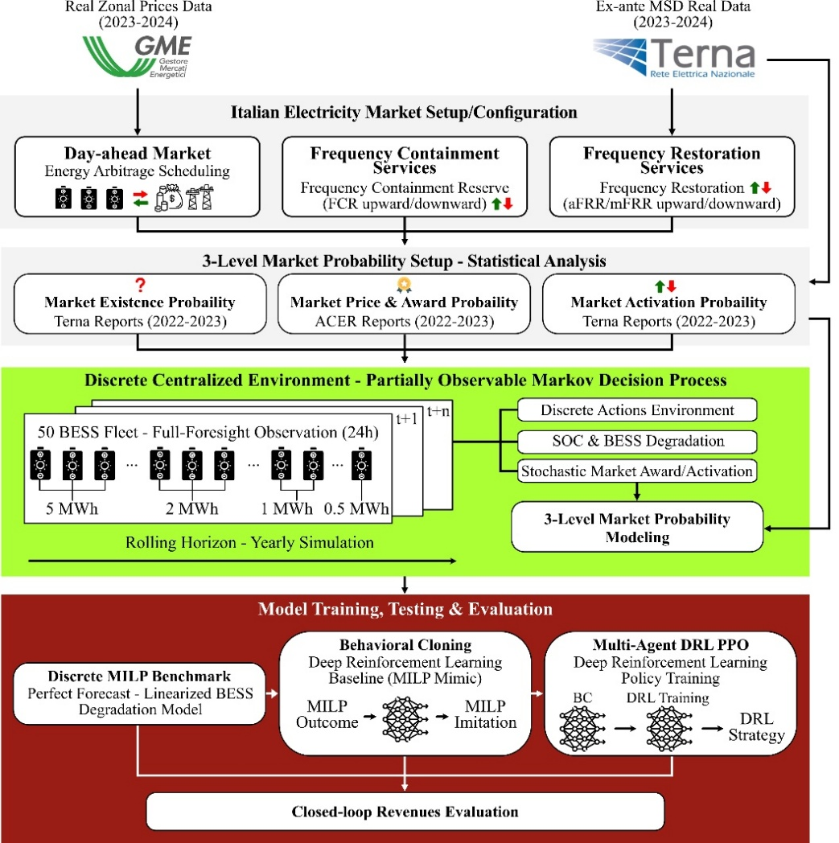
Fig. 1. Methodological framework: GME/TERNA data (2023–2024) and a three-level model define a fifty-BESS POMDP for training and evaluating MILP and PPO, with behavioral cloning providing the warm start.
operators of the Italian power system: GME, which runs the MGP clearing hourly energy at zonal prices, and TERNA, the transmission system operator, which procures reserves through the MSD, the Italian implementation of the European balancing framework. Hourly MGP zonal prices for the northern bidding zone and ex-ante MSD results for the same zone cover 2023 and 2024 and drive the arbitrage and the reserve streams respectively, while TERNA balancing statistics and ACER benchmark reports for 2022–2023 calibrate the probability model of Section 2.2. The selected data define three hourly revenue streams that correspond to the three market blocks in Fig. 1. The first stream is energy arbitrage on the day-ahead market: buying in low-price hours and selling in high-price hours, net of losses and degradation. The other two are reserve products on the MSD, which are the Frequency Containment Reserve (FCR), which is a symmetric product that reserves headroom in both directions. Containment has historically been a mandatory and unremunerated obligation for eligible units under the Italian Grid Code, so the capacity payment modelled here reflects the market-based procurement mechanism introduced in Annex A.83 to the Grid Code and approved by the regulator, under which the awarded band is remunerated irrespective of activation. The results for this product are therefore prospective with respect to the 2023–2024 evaluation window. Alongside containment sit and the automatic and manual Frequency Restoration Reserve (aFRR and mFRR), which are directional products with distinct upward and downward reservations. Intraday sessions are not modeled, so the sequence considered here is the day-ahead market followed by the balancing market. As summarized in Table 1, these three products differ in direction, required sustained duration, and activation likelihood. Committing battery SOC to a reservation reduces the energy available for arbitrage in nearby hours. Together with the per-unit capacity balance and the portfolio-level minimum-capacity threshold, this defines the coupling constraints under which the fifty units are jointly scheduled. That threshold is set at 1 MW per service on the aggregate bid, following the provisions for virtual units [6], and it is disjunctive rather than continuous: a service is either not offered at all or offered at no less than 1 MW. It is the only constraint that couples the units to one another, and against a 55 MW fleet it binds only where the aggregate bid for a service would otherwise fall below 1 MW.
Table 1. Reserve products stacked by the fleet: direction, sustain duration, baseline activation probability, and remuneration structure.
Product | Direction | Sustain Duration | Baseline Activation Probability | Remuneration
Frequency Containment Reserve (FCR) | Symmetric (upward and downward) | 0.25h | 0.10 | Capacity payment
Automatic Frequency Restoration Reserve (aFRR) | Directional (distinct upward/downward) | 1h | 0.30 | Capacity payment + energy on activation
Manual Frequency Restoration Reserve (mFRR) | Directional (distinct upward/downward) | 2h | 0.20 | Capacity payment + energy on activation

From a general perspective, the algorithms’ training and evaluation periods are separated, so policies are evaluated based on conditions that have not been seen before. The two years differ in level and not only in realization, since Italian wholesale prices fell markedly between 2023 and 2024 as the post-2022 crisis unwound, so the evaluation year is not a stationary continuation of the training year and the reported performance embeds whatever loss that shift imposes.
  - Three-Level Market Probability Modeling
In this study, the participation in the analyzed reserve markets involves three levels of uncertainty. As mentioned, these levels are estimated from historical records and shared by all methods. The first level is market occurrence: a service is procurable when TERNA's ex-ante MSD record reports procurement activity, with sparse hours aggregated more coarsely. The second level is the award. Capacity holding a reservation is paid for, regardless of whether it is activated. The award probability is an empirical rate based on the time of day, which is higher overnight and lower during the evening peak. Capacity and energy prices are calibrated against European balancing benchmarks from the Agency for the Cooperation of Energy Regulators (ACER) for 2022–2023 and refined by ex-ante MSD prices. The third level is activation, set per service based on TERNA reports and statistics from 2022–2023: 10% for containment, 30% for automatic restoration, and 20% for manual restoration. The optimizer embeds these information in its objective function, and the environment books the expected reward of Eq. 1 during training so that agents receive the same information. Samples of awards and activations are drawn from Bernoulli distributions during evaluation so that performance reflects realized outcomes.
$E[R_{i,t}^{s}]=p_{s,t}^{aw} r_{i,t}^{s} Δt (c_{s,t}^{cap}+p_{s}^{act} c_{s,t}^{en})$ (1)
$p_{s,t}^{aw}$ is the hour-conditioned award probability of service s, $p_{s}^{act}$ its activation probability, $r_{i,t}^{s}$ the reserved power of unit i, and $c_{s,t}^{cap}$ and $c_{s,t}^{en}$ the capacity and energy remunerations of the product in hour t.
  - Discrete Stochastic Environment
    - Case Study & BESS Fleet

The case study concerns a portfolio of grid-connected BESS managed by a single BSP under the Italian framework for virtual units, designed to replicate the asset diversity a real aggregator would manage, from behind-the-meter commercial installations to large standalone plants. The fleet comprises fifty systems in three clusters (commercial, industrial, and utility) sharing a Lithium Iron Phosphate (LFP) chemistry but differing in energy capacity, power rating, and duty, as detailed in Table 2.
Table 2. Composition of the heterogeneous storage fleet. All units share an LFP chemistry, a one-way efficiency of 0.95, SOC bounds of 0.10 and 0.90, and a cell replacement cost of 25 000 EUR per MWh of installed capacity, amortized over a cycle life of 8 000 full equivalent cycles to give a marginal degradation cost of about 1.6 EUR per MWh of throughput.
Cluster | Units | Capacity | Power | Representative duty
Commercial | 20 | 1 MWh | 0.5 MW | Supermarkets, small industrial sites, EV depots
Industrial | 20 | 2 MWh | 1.0 MW | Manufacturing plants, logistics hubs
Utility | 10 | 5 MWh | 2.5 MW | Standalone grid-connected storage
Fleet total | 50 | 110 MWh | 55 MW | Two-hour energy-to-power ratio, LFP chemistry
The problem is not the dispatch of a single asset but the joint scheduling of many coupled units whose aggregate offer must meet participation thresholds while respecting their own physical limits. Each unit's SOC at the start of the simulation is drawn uniformly from 0.40 to 0.60 and is thereafter carried forward rather than reset. Heterogeneity arises from sizing rather than cost noise, which isolates coordination from cost asymmetry; since the three clusters share a two-hour energy-to-power ratio, it is one of scale rather than of duration. Varying the duration, as real portfolios do, would make the sustain constraints bind unevenly across units and is left to future work.
    - SOC Dynamics

The dynamics below govern the environment and constrain the optimizer of Section 2.4, and are shared by all methods without modification, so that the physical setting of the comparison is identical. Let the SOC of unit i at the end of hour t be $s_{i,t}$, expressed as a fraction of the unit's energy capacity $E_{i}$. Let $p_{i,t}^{ch}$ and $p_{i,t}^{dis}$ denote the charging and discharging power scheduled for arbitrage in hour t, let $η_{i}$ be the one-way efficiency, and let Δt be the settlement interval, the SOC evolves according to the balance expressed in Eq. 2:
$s_{i,t} = s_{i,t-1} + η_{i} p_{i,t}^{ch}\frac{Δt}{E_{i}} - p_{i,t}^{dis}\frac{Δt}{η_{i} E_{i}} + Δs_{act,i,t}$ (2)
Charging adds energy net of conversion losses and discharging removes it net of losses on the way out, while $Δs_{act,i,t}$ is the net change in stored energy caused by the activation of reserve services in hour t. The term is signed: an upward activation delivers energy and lowers the SOC, a downward one absorbs it and raises it. Since activations are stochastic, $Δs_{acti,t}^{ }$ is a realized quantity revealed to a causal policy only after the activation has occurred, which is one of the mechanisms through which the environment departs from a deterministic plan and through which a closed-loop policy gains its advantage over an open-loop schedule. Finally, the SOC is constrained to remain within operational bounds at all times, as in Eq.3:
$s_{i}^{min}≤s_{i,t} ≤s_{i}^{max} ∀ t∈T$ (3)
with $s_{i}^{min}$ = 0.10 and $s_{i}^{max}$ = 0.90 for every unit. Charging and discharging are mutually exclusive within an hour, so that a unit does not simultaneously import and export energy for arbitrage, and the scheduled powers are bounded by the unit's power rating $P_{i}$, that is 0 ≤ $p_{i,t}^{ch}$ ≤ $P_{i}$ and 0 ≤ $p_{i,t}^{dis}$ ≤ $P_{i}$, with the two never simultaneously positive.

    - Sustain Constraints for Reserve Provision

Reserve participation imposes energy-adequacy constraints that couple the reserved power to the SOC. If unit i reserves power $r_{i,t}^{s}$ for service s in hour t, it must be able to sustain that power for the service-specific minimum duration $τ_{s}$. For a reservation in the discharging direction, the unit must hold sufficient usable energy above its lower bound to deliver the reserved power for the full sustain window, as shown in Eq. 4.
$\left(s_{i,t}-s_{i}^{min}\right)E_{i}≥r_{i,t}^{s}\frac{τ_{s}}{η_{i}}$ (4)
On the other hand, for a reservation in the charging direction the symmetric condition applies to the available headroom below the upper bound, as expressed in Eq. 5.
$\left(s_{i}^{max}-s_{i,t}\right)E_{i}≥η_{i} r_{i,t}^{s} τ_{s}$ (5)
The three products differ in $τ_{s}$: fifteen minutes for containment, one hour for automatic restoration, and two hours for manual restoration. The containment figure follows Article 156 of Regulation (EU) 2017/1485, which bounds the minimum activation period required of providers with limited energy reservoirs between fifteen and thirty minutes and sets fifteen minutes as the default; the energy-margin requirement for electrochemical storage in primary regulation is specified in Annex A.15 to the Italian Grid Code. Since this window governs how much power a given state of charge can back, and thereby which products a two-hour fleet can offer at rated power, Section 3.5 reports a sensitivity over τFCR spanning the admissible range and beyond it. These constraints express the revenue-stacking tension: committing SOC to a reserve reduces the energy available for arbitrage in the same and adjacent hours, so a unit's finite energy is not separable across services but must be allocated jointly over the horizon.
    - Lifecycle-Aware Degradation

Battery degradation is represented as a cost proportional to energy throughput, capturing the loss of residual asset value induced by cycling. Let $c_{deg}$ denote the per-unit degradation cost and let the throughput of unit i in hour t be the total energy moved through the cell, comprising the arbitrage charge and discharge and the energy delivered or absorbed through realized activations, the degradation cost charged in hour t is then evaluated according to Eq. 6.
$d_{i,t}=c^{deg}\left(p_{i,t}^{ch}+p_{i,t}^{dis}+\left|Δe_{i,t}^{act}\right|\right)Δt$ (6)
$Δe_{i,t}^{act}$ is the energy exchanged through activations in that hour. The coefficient $c_{deg}$ is the amortization of the cell replacement cost over the useful throughput, not the replacement cost itself. With a replacement cost of 25 000 EUR per MWh of installed capacity for a modern LFP cell, a cycle life of 8 000 full equivalent cycles to the conventional 20% capacity-loss threshold, and two units of throughput per full equivalent cycle, it evaluates to about 1.6 EUR per MWh of energy moved through the cell, which is the value charged for every unit.

    - Formalization as a Partially Observable Markov Decision Process

All the elements described in the previous subsections form a centralized, single environment modeled as a POMDP. Each of the fifty units is governed by an agent through a shared policy. Every hour, an agent observes its unit's local state (SOC and degradation) and the market context. Here, the observation deliberately provides complete foresight over the 24-hour horizon, matching the information available to the perfect-foresight optimizer. This is a design choice rather than a deployment assumption: it removes forecast quality as a confounder, so that any residual gap is attributable to the scheduler and not to what each method knows. Partial observability arises because awards and activations are revealed only after they occur. Actions are discrete: each hour, an agent selects one level per axis on a seven-axis grid covering charging and discharging power, the symmetric containment reservation, and the upward and downward reservations of the two restoration products. The chosen setpoints are clipped to the per-unit capacity balance and aggregated, the portfolio-level thresholds of Section 2.1 determine which offers are admissible, and awards and activations are then sampled from the model of Section 2.2. The SOC advances according to the dynamics above, and each agent receives its realized hourly profit (including arbitrage, reserve capacity, activation revenues, and degradation costs). The evaluation progresses day by day over a full year. Each 24-hour episode carries its terminal state to the next to preserve intertemporal coupling. All methods, including the optimizer, share this rolling structure at evaluation, so that yearly trajectories are compared on equal terms; the training of the learned policies samples days rather than walking the calendar, as detailed in Section 2.5.3.
  - Model Training, Testing, and Evaluation
    - Discrete MILP Benchmark

As previously mentioned, the reference optimizer is an MILP that schedules the entire fleet with perfect foresight over the daily horizon. It embeds the SOC dynamics, the mutual exclusion of charging and discharging, the sustain constraints of the three reserve products, the per-unit capacity balance, and the portfolio-level minimum-capacity thresholds, and maximizes the expected daily fleet profit, with each reserve revenue weighted by the award and activation probabilities of Section 2.2. It is solved day by day along the rolling horizon with SOC carried over, exactly as in the environment. The employed objective function is detailed in Eq. 7.
$max \sum_{i∈N}{\sum_{t∈T}{[λ_{t}(p_{i,t}^{dis}-p_{i,t}^{ch}) Δt +\sum_{s∈S}{E[R_{i,t}^{s}]}-d_{i,t}]}}$ (7)
$λ_{t}$ is the day-ahead price, N the set of units, T the daily horizon, and S the set of reserve products. The maximization is subject to the SOC dynamics and bounds of Eqs. 2 and 3, the sustain constraints of Eqs. 4 and 5, and the degradation cost of Eq. 6, and each daily instance is solved to optimality with the Gurobi solver. The optimizer contributes one quantity: its schedule projected onto the grid and executed on the same sampled episodes as the learned policies, which yields the discrete MILP benchmark, the realized profit of a perfect-foresight open-loop plan under identical action resolution and market draws. Since the continuous optimum is projected rather than solved on the grid, the plan is feasible at that resolution but not necessarily optimal on it, so the benchmark is conservative and the gaps against it are, if anything, understated. It is deliberately not called an upper bound: awards are priced in expectation but realized by sampling, so a closed-loop policy reacting to the draws could in principle exceed it.

    - Behavioral Cloning

Behavioral cloning provides the warm start for the DRL. In this process, the MILP schedules over the training horizon are converted into per-agent observation-action pairs pooled into one dataset, enlarged by the number of units through parameter sharing. A feedforward network that matches exactly the PPO actor network is trained by supervised learning to reproduce the expert action on each grid axis, each treated as an independent classification head, so the weights transfer unmodified. The resulting clone acts on observations alone and reproduces the perfect-foresight expert up to imitation error and grid resolution, and supplies the initialization for the warm-started agent. The network has two hidden layers with 512 and 256 units and tanh activations, followed by seven softmax heads, trained with Adam (learning rate 0.001, batch size 128, 100 epochs) on the multi-axis cross-entropy loss of Eq. 8.
$L_{BC}(θ)=-\frac{1}{|D|}\sum_{(o,a)∈D}{\sum_{k=1}^{7}{log π_{θ}(a_{k} | o)}}$ (8)
D is the pooled demonstration dataset, (o, a) an expert observation–action pair, and $π_{θ}(a_{k} | o)$ the probability that the network assigns to the expert level on axis k.

    - Multi-Agent Proximal Policy Optimization and Revenues Evaluation

The other tested optimizer is a multi-agent PPO DRL in a vanilla and a BC-warm-start variant, where all fifty units share one policy network trained through closed-loop interaction. Both are trained against an expected-reward environment and evaluated against its sampled form. The vanilla variant starts from a random policy; the warm-started one initializes from the BC weights and adds a term penalizing divergence from the clone, which protects the injected knowledge through the early, high-variance phase while allowing departures when interaction reveals better behavior. Each training episode covers one day drawn uniformly at random from the 2023 window, so the policy sees the same price and service series used to build the MILP demonstrations, with the empirical award probabilities of Section 2.2 attached to each hour, and the fleet SOC is carried from one episode to the next rather than reset, matching the evaluation. Both variants train for 200 iterations on batches of 4 000 transitions in fragments of 200 steps with a base learning rate of 0.0003 and an entropy bonus of 0.001. The warm-start variant cuts the learning rate by tenfold, removes the entropy bonus, and adds the anchoring term of Eq. 9 to the clipped surrogate.
$L_{PPO}(θ)=E_{t}[min(ρ_{t}(θ) Â_{t}, clip(ρ_{t}(θ),1-ε,1+ε) Â_{t})]-β_{t} KL(π_{BC} ‖ π_{θ})$ (9)
$ρ_{t}(θ)$ is the likelihood ratio between the current and the previous policy, $Â_{t}$ the advantage estimate, and ε the clipping parameter. The anchoring coefficient $β_{t}$ is annealed from 1.0 toward a strictly positive floor of 0.1, so that the pull toward the BC policy never vanishes; the vanilla variant corresponds to $β_{t}=0$. All methods share one evaluation protocol: each model runs in the same discrete stochastic environment on the held-out horizon with identical episodes and shared award and activation draws, so none is advantaged by a favorable draw. Models’ performance is the realized profit over the year net of degradation, decomposed by revenue stream across arbitrage and reserve products. All timings reported in Section 3.4 were measured on the same machine, an Intel Core i7-1355U at 1.70 GHz with 16 GB of RAM and integrated graphics only, so that the solver and the network run on the same CPU and neither is advantaged by dedicated acceleration. The reported DRL cost includes observation construction and action decoding, so that both schedulers are timed on the work required to produce an admissible fleet bid.
- Results & Discussion
In this section the results obtained from the framework described in Section 2 are analyzed and discussed. As mentioned, the two learned schedulers are evaluated on a fifty-unit heterogeneous fleet over a held-out year and compared against the discrete MILP reference. Additionally, a random policy optimizer sets a lower baseline.
  - Aggregate Economic Performance Evaluation
Aggregate profitability over the evaluation year is examined first against the discrete MILP reference. Fig. 2 reports the cumulative environment-realized net profit of each optimizer. As can be observed, in terms of realized net profit, the discrete MILP reference reaches about 11.7 M€ by year end; the warm-started PPO agent reaches about 9.3 M€, the vanilla agent about 7.4 M€, and the random baseline about 3.1 M€. That an uninformed policy captures a quarter of the reference is a property of the remuneration structure rather than of the policy: reserve capacity is paid on reservation rather than on delivery, so any agent that bids accrues it, and the positive reserve revenue of the random baseline more than offsets its negative arbitrage. The ordering is set within weeks and preserved without crossover. Even warm-started, PPO recovers only about four-fifths of the discrete benchmark and the vanilla agent about two-thirds; the warm start adds close to two million euros over learning from scratch yet does not close the gap. The daily net-profit distribution (Fig. 3) orders the policies as the totals do while exposing the spread of daily outcomes. The MILP lies farthest to the right, around 33 k€; the warm-started agent sits near 26 k€, the vanilla near 22 k€, and the random baseline forms a narrow distribution around 10 k€. The gap is systematic rather than the product of a few adverse days: the optimizer and the learned agents barely overlap at their medians. The narrow random baseline, achieved at the lowest profit level, confirms that consistency alone is not valuable, whereas the optimizer-based policies are both higher and appropriately variable, tracking the day-to-day value available in the market.
  - Revenue Decomposition Across Stacked Markets
The realized revenue can be decomposed across the stacked markets to show where each scheduler earns and how the market mix of the learned policies departs from that of the optimizer. The decomposition of gross revenue by product is shown in Fig. 4.

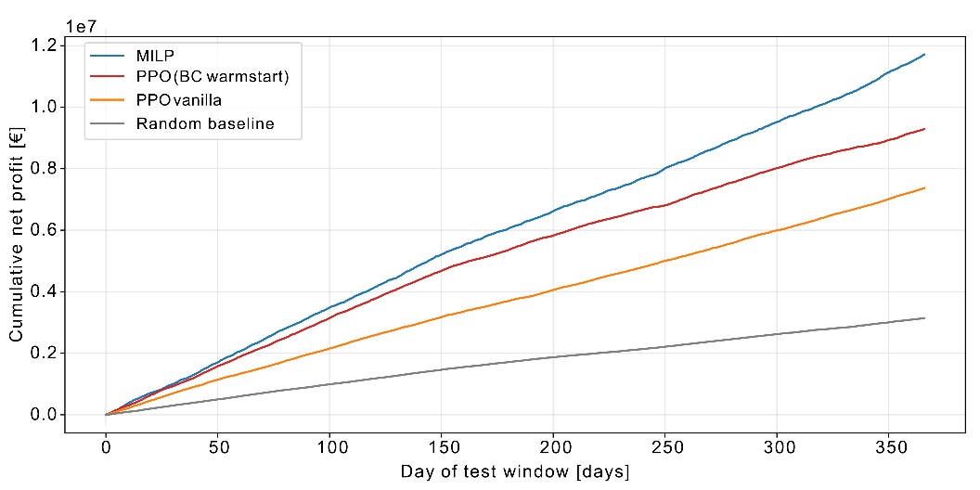
Fig. 2. Cumulative environment-realized profit of each policy over the test window, net of degradation cost.
The totals reported here are gross of the degradation cost and therefore sit slightly above the net figures of Section 3.1. As can be observed, over the test window the gross revenue totals about 11.8 M€ for the MILP, 9.4 M€ for the warm-started agent, 7.5 M€ for the vanilla agent, and 3.3 M€ for the random baseline. For the optimizer the composition is essentially bipartite: about a quarter from arbitrage and almost all the rest from the downward automatic-restoration reserve. The warm-started agent diverts a visible share into containment, and the vanilla agent spreads more widely into containment and both manual-restoration products. Within the reserve revenue alone, the optimizer draws essentially all of it, about 99.7%, from the downward automatic-restoration product; the warm-started agent draws about 83% from it and 17% from containment; and the vanilla agent is most dispersed, at roughly 52% downward automatic restoration, 24% containment, and 21% manual downward restoration. Monetizing the availability-paid products raises the learning agents' gross participation but not their net profit, since capacity payments are offset by energy forgone and reserve held without delivering. Concentration, not diversification, is profitable here: the downward automatic-restoration product pairs a high activation likelihood with favorable energy pricing, so spreading into rarely activated products only dilutes realized reserve revenue.
  - Operational Behavior of the Storage Fleet
The economic differences between the policies are underpinned by distinct operating regimes, which the SOC distribution makes explicit. The distribution of the fleet-mean SOC over the evaluation year is shown in Fig. 5. The optimizer operates almost entirely within a narrow band close to the lower SOC limit, with a median around 0.14 and only

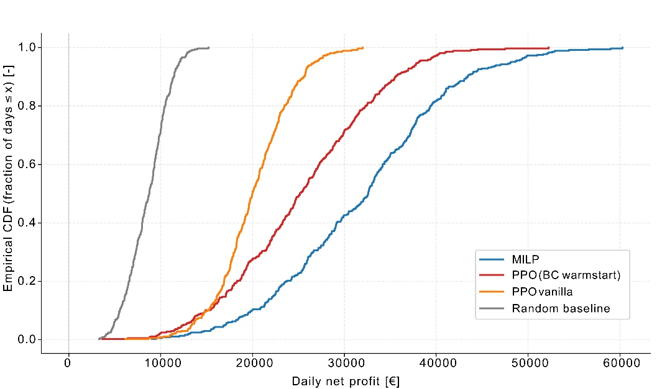
Fig. 3. Empirical cumulative distribution of daily net profit across policies; a curve farther to the right denotes higher daily profit.
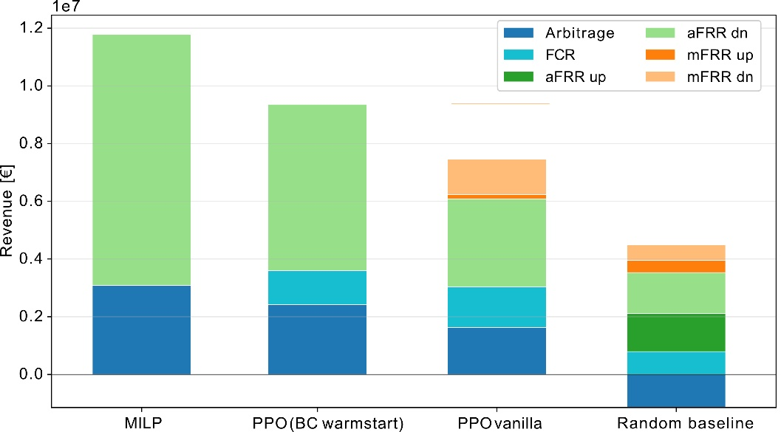
Fig. 4. Revenue over the test window decomposed by product for each policy, reported gross of degradation cost and therefore not directly comparable with the net totals of Fig. 2.
a thin tail toward higher values. The warm-started agent occupies the opposite regime, saturating in the upper part of the admissible range with a median around 0.65 and substantial mass approaching the maximum. The vanilla agent is bimodal, alternating between a low-charge mode near the limit and a partially charged mode around 0.55, with a median near 0.40, while the random baseline concentrates around mid-charge.

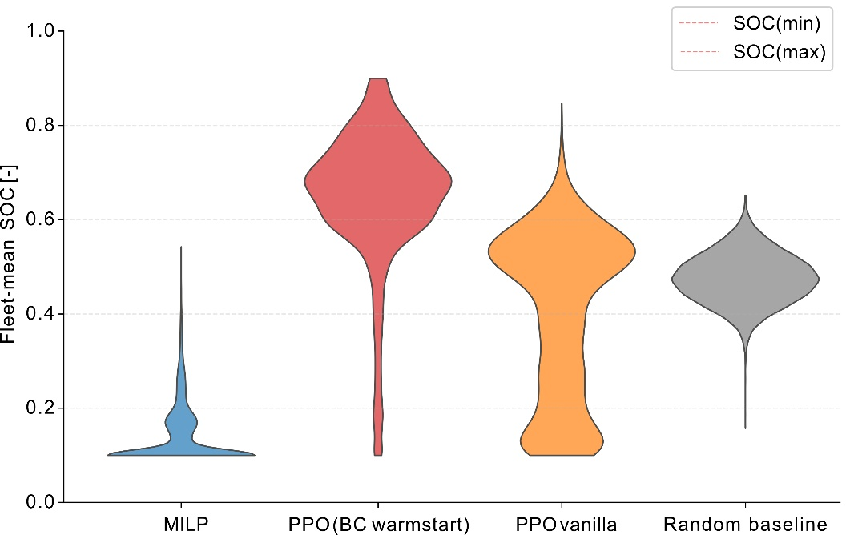
Fig. 5. Distribution of the fleet-mean SOC over the evaluation year for each policy; the dashed lines mark the admissible limits.
This behavior can primarily be attributed to the underlying revenue strategies. Holding the fleet close to the lower limit maximizes the headroom available to absorb energy, which is exactly what the downward automatic-restoration reserve requires: the optimizer therefore keeps a low SOC so as to remain able to deliver the product from which it earns most of its revenue. The warm-started agent instead accumulates and retains charge, a regime consistent with holding capacity for the availability-paid containment product rather than delivering downward reserve. The SOC signature is the operational counterpart of a market mix that favors availability over delivered flexibility.
  - Computational Scalability
The two schedulers differ sharply in how they scale (Fig. 6). The MILP solve time rises with fleet size, from about 30 ms at N = 3 to 75 ms at N = 10 and 341 ms at N = 50, since each added unit enlarges the mixed-integer program. The policy instead emits the full set of fleet bids in one forward pass at almost fixed cost, about 0.04 ms at N = 3 and 0.01 ms at N = 50; the small decrease reflects the better vectorization of a larger agent batch rather than less work. The two must be compared on the same unit of work, since one solve returns a full day for the whole fleet whereas the policy is queried hourly: a scheduled day costs about 0.96 ms at N = 3 and 0.24 ms at N = 50, so the speedup widens from about thirtyfold to over three orders of magnitude. The case is therefore one about large portfolios. At three units the saving is a few tens of milliseconds per day and would not repay any loss of revenue, whereas the cost of re-solving compounds wherever scheduling is revised repeatedly, through intraday re-optimization at fifteen-minute resolution, portfolios well beyond fifty units, or Monte Carlo evaluation over many price scenarios.
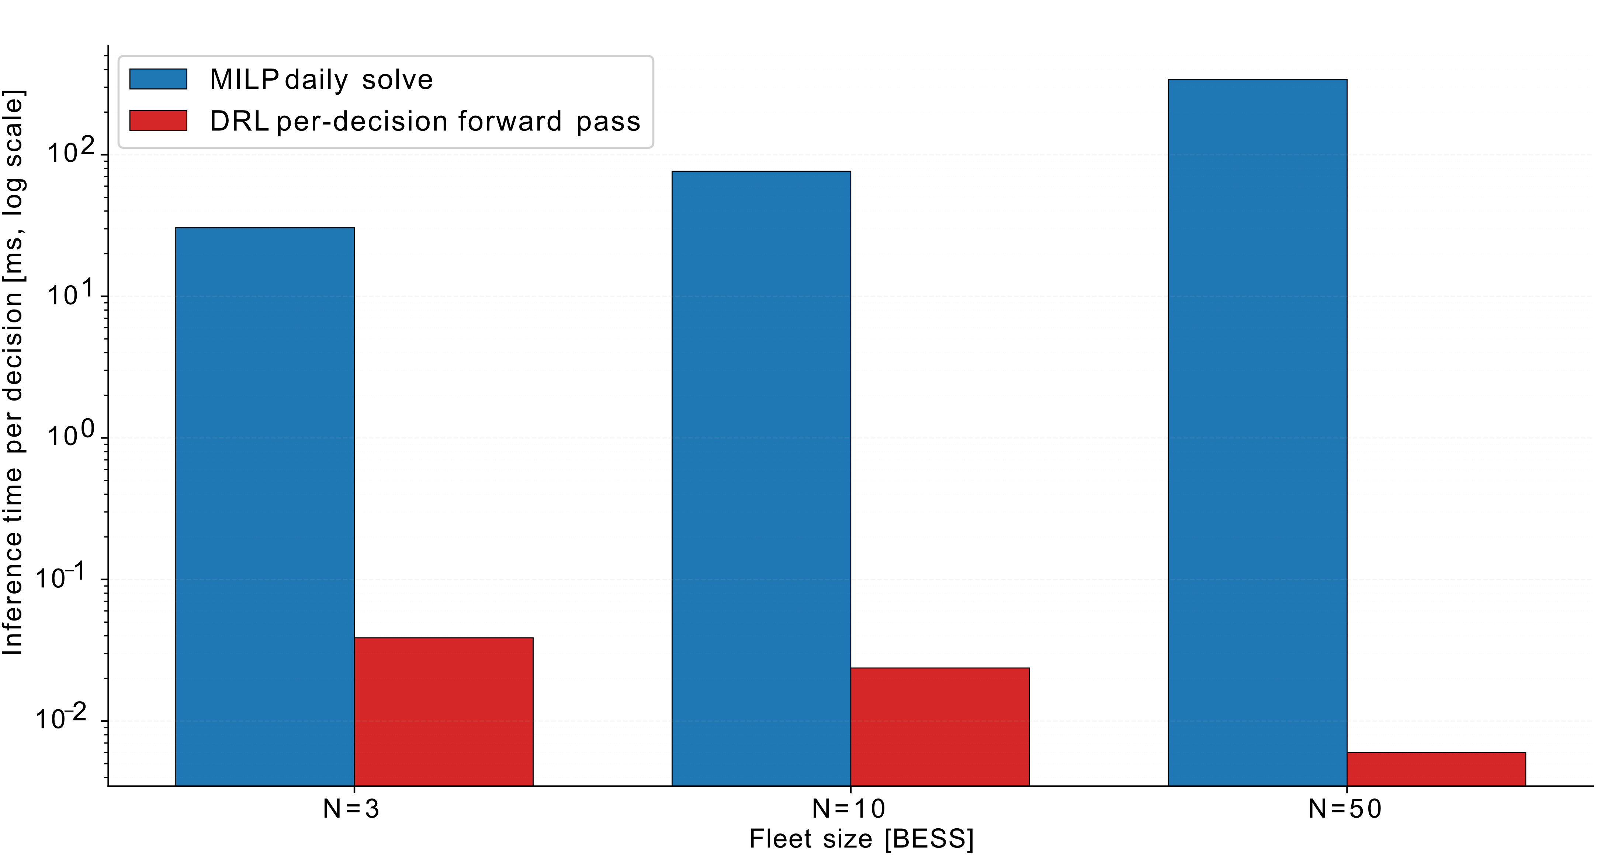
Fig. 6. Inference time per decision against fleet size (N = 3, 10, 50 BESS), on a logarithmic scale. The MILP daily solve grows with fleet size, whereas the DRL forward pass stays near-constant, so that, once both are expressed per day of fleet scheduling, the speedup widens from about thirtyfold to over three orders of magnitude.
- Conclusions
This work cast the coordinated scheduling of a fifty-unit battery fleet stacking energy and reserve services across the Italian day-ahead and balancing markets as a multi-agent reinforcement-learning task, benchmarked against a perfect-foresight mixed-integer optimizer executed in the same environment and warm-started from a behavioral clone of it. Closed-loop learning did not close the gap: warm-started, the policy reached roughly four-fifths of the benchmark, and from scratch about two-thirds. The market mix locates the loss. The optimizer concentrated on arbitrage and downward automatic restoration and held a low SOC to preserve headroom, whereas the agents dispersed into availability-paid products and accumulated charge, raising gross participation without a commensurate net gain. That reading is incomplete. Both schedulers receive the same 24-hour price path, so the policy holds an informational tie, and acting hour by hour on realized awards it also holds a closed-loop advantage the open-loop plan cannot have. A policy so placed should at least match the plan it is measured against. That it does not points not to the method but to what the reward makes attractive: capacity is remunerated on reservation, so an agent is paid for announcing availability rather than for delivering it, and learns to monetize participation instead of exploiting its adaptivity. Conditioning the capacity payment on the energy a unit can deliver at the delivery hour is therefore the first change to make, and it belongs to the market model rather than to the learning algorithm. Against this sits computational cost. The mixed-integer program scales unfavorably, from about 30 ms at N = 3 to 341 ms at N = 50, whereas the trained policy schedules a day in about 0.24 ms, a speedup beyond three orders of magnitude at fifty units that widens with the fleet. The learned scheduler therefore trades a portion of realized profit for real-time, fleet-scalable dispatch, in the regime where repeated optimization becomes impractical. Several limitations qualify these results. A single market design and fleet are considered, and the agents over-participate in availability-paid reserve. Each variant was trained once, so the difference between the warm-started and the randomly initialized agent carries no dispersion estimate and is indicative rather than tested; the two moreover differ in four respects at once, namely initialization, a tenfold lower learning rate, no entropy bonus, and the anchoring term, so it cannot be attributed to the warm start alone. The fifty units share one policy and are coupled only through the portfolio threshold, so the multi-agent formulation is not isolated against a centralized policy with a factored action space. Training prices awards in expectation while evaluation samples them, so the closed-loop advantage is available at evaluation but never exercised during training. Finally, both schedulers are granted perfect foresight and no published DRL baseline is included, so the forecast-free regime remains open. Future work will pursue online adaptation to non-stationary prices, larger and more diverse fleets, and additional market products and regulatory frameworks.

Acknowledgements This publication is part of the project “Network 4 Energy Sustainable Transition – NEST”, Project code PE0000021, Concession Decree No. 1561 of 11.10.2022 adopted by Ministero dell’Università e della Ricerca (MUR), CUP E13C22001890001, funded under the National Recovery and Resilience Plan (NRRP), Mission 4 Component 2 Investment 1.3, by the European Union – NextGenerationEU.
Author Contributions Lorenzo Giannuzzo: conceptualization, methodology, software, validation, formal analysis, investigation, data curation, visualization, writing – original draft. Daniele Salvatore Schiera: conceptualization, investigation, visualization. Francesco Demetrio Minuto: conceptualization, formal analysis, supervision, writing – review and editing. Andrea Lanzini: supervision, funding acquisition, writing – review and editing.

Data Availability The market data used in this study are publicly available from GME (https://www.mercatoelettrico.org), TERNA (https://www.terna.it), and ACER. The simulation environment, the optimizer, and the training code will be deposited in a public repository with a permanent identifier upon acceptance.

Competing Interests The authors declare that they have no known competing financial interests or personal relationships that could have appeared to influence the work reported in this paper.

References
- Mnih, V., Kavukcuoglu, K., Silver, D., Rusu, A.A., Veness, J., Bellemare, M.G., et al.: Human-level control through deep reinforcement learning. Nature 518(7540), 529–533 (2015).
- Mirzaei Alavijeh, N., Khezri, R., Mazidi, M., Steen, D., Tuan, L.A.: Optimal scheduling of battery storage systems in the Swedish multi-FCR market incorporating battery degradation and technical requirements. arXiv:2406.07301 (2024).
- Sutton, R.S., Barto, A.G.: Reinforcement Learning: An Introduction, 2nd edn. MIT Press, Cambridge (2018).
- Paredes, Á., Aguado, J.A., Essayeh, C., Xia, Y., Savelli, I., Morstyn, T.: Stacking revenues from flexible DERs in multi-scale markets using tri-level optimization. IEEE Transactions on Power Systems 39(2), 3949–3962 (2024).
- Gestore dei Mercati Energetici (GME): Vademecum to the Italian Power Exchange. GME, Rome (2025).
- Autorità di Regolazione per Energia Reti e Ambiente (ARERA): Resolution 345/2023/R/eel, Integrated Text of the Electricity Dispatching Rules (TIDE). ARERA, Milan (2023).
- Savelli, I., Howey, D.A., Morstyn, T.: Locating large-scale energy storage: spillover effects, carbon emissions, and balancing costs across Italy. Utilities Policy 95, 101937 (2025).
- Li, F., Hou, H., Ni, T., Wang, P., Wang, Y., Li, Z., Pouresmaeil, E.: A novel deep reinforcement learning framework for optimal scheduling of low-carbon integrated energy systems considering battery degradation. Energy 341, 139476 (2025).
- Zhang, Y., et al.: Optimal battery storage arbitrage considering degradation cost in energy markets. IEEE Transactions (2020).
- Hernandez-Leal, P., Kartal, B., Taylor, M.E.: A survey and critique of multiagent deep reinforcement learning. Autonomous Agents and Multi-Agent Systems 33(6), 750–797 (2019).
- Gronauer, S., Diepold, K.: Multi-agent deep reinforcement learning: a survey. Artificial Intelligence Review 55(2), 895–943 (2022).
- Koller, M., Borsche, T., Ulbig, A., Andersson, G.: Defining a degradation cost function for optimal control of a battery energy storage system. In: 2013 IEEE PowerTech, Grenoble (2013).
- Reniers, J.M., Mulder, G., Howey, D.A.: Unlocking extra value from grid batteries using advanced models. Journal of Power Sources 487, 229355 (2021).
- Sayfutdinov, T., et al.: Profitability of energy arbitrage for grid-scale battery energy storage considering dynamic efficiency and degradation using linear, mixed-integer linear, and mixed-integer non-linear optimization. Journal of Energy Storage 90, 111844 (2024).
- Powell, W.B.: Approximate Dynamic Programming: Solving the Curses of Dimensionality, 2nd edn. Wiley, Hoboken (2011).
- Birge, J.R., Louveaux, F.: Introduction to Stochastic Programming, 2nd edn. Springer, New York (2011).
- Mnih, V., et al.: Playing Atari with deep reinforcement learning. arXiv:1312.5602 (2013).
- Lillicrap, T.P., Hunt, J.J., Pritzel, A., Heess, N., Erez, T., Tassa, Y., Silver, D., Wierstra, D.: Continuous control with deep reinforcement learning. arXiv:1509.02971 (2015).
- Haarnoja, T., Zhou, A., Abbeel, P., Levine, S.: Soft actor-critic: off-policy maximum entropy deep reinforcement learning with a stochastic actor. arXiv:1801.01290 (2018).
- Schulman, J., Wolski, F., Dhariwal, P., Radford, A., Klimov, O.: Proximal policy optimization algorithms. arXiv:1707.06347 (2017).
- Sutton, R.S., McAllester, D., Singh, S., Mansour, Y.: Policy gradient methods for reinforcement learning with function approximation. In: Advances in Neural Information Processing Systems, vol. 12 (1999).
- Huang, B., Wang, J.: Deep-reinforcement-learning-based capacity scheduling for PV-battery storage system. IEEE Transactions on Smart Grid 12(3), 2272–2283 (2021).
- Li, J., Wang, C., Wang, H.: Deep reinforcement learning for wind and energy storage coordination in wholesale energy and ancillary service markets. Energy and AI 14, 100280 (2023).
- Li, J., Wang, C., Zhang, Y., Wang, H.: Temporal-aware deep reinforcement learning for energy storage bidding in energy and contingency reserve markets. IEEE Transactions on Energy Markets, Policy, and Regulation 2(3), 392–406 (2024).
- Sun, H., Xu, Y., Xia, Y., Xie, D., Zhang, R.: A learning based bidding strategy for energy arbitrage of battery energy storage systems in day-ahead electricity market. In: 2025 IEEE PES Innovative Smart Grid Technologies—Asia (ISGT Asia), Guangzhou, China (2025).
- Xu, H., Hu, Q., Wu, Q., Wang, K., Wu, F., Wen, J.: Deep multi-task multi-agent reinforcement learning based joint bidding and pricing strategy of price-maker load serving entity. IEEE Transactions on Power Systems 40(1), 505–518 (2025).
- Muthukumar, P.: Multi-agent deep reinforcement learning for joint scheduling of EV charging, solar PV, and BESS under real-time tariff feedback. In: 2026 IEEE 2nd International Conference on Quantum Photonics, Artificial Intelligence, and Networking (QPAIN), Chittagong, Bangladesh (2026).
- Wang, B., Xu, X., Wang, P.: Multi-market agency-based power procurement strategies for power grid companies using reinforcement learning. Applied Energy 402, 126959 (2026).
- Cao, D., et al.: Multi-agent deep reinforcement learning for efficient multi-timescale bidding of a hybrid power plant in day-ahead and real-time markets. Applied Energy 320, 119314 (2022).
- Tang, Q., Guo, H., Chen, Q.: Multi-market bidding behavior analysis of energy storage system based on inverse reinforcement learning. IEEE Transactions on Power Systems 37(6), 4819–4831 (2022).
- Hussein, A., Gaber, M.M., Elyan, E., Jayne, C.: Imitation learning: a survey of learning methods. ACM Computing Surveys 50(2), 1–35 (2017).
- Torabi, F., Warnell, G., Stone, P.: Behavioral cloning from observation. In: Proceedings of the 27th International Joint Conference on Artificial Intelligence (IJCAI), pp. 4950–4957 (2018).

