# **Add new futures to your opencart store**

## **Test Execution Report**

**Project:** OpenCart  
**Execution Date:** June 18, 2024

### **Tested Features**

#### **Feature: User Login**

**Tested Scenarios:**



* **Scenario: Successful login with valid credentials**
  + **Status:** Passed
  + **Duration:** 4.73 seconds
  + **Steps:**
    - User enters valid credentials in the login fields.
    - User presses the login button.
    - System grants access to the user.
* **Scenario: Failed login with invalid credentials**
  + **Status:** Passed
  + **Duration:** 1.43 seconds
  + **Steps:**
    - User enters invalid credentials in the login fields.
    - User presses the login button.
    - System displays an error message indicating incorrect credentials.

#### **Feature: Product Purchase**



**Tested Scenarios:**

* **Scenario: User purchases a product (example #1)**
  + **Status:** Passed
  + **Duration:** 11.76 seconds
  + **Steps:**
    - User selects a product.
    - User adds the product to the cart.
    - User proceeds to checkout.
    - User completes the purchase.
* **Scenario: User purchases a product (example #2)**
  + **Status:** Failed
  + **Duration:** 9.46 seconds
  + **Steps:**
    - User selects a product.
    - User adds the product to the cart.
    - User proceeds to checkout.
    - **Failure:** The system cannot continue and complete the purchase.
    - **Identified Bug:** The product Apple Cinema 30" requires a radio button to be selected to add to the cart correctly. This radio button does not appear on the page.

#### **Feature: User Registration**

**Tested Scenarios:**

### 

* **Scenario: Successful registration with valid details**
  + **Status:** Passed
  + **Duration:** 5.34 seconds
  + **Steps:**
    - User enters valid details in the registration form.
    - User presses the registration button.
    - System registers the user and displays a welcome message.
* **Scenario: Failed registration with invalid details**
  + **Status:** Passed
  + **Duration:** 3.91 seconds
  + **Steps:**
    - User enters invalid details in the registration form.
    - User presses the registration button.
    - System displays an error message indicating invalid details.

#### **Feature: View and Edit Cart**

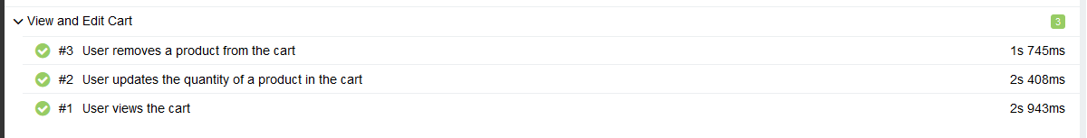

**Tested Scenarios:**

* **Scenario: User views the cart**
  + **Status:** Passed
  + **Duration:** 2.95 seconds
  + **Steps:**
    - User opens the cart.
    - System displays the products in the cart.
* **Scenario: User updates the quantity of a product in the cart**
  + **Status:** Passed
  + **Duration:** 2.39 seconds
  + **Steps:**
    - User selects a product in the cart.
    - User updates the quantity of the product.
    - System updates the quantity and displays the new total.
* **Scenario: User removes a product from the cart**
  + **Status:** Passed
  + **Duration:** 1.72 seconds
  + **Steps:**
    - User selects a product in the cart.
    - User removes the product.
    - System removes the product from the cart and updates the total.

#### **Feature: Add to Cart**



**Tested Scenario:**

* **Scenario: User adds a product to the cart**
  + **Status:** Passed
  + **Duration:** 2.62 seconds
  + **Steps:**
    - User selects a product.
    - User adds the product to the cart.
    - System displays the product in the cart.

### **Summary of Results**

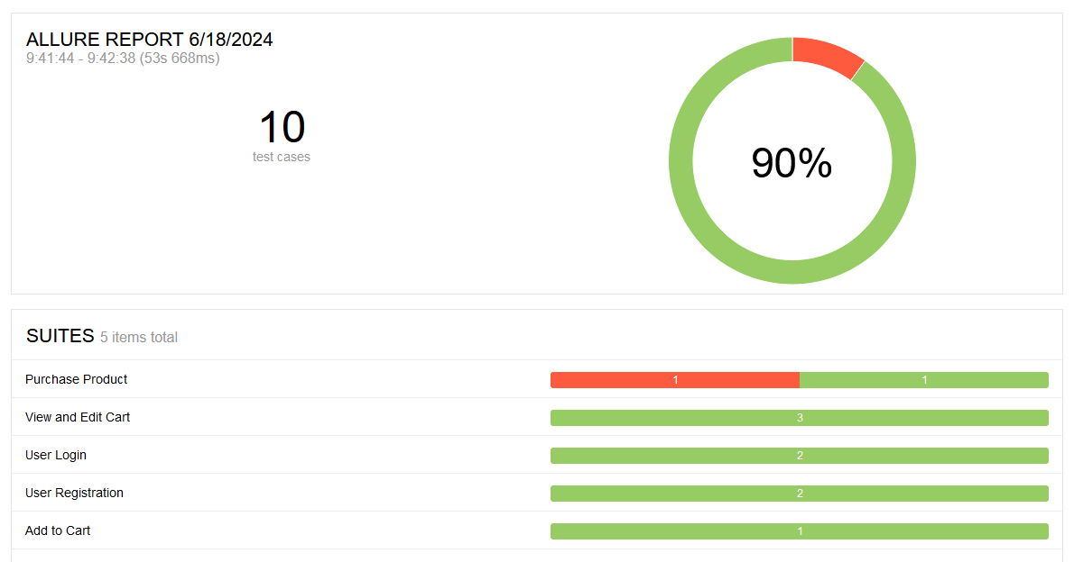

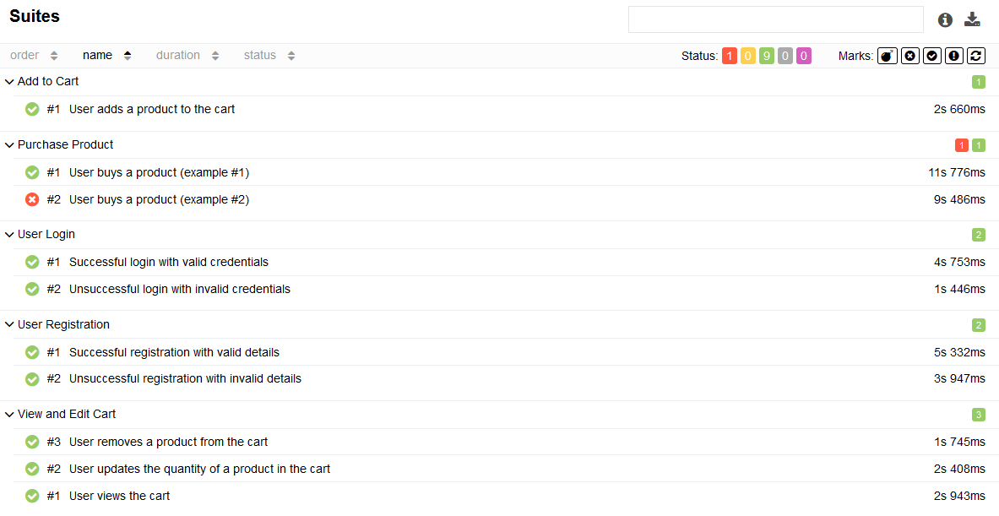

* **Total Features Tested:** 5
* **Total Scenarios Tested:** 10
* **Total Scenarios Passed:** 9
* **Total Scenarios Failed:** 1

### **Conclussion**

Most tests were executed successfully, validating the system functionalities. However, a critical bug was identified during the product purchase flow for a specific product due to the missing radio button on its detail page. This issue needs to be resolved as soon as possible.

### **Identified Bug:**

* **Description:** The system does not find the #button-payment-address button necessary to complete the purchase in the product purchase scenario (example #2).
* **Impact:** The user cannot complete the purchase of the product.
* **Priority:** High