## 



## **Test Execution Report**

**Project:** Rick and Morty  
**Execution Date:** June 15, 2024

### **Tested Features**

#### **Feature: Character Search by Name**

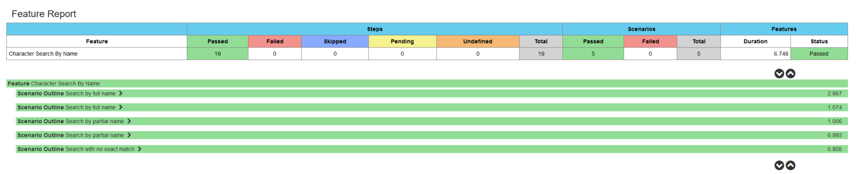

**Tested Scenarios:**

* **Scenario: Search by full name (Rick Sanchez)**
  + **Status:** Passed
  + **Duration:** 2.95 seconds
  + **Steps:**
    - User enters "Rick Sanchez" in the search field.
    - User presses the search button.
    - System displays the details for "Rick Sanchez."
    - Details include name, status, location, image, and episodes.
* **Scenario: Search by full name (Morty Smith)**
  + **Status:** Passed
  + **Duration:** 1.12 seconds
  + **Steps:**
    - User enters "Morty Smith" in the search field.
    - User presses the search button.
    - System displays the details for "Morty Smith."
    - Details include name, status, location, image, and episodes.
* **Scenario: Search by partial name (Rick)**
  + **Status:** Passed
  + **Duration:** 1.0 seconds
  + **Steps:**
    - User enters "Rick" in the search field.
    - User presses the search button.
    - System displays a list of characters that include "Rick" in their name.
    - Each character in the list shows name, status, location, image, and episodes.
* **Scenario: Search by partial name (Morty)**
  + **Status:** Passed
  + **Duration:** 1.13 seconds
  + **Steps:**
    - User enters "Morty" in the search field.
    - User presses the search button.
    - System displays a list of characters that include "Morty" in their name.
    - Each character in the list shows name, status, location, image, and episodes.
* **Scenario: Search with no exact match (Rack Sanchez)**
  + **Status:** Passed
  + **Duration:** 0.90 seconds
  + **Steps:**
    - User enters "Rack Sanchez" in the search field.
    - User presses the search button.
    - System offers suggestions close to "Rick Sanchez."

#### **Feature: Filter Characters by Status**

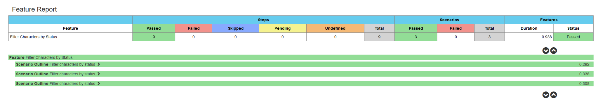

**Tested Scenarios:**

* **Scenario: Filter by status (alive)**
  + **Status:** Passed
  + **Duration:** 0.67 seconds
  + **Steps:**
    - User filters characters by status "alive."
    - User presses the status search button.
    - System displays a list of characters with status "alive."
* **Scenario: Filter by status (dead)**
  + **Status:** Passed
  + **Duration:** 0.32 seconds
  + **Steps:**
    - User filters characters by status "dead."
    - User presses the status search button.
    - System displays a list of characters with status "dead."
* **Scenario: Filter by status (unknown)**
  + **Status:** Passed
  + **Duration:** 0.29 seconds
  + **Steps:**
    - User filters characters by status "unknown."
    - User presses the status search button.
    - System displays a list of characters with status "unknown."

#### **Feature: Obtain Character Details by ID**

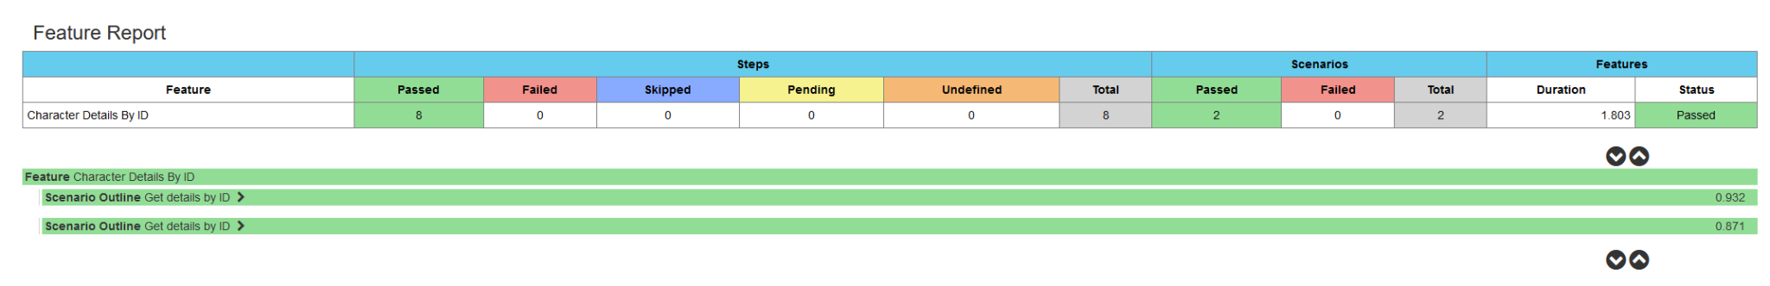

**Tested Scenarios:**

* **Scenario: Get details by ID (1)**
  + **Status:** Passed
  + **Duration:** 1.0 seconds
  + **Steps:**
    - User has the ID "1."
    - User requests details for the character.
    - System displays the details of the character with ID "1."
    - Details include name, status, species, gender, origin, location, image, and episodes.
* **Scenario: Get details by ID (2)**
  + **Status:** Passed
  + **Duration:** 1.19 seconds
  + **Steps:**
    - User has the ID "2."
    - User requests details for the character.
    - System displays the details of the character with ID "2."
    - Details include name, status, species, gender, origin, location, image, and episodes.

#### **Feature: Obtain Episode Details by ID**

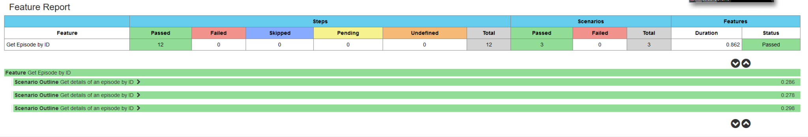

**Tested Scenarios:**

* **Scenario: Get episode details by ID (1)**
  + **Status:** Passed
  + **Duration:** 0.50 seconds
  + **Steps:**
    - User knows the episode ID "1."
    - User requests details for the episode.
    - System displays the details of the episode with ID "1."
    - Details include name, air date, and characters.
* **Scenario: Get episode details by ID (2)**
  + **Status:** Passed
  + **Duration:** 0.37 seconds
  + **Steps:**
    - User knows the episode ID "2."
    - User requests details for the episode.
    - System displays the details of the episode with ID "2."
    - Details include name, air date, and characters.
* **Scenario: Get episode details by ID (10)**
  + **Status:** Passed
  + **Duration:** 0.29 seconds
  + **Steps:**
    - User knows the episode ID "10."
    - User requests details for the episode.
    - System displays the details of the episode with ID "10."
    - Details include name, air date, and characters.

**Summary of Results**

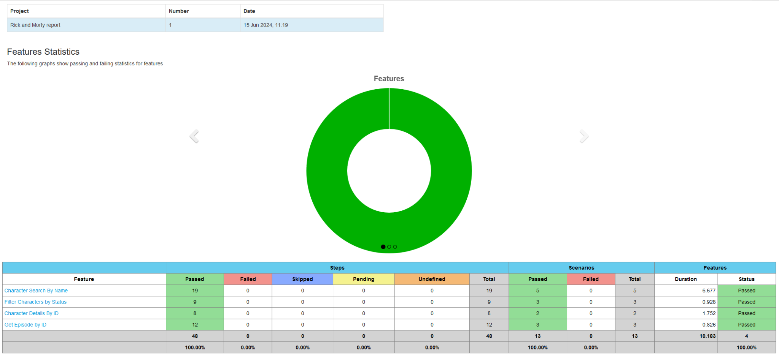

* **Total Features Tested:** 4
* **Total Scenarios Tested:** 10
* **Total Scenarios Passed:** 10
* **Total Scenarios Failed:** 0

### **Conclussion**

All tests were executed successfully, and all functionalities were validated successfully. The system meets the defined acceptance criteria and is ready for release.