Practical assignments

Algorithms

**Assignment No.0 (10min)**

The algorithm is the list with actions that are needed to get the goal.

For example, to bake a cake

* Buy all ingredients;
* Mix together all ingredients in the bowl;
* Preheat the oven to 175°C.
* Put mixed ingredients in the oven for 40min.
* Eat a cake!

Or use this recipe for advance example:

<https://www.bbcgoodfood.com/recipes/angel-cake-meringue-icing-strawberry-ganache>

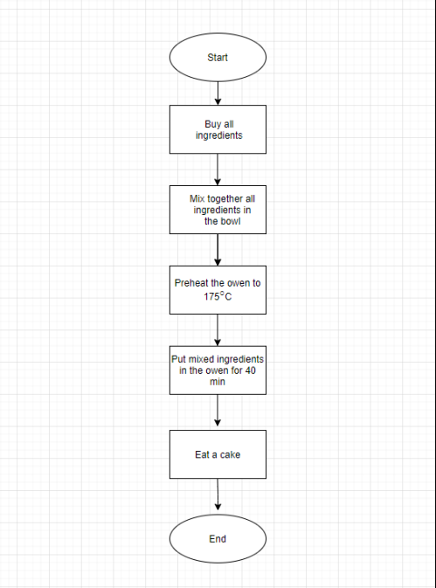

**Assignment No.2 (20min)**

Create an algorithm - what to do today!

An information:

Mary woke up at 7 AM. She asked herself - is this day a holiday? She can’t remember. If this day is a working day - need to go to work. If this day is a holiday - need to take a look at the weather forecast. If the forecasts show the possibility of rain - need to go to the Shopping center, if not - need to go to the beach.

* How many options Mary has?
* Please take a look here:

<https://www.lucidchart.com/pages/templates/flowchart/sample-flowchart-template>

* Create a flowchart of all options of Mary activities.

Another example:

<https://www.lucidchart.com/pages/templates/flowchart/decision-flowchart-template>

Flowchart 2

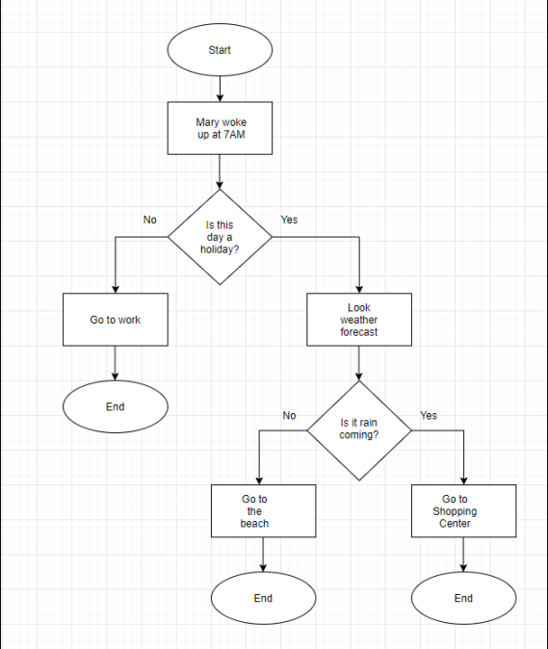

**Assignment No.3 (40min)**

Algorithms are used in programming as well. If we need to create a program with the specific goal, the list of the actions should be described.

Please take a look here:

<https://www.lucidchart.com/pages/templates/flowchart/algorithm-flowchart-template>

* Create and algorithm how to find out which is larger $2^{3}$ or $3^{2}$

Flowchart 3

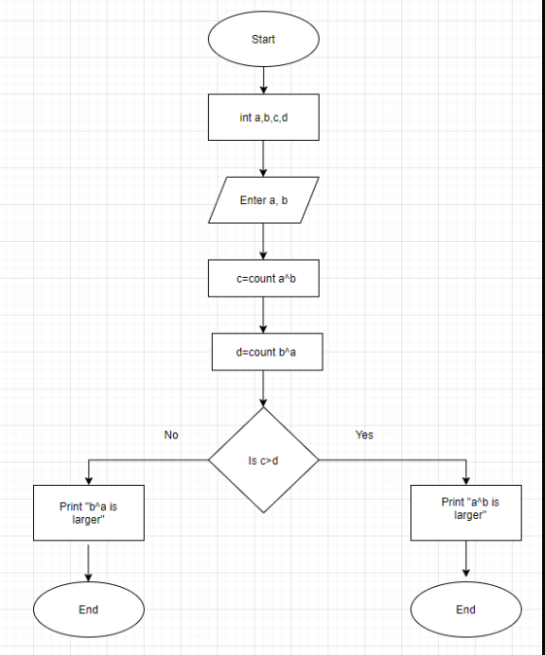

* Create and algorithm how to solve this equation:



Flowchart 4

