Loreto E Eclevia

Bellevue University

Module 10.2

July 21, 2024

* Shared Code Repository (Collaboration on GitHub Repository).

What an exciting practice. Excited about learning this.

On the index.html code, I made a correction on the spelling of my First Name. It was misspelled as Lorento, so I remodified it to Loreto.

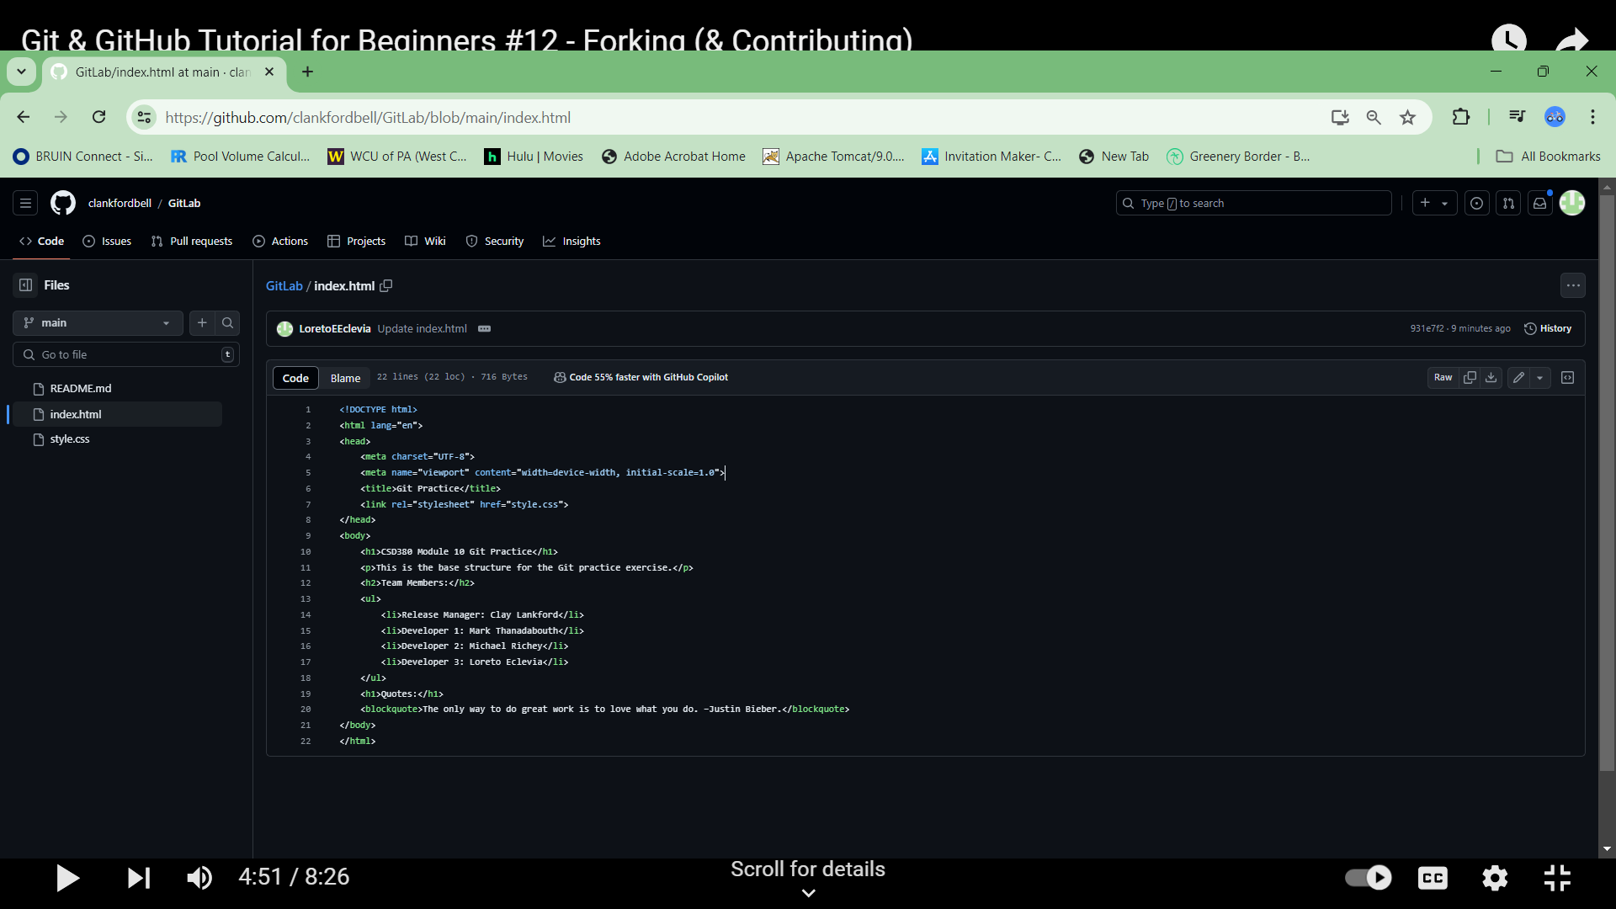

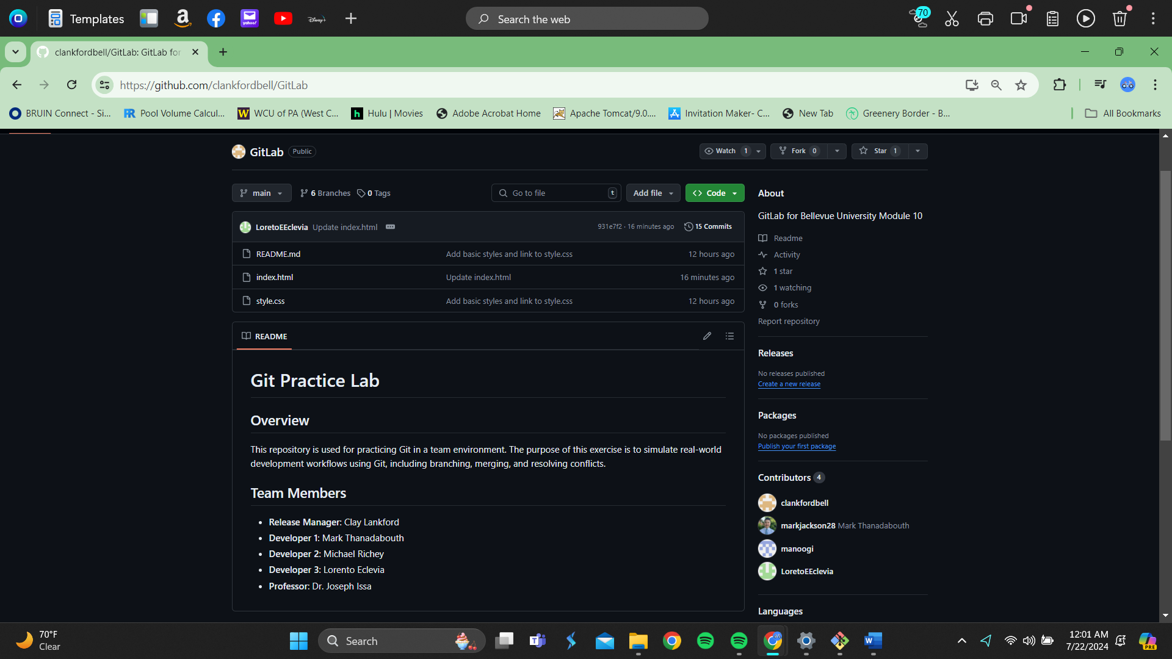

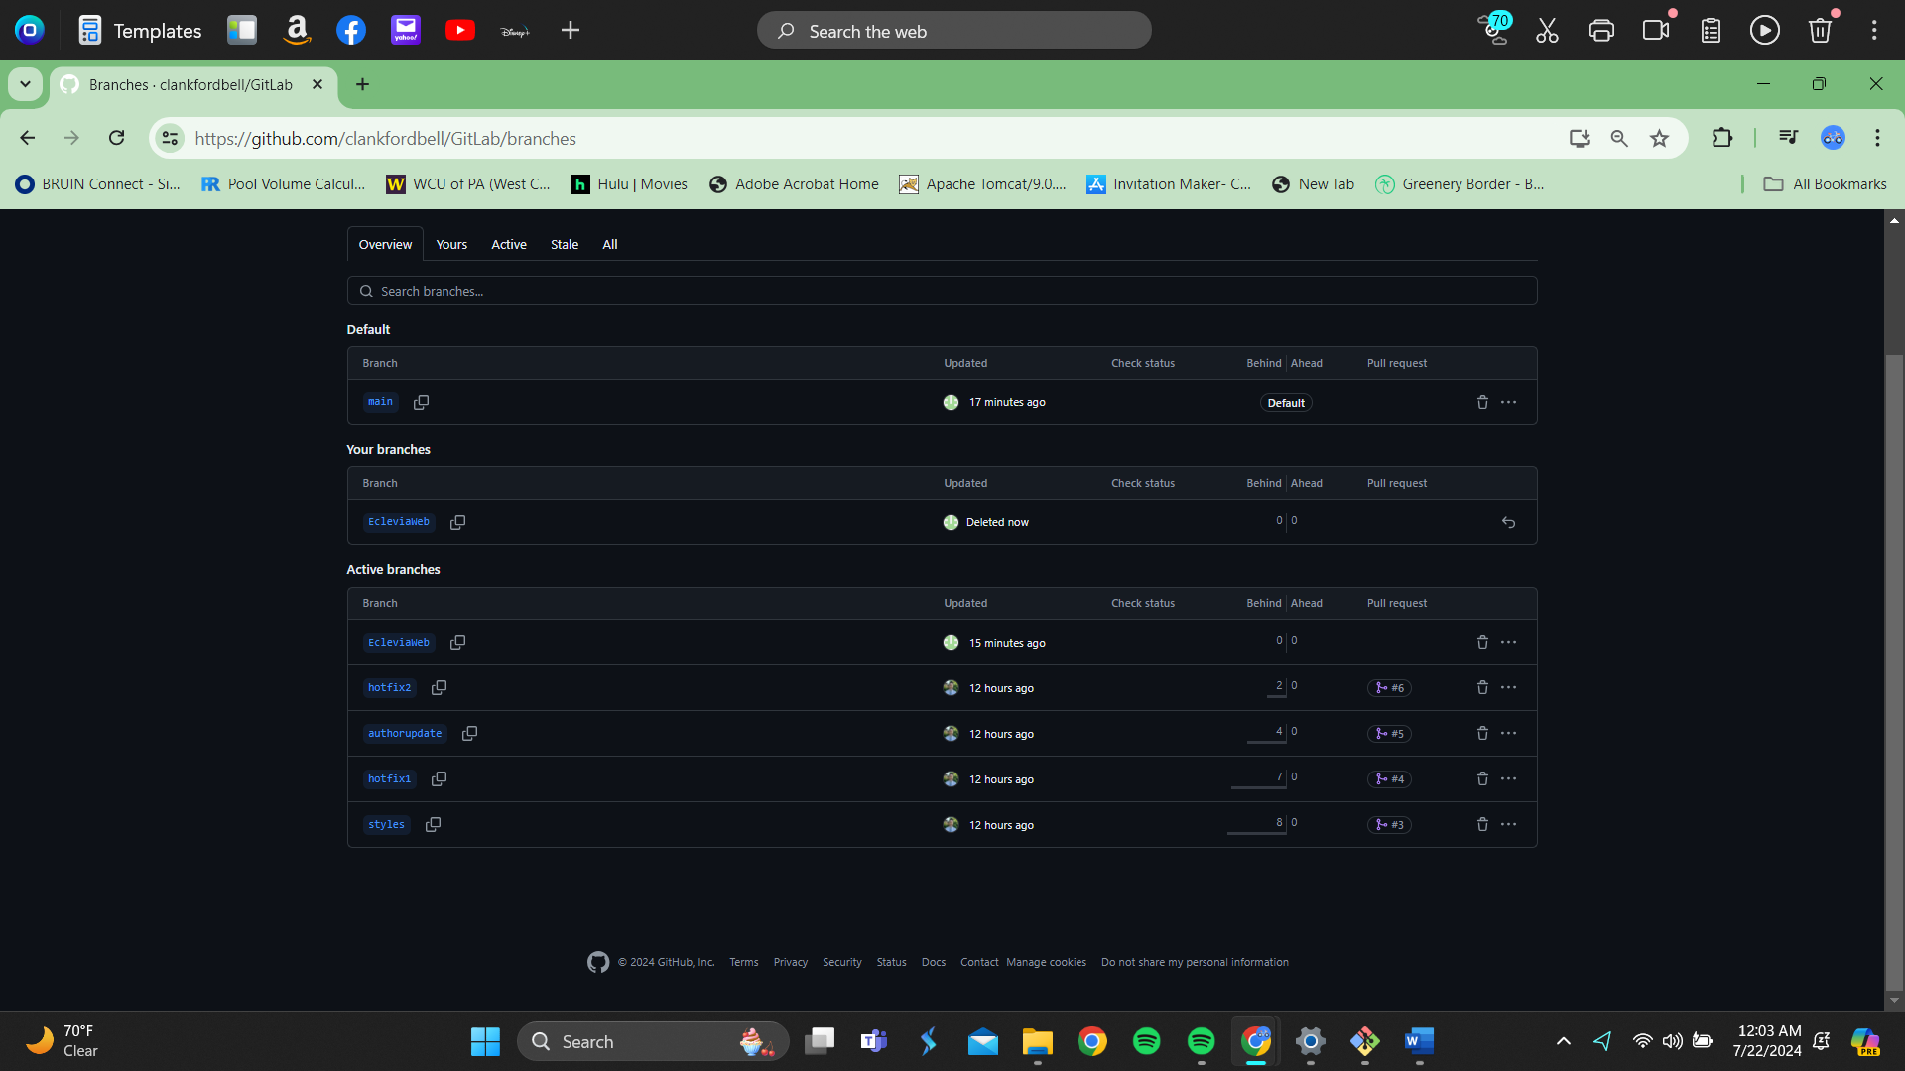I created a branch for myself

Updated index.