Loreto E Eclevia

Bellevue University

Module 6.2

June 30, 2024

According to the case study presented in Chapter 13, the Case of Blackboard Learn's Software Transformation (2011) delves into the process by which the educational technology firm, Blackboard Learn, adopted a software architecture strategy called the Strangler Pattern to overhaul its current system. This strategy involves gradual replacement of an old system with a new one, where the new system slowly engulfs the old one until it is fully replaced. In other words, the Strangler Pattern uses a step-by-step method for replacing an outdated system with a new one in which the new system progressively chokes out the old system until it is replaced entirely.

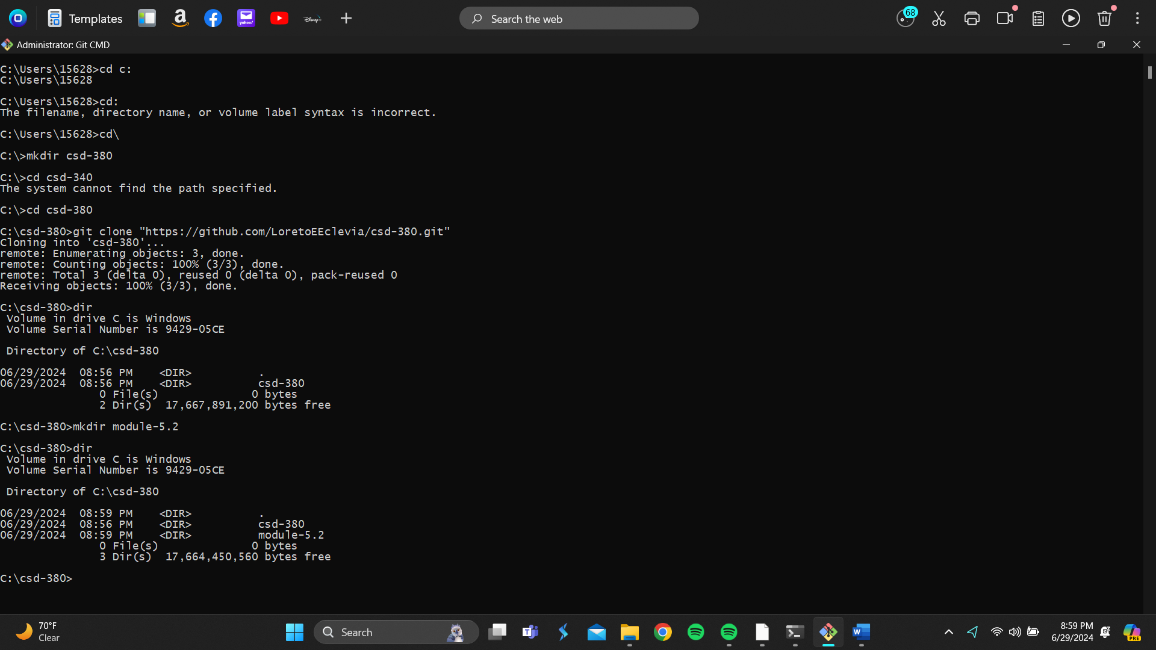

**REFERENC**

DevOps Handbook: Kim. (2016). DevOps Handbook (2nd ed.). National Book Network.