Project Report

Architecture Diagram :

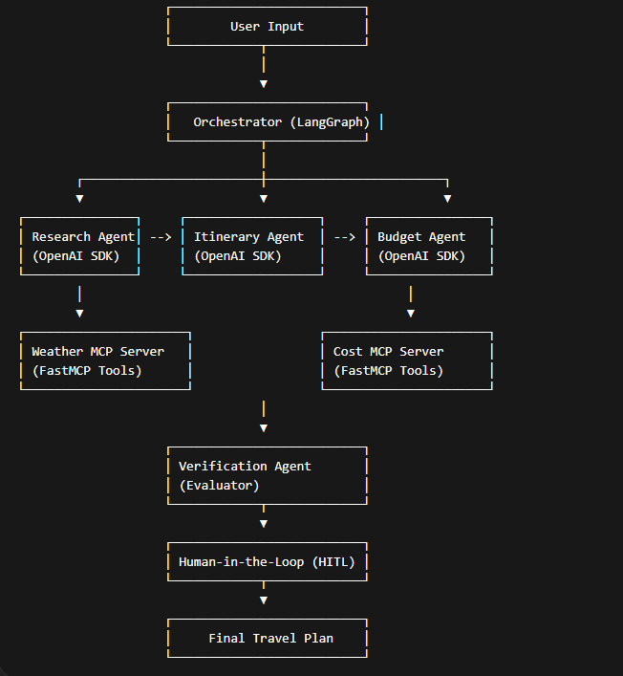
The system uses LangGraph as an orchestrator to manage state and workflow.
“Agents are implemented using the OpenAI Agents SDK with Groq as the LLM backend. LangGraph is used as the orchestration layer managing state and agent execution flow.”
The architecture follows:
- Orchestrator-Workers pattern
- Prompt Chaining
- Evaluator-Optimizer
The system integrates two custom MCP servers (Weather and Cost) built with FastMCP.
These servers expose tools that are consumed by agents through HTTP clients, enabling real-time external data access.
This ensures modularity, extensibility, and compliance with the MCP architecture requirements.
A Human-in-the-Loop checkpoint ensures reliability before final output.

Project Structure :

travel-assistant/
│
├── agents/
│ ├── research_agent.py
│ ├── itinerary_agent.py
│ ├── budget_agent.py
│ ├── verification_agent.py
│
├── mcp_servers/
│ ├── cost_api.py
│ ├── cost_mcp.py
│ ├── weather_api.py
│ ├── weather_mcp.py
│
├── mcp_clients/
│ ├── weather_client.py
│ ├── cost_client.py
│
├── graph/
│ ├── workflow.py
│
├── config/
│ ├── llm.py
│
│
├── main.py
├── .env
├── requirements.txt
└── README.md

System performance :

The system can provide a traveling plan based on the input of the clients.
It gives the Itineary and the estimate cost of the travel.
Normally the system shouldn’t crash.

