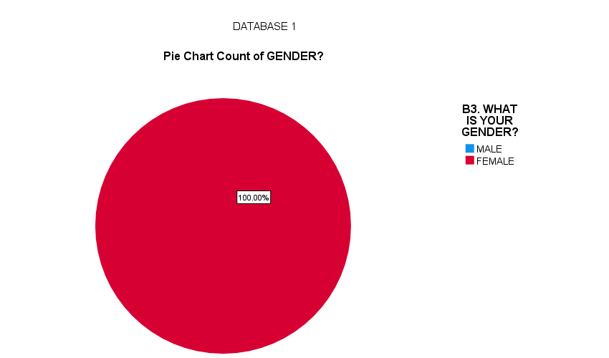

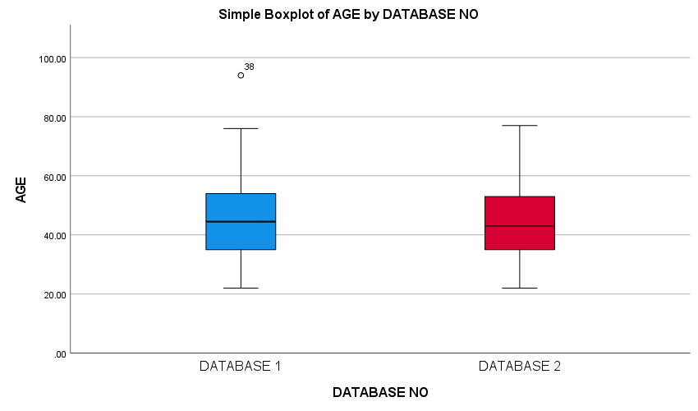

 | DATASET |  |  | SAMPLE SIZE
 | Mean Difference | 95% Confidence interval of the difference |  | Mean Difference | 95% Confidence Interval of the Difference
 |  | Lower | Upper |  | Lower | Upper
B4. WHAT IS YOUR AGE? | 42.285 | 41.27 | 43.30 | 45.81429 | 42.3363 | 49.2923
C1. ON AVERAGE, HOW MANY CHILDREN DO YOU PROVIDE CARE FOR WHEN YOU HAVE MOST OF THE CHILDREN? | 5.408 | 5.03 | 5.78 | 9.81429 | 6.8132 | 12.8154
D2. WHAT IS THE FEE YOU CHARGE FOR CHILDCARE PER CHILD PER DAY? (ESTIMATE PER DAY IN KES) | 106.4087 | 73.893 | 138.924 | 158.63636 | 56.7549 | 260.5178

The table compares the mean and confidence interval of the data set containing 684 respondents and the sample size of 70 respondents.
The objective of the analysis is to determine whether the sample size is likely drawn from the dataset by comparing mean differences and their associated confidence interval (95%). The mean difference of age in the data set is 42.285 with a confidence interval of (41.27, 43.30) while the mean difference of the sample size is 45.81429 with a confidence interval of (42.3363, 49.2923).
For the Average number of Children, Dataset 1 has an average Mean of 5.408 with 95% Confidence Interval of [5.03, 5.78] and Dataset 2 as an average Mean of 9.814 and 95% Confidence Interval of [6.813, 12.815]. Dataset 2 exhibits a significantly higher average number of children under care compared to Dataset 1. The confidence intervals do not overlap, indicating a statistically significant increase. This suggests a potential rise in childcare demand or increased capacity of childcare providers in Dataset 2.
Fee Charges for Childcare Per Child indicates an average mean of 106.409 and 95% Confidence Interval of [73.893, 138.924] for database 1, 95% Confidence Interval [56.755, 260.518] and average Mean of 158.636 for Dataset 2. The indicates that fee charged per child is higher in Dataset 2.

