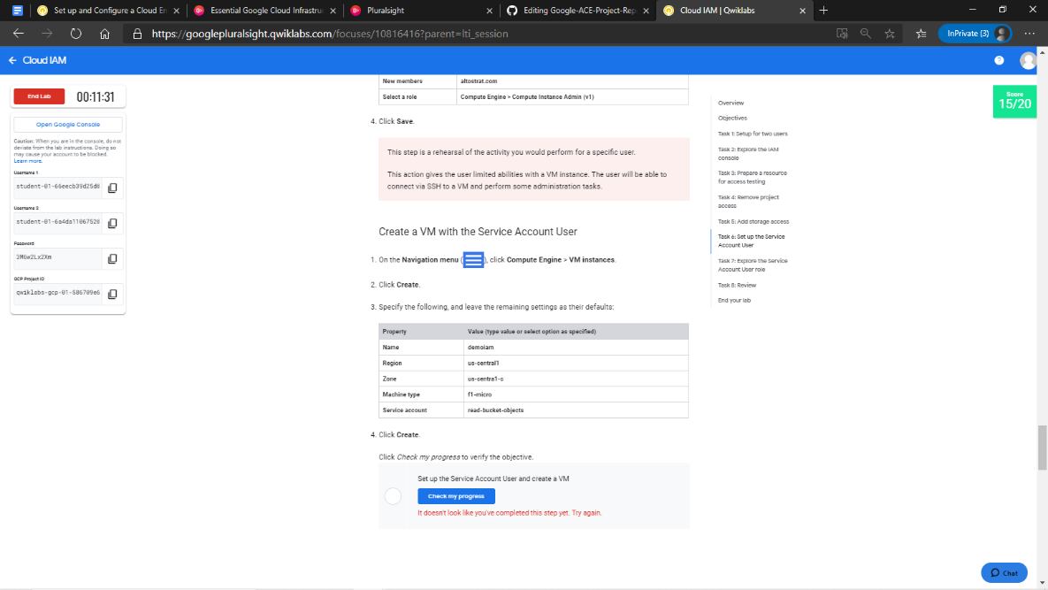1. Project Access Management with Cloud IAM

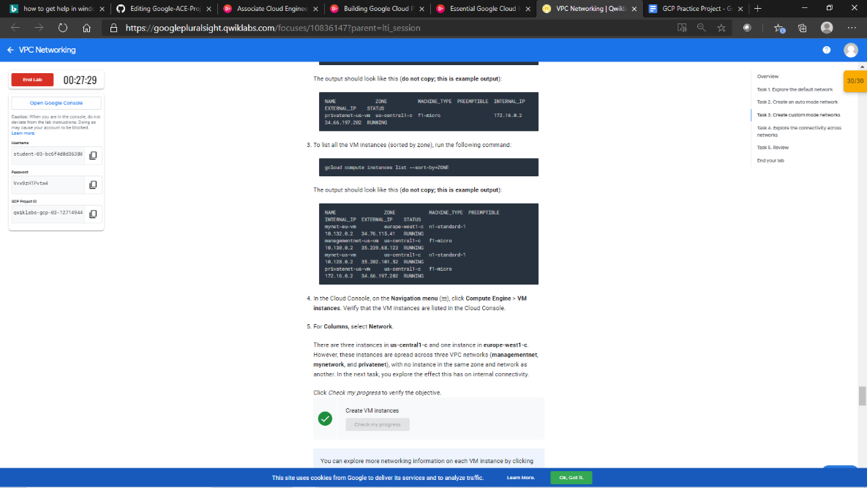2. Network Management with VPC Networks

3. Cloud Computing Provisioning (Virtual Machines) with Compute Engine

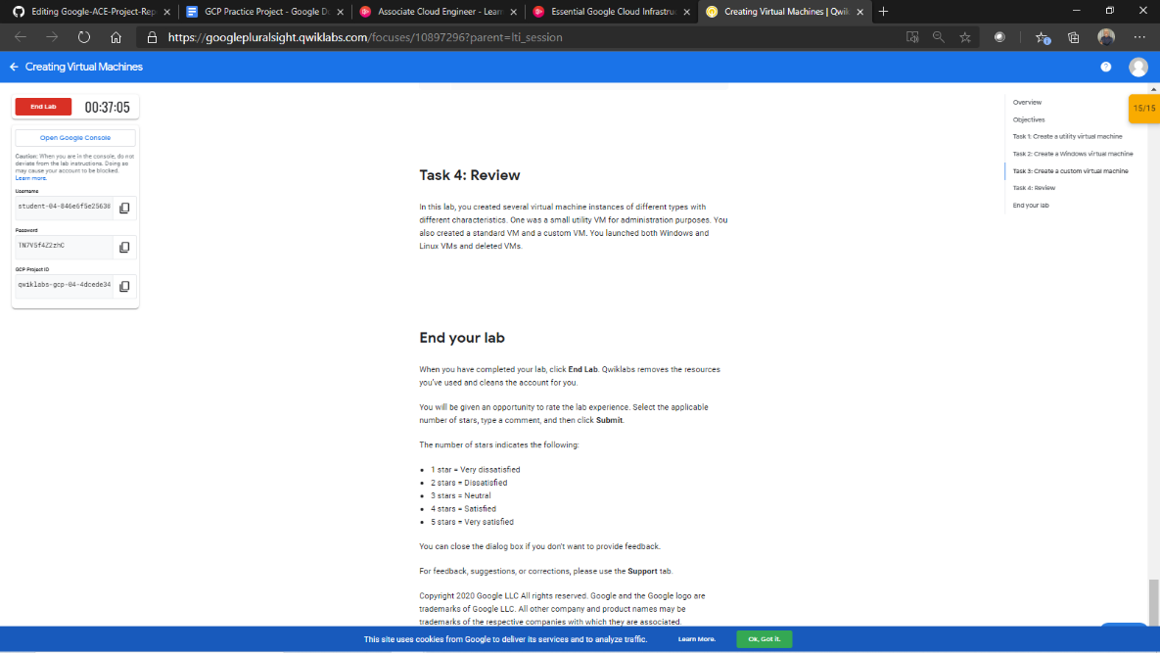

3.1 Working with Virtual Machines

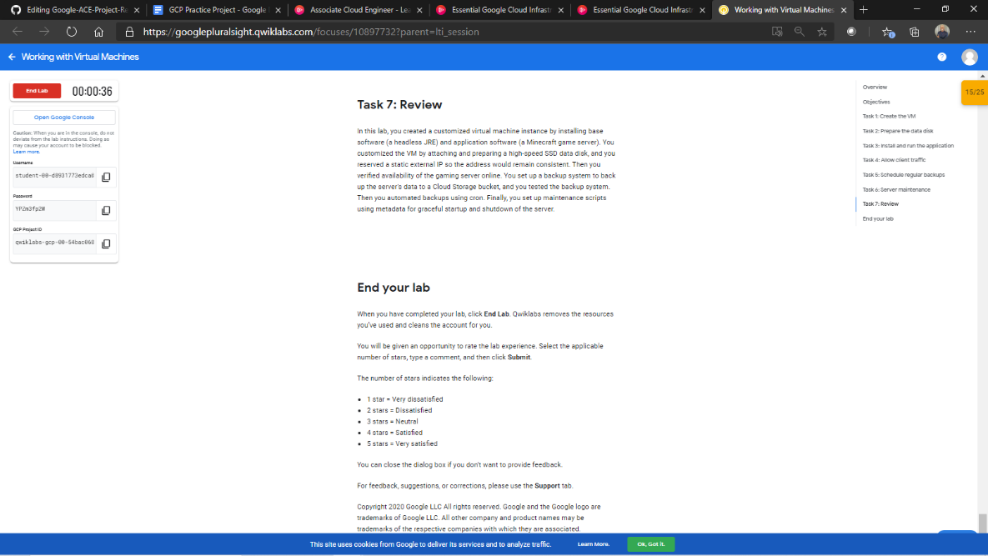

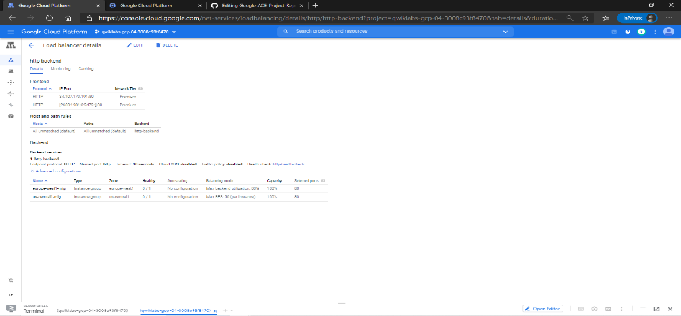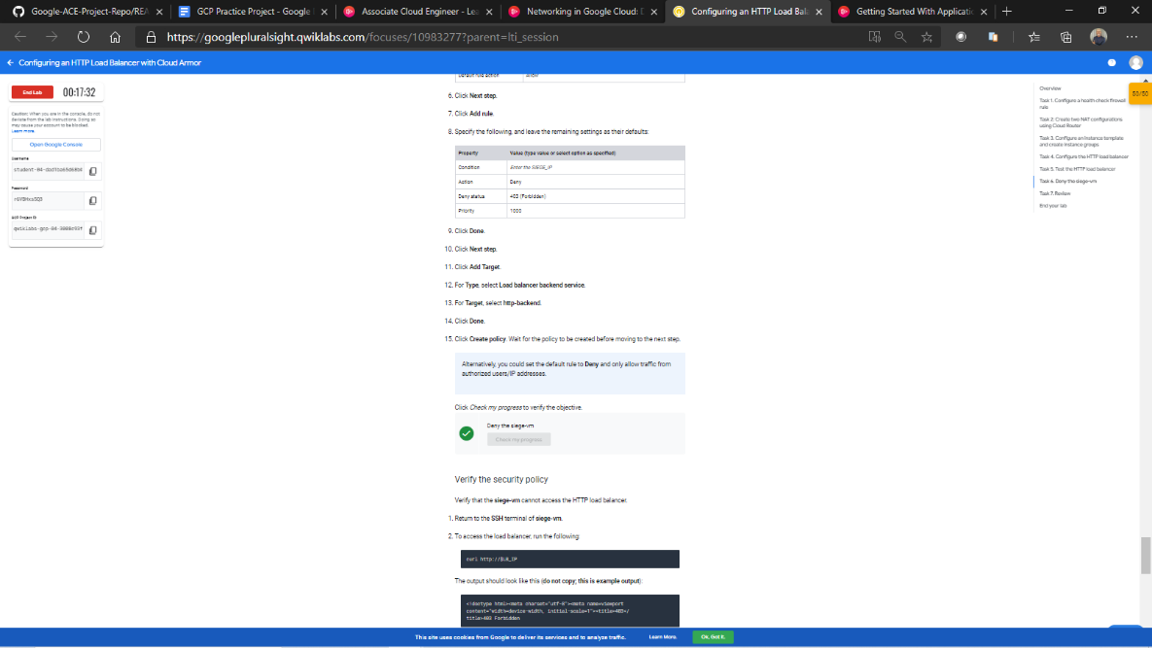4. Load Balancer and Cloud Armor

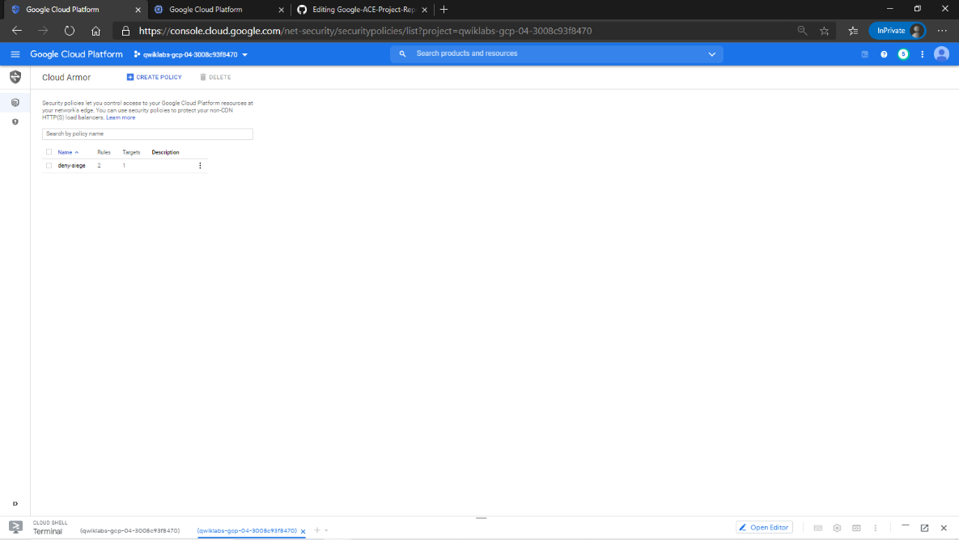

5. Kubernetes

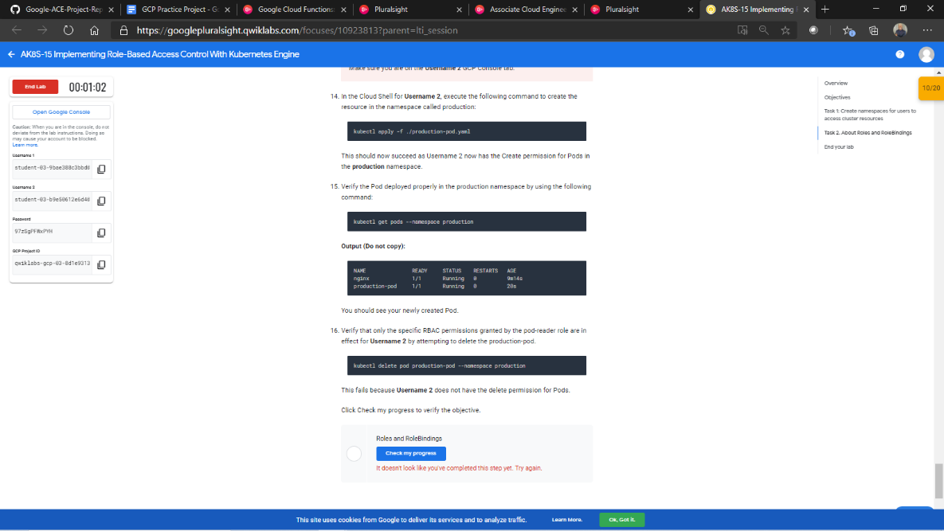

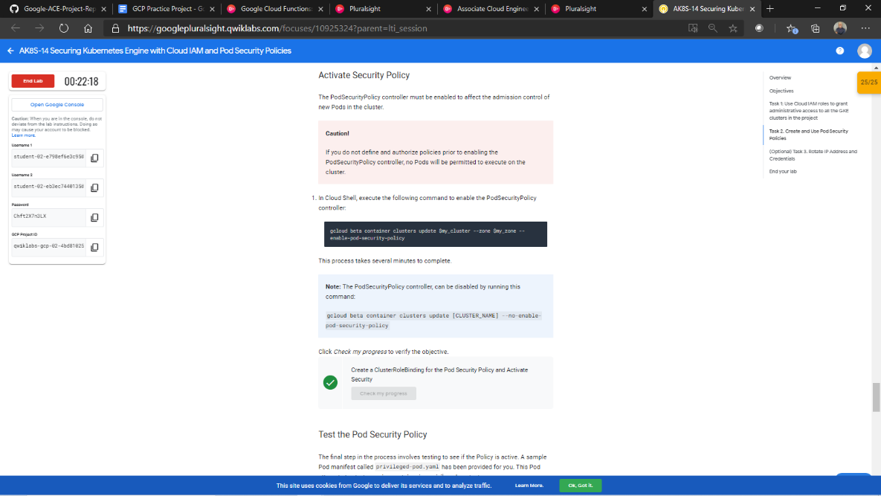

6. Cloud SQL, BigQuery and Machine Learning – Data Management and Data Analytics

6.1 Exploring a BigQuery Public Dataset

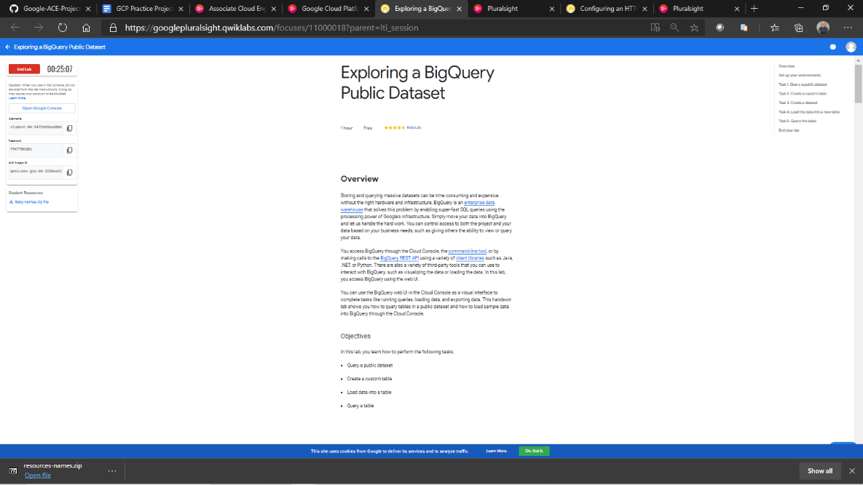

6.2 Recommending Products Using Cloud SQL and Spark

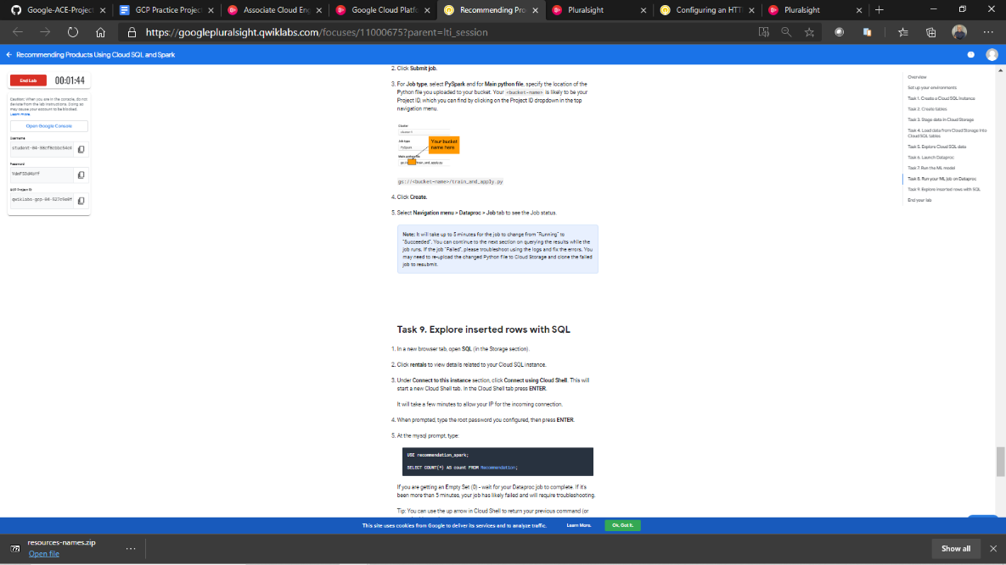

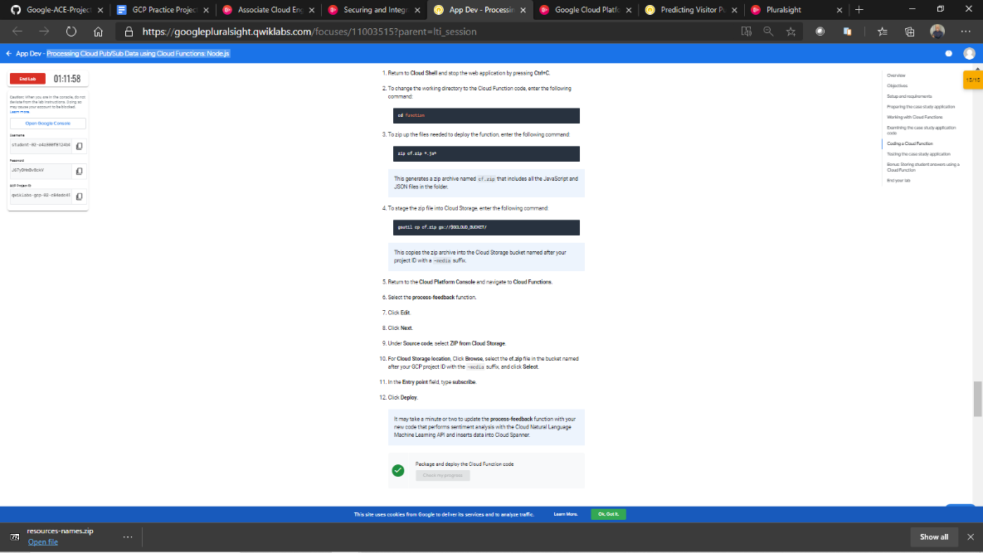7. Cloud Functions and Cloud Pub/Sub

8. Deployment Manager and Cloud Monitoring with StackDriver