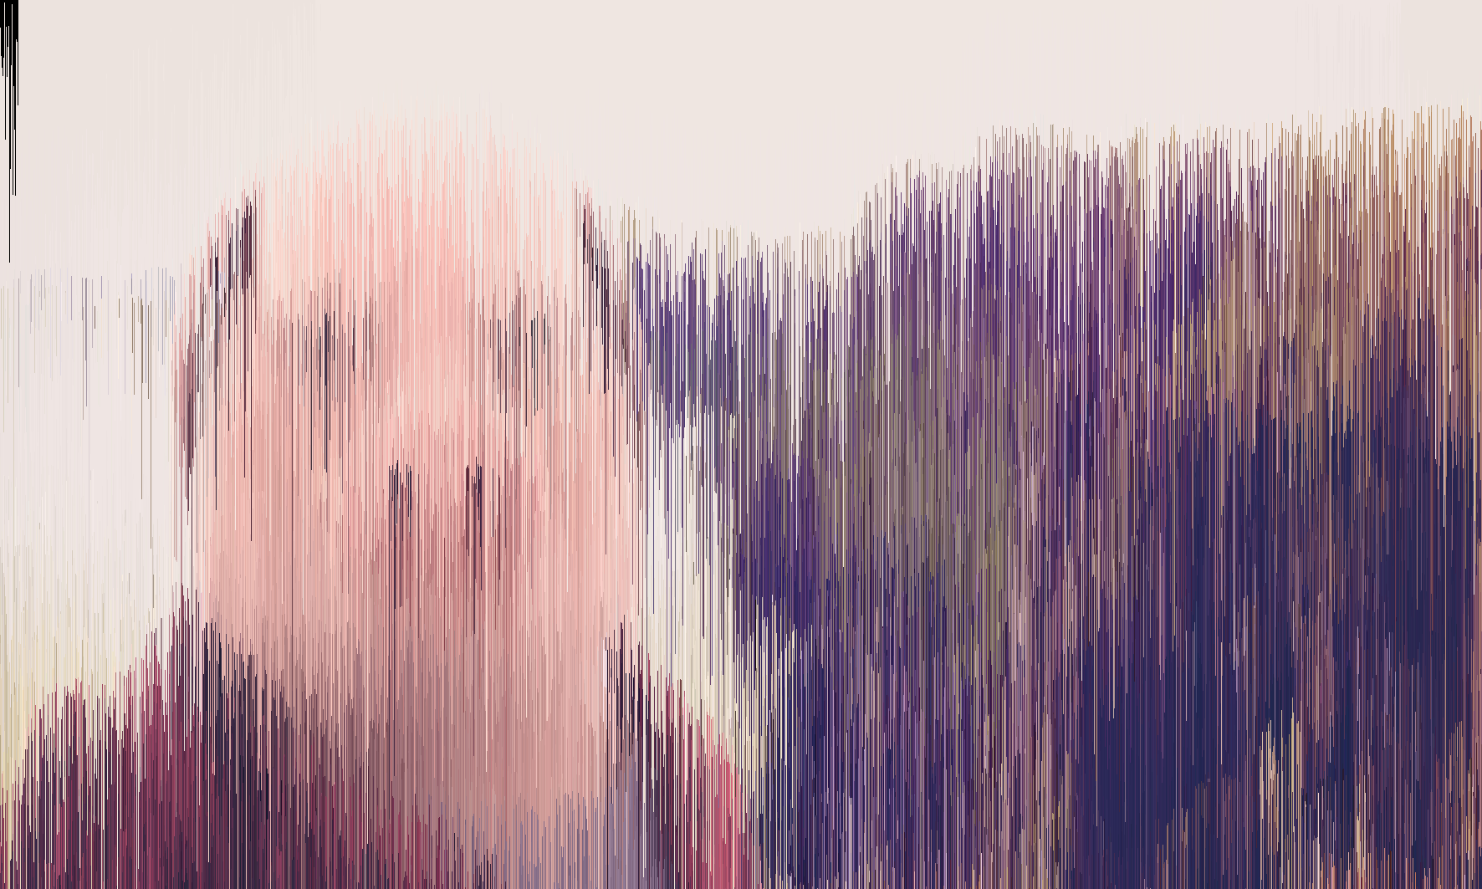
How to code an Image denoiser in Java?

- What is an image denoiser?
The goal of an image denoiser is to remove noise from an image. And make it look like before the noising. Here is an example: Original:
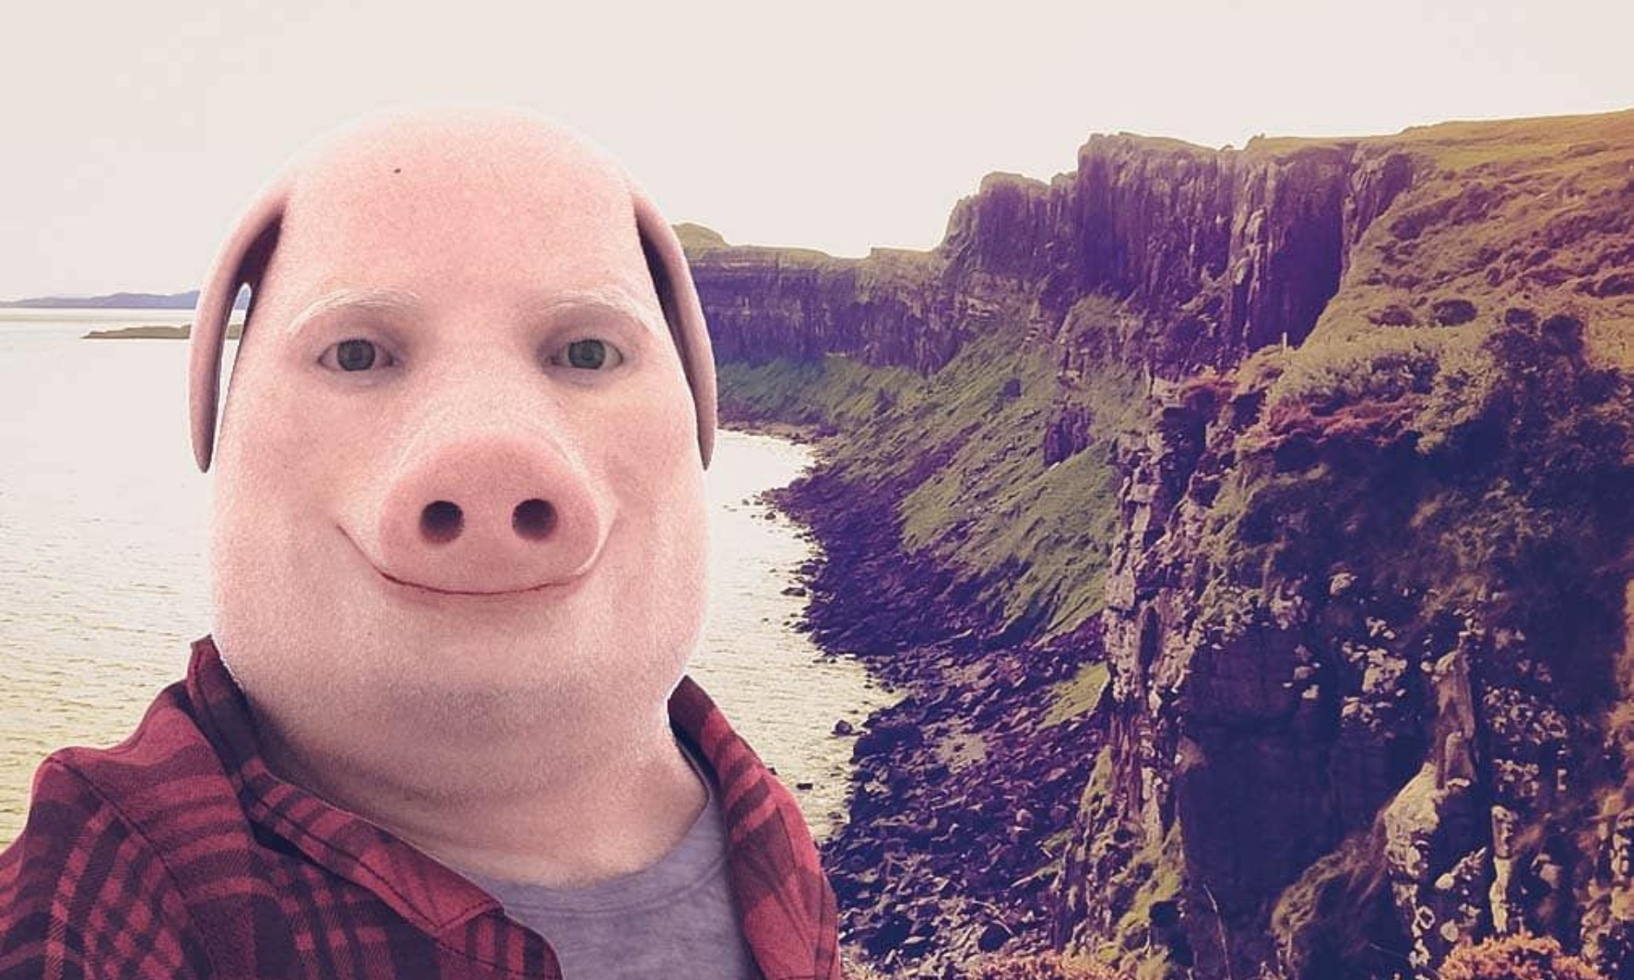
With noise:
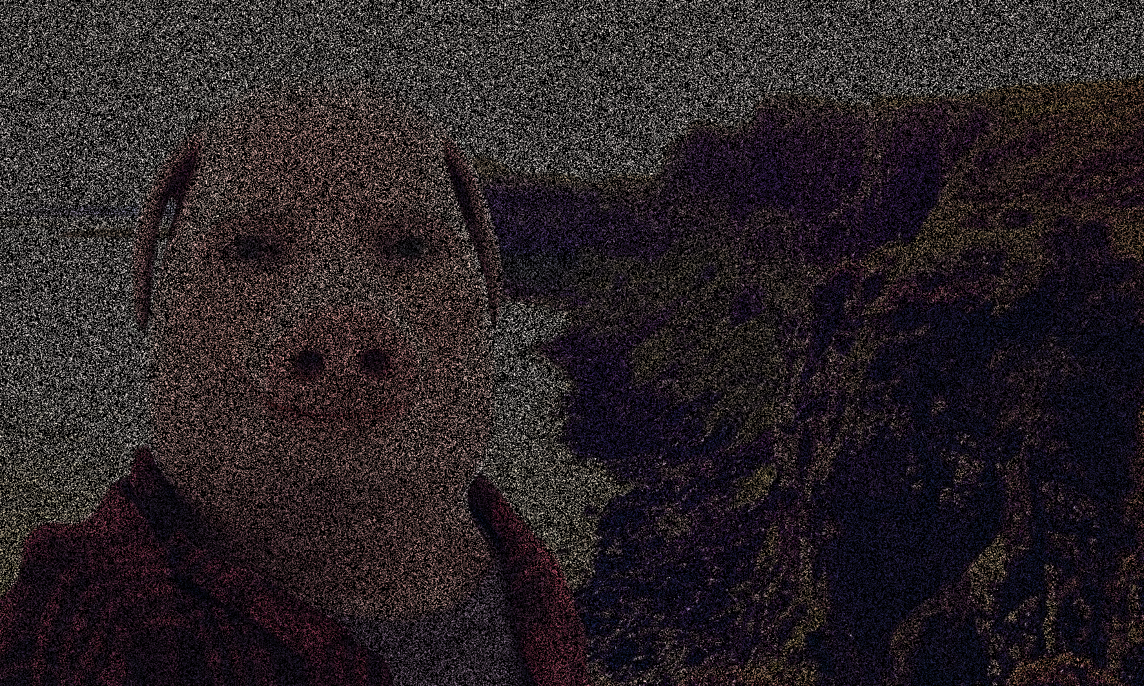

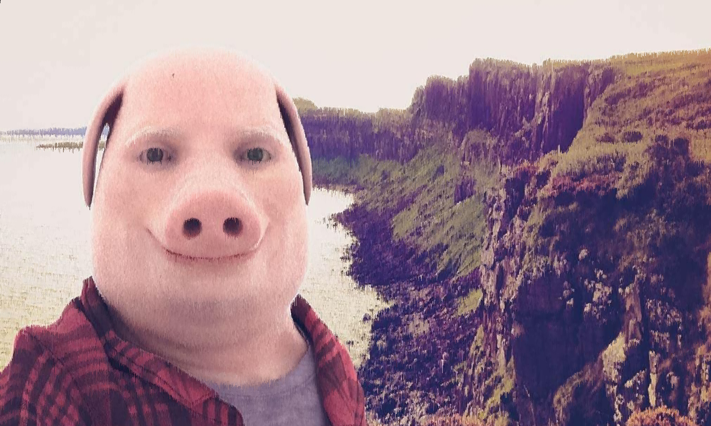
After running the image through the Noise Remover:

As you can see, the picture after being denoised is not as sharp as the original.
Here is an more extreme example (this time with 99% of the picture being noise instead of 75%):
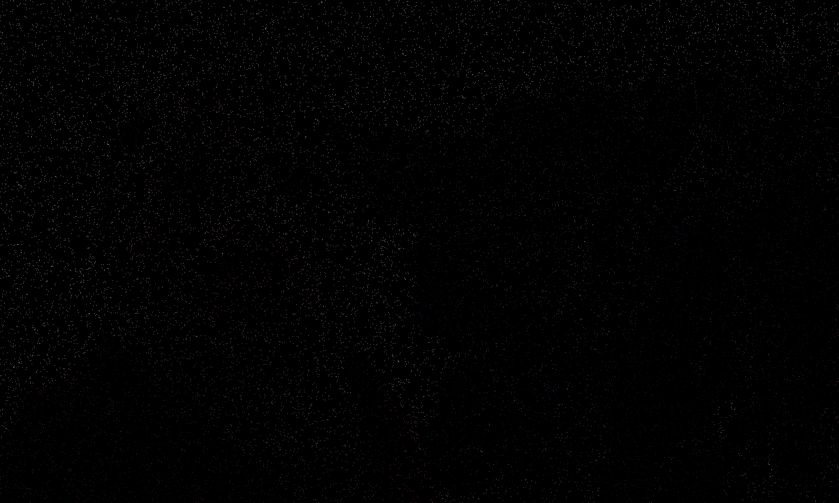
Noisy Version (zoom in to see some colourful pixels):

Denoised Version:

This can be used in real life. For example, if you want to compress an image, you could just delete some data about the colours of some pixels, and then, if you want to look at the picture, the denoiser can guess the colours of the pixels.

Now let’s start with the coding.
- Setting up the coding environment
  - Download IntelliJ (https://www.jetbrains.com/idea/download/?section=windows).
  - Click “New Project”.
  - While creating the project, download a JDK.

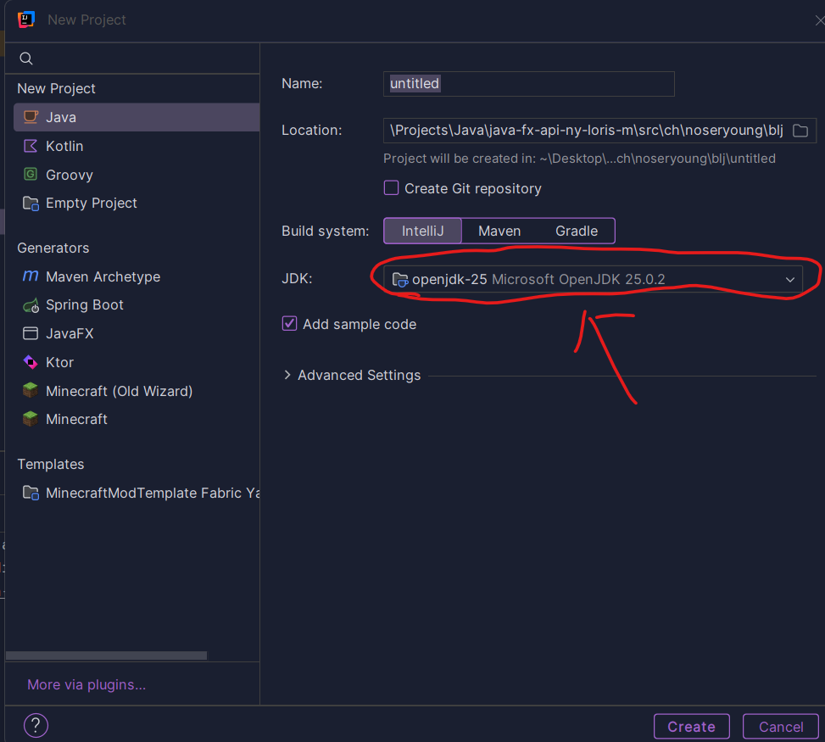

(Just download a JDK that appears at the top; shouldn’t really matter which one).

- Files
  - Create a file in the src directory named: Main.java, and another one named: Image.java.

- Code
  - Paste this code into Main.java:
package ch.noseryoung.blj;
import java.awt.*;
import java.io.IOException;
import java.util.Scanner;
public class Main {
public static void main(String[] args) throws IOException {
Scanner sc = new Scanner(System.in);
System.out.println("do you want to make noise or Ascii art? 1, 2");
int userInput = sc.nextInt();
sc.nextLine();
if (userInput == 1) {
Image picture;
System.out.println("Filepath: ");
while (true) {
String filepath = sc.nextLine();
picture = new Image(filepath);
if (!(picture.image == null)) {
break;
}
}
System.out.println("how much percent should be noise?");
float noisePercent = sc.nextFloat();
Color noiseColor = Color.BLACK;
picture.addNoise(noisePercent, noiseColor);
picture.removeNoise(noiseColor);
} else if (userInput == 2) {
Image picture;
System.out.println("Filepath: ");
while (true) {
String filepath = sc.nextLine();
picture = new Image(filepath);
if (!(picture.image == null)) {
break;
}
}
picture.makeGray();
picture.makeAsci();
}
}
}

  - Paste this code into Image.java:
package ch.noseryoung.blj;
import javax.imageio.ImageIO;
import java.awt.*;
import java.awt.image.BufferedImage;
import java.io.BufferedWriter;
import java.io.File;
import java.io.FileWriter;
import java.io.IOException;
public class Image {
private String filepath;
private int width;
private int height;
BufferedImage image;
// constructor
public Image(String filepath) {
this.filepath = filepath;
try {
File input = new File(filepath);
image = ImageIO.read(input);
} catch (IOException e) {
System.err.println("Error reading the image: " + e.getMessage());
return;
}
width = image.getWidth();
height = image.getHeight();
}
public void addNoise(float noisePercent, Color noiseColor){
for (int i = 0; i < image.getHeight(); i++) {
for (int j = 0; j < image.getWidth(); j++) {
float randomNumber = (float)(Math.random() * 100);
if (randomNumber < noisePercent) {
image.setRGB(j, i, noiseColor.getRGB());
}
}
}
File outputFile = new File("Noise.png");
try {
ImageIO.write(image, "png", outputFile);
} catch (IOException e) {
}
}
public void removeNoise(Color noiseColor) {
for (int i = 0; i < width; i++) {
for (int j = 0; j < height; j++) {
if (image.getRGB(i, j) == noiseColor.getRGB() && j != 0 ) {
image.setRGB(i, j, image.getRGB(i, j - 1));
} else if (image.getRGB(i, j) == noiseColor.getRGB() && i != 0) {
image.setRGB(i, j, image.getRGB(i - 1, j));
}
}
}
File outputFile = new File("noNoise.png");
try {
ImageIO.write(image, "png", outputFile);
} catch (IOException e) {
System.out.println(e);
}
}
public void makeGray() {
BufferedImage grayImage = new BufferedImage(width, height, BufferedImage.TYPE_BYTE_GRAY);
Graphics g = grayImage.getGraphics();
g.drawImage(image, 0, 0, null);
g.dispose();
try {
ImageIO.write(grayImage, "png", new File("gray.png"));
} catch (IOException e) {
System.out.println(e);
}
}
public void makeAsci() throws IOException {
String asciiChars = "$@B%8&WM#*oahkbdpqwmZO0QLCJUYXzcvunxrjft/\\|()1{}[]?-_+~<>i!lI;:,\"^`'. ";
BufferedWriter writer = new BufferedWriter(new FileWriter("Ascii.txt"));
for (int i = 0; i < image.getHeight(); i++) {
for (int j = 0; j < image.getWidth(); j++) {
int gray = image.getRGB(j, i)& 0xFF;
int index = ((asciiChars.length() - 1) * gray) / 255;
writer.write(asciiChars.charAt(index));
System.out.print(asciiChars.charAt(index));
}
writer.newLine();
}
writer.close(); }
}
- Click on Main.java, and then you will be able to compile the code (click on the green button at the top right).
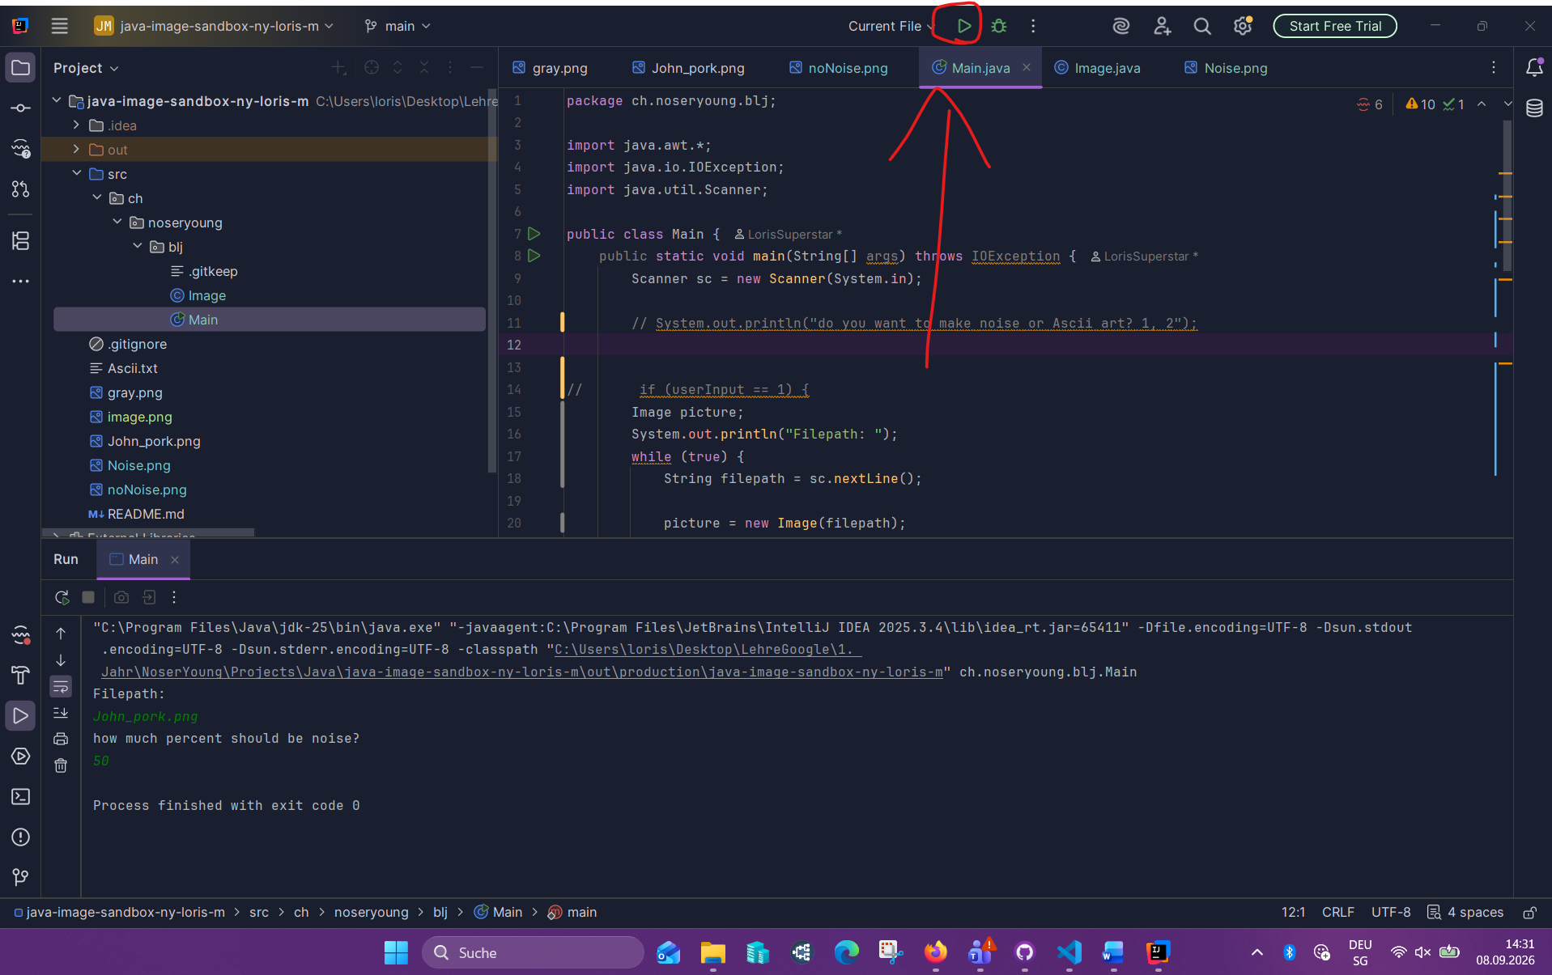

- If it compiles, it works! You can close the program again. Now you only need to add a picture (preferably an .png), and then when you run the program again, you can just put in the filename and then how much percent noise you want to do, and voilà! It generates 2 files. 1. The Noised Version, and 2. The Denoised Version.

- BONUS STEP!
You are almost finished, but this step will explain how the code works!
To denoise the image, the code scans every pixel line by line. When it finds a missing pixel, it replaces it with the colour of the adjacent pixels directly above or to the right. This simple neighbour-copying technique fills in the missing visual data, smoothing out noise while sacrificing a bit of overall sharpness.

