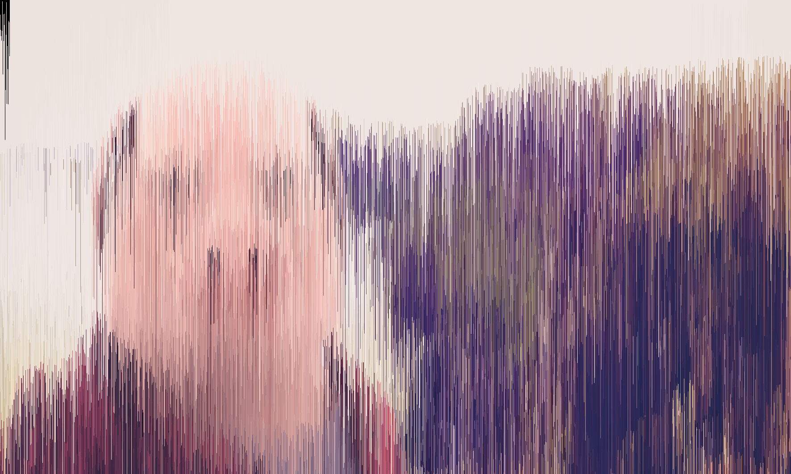
How to code an Image denoiser in Java?

What is an Image denoiser?
The Goal of an Image denoiser is to remove Noise from an Image. And make it look like before the noising. Here an example:
Original:
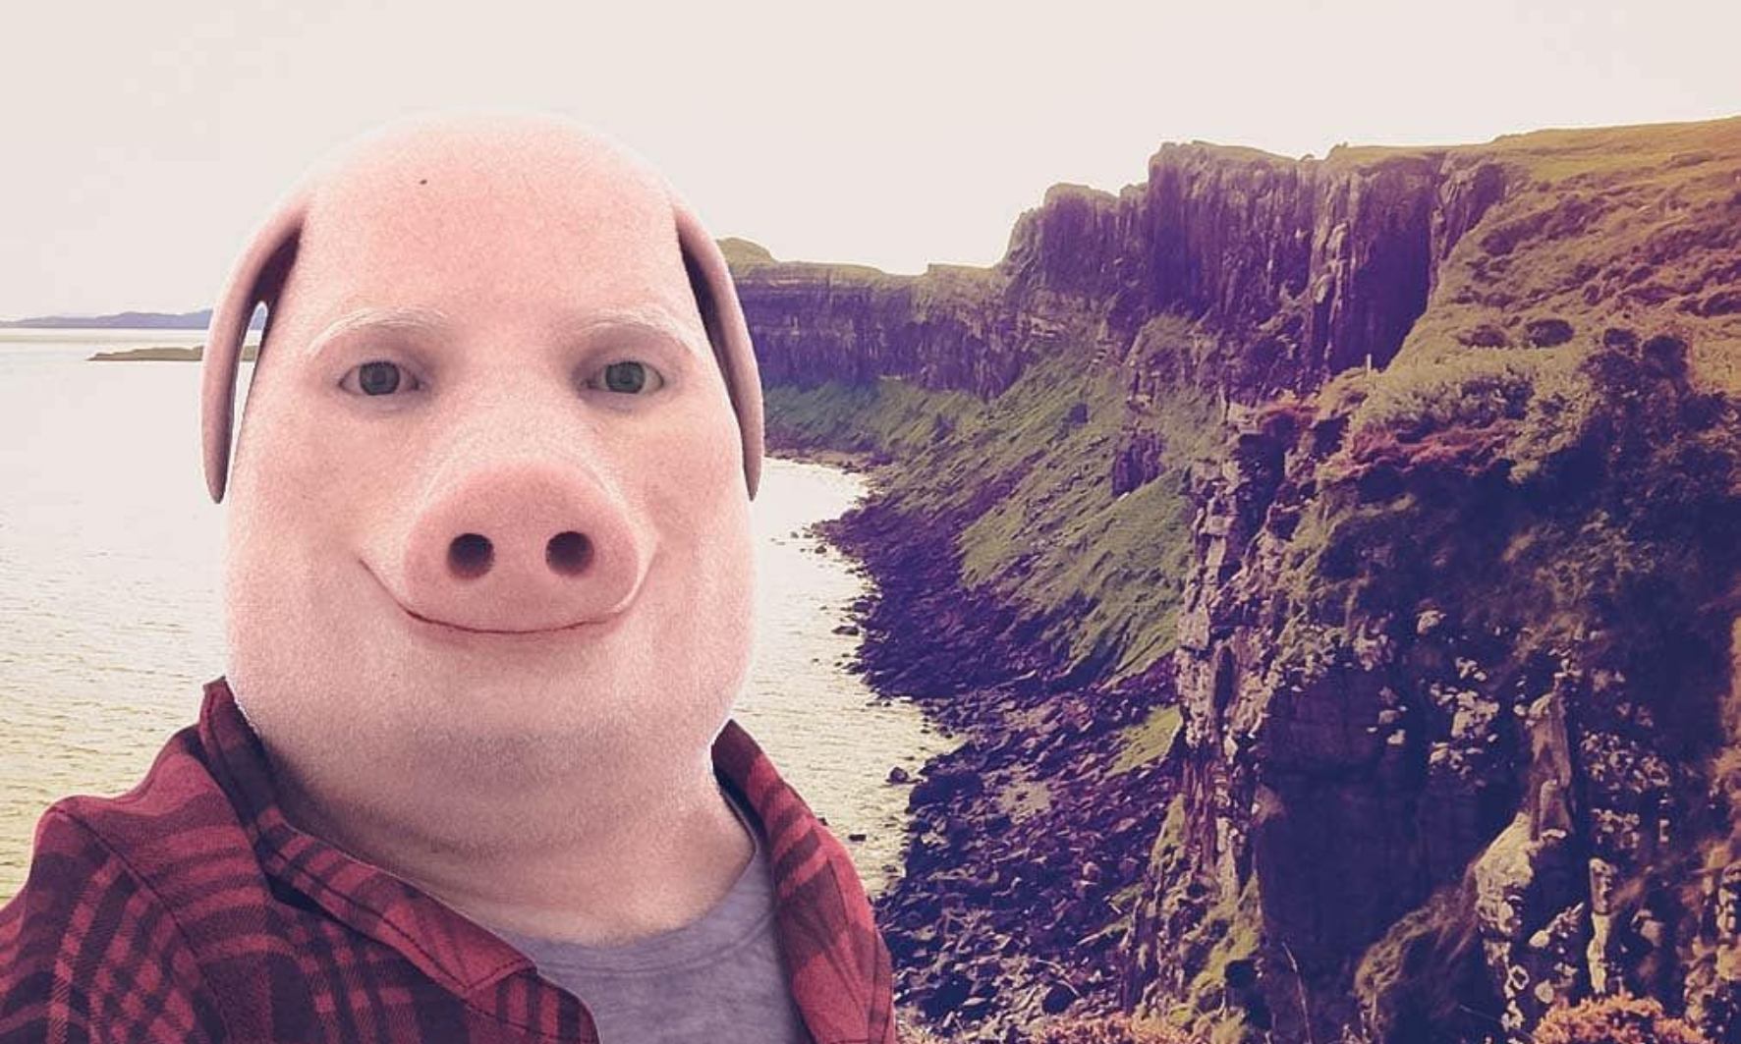
With noise:
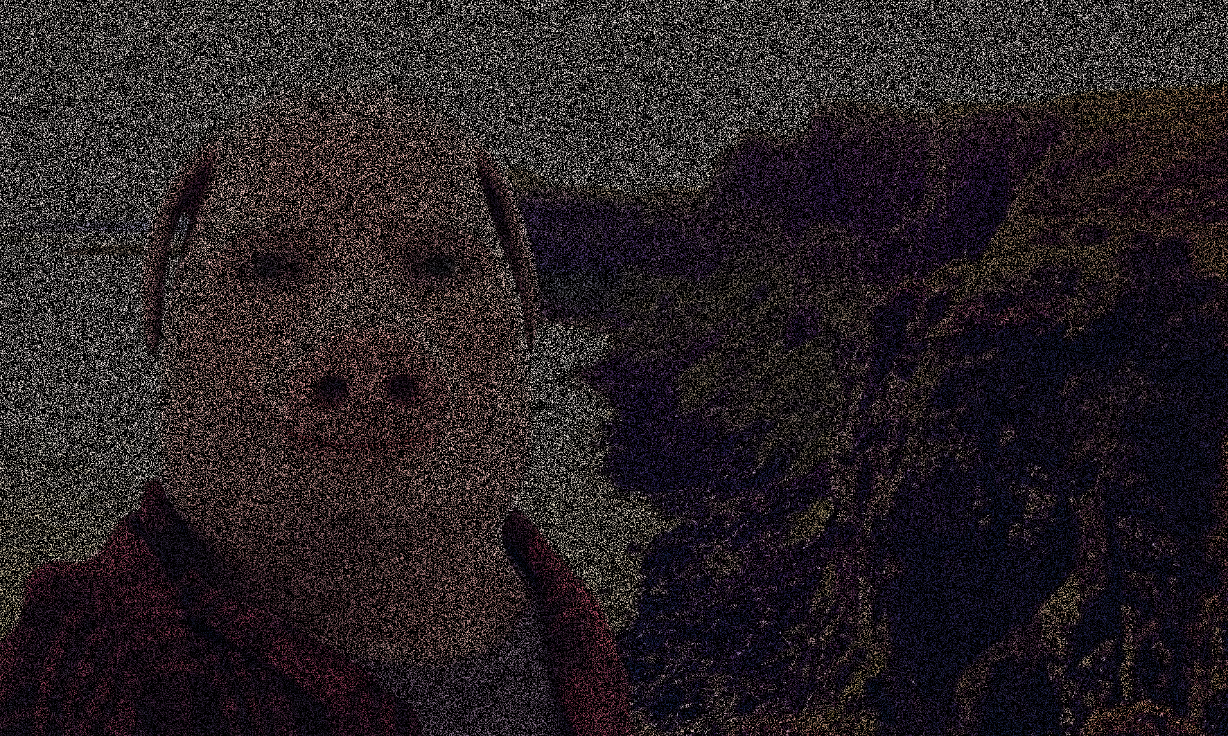

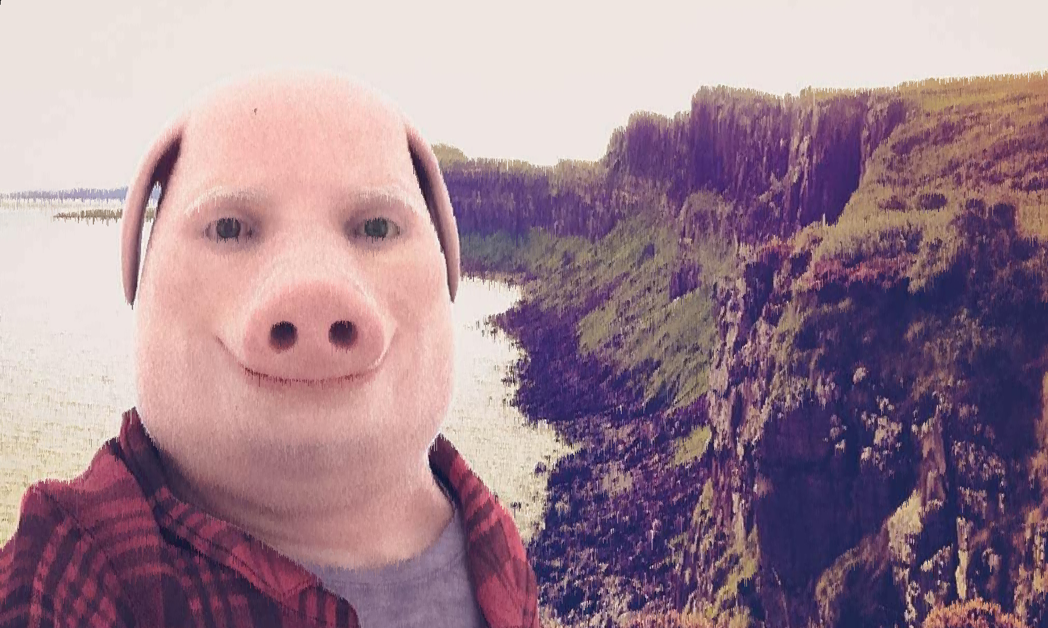
After running the Image through the Noise Remover:

As you can see, the Picture after being denoised is not as sharp as the original.
Here an more extreme example (this time with 99% of the picture being noise instead of 75%):
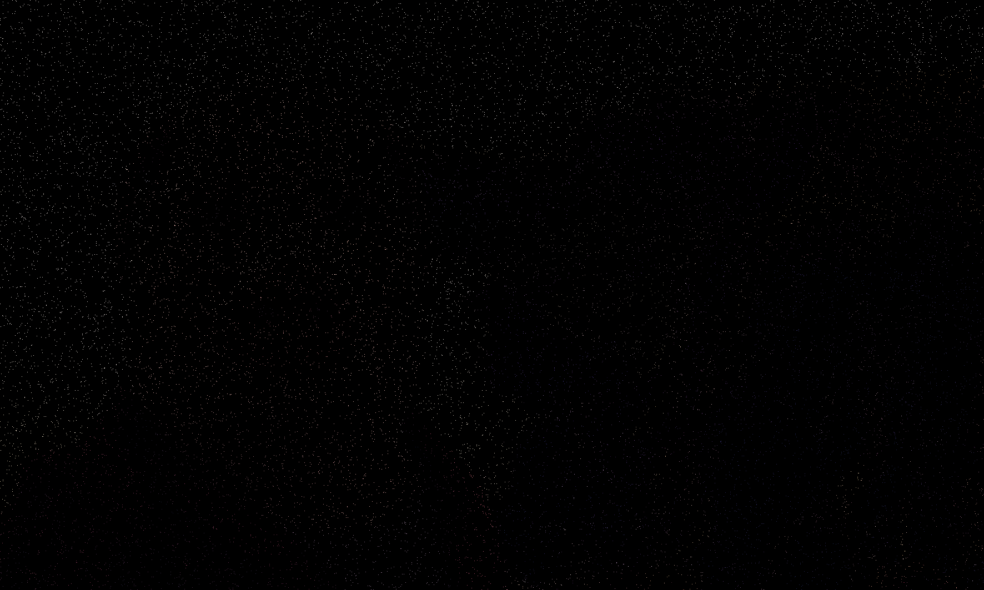
Noised Version (Zoom in too see some colourful pixels) :
Denoised Version: 

This can be used in real life, for example if you want to compress an image, you could just delete some data about the colours of some pixels and then if you want to look at the picture, the denoiser can guess the colours of the Pixels.

Now let’s start with the coding.
1. Make an Image class.
2.
3.
4.

