**HANNAH BOADIWAA LORMENYO**

**IOT FINAL EXAM**

**PART A**

For each hydroponics farm, a door switch magnet will be used at the door to check the number times the door is opened. An LDR and a DHT sensor will be placed in every room to measure the light intensity, temperature, and humidity of the room. There will also be a heater to regulate the temperature of the room when necessary. A soil salinity sensor will be placed in the hydroponics solution to measure the soil salinity of the solution. When the threshold for the different sensors is exceeded, an alert is sent to the dashboard for an action to be taken. The average readings recorded during every 5 minutes period is sent to the MongoDB cloud database using IEEE 802.11 WiFi as an access technology. In the database, the time stamp is recorded as well as the temperature, humidity, light intensity, door switch magnet status, the heater status, the soil salinity, and the room number. Afterwards, the data is retrieved from the database and displayed on a dashboard**.** The image below shows the snippet of the architecture for one room. Then entire architecture can be found in the image file attached to the submissions.

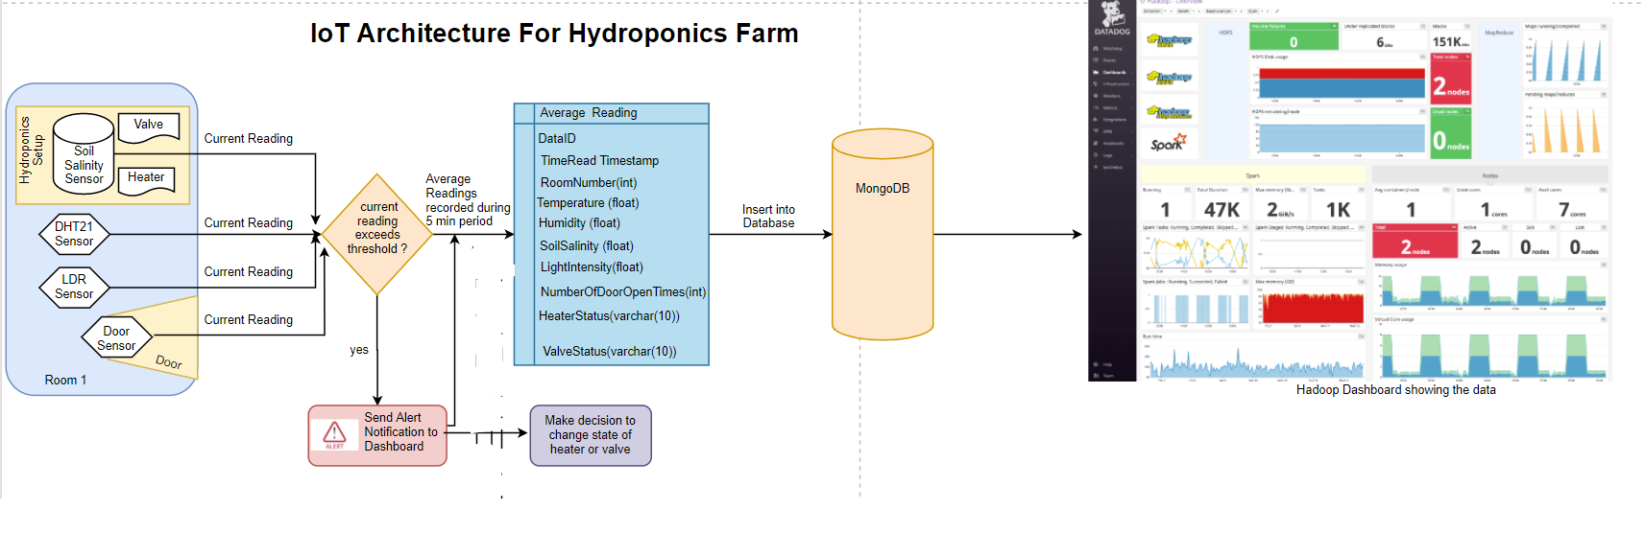

**ii. Reasons for Design**

1. **MongoDB:** I choose MongoDB because it is flexible. Since the IoT system of the hydroponics farm is liable to changes (for example the addition of new sensors like sensors for measuring oxygen and pH levels) it is best to use a database that can easily be changed without causing much effect on the database. One more reason is that MongoDB is much more scalable. IoT is a big data issue because the IoT systems have a high data ingestion rate, the data is voluminous, and it has a wide variety. MongoDB is globally known for its efficiency with Big Data since it can easily scale as the data grows.
2. **Real Time Data Processing in the Cloud:** To ensure real time data processing and data analytics, I included Hadoop in the design. Hadoop will consume the data from MongoDB and perform analytics using machine learning and other algorithms in real time. This would help the MIS manager make very informed decisions in real time. He/She can detect problems and provide solutions before they happen using prescriptive analysis on the data. Another advantage of Hadoop is its speed.
3. **Access Technology:** All the sensors will be connected to NodeMCU with ESP8266 Wi-Fi module. The ESP8266 module uses IEEE 802.11g protocol which uses 2.4 GHz range. Hence, it is compatible with a lot of devices. Its range is less the 15km which is the distance between the farm and the headquarters. Due to this, the data will be stored in a cloud storage which can be accessed from anywhere provided you have the necessary rights to access the data.
4. **Security**: JSON Web Tokens will be used to authenticate the devices in the network. For every data that is sent from the device to the database, a token will be added to the request which confirms the identity and rights of the device in the network. This will help to prevent unauthorized penetrations into the network. This authentication will also be included at the dashboard. To view the dashboard, users will be required to log in with the credentials given by the company.
5. **Data frequency:** The data is recorded in real time but only the average of the readings recorded in the 5-minute window period is inserted into the database. This is meant to reduce the ingestion rate and the volume of data accumulated over time. When any of the readings exceed the respective threshold set by the manager, an alert is sent to the manager via the dashboard for him/her to take an action[turn heater on/off or open/close solenoid valve].

**iii. The circuitry can be seen below:**

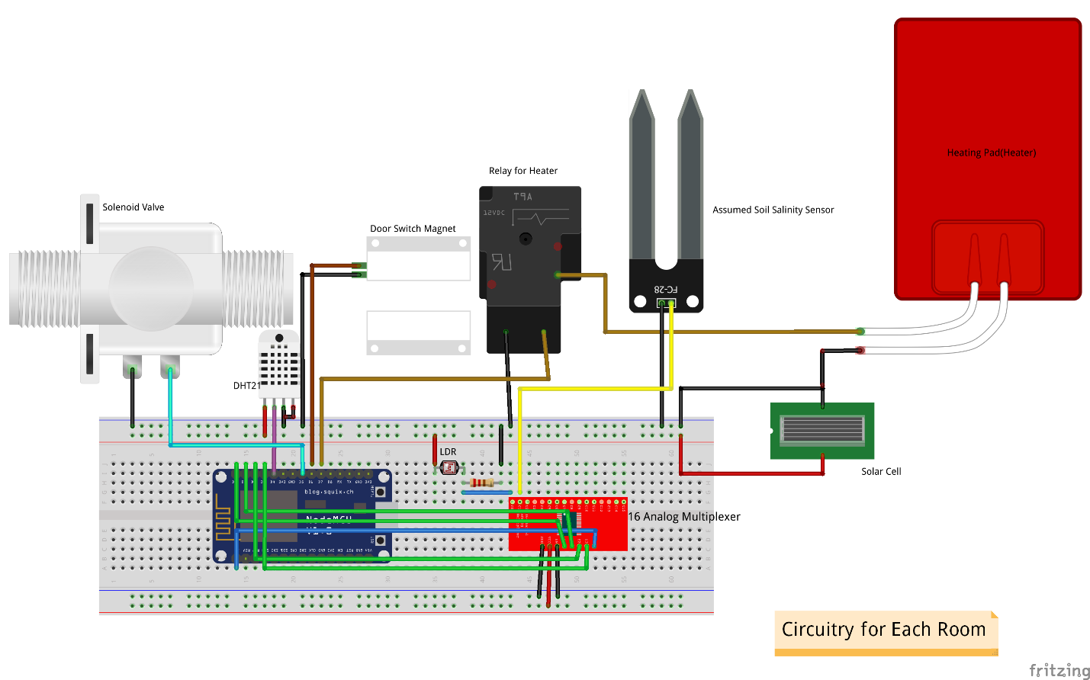

**Components used:**

1. Solar cell
2. NodeMCU (x4)
3. DHT21 (x4)
4. LDR (x4)
5. Solenoid valve(x4)
6. Relay(x4)
7. Door Switch Magnet(x4)
8. Heater(x4)
9. Soil Salinity sensor (x4)
10. Connecting wires

**PART B**

You can find the dashboard here: <https://mysensors.herokuapp.com/>

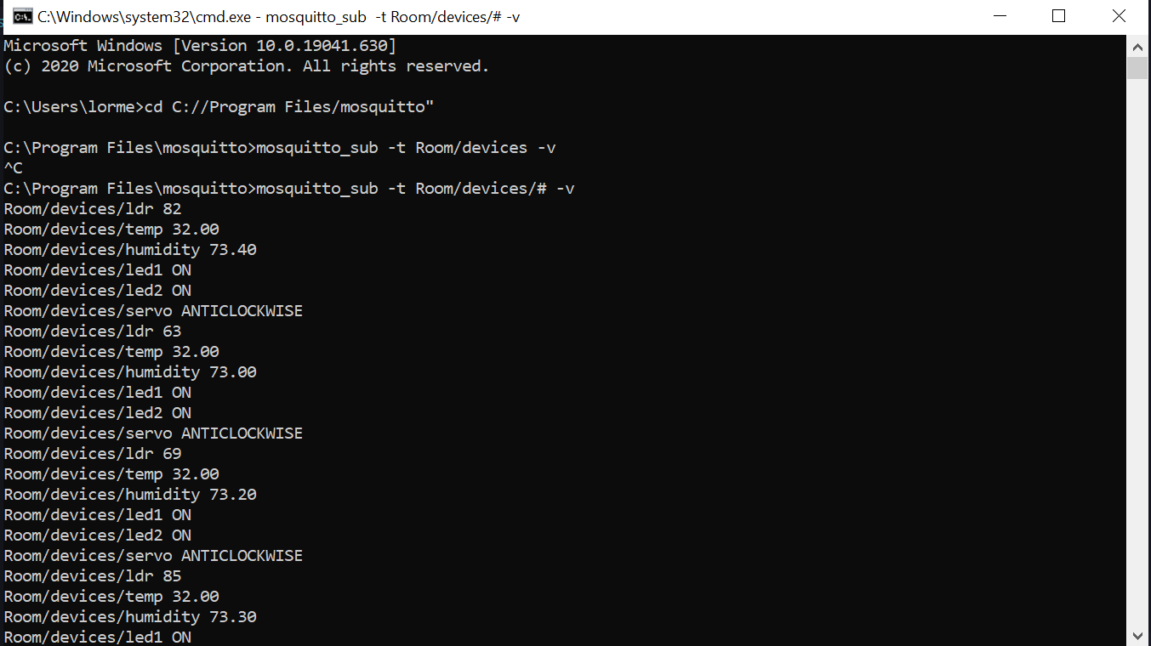

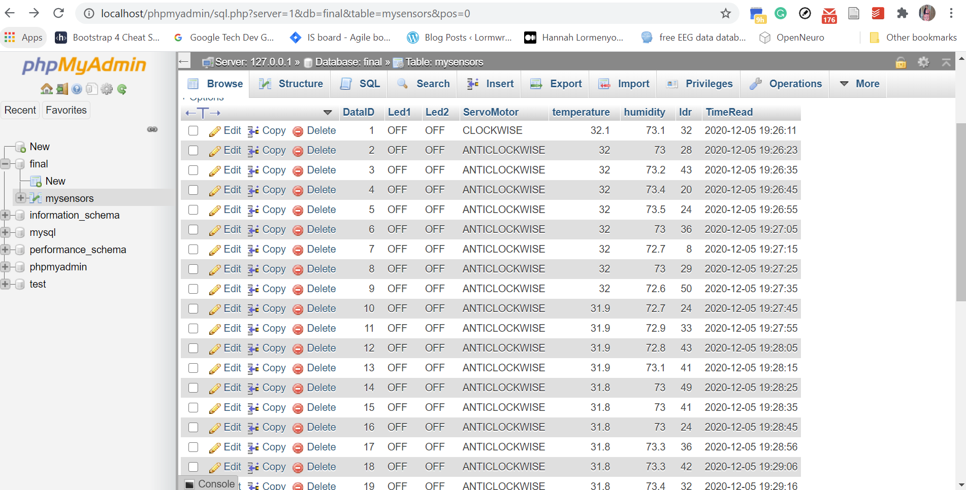

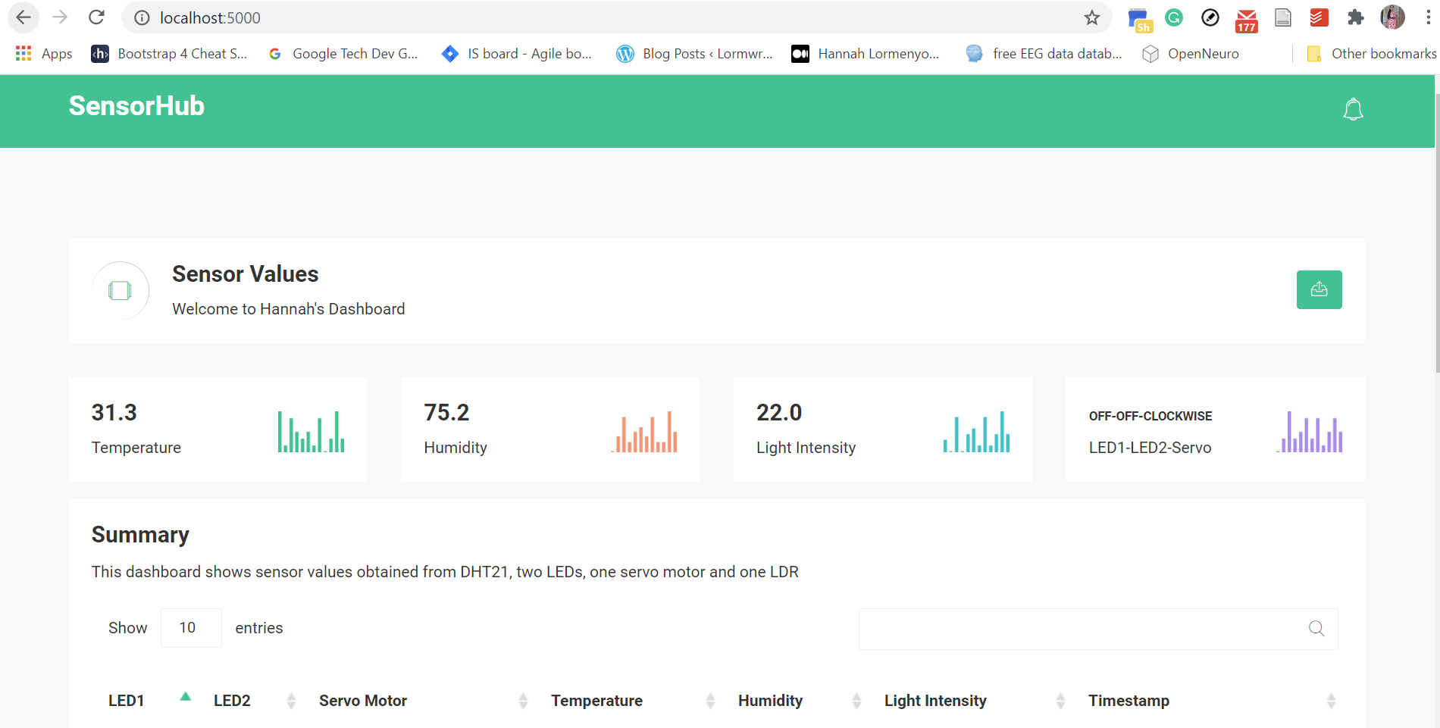

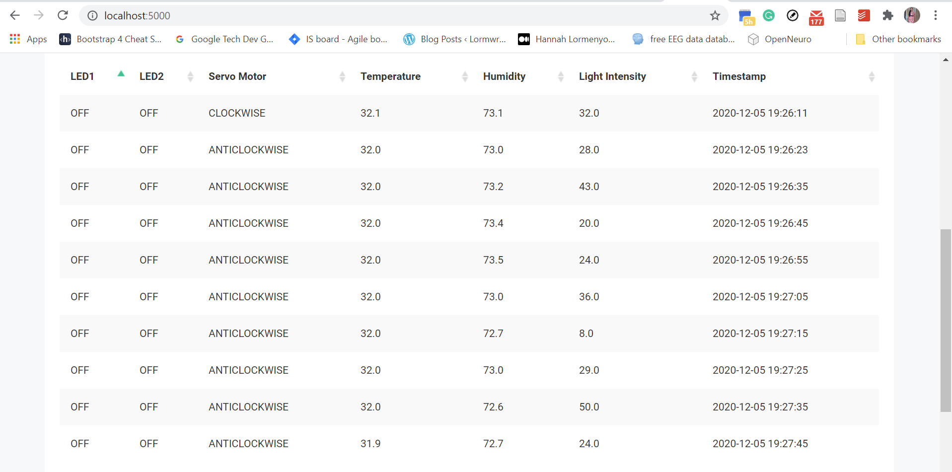

**PART C**

The notebook can be found here:

<https://colab.research.google.com/drive/18DrViL3kXp8pCfcy8hnMibyd_6Luf1WN?usp=sharing>

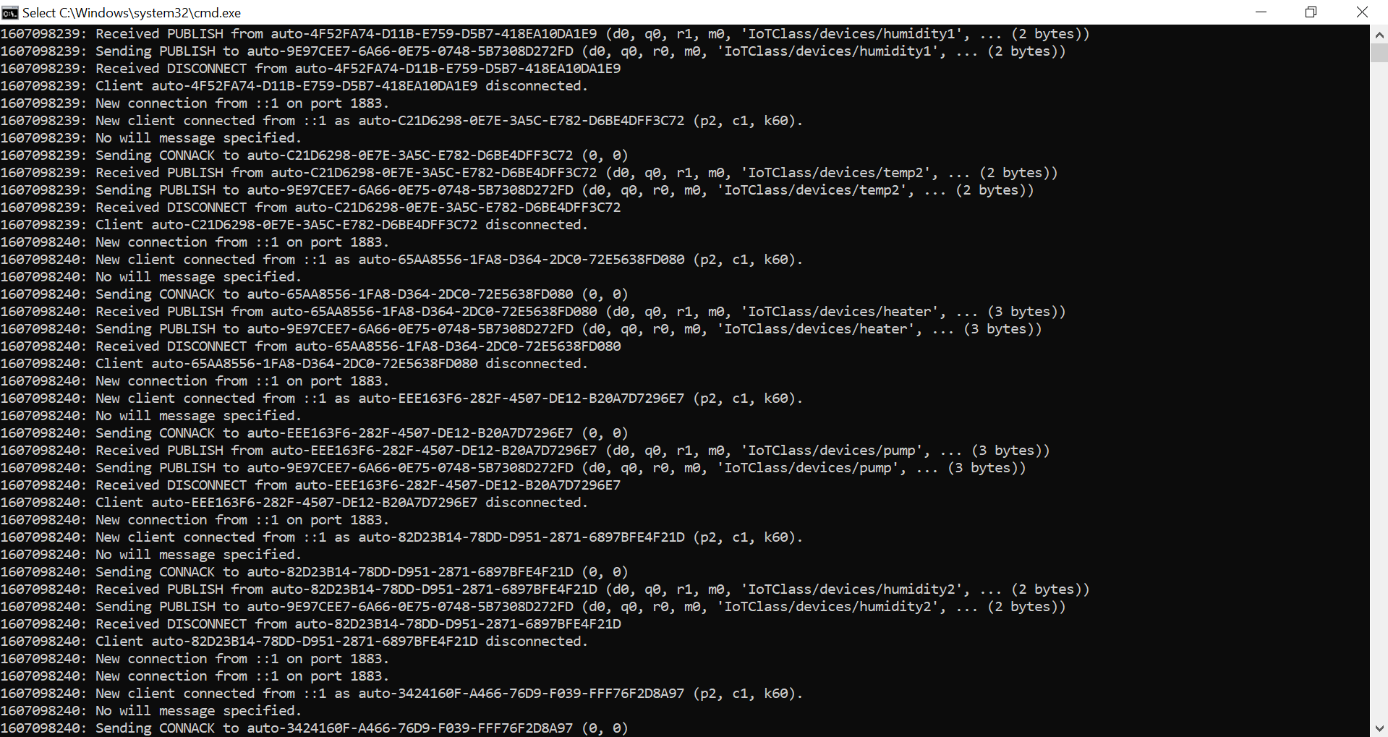

Figure 1: MQTT server

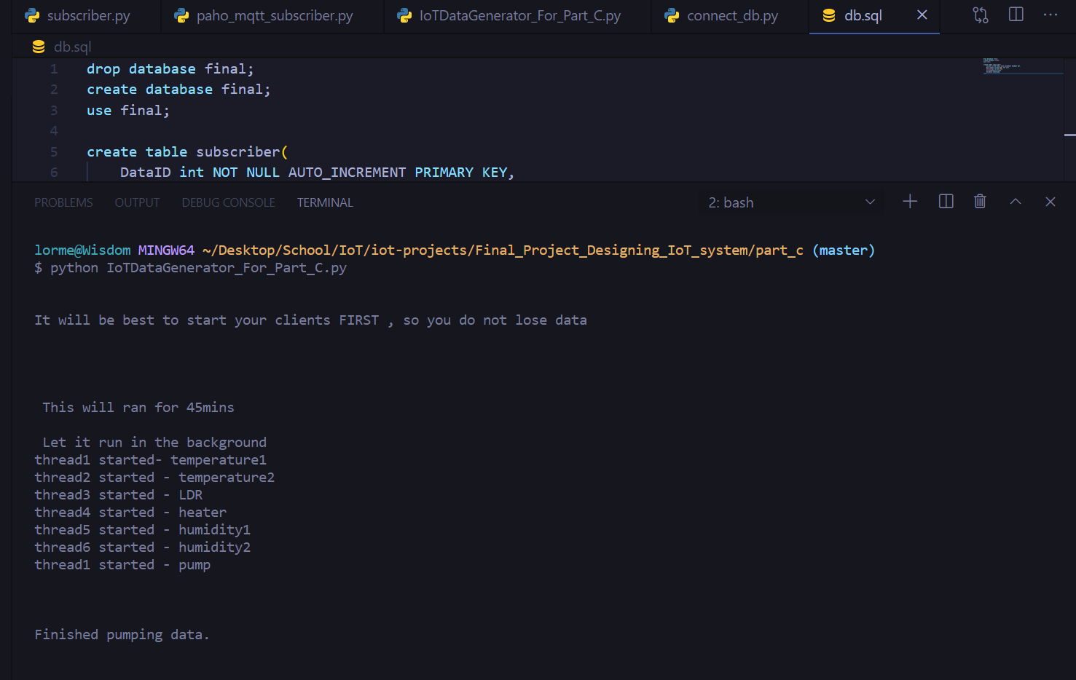

Figure 2: Data Generator

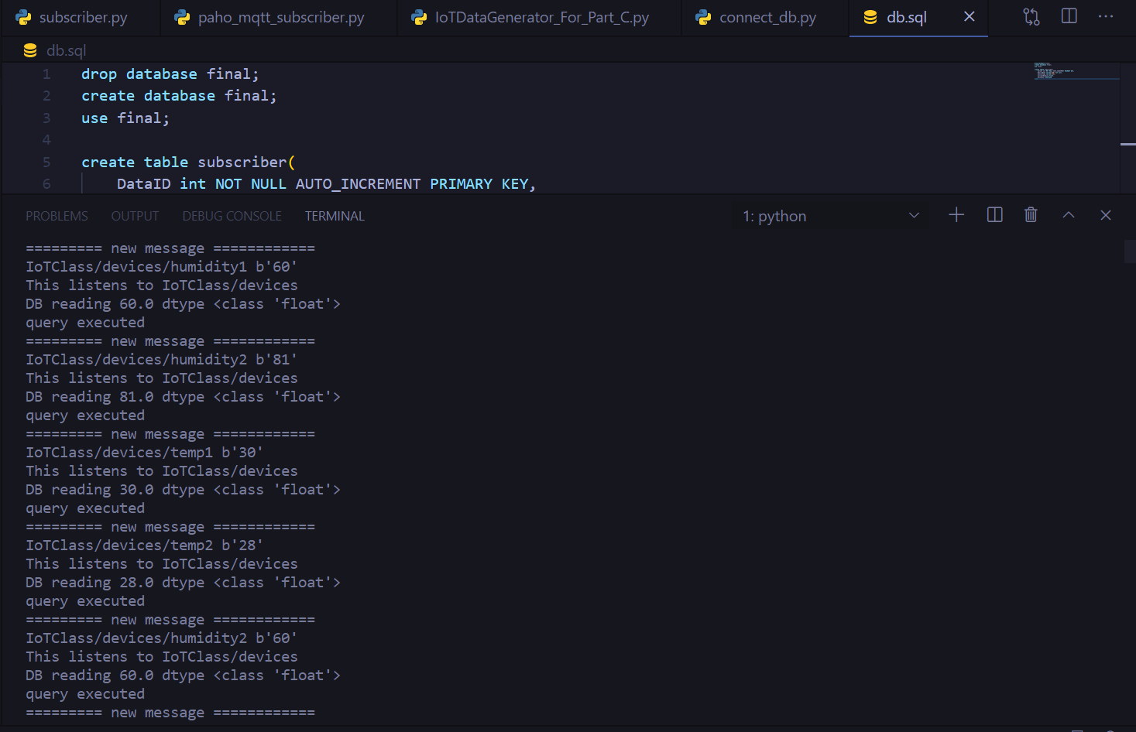

Figure 3: Subscriber

