**TASK MANAGEMENT APPLICATION**

**MATAAM**

**Dr. Subject Teacher:**

**DR. Mohammed Abuhelaleh**

**Developers:**

|  |  |
| --- | --- |
| **Team leader:** | **Lorns talal hikmat alskhily** |
| **Document writer:** | **Majd mahmoud fawzi alghazawi** |
| **programmer:** | **Ahmad MAHMOUD Ali Saleh** |
| **Programmer:** | **EmadAldeen Hani Mahmoud hasan** |
| **Programmer:** | **Mohammed Shaher Mohammed Mashhour** |

**بسم الله**

**The program starts with a login screen where you can login with admin account, restaurant account, customer account and create customer account. Admin can view, edit and delete restaurant and customer accounts with details and can create restaurant accounts. Restaurant accounts can post food posts and take orders. User can select restaurants, order food and rate restaurants.**

**Admin Features:**

* View and manage customer and restaurant accounts.
* Edit and delete accounts.
* Create new restaurant accounts.

(username is : “admin” , password is “admin2005##”)

**Customer Features:**

* Browse restaurants.
* Order food.
* Rate restaurants.

(username is : “lorns” , password is “078111”)

**Restaurants Features:**

* Post food posts.
* View food orders.

(username is : “burger” , password is “gg”)

________________________________________________________________________

Main screen is login form:

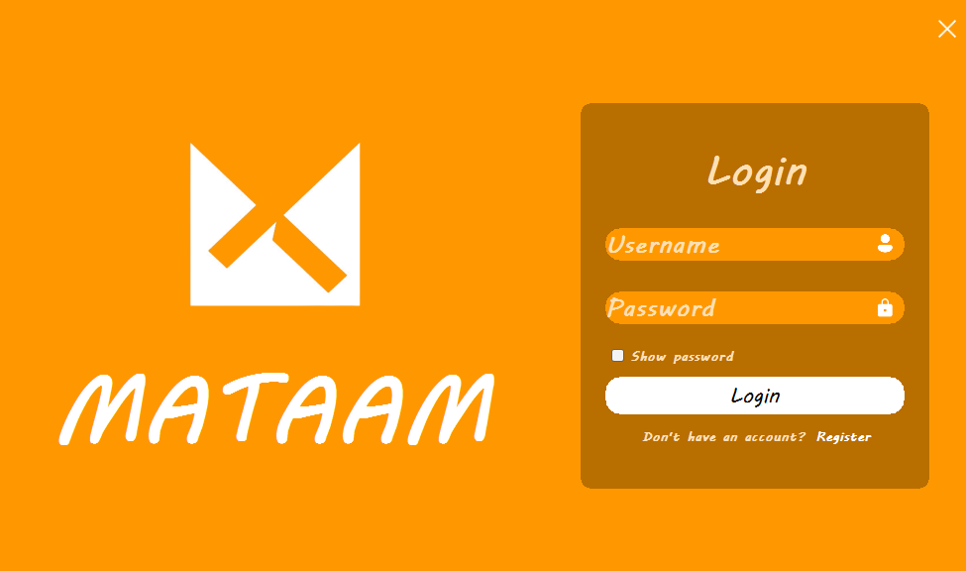

You must enter username and password to login from login button

If you don’t have an account, you can click **register** text to create new customer account.

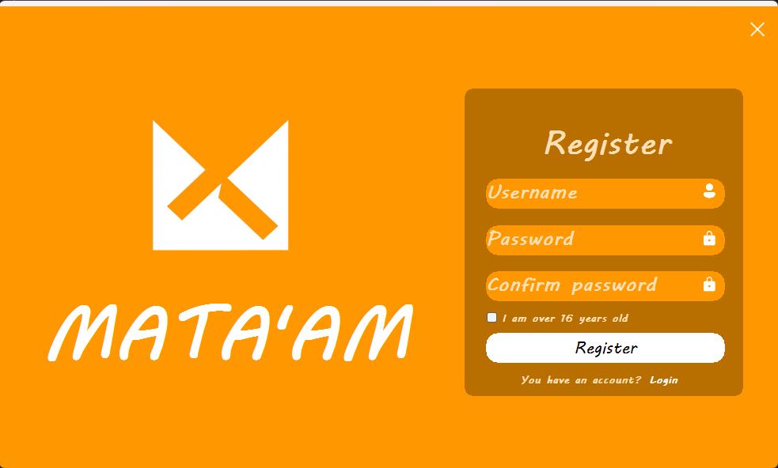

You can make new account from via enter username and password and confirm password and you must be over than 16 years old and then you can create account from register button.

You can return to login form from the **Login** text.

When you click the "Login" button:

* If you login with admin account you will get:

**Admin's First Screen - Customers**  
If the user logs in as an Admin, the first interface appears, allowing the Admin to:

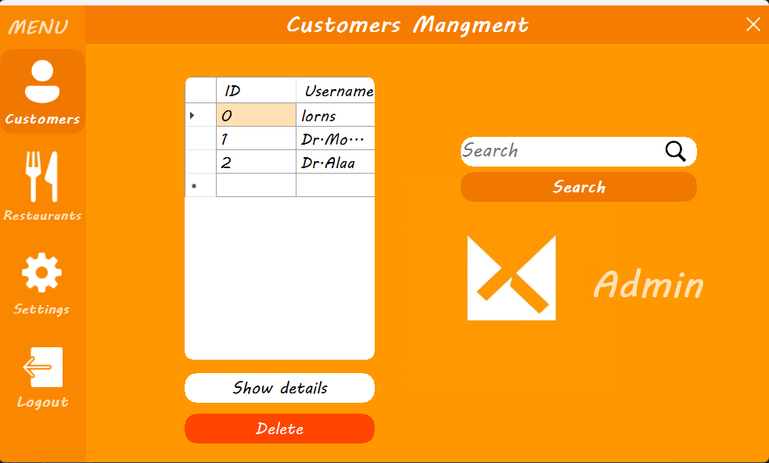

* View customer accounts from the table.
* Search for customers from the search button.
* Delete customer accounts from the delete button.
* View customer details, such as password, phone number, and identification number and can modify it.

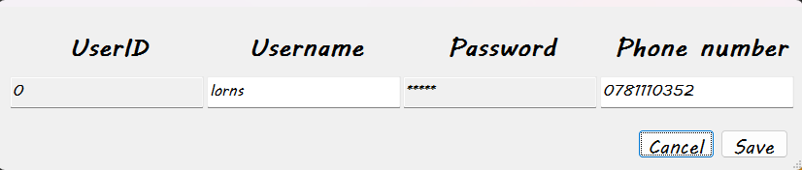

**Note:** The password is encrypted and requires clicking on it and entering the Admin's password to view it.

________________________________________________________________________

**Admin's Second Screen - Restaurants**  
When the Admin accesses the Subscribers (Restaurants) screen, they can:

* View restaurant accounts from the table.
* Search for restaurants from the search button.
* Create new restaurant accounts from the create account button.

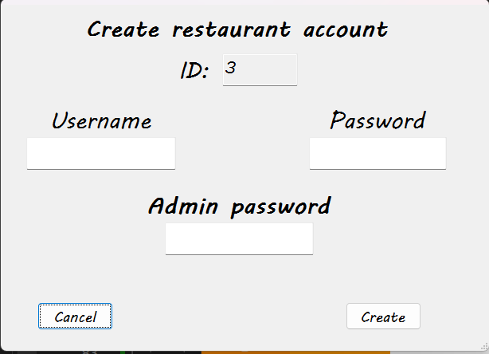

* You must enter your username, password, and administrator password to create the account.
* Delete restaurant accounts.
* View restaurant details, such as password, phone number, like and dislike number ,and identification number and modify it.

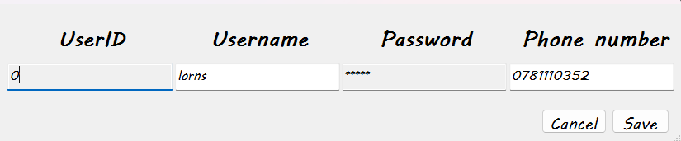

**Note:** The password is encrypted and requires clicking on it and entering the Admin's password to view it.

______________________________________________________________________________

**Admin's Third Screen - Settings**  
When the Admin accesses the Settings screen, they can:

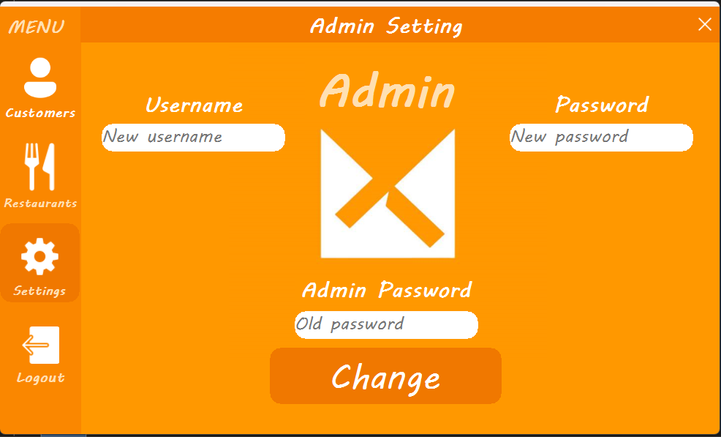

* Change the Admin's name.
* Change the Admin's password.

**Note: Changing the password or email requires entering the current password.**

Admin can logout from logout button

________________________________________________________________________

if you login with restaurant account you will get:

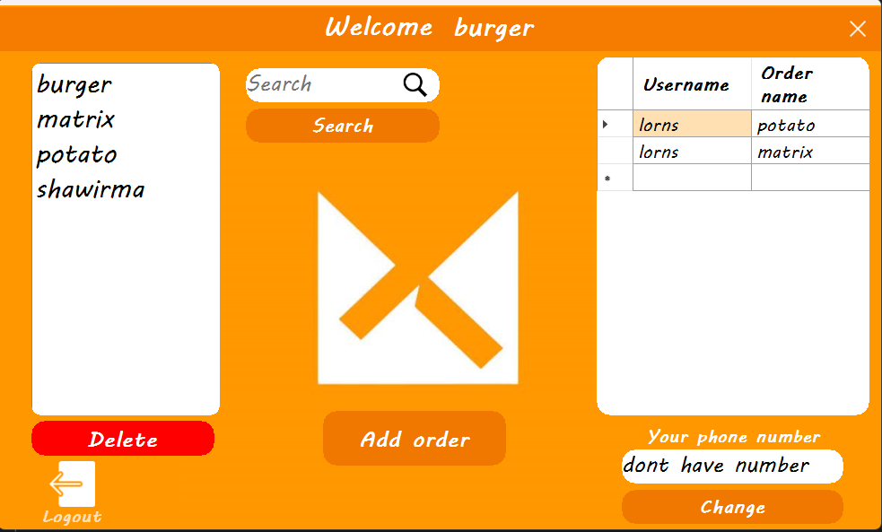

* you can see customers’ request from right table
* you can add order from add order button

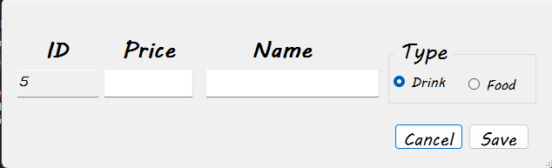

* you can add order from write the price , name, and select the type of order and click save button.
* You can change your phone number from write your number and click change to change number.
* You can search for your order from the search button
* You can delete order from the delete button
* If you click on the order from right list you can see order details and change it

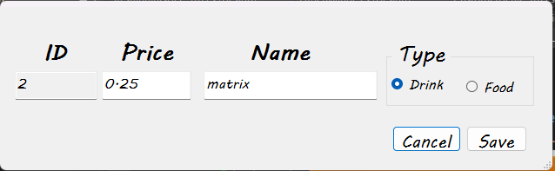

______________________________________________________________________________

if you login with customer account you will get:

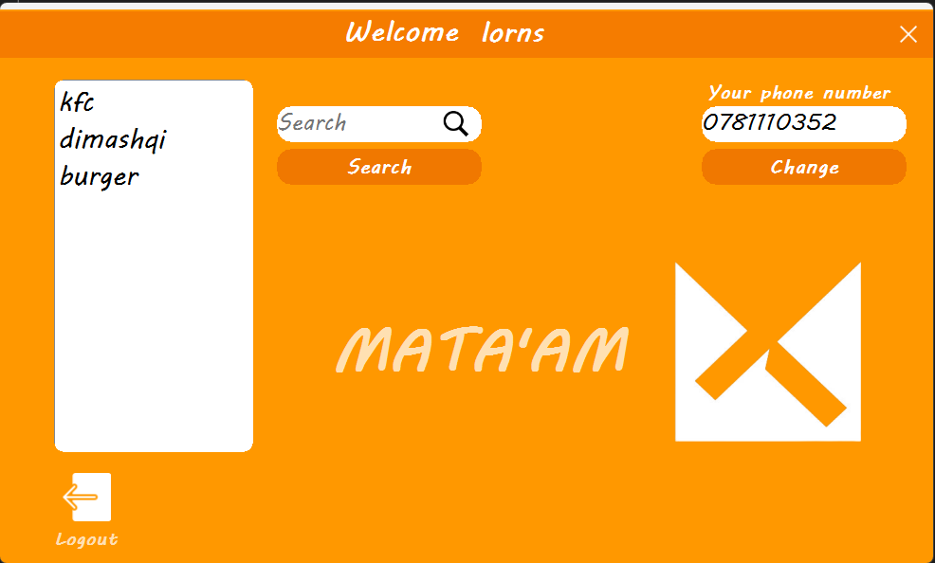

* You can change your phone number form change button
* You can see the restaurant form the left list
* If you click in the restaurant name you can see her details

* You can see the order list from the left order
* You can search for order from order button
* You can add the order to right order from add button and you can edit added number from the counter over the add button
* You can delete order form right list from delete button
* You can rate the restaurant from like and dislike under the delete button
* If you click ok button you will request order to the restaurant

Release date: 27/12/2024