CHAPTER I

INTRODUCTION

Overview of the Current State of Technology
The integration of advanced technologies, including IoT (Internet of Things), GPS (Global Positioning System), and data analytics, has revolutionized transportation systems globally (Manogaran & Vijayakumar, 2021). These innovations facilitate real-time tracking and efficient management, addressing challenges in urban mobility and enhancing service reliability. Developed nations have leveraged these systems to improve commuter satisfaction and optimize operations.
In the Philippine context, such technological applications are emerging, signaling opportunities to modernize public transportation networks and bridge existing gaps in service efficiency and accessibility. The application of these technologies in public transportation remains limited. The majority of public transport systems continue to rely on traditional practices, such as fixed timetables and manual dispatching. Consequently, such systems often suffer from inefficiencies, including delayed arrivals, overcrowding, and unreliable service. While urban centers like Metro Manila have made strides toward incorporating real-time tracking solutions, smaller cities, such as Roxas City, Capiz, have yet to fully embrace these technological advancements, thereby hindering the optimization of local transportation systems.
In Roxas City, the absence of real-time tracking systems contributes to inefficiencies in the public transport network. Commuters are frequently subjected to long waiting times and uncertainty regarding bus schedules, which adversely affects the overall commuting experience. Addressing these issues through the implementation of a real-time tracking system could significantly enhance the accuracy of service schedules, reduce waiting times, and improve operational efficiency, thus providing substantial benefits to both commuters and transport operators.
Desired State of Technology
The envisioned system for real-time bus tracking in Roxas City aims to integrate state-of-the-art technology to enhance commuter experience and operational efficiency. Central to this modernization effort are features such as GPS-enabled location tracking, real-time updates on arrival times, and a user-friendly interface accessible via mobile applications. These advancements align with the evolving needs of the city's transportation network.
Complementing this vision are the modernized PUV routes in Roxas City, which feature two main services. The Green Bus connects Brgy. Tanza and Brgy. Banica to the Roxas City Integrated Transport Terminal via significant stops like Roxas City Fountain and Robinsons Place Roxas. Similarly, the Red Bus links Brgy. Culasi to the terminal, passing through key points such as Roxas City Hall and the airport. Routes are color-coded for clarity, with yellow indicating travel to the terminal and blue for the return.

The fleet comprises five (5) modernized Isuzu Euro 4 Class 2 PUVs, adhering to the Public Utility Vehicle Modernization Program. These buses are equipped with air-conditioning systems for commuter comfort and automatic doors to enhance accessibility and safety. These services not only offer improved efficiency but also promote affordability with fare rates of ₱10.20 for the first 4 kilometers and ₱1.38 for succeeding kilometers, alongside discounts for priority groups like seniors, PWDs, and students.
This desired state underscores the alignment of advanced technology and urban transportation planning to create a robust, user-focused public utility vehicle system in Roxas City.
Statement of the Problem
The public transportation system in Roxas City, Capiz, currently lacks a real-time tracking mechanism, leading to significant inefficiencies and challenges. Commuters face difficulty in planning their travel due to the unpredictability of bus schedules, often resulting in prolonged waiting times and inconvenience. At the same time, transportation operators are unable to effectively manage fleet operations or respond dynamically to changing traffic and commuter demands. These issues contribute to resource inefficiencies and diminished user satisfaction, highlighting the need for an innovative technological solution.
- Low Commuter Satisfaction: The lack of reliable transportation services and real-time information diminishes commuter confidence and satisfaction, affecting overall public perception and usability.
- Prolonged and Unpredictable Waiting Times: The absence of real-time tracking results in extended waiting periods, leading to inefficiencies in commuter travel.
- Extended Waiting Times: The inefficiency in providing real-time updates results in unpredictable and prolonged waiting periods at bus stops, causing significant commuter inconvenience.
- Inefficient Commuter Route Planning: Commuters face difficulties in planning their trips effectively due to a lack of real-time bus tracking information.
- Lack of Accessible Tracking Platform: Commuters lack an integrated system where they can conveniently access real-time bus location updates.
Objectives of the study
General Objectives
The overarching goal of this study is to develop and evaluate a real-time tracking system for the bus transportation network in Roxas City, Capiz. This system seeks to enhance public transportation efficiency by providing accurate and real-time data on bus locations, schedules, and delays, thereby improving commuter satisfaction and operational effectiveness.

Specific Objectives
- To develop a real-time tracking system that enhances commuter satisfaction by reducing waiting times and improving travel planning.
- To develop a system that minimizes waiting times by offering real-time bus arrival notifications.
- To develop a system that minimizes waiting times by delivering real-time updates to commuters.
- To develop a route advisory feature that provides users with real-time bus locations and estimated arrival times to improve trip planning.
- To develop a user-friendly mobile or web-based platform that provides commuters with real-time bus tracking and scheduling information.
Theoretical and Conceptual Frameworks
Theoretical Framework
The real-time tracking system for the bus network in Roxas City, Capiz, is grounded in several established theoretical perspectives that inform the design and implementation of the system.
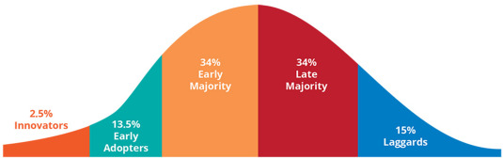
Diffusion of Innovations Theory (Rogers) explains the process by which new technologies are adopted. It outlines stages of adoption—knowledge, persuasion, decision, implementation, and confirmation—and highlights potential barriers such as technological resistance and infrastructure challenges.

Figure 1. Diffusion of Innovations
Systems Theory emphasizes the interrelation of system components. The proposed tracking system integrates hardware (GPS devices), software (data processing), and human elements (commuters, operators). This theory ensures that all components work cohesively to optimize performance.
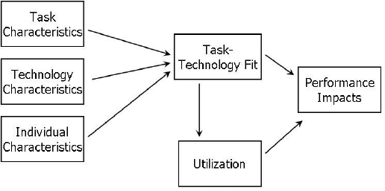
Task-Technology Fit Theory (Goodhue & Thompson) posits that the effectiveness of technology depends on its alignment with the tasks it is designed to support. The system’s design must address specific transportation needs, such as schedule reliability and resource optimization.

Figure 2. Task-Technology Fit Theory
Stakeholder Theory underscores the importance of considering all stakeholders in system design. In this study, it ensures that the interests of commuters, transport operators, local government, and technology providers are all addressed.
Human-Computer Interaction Theory focuses on the design of user interfaces. It ensures that the real-time tracking system is intuitive and user-friendly, promoting accessibility for both commuters and operators.
Conceptual Framework
The conceptual framework for the real-time tracking system in Roxas City’s bus network consists of three main components: hardware, software, and users. The hardware includes GPS devices on buses that transmit real-time location data to a central server. The software processes and visualizes this data, providing updates to users through mobile applications. The system serves commuters, bus operators, and local government units by providing information such as bus locations and estimated arrival times.
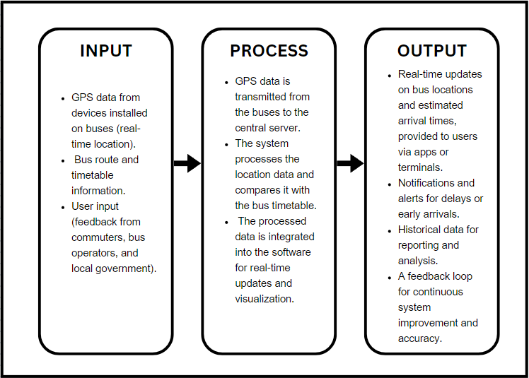
The system interface ensures efficient interaction, offering real-time maps, notifications, and feedback mechanisms. The integration of hardware, software, and users facilitates the smooth operation of the system, improving transportation management and enhancing the commuter experience. This framework highlights the flow of data and the role of each component in delivering accurate information.

Figure 3. Conceptual Framework of Real-Time Tracking System

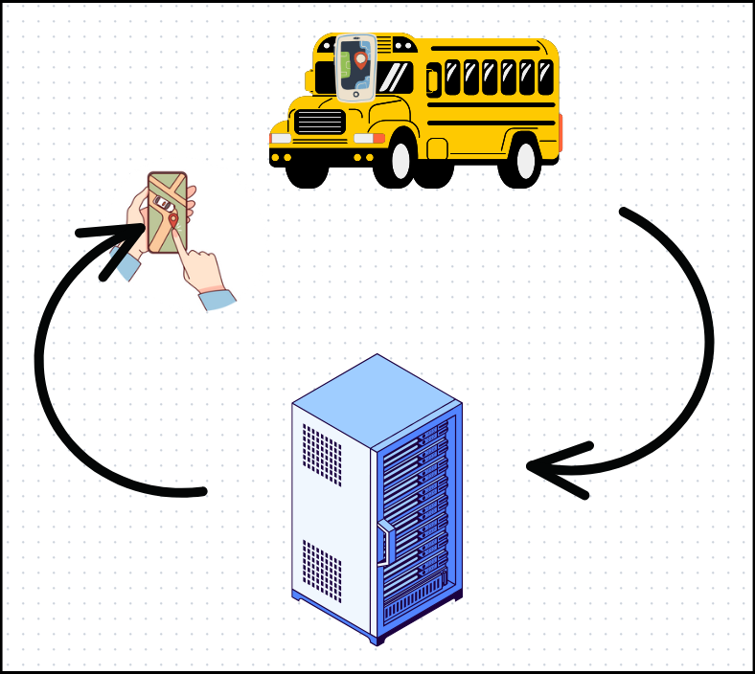

Figure 4. Conceptual Framework of Real-Time Tracking System

Operational Definition of Terms
Real-Time Tracking System. A system that uses GPS technology to monitor and report the real-time location of vehicles, in this case, buses, providing users with updated information on bus locations and estimated arrival times.
GPS (Global Positioning System). A satellite-based navigation system used to determine the precise location of objects, such as buses, in real time.
Central Server. A system that stores, processes, and manages data received from GPS devices and other inputs, enabling data sharing and visualization for users.
Bus Route and Timetable. The predefined paths and schedules that buses follow, used by the tracking system to estimate arrival times and manage bus operations.
Mobile Application. A software application designed for mobile devices, providing users with access to real-time tracking data, such as bus locations and arrival times.
Digital Signage. Electronic displays located at bus terminals that show real-time information, including bus locations, arrival times, and any delays or early arrivals.
User Feedback. Input collected from users, including commuters, bus operators, and local government units, used to assess system performance and make improvements.
System Interface. The platform or interface through which users interact with the system, accessing information such as tracking maps, notifications, and feedback features.
Historical Data. Data collected over time that provides insights into the system’s performance, such as trends in bus arrivals, delays, and user feedback.
Notification. An alert sent to users to inform them about important updates, such as delays, early arrivals, or schedule changes.

Scope and Limitations of the Study
This study focuses on developing a real-time tracking system for the bus network in Roxas City, Capiz. The scope encompasses the design, implementation, and testing of a GPS-based system integrated with a centralized database for real-time tracking and monitoring of bus locations. The system also includes a user interface accessible via mobile devices, providing estimated arrival times and route details for commuters. The primary stakeholders of this system are commuters, bus operators, and relevant government agencies.
The system is limited to buses operating within Roxas City and does not extend to other modes of transportation. It assumes that all buses are equipped with GPS devices and that there is consistent internet connectivity for real-time data transmission. The study also excludes maintenance and upgrades to hardware components beyond the initial deployment phase. Data security and user privacy are considered but are not the primary focus of the system's implementation.
The results of the study are intended to benefit the transportation sector by improving efficiency and providing timely information to users. However, challenges such as technical malfunctions, network outages, and user adaptability may affect the system's effectiveness and require further exploration in subsequent research. The findings are expected to serve as a foundation for similar systems in other localities.
Significance of the study
This study is significant in improving the bus transportation system in Roxas City, Capiz, by introducing a real-time tracking system. The system's development aims to address issues related to transportation inefficiencies, such as unpredictable arrival times and long waiting periods. By providing real-time data on bus locations and schedules, it is expected to enhance transportation management and improve commuter satisfaction.
Commuters
The real-time tracking system will offer commuters timely information, enabling them to make informed decisions about their travel plans. It will also assist bus operators in optimizing routes and schedules, ultimately improving the overall efficiency of the transportation network. This system's implementation can lead to reduced waiting times and more reliable transportation services for the public.
Bus Operators
Bus operators also stand to benefit from the system, as it provides tools for effective fleet management, route optimization, and monitoring. Operators can use the data to ensure operational efficiency, reduce fuel costs, and address service gaps.
Government Agencies
The government agencies are empowered by the system to oversee the city's transportation network effectively. By providing real-time data, the system enhances regulatory compliance, assists in decision-making, and supports the development of policies to improve public transit. These contributions create a more organized and efficient transportation system, benefiting the community and fostering economic growth in the region.
Finally, this study will add to the academic discourse on the integration of technology in public transportation systems. The insights gained from the real-time tracking system could influence future transportation policies and research, driving innovation in public transit management and service delivery.

CHAPTER II
REVIEW OF RELATED LITERATURE
Overview
This chapter presents a review of the literature related to real-time tracking systems in public transportation, focusing on their development, implementation, and impact. It examines GPS-based tracking technologies, their role in improving transportation management, and enhancing commuter satisfaction. The review also includes international case studies to contextualize the research, discussing both the technical components and the challenges of real-time tracking systems. Additionally, it explores the integration of technology in public services and the potential benefits for urban mobility. By identifying gaps in existing studies, this review provides a foundation for understanding how real-time tracking can be effectively applied in the context of Roxas City, Capiz, contributing to the broader discourse on innovative solutions for urban transportation.
Development of a GPS-Based Vehicle Tracking System Using Arduino MEGA
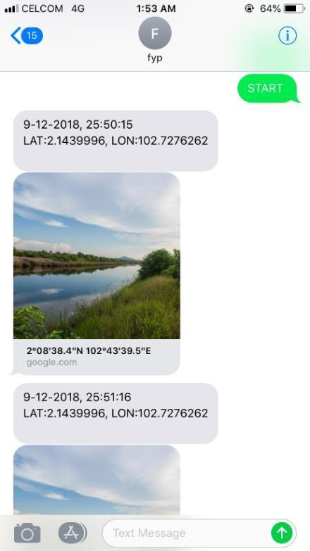
This study focuses on designing and developing a GPS-based vehicle tracking system utilizing the Arduino MEGA microcontroller as the main processing unit. The system incorporates a Ublox NEO-6m GPS module for location tracking and a SIM 900A GSM module to facilitate communication with the user. While the system functions well outdoors, it faces challenges indoors due to signal obstruction, which affects the GPS module's accuracy. The study suggests improvements, such as upgrading to a higher-quality GPS module like the NEO-6P, to enhance performance and satellite connectivity.

Figure 5. Development of a GPS-Based Vehicle Tracking System Using Arduino MEGA

Real-time GPS Tracking System for IoT-Enabled Connected Vehicles

This paper presents a real-time GPS tracking solution for connected vehicle networks using IoT, V2X communication, and VANET technologies. The system integrates Arduino Uno R3, SIM800L GSM module, NEO6M GPS module, Node.js, socket communication, and Firebase for GPS data collection, storage, and visualization via a web interface. The system supports applications such as dynamic routing for energy efficiency, smart charging, intelligent traffic management, and fleet emissions reduction, promoting sustainability and improved decision-making. By enabling seamless communication between vehicles, infrastructure, and the cloud, the system optimizes transportation and logistics through real-time GPS tracking.
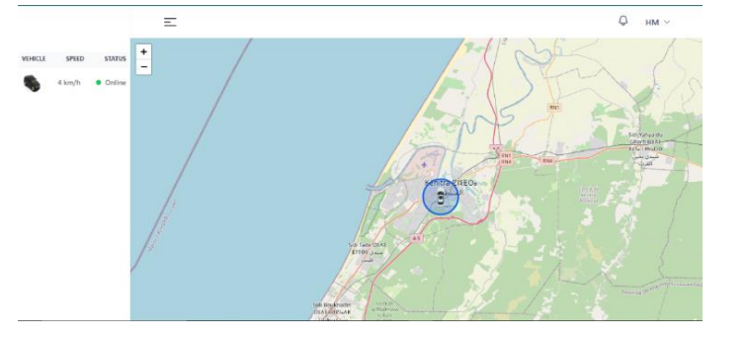

Figure 6. Real-time GPS Tracking System for IoT-Enabled Connected Vehicles

Design and Development for a Vehicle Tracking System

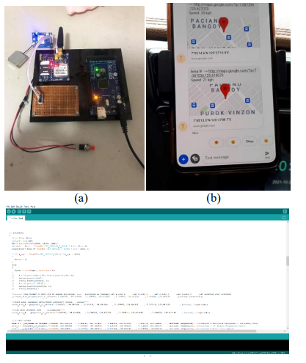
This study addresses the growing problem of vehicle theft by designing and developing a vehicle tracking prototype with route detection, emergency button, and STATUS command functionalities. The system uses Arduino Mega 2560, SIM900 GSM module, and NEO-6M GPS module for real-time monitoring of the vehicle's location. The prototype detects deviations from the route, responds to an emergency button, and provides status updates through SMS. While the system successfully met its objectives, the study noted limitations due to the use of a prototyping-grade GPS module. The recommendation is to use an industrial-grade GPS with an external antenna for better performance.

Figure 7. Design and Development for a Vehicle Tracking System

Vehicle Tracking and Monitoring: A Security System for Exclusive Subdivision

This study proposes the design and implementation of a vehicle tracking system using GPS with web-based monitoring, aimed at enhancing security in exclusive subdivisions. The system allows security officers to track vehicles in real-time and monitor their routes, storing this data for future reference if necessary. The system's evaluation based on functionality, reliability, usability, efficiency, maintainability, and portability demonstrates its feasibility and effectiveness for improving security within the subdivision.
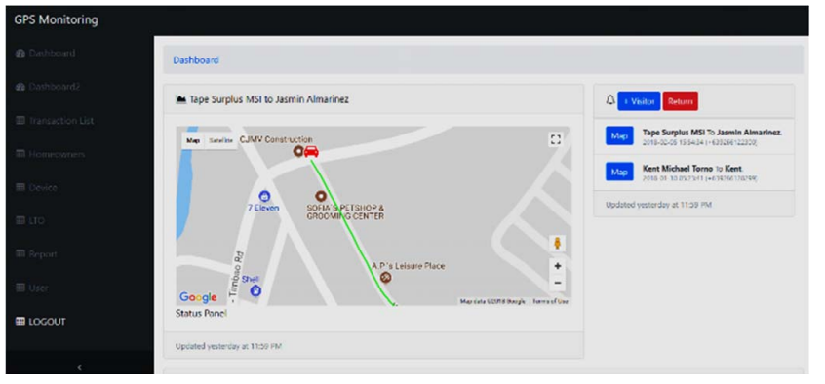

Figure 8. Vehicle Tracking and Monitoring: A Security System for Exclusive Subdivision
Wireless Fingerprint Motor Vehicle Ignition With GPS Tracker


This study proposes a wireless motor vehicle ignition system that integrates GPS tracking and fingerprint identification technology to enhance vehicle security and prevent theft. The system uses a fingerprint scanner to authorize ignition, ensuring only authorized users can start the vehicle. Additionally, GPS tracking allows the vehicle's real-time location to be monitored, aiding in recovery in case of theft. The system is designed to be user-friendly, with communication between the vehicle and the owner's smartphone facilitated by wireless technology. The goal is to provide a more secure and efficient way to protect vehicles, particularly motorcycles, from theft, and improve their recovery chances. The implementation of this system aims to reduce the growing problem of motor vehicle theft and ensure better security for both owners and the general public.

Figure 9. Wireless Fingerprint Motor Vehicle Ignition With GPS Tracker

RideExpress: An Online Seat Reservation and Vehicle Location Tracker with Estimated Time of Arrival


This study presents RideExpress, a mobile application designed to help commuters of Utility Vehicle (UV) Express services by allowing them to reserve seats and track the nearest vehicle with an estimated time of arrival (ETA). The system utilizes GPS to find the nearest terminal and vehicle on the road. Developed using Java for the Android platform, the app aims to reduce commuter uncertainty caused by heavy traffic. The software evaluation results showed that the application was rated as "Highly Acceptable" based on criteria such as functionality, reliability, usability, efficiency, maintainability, and portability.

Figure 10. An Online Seat Reservation and Vehicle Location Tracker with Estimated Time of Arrival

JeePS
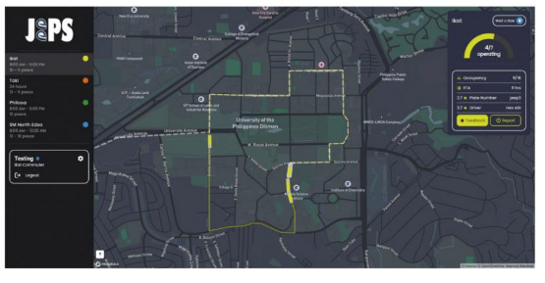
JeePS is a web and mobile application aimed at improving the informal public transportation experience in the Philippines. It includes features like GPS tracking, route and fare information, feedback mechanisms, and passenger demand analytics. The system improves passenger satisfaction by addressing key transportation challenges. Live testing confirmed enhancements in user experience and satisfaction with jeepney services.
Figure 11. JeePS
Two-Way Motorcycle Authentication with Alerting and Tracking System Using Mobile Application
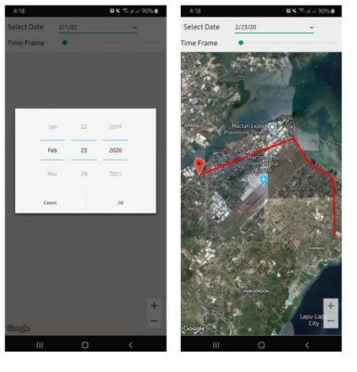
This study introduces the TWAMATS (Two-Way Motorcycle Alerting and Tracking System), aimed at preventing motorcycle theft and providing real-time alerts to owners. The system consists of a device with an alarm, fingerprint sensor, Wi-Fi module, accelerometer, gyroscope sensor, and GPS locator, all controlled by a microcontroller. The system sends data to a mobile application that allows users to track their motorcycle's location, view images, and register fingerprints for authentication. If a theft is detected, the system automatically alerts the owner, enabling quick responses. This solution enhances motorcycle security by providing real-time tracking and instant notifications.

Figure 12. TWAMATS

Taxicab Tracking System with Cloud Data Logging using the Internet of Things
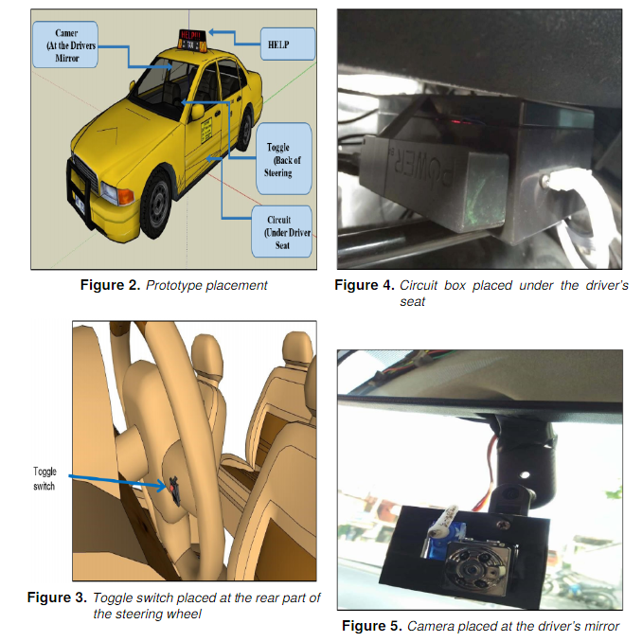
A tracking system for taxicabs was developed to address security concerns, particularly robbery. It uses GPS and IoT to provide real-time location data, SMS alerts with key details, and SD card-based activity recordings. An emergency toggle switch triggers a blinking distress message on the taxi's display panel. Reliability tests in Cebu, Philippines, verified its effectiveness. The system enhances security by improving visibility, enabling real-time monitoring, and providing timely alerts during emergencies, contributing to the reduction of robbery incidents in taxicabs.

Figure 13. Taxicab Tracking System

Development of GPS-based Vehicle Tracking System that Achieves a Secure Tracking and Monitoring of the Whereabouts of a Vehicle
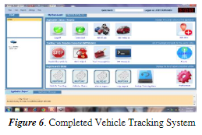
The study introduces a GPS-based Vehicle Tracking System that incorporates an anti-theft module capable of immobilizing vehicles taken by unauthorized individuals. The system provides features such as vehicle location tracking, speed and route monitoring, distance reporting, and anti-car theft functionalities. Test results demonstrated high effectiveness, with evaluations from private individuals, automotive, and IT experts rating the system as “Very Good” with a mean score of 3.83. This innovative solution addresses carjacking and theft, offering enhanced vehicle security and aiding authorities in apprehending offenders.

Figure 14. Development of GPS-based Vehicle Tracking System that Achieves a Secure Tracking and Monitoring of the Whereabouts of a Vehicle

Synthesis
The reviewed studies demonstrate significant advancements in real-time tracking systems for public and private transportation. Palconit highlights the use of IoT and GPS for taxicab tracking with cloud data logging, focusing on improving visibility, emergency alerts, and security. Borromeo builds on this by incorporating anti-theft functionalities and vehicle immobilization, addressing both security and operational monitoring. Similarly, the GPS-Based Vehicle Tracking System (2021) emphasizes the role of real-time tracking for efficient monitoring and reducing delays.
Research like Real-Time GPS Tracking System for IoT-Enabled Connected Vehicles and Design and Development for a Vehicle Tracking System emphasize the integration of IoT and GPS technologies to improve route monitoring, commuter safety, and operational efficiency. These systems address challenges such as route deviations, security alerts, and real-time location sharing, enhancing both user and operator experience.
For public transportation, Vehicle Tracking Systems for Public Transportation (and JeePS Tracking System for Modernized Public Transportation focus on improving commuter satisfaction through real-time tracking, route optimization, and fare management. These systems provide solutions tailored to urban mobility needs, reducing uncertainty for commuters and ensuring efficient fleet utilization.
The Development and Analysis of a Vehicle Tracking System for Smart Cities expands on these innovations by integrating tracking systems into urban transportation infrastructure, promoting sustainability and scalability. Likewise, the IoT-Based Vehicle Tracking System Using GPS and GSM offers practical solutions for real-time location tracking and data reliability, ensuring accurate and consistent updates.
Further, GPS and IoT-Enabled Tracking System for Efficiency in Transportation (2022) highlights the transformative role of combining GPS and IoT technologies in optimizing resource allocation, commuter planning, and operational management. This complements solutions like the RideExpress system, which provides seat reservation and estimated time of arrival, further enhancing commuter convenience.
Overall, the studies reviewed highlight the convergence of GPS, IoT, and advanced communication technologies in addressing transportation inefficiencies, improving commuter satisfaction, and enhancing security. These innovations offer scalable and sustainable solutions that are particularly relevant for modernizing public transportation networks, such as those in Roxas City, Capiz.

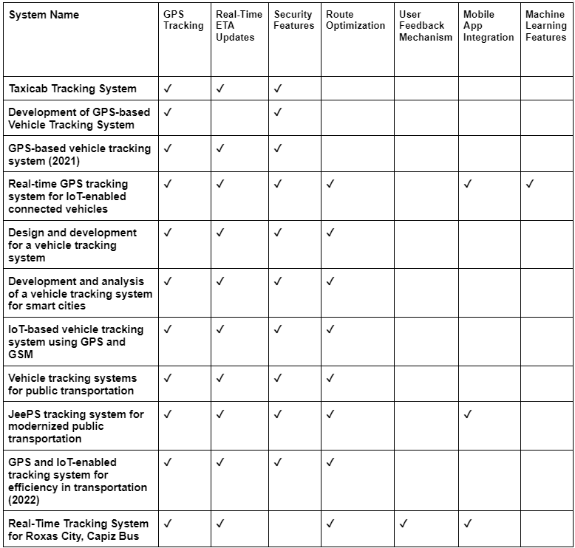
Table1. Synthesis

CHAPTER III
METHODOLOGY
This chapter details the research methods, procedures, and tools employed in the design, development, and evaluation of the proposed real-time tracking system for the bus transportation network in Roxas City, Capiz. The discussion includes the research design, data collection strategies, the selected development framework, and the metrics used for system evaluation.
By employing the Agile methodology, this study aims to iteratively design, develop, and refine a real-time tracking system that effectively addresses transportation challenges in Roxas City, Capiz. The proposed approach ensures a user-centric solution that enhances commuter satisfaction and operational efficiency.
We selected the Agile methodology as the development framework for several reasons:
1. Iterative Process: Agile breaks the project into smaller, manageable stages called sprints, allowing continuous improvements based on user feedback.
2. Flexibility: The methodology adapts to changes in requirements, ensuring the system evolves according to the needs of commuters, operators, and stakeholders.
3. Stakeholder Collaboration: Agile encourages frequent interaction with stakeholders, such as bus operators and local government, ensuring their needs are addressed during development.
4. Focus on User Experience: By incorporating user feedback at every stage, Agile ensures the system remains intuitive and user-centered.

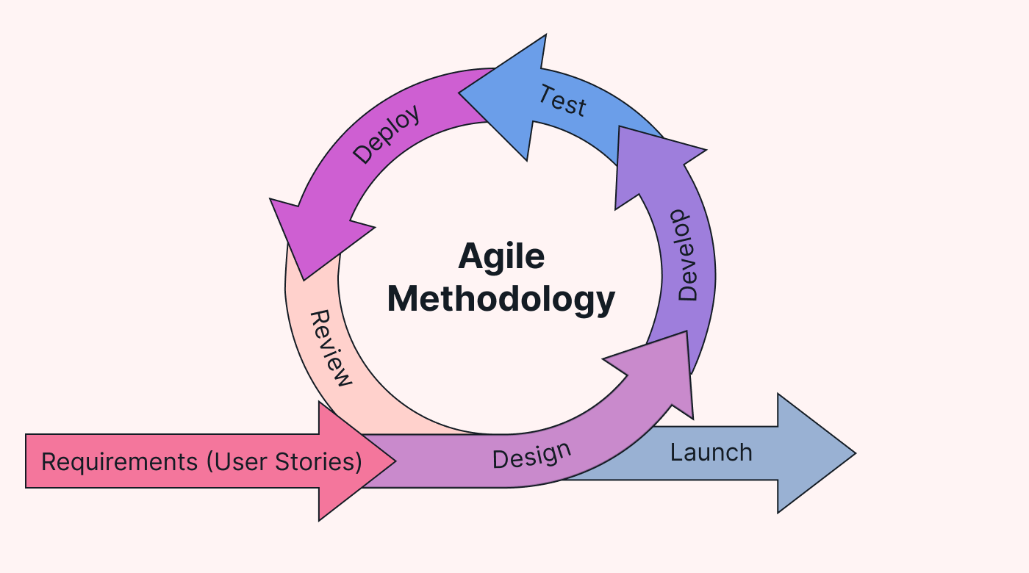
Agile Methodology

Figure 4. Agile Methodology

Research Design
The study utilizes a combination of descriptive and developmental research designs. The descriptive approach identifies and analyzes existing challenges within Roxas City’s public transportation system, while the developmental design facilitates the systematic creation and implementation of the real-time tracking system. This integration ensures a comprehensive understanding of the problem and the development of an effective solution.

Data Collection Methods
To achieve the objectives of the study, multiple data collection methods are employed to gather relevant information:
Interviews
Structured interviews are conducted with bus operators, drivers, and local government representatives to gather insights into current transportation challenges and inefficiencies.
Surveys
Questionnaires are distributed to commuters to document their experiences regarding waiting times, schedule inconsistencies, and overall satisfaction with the existing public transportation system.
Observation
Direct observation of bus terminal operations and route schedules is performed to analyze delays, resource utilization, and operational challenges in real-time.
Document Review
Existing transportation policies, schedules, and infrastructure capabilities are reviewed to identify gaps that the proposed system aims to address.
Requirement Gathering
Requirement gathering is a critical phase in the development process that focuses on identifying the specific needs and functionalities the proposed system must fulfill. This phase ensures that the system is aligned with user expectations and operational goals. The following methods are employed:
Stakeholder Meetings
Meetings with bus operators, administrative staff, and local government representatives to determine system requirements such as GPS integration, route optimization, and commuter notifications.
User Stories
Development of user stories to capture the needs of commuters and operators, such as real-time location updates, reduced waiting times, and efficient fleet management.
Analysis of Existing Systems
Review of similar systems implemented in other cities to identify best practices and features that could be adapted for Roxas City.
Requirement Prioritization
Collaboration with stakeholders to prioritize features based on their importance and feasibility, ensuring the most critical functionalities are implemented first.
System Development Methodology
The study adopts the Agile methodology as its development framework. Agile emphasizes iterative processes, stakeholder collaboration, and flexibility, which are critical for developing a user-centered system. The development process is outlined as follows:
Planning
The project’s scope, objectives, and deliverables are defined.
Stakeholders collaborate to prioritize essential features, such as GPS integration, real-time data visualization, and commuter notifications.
Iterative Development
The project is divided into sprints, each focusing on a specific system module (e.g., GPS tracking, user interface design, or cloud database development).
Prototypes are developed and presented to stakeholders for feedback after each sprint.
Testing and Quality Assurance
Unit testing and integration testing are performed during each sprint to identify and resolve issues early in the development process.
Usability testing is conducted with end-users (commuters and operators) to ensure that the system meets user expectations.
Stakeholder Feedback and Refinement
Stakeholders provide feedback at the end of each sprint.
Improvements and enhancements are implemented to refine the system’s functionality and user experience.
Deployment
The system is gradually deployed on selected routes within Roxas City to assess its real-world applicability.
Training sessions are conducted for bus operators and administrative staff to ensure efficient system utilization.
Maintenance and Updates
The system’s performance is continuously monitored to address any issues.
Updates and new features are released periodically based on user feedback and evolving requirements.
Tools and Technologies
The development and implementation of the system utilize the following tools and technologies:
Hardware
GPS devices for tracking real-time bus locations.
Servers for data storage and processing.
Digital signage for displaying updates at bus terminals.
Software
Programming languages: Python and JavaScript for backend and frontend development.
Databases: MySQL for data management.
Frameworks: React Native for mobile application development.
Evaluation Tools
Statistical software for analyzing survey results.
Testing tools to ensure system reliability and functionality.
Evaluation Metrics
The success and effectiveness of the real-time tracking system are evaluated using the following metrics:
Commuter Satisfaction
Measured through surveys to determine reductions in waiting times and improvements in journey planning.
Operational Efficiency
Assessed based on improvements in fleet management and route scheduling.
System Reliability
Evaluated by the accuracy of real-time location data and system uptime.
Cost-Effectiveness
Analyzed by comparing implementation and operational costs against the benefits achieved.

BIBLIOGRAPHY
Palconit, M. G. Taxicab tracking system with cloud data logging using the Internet of Things. (2018). Retrieved from https://www.researchgate.net/publication/329013955_Taxicab_Tracking_System_with_Cloud_Data_Logging_using_the_Internet_of_Things
Borromeo, J. Development of GPS-based vehicle tracking system for secure monitoring. (2018). Retrieved from https://www.researchgate.net/publication/355118191_Development_of_GPS-based_Vehicle_Tracking_System_that_Achieves_a_Secure_Tracking_and_Monitoring_of_the_Whereabouts_of_a_Vehicle
Zohari, et al. GPS-based vehicle tracking system. (2021). Retrieved from https://www.ijstr.org/final-print/apr2021/Gps-Based-Vehicle-Tracking-System.pdf
Moumen, et al. Real-time GPS tracking system for IoT-enabled connected vehicles. (2021). Retrieved from https://www.researchgate.net/publication/373174342_Real-time_GPS_Tracking_System_for_IoT-Enabled_Connected_Vehicles
Andutan, et al. Design and development for a vehicle tracking system. (2022). Retrieved from https://thesai.org/Downloads/Volume13No3/Paper_23-Design_and_Development_for_a_Vehicle_Tracking_System.pdf
Lino, et al. Development and analysis of a vehicle tracking system for smart cities. (2022). Retrieved from https://ijssst.info/Vol-20/No-S2/paper33.pdf
Engana, et al. IoT-based vehicle tracking system using GPS and GSM. (2024). Retrieved from https://www.kuey.net/index.php/kuey/article/view/4938
Chavez, et al. Vehicle tracking systems for public transportation. (2017). Retrieved from https://uruae.org/siteadmin/upload/DIR0117005.pdf
Mylonas, et al. JeePS tracking system for modernized public transportation. (2024). Retrieved from https://books.google.com.ph/books?hl=en&lr=&id=msMpEQAAQBAJ&oi=fnd&pg=PA417&dq=jeePS+tracking+system&ots=w1PtGnNw3h&sig=axei8vocAi2shPn6Y8h8RJjq81k&redir_esc=y#v=onepage&q=jeePS%20tracking%20system&f=false
Fernandez, et al. GPS and IoT-enabled tracking system for efficiency in transportation. (2022). Retrieved from https://irjaes.com/wp-content/uploads/2022/09/IRJAES-V7N3P301Y22.pdf
https://www.pueblodepanay.com/ppltsi-starts-operations-of-modernized-puvs-in-roxas-city/?fbclid=IwZXh0bgNhZW0CMTAAAR23b9YCB_MU_ldtJGuvHrsl6d_doKXYhmObFoYSwziCmaMLQJoxmxjP33I_aem_tXnxRE-xoyODLQc4_6L9dA
Schlagwein, Daniel & Daneshgar, Farhad & Van Toorn, Christine. (2012). A Theoretical Model of E-Learning Ability to Support Attainment of Students' Graduate Attributes. Proceedings - Pacific Asia Conference on Information Systems, PACIS 2012.
Image: https://www.usemotion.com/blog/agile-methodology

