INTERNATIONAL ORGANISATION FOR STANDARDISATION
ORGANISATION INTERNATIONALE DE NORMALISATION
ISO/IEC JTC 1/SC 29/WG 4
MPEG VIDEO CODING

ISO/IEC JTC 1/SC 29/WG 4 m74517
October 2025, Geneva

Title: [GSC][JEE6.7] TMCV performances and common test conditions
Authors: Julien Ricard, Gilles Teniou, Stephen Wenger

Abstract
This document presents the performance of the TMCV and proposes new configurations that can be used as future common test conditions.

Introduction
This contribution presents the results that can be obtained with TMCV compared to the GPCC and Video anchors.

Configuration
The configurations are based on 3 videos configurations files :
# First video
bd_0 : 10
qp_0 : 0
codec_0 : hmr
config_0 : ./dependencies/HM-18.0-Rext/cfg/encoder_intra_main_rext.cfg,./dependencies/HM-18.0-Rext/cfg/lossless/lossless.cfg
comp_0 : x,y,z,x_add,y_add,z_add
format_0 : yuv400
packing_0 : planar

# Second video
bd_1 : 10
codec_1 : hmr
config_1 : ./dependencies/HM-18.0-Rext/cfg/encoder_intra_main_rext.cfg
comp_1 : opacity,rot_3,zero,scale_0,scale_1,scale_2,rot_0,rot_1,rot_2
format_1 : yuv400
packing_1 : planar

# Third video
bd_2 : 10
codec_2 : hmr
config_2 : ./dependencies/HM-18.0-Rext/cfg/encoder_lowdelay_main_rext.cfg
comp_2 : f_dc_0,f_dc_1,f_dc_2,f_rest_0,f_rest_15,f_rest_30,f_rest_1,f_rest_16,f_rest_31,f_rest_2,f_rest_17,f_rest_32,f_rest_3,f_rest_18,f_rest_33,f_rest_4,f_rest_19,f_rest_34,f_rest_5,f_rest_20,f_rest_35,f_rest_6,f_rest_21,f_rest_36,f_rest_7,f_rest_22,f_rest_37,f_rest_8,f_rest_23,f_rest_38,f_rest_9,f_rest_24,f_rest_39,f_rest_10,f_rest_25,f_rest_40,f_rest_11,f_rest_26,f_rest_41,f_rest_12,f_rest_27,f_rest_42,f_rest_13,f_rest_28,f_rest_43,f_rest_14,f_rest_29,f_rest_44
format_2 : yuv444
packing_2 : temporal

# Global settings
min_block_size: 16
sh_conversion : 601
trans_position: 1
The next figure shows the generated videos.
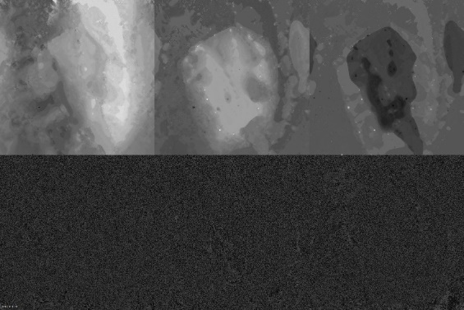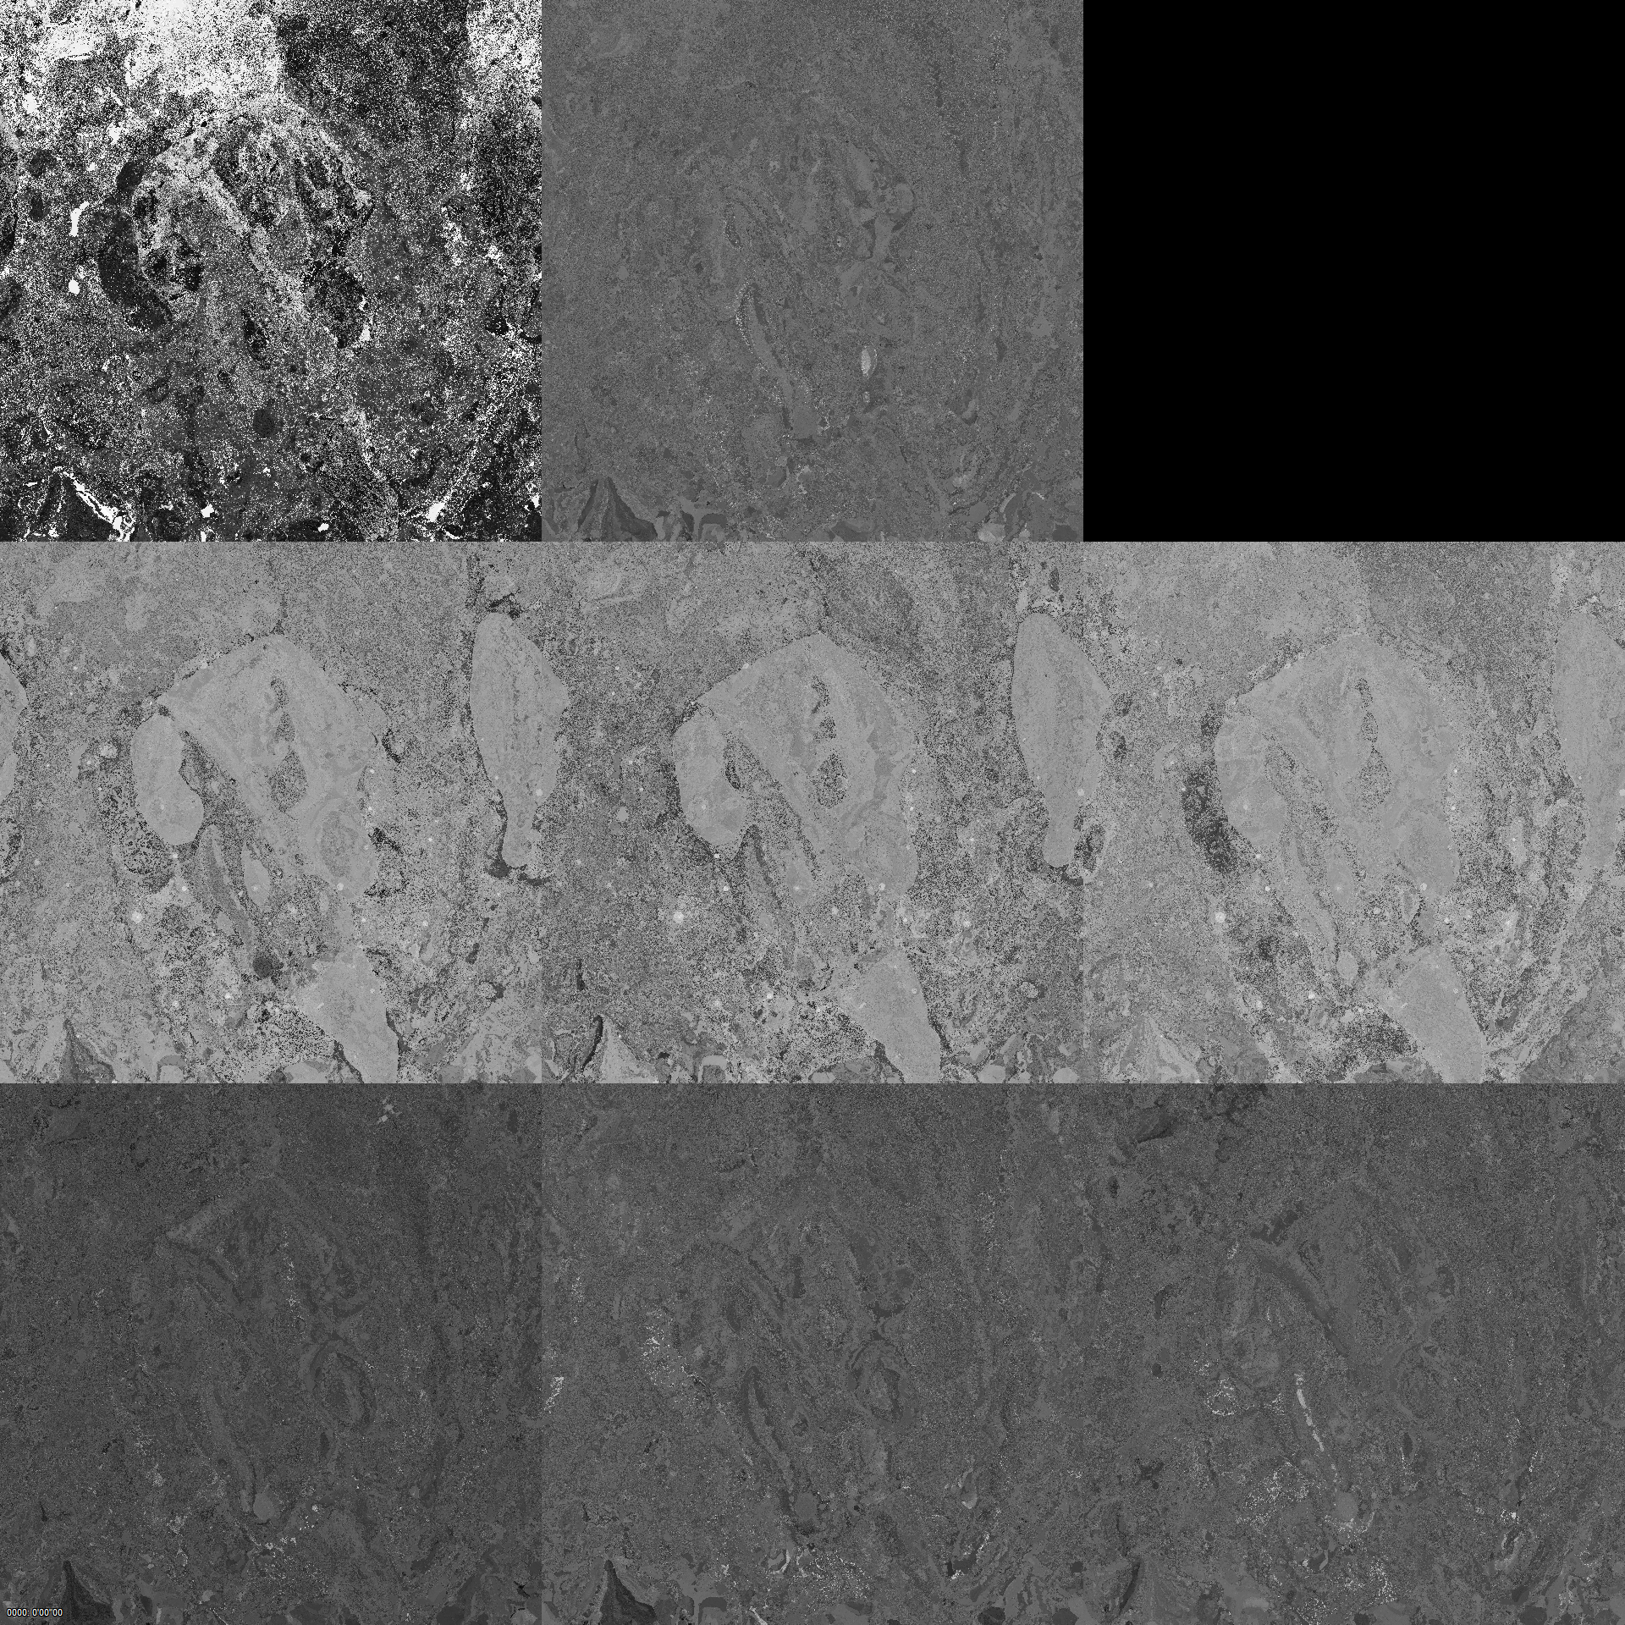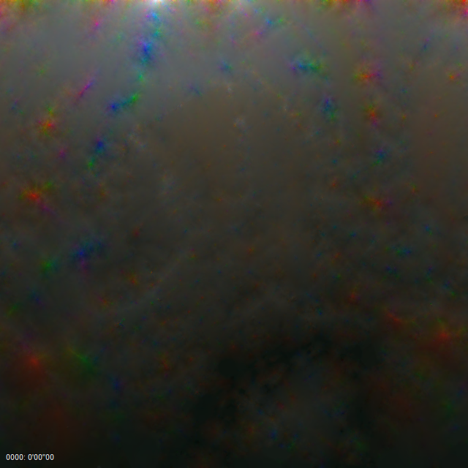
Figure 1. Examples of generated videos: Geometry (top left), attributes (right) and color and spherical harmonics (bottom left).
The next parameters have been changed by rate points:
- Video QP: QP_1 and QP_2
- Geometry bit depths for MSB and LSB parts
- Format of the color and spherical harmonics (YUV444 or YUV420).
The next table shows the chosen values.
Rate | MSB BD | LSB BD | Format_2 | QP_1 | QP_2
1 | 10 | 9 | YUV444 | -8 | 0
2 | 10 | 6 | YUV444 | -4 | 4
3 | 9 | 6 | YUV444 | 4 | 12
4 | 9 | 6 | YUV420 | 8 | 16
5 | 8 | 6 | YUV420 | 16 | 24

The main configuration are built to stay in the same biterate range than G-PCC anchor with:
- MSB and LSB bit depth decreasing according to the wich quality : 10/9, 10/6, 9/6
- Color and spherical harmonics video format in YUV444 for the high quality and YUV420 for the low bitrate
- Fixed QP :
  - QP_1 = {-8,-4,4,8,12}
  - QP_2={0,4,12,16,24}

Results

Cinema
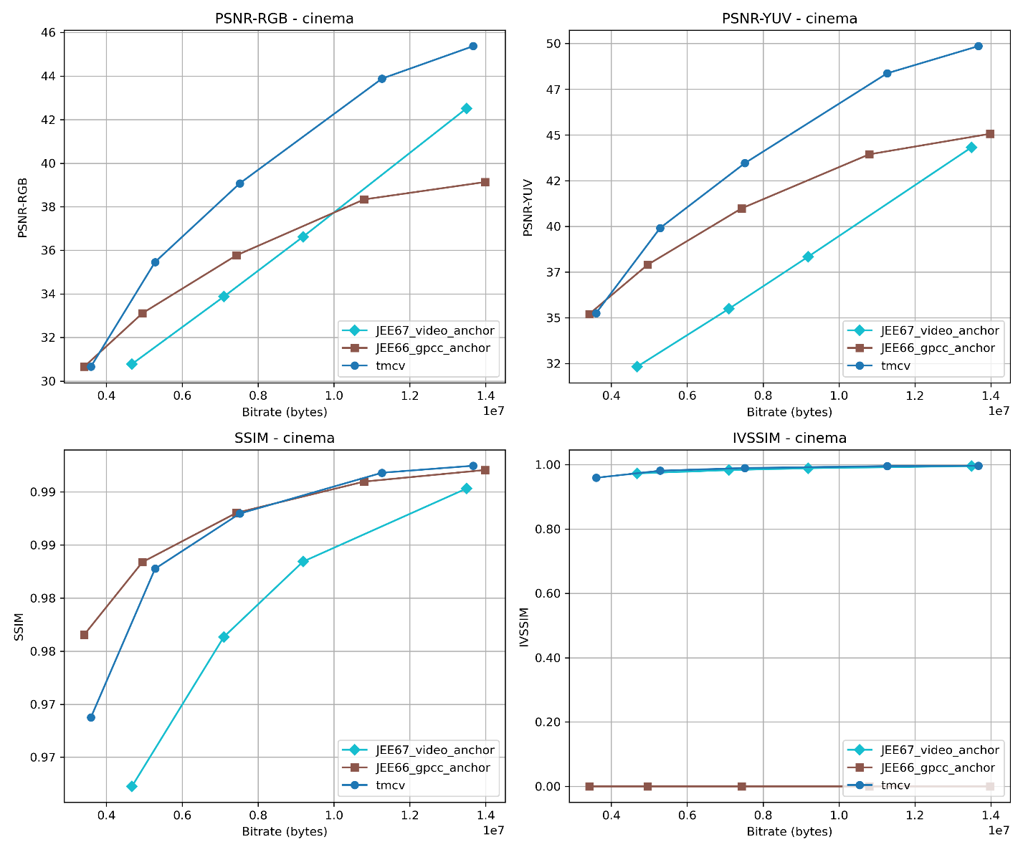

Bartender
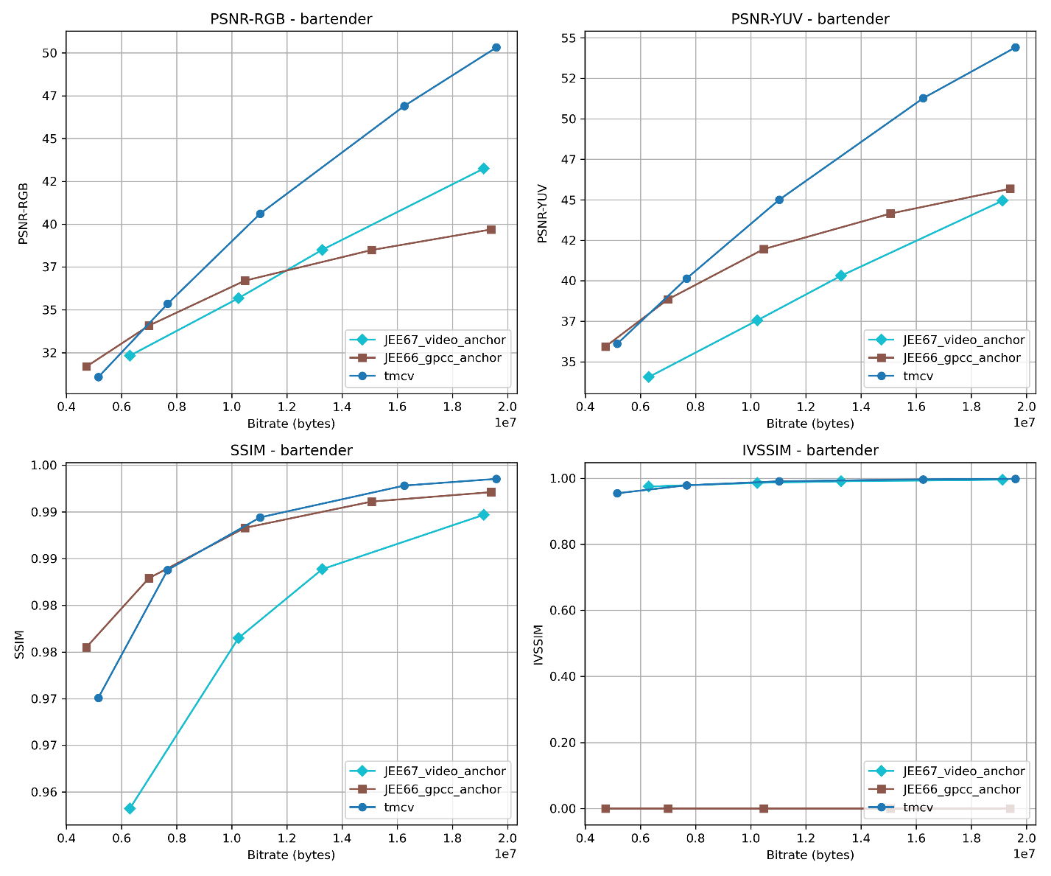

Breakfast
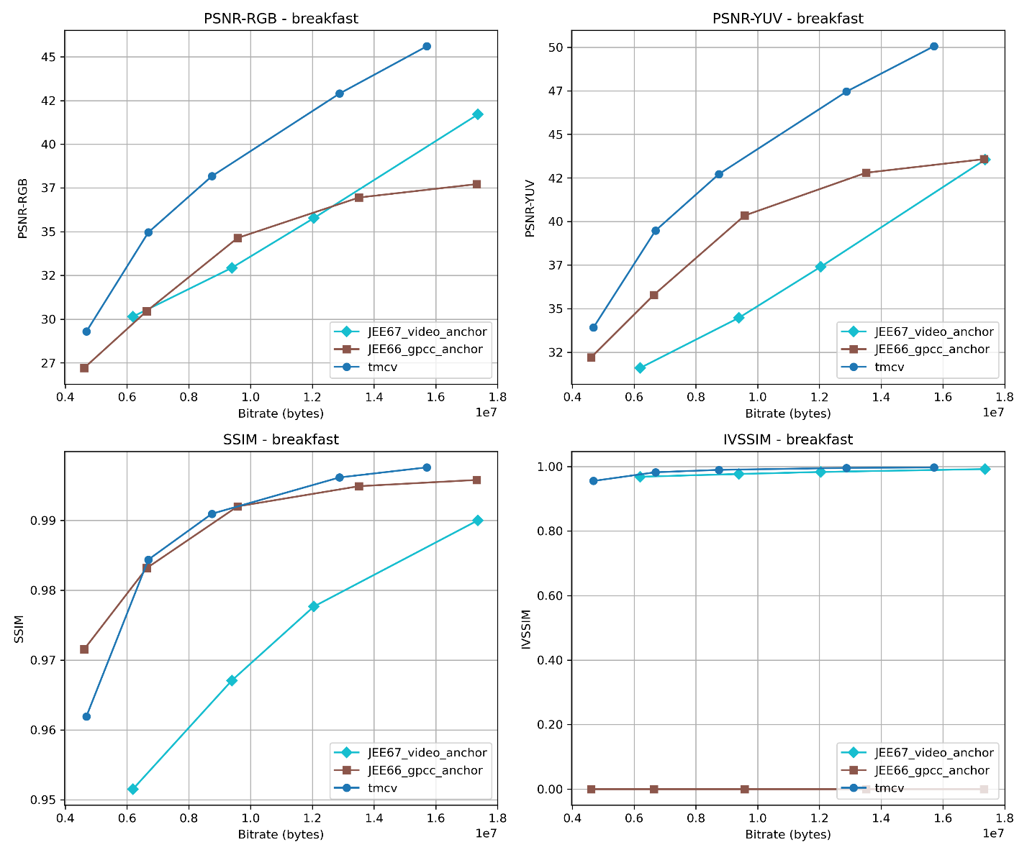

Man with fruit
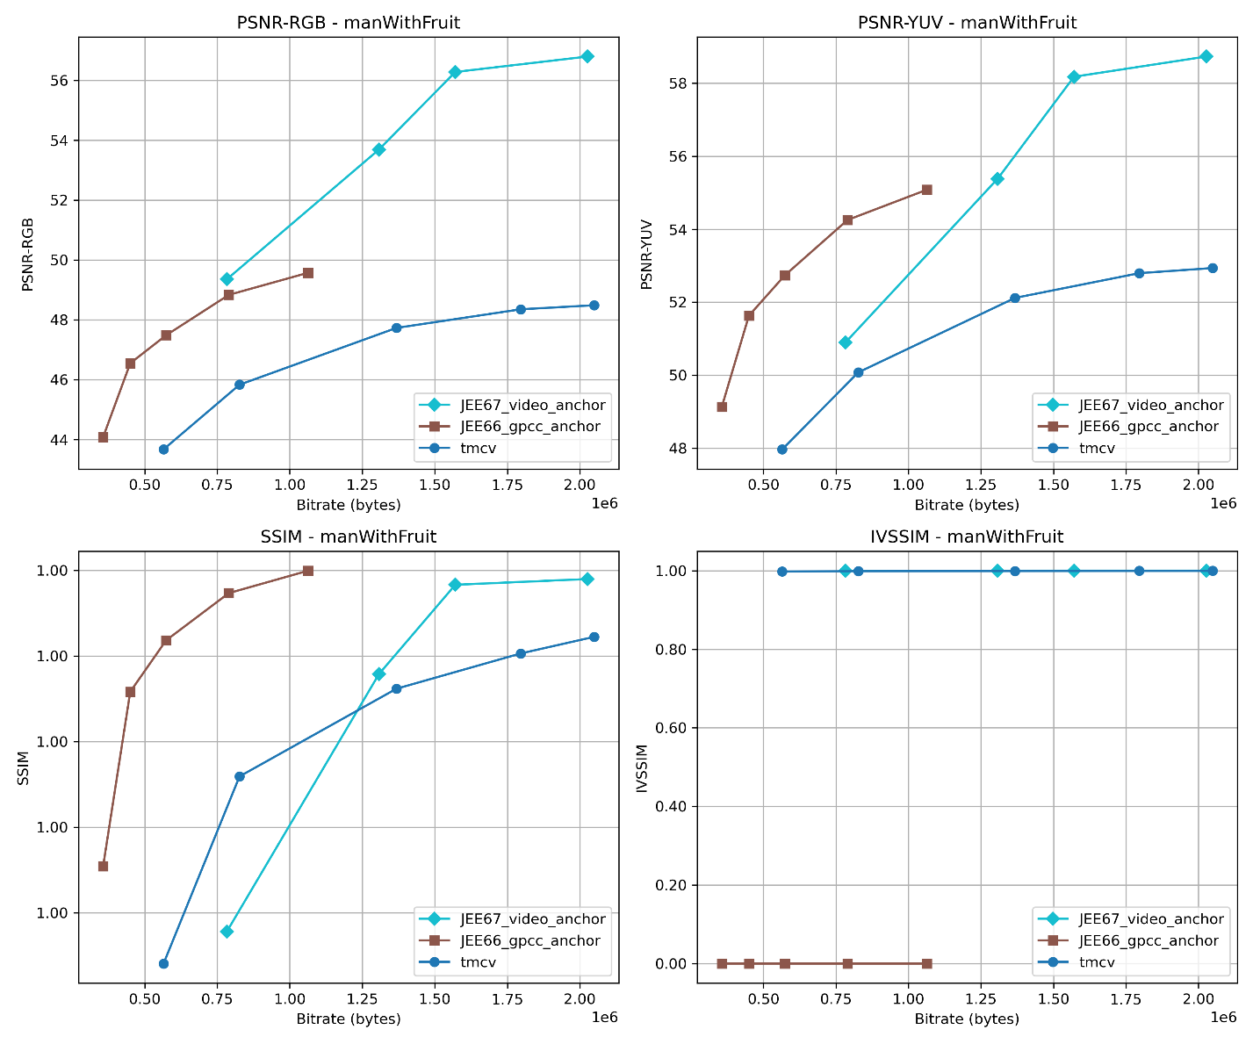

BD-rate
The following table shows the BD-rate compared to video anchor:
Sequence | BD-rate  RGB-PSNR | BD-rate  YUV-PSNR | BD-rate  YUV-SSIM
bartender_track | -25.0% | -41.6% | -42.2%
breakfast_track | -36.8% | -50.4% | -51.4%
cinema_track | -32.2% | -47.3% | -39.5%
Average | -31.3% | -46.4% | -44.3%
ManWithFruit | No overlap | 45.7% | 1.8%
The following table shows the BD-rate compared to gpcc anchor:

Sequence | BD-rate  RGB-PSNR | BD-rate  YUV-PSNR | BD-rate  YUV-SSIM
bartender_track | -15.4% | -14.2% | 2.9%
breakfast_track | -31.6% | -25.5% | -1.1%
cinema_track | -21.4% | -17.4% | 7.5%
Average | -22.8% | -19.0% | 3.1%
ManWithFruit | #VALUE! | #VALUE! | #VALUE!
Note: The results for the Man with Fruit sequence do not appear consistent and require further study to refine the coding parameters. The image size parameters used by the metric software need to be more studied.
The previous results shows that the proposed configurations outperform the GPCC and Video anchors.

Conclusion
Based on the previous results, we propose that the previous defined configurations are used for the future common test conditions.

