Lab 1 – VLANs + Trunking + DHCP + Router-on-a-Stick

Topology
Description:
The project represents a network based on 5 VLANs. Each VLAN is assigned to an appropriate access switch, and all uplinks are configured as trunk ports.
Diagram:
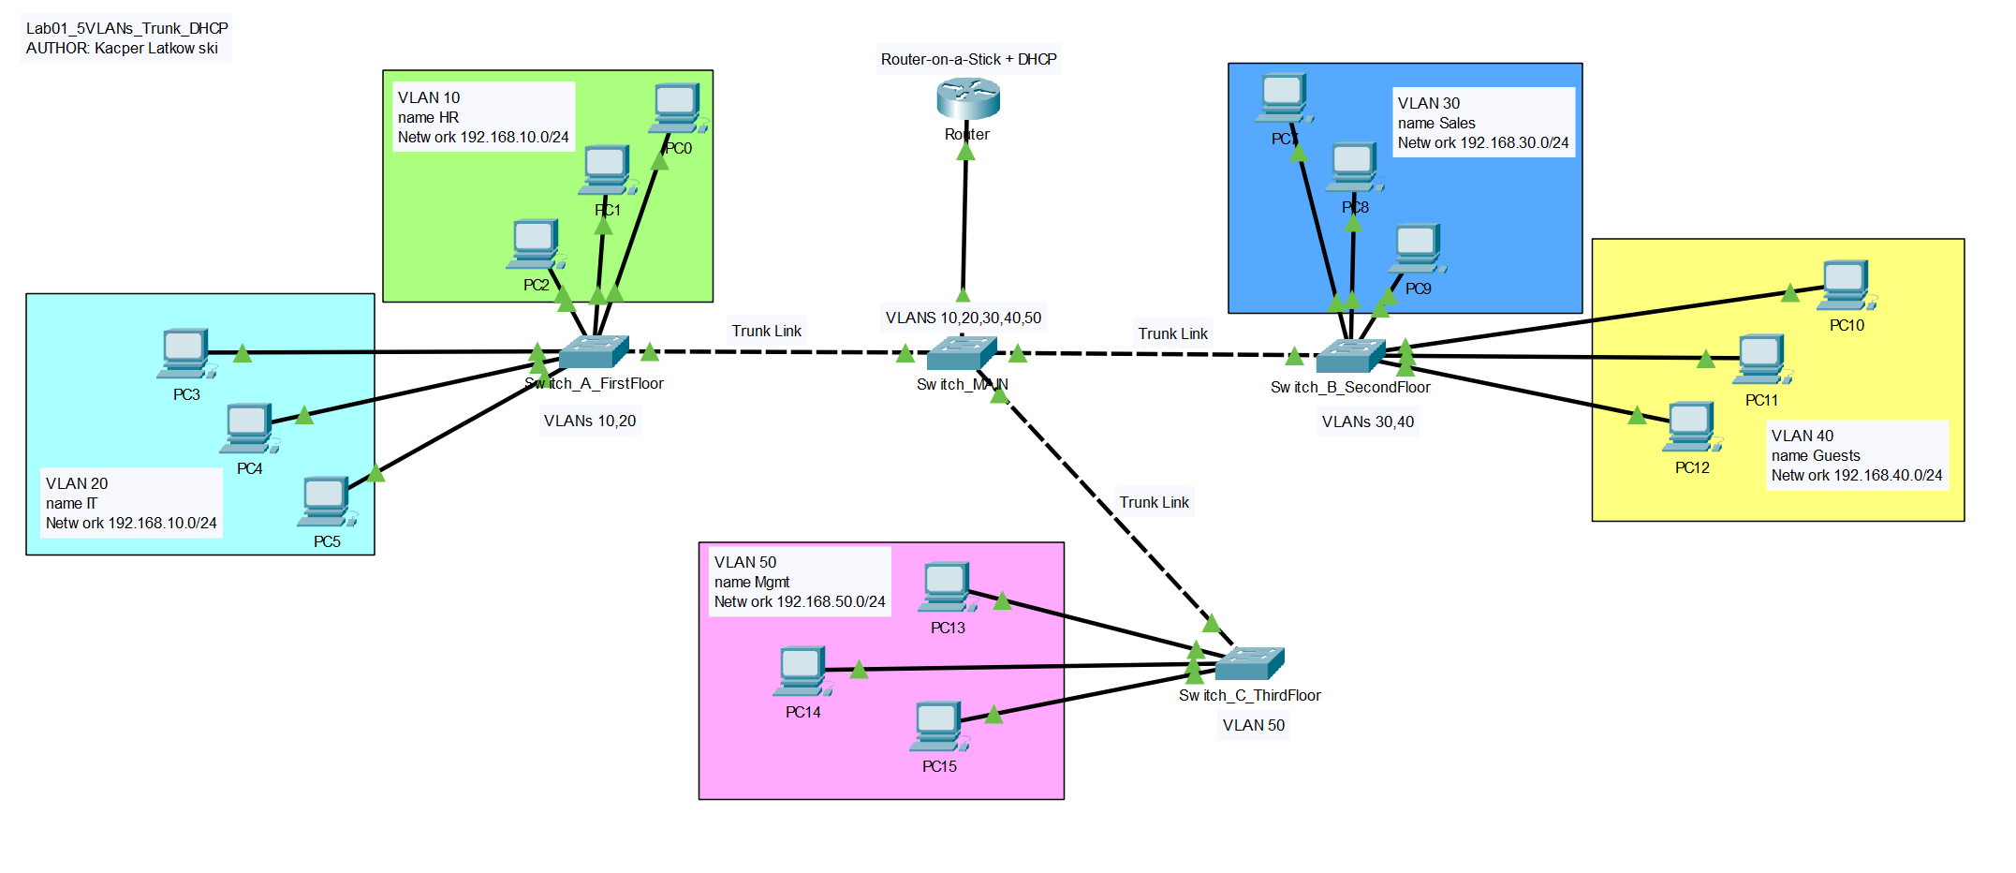
VLAN Details:
- VLAN 10 (HR) - 192.168.10.0/24
- VLAN 20 (IT) - 192.168.20.0/24
- VLAN 30 (Sales) - 192.168.30.0/24
- VLAN 40 (Guests) - 192.168.40.0/24
- VLAN 50 (Mgmt) - 192.168.50.0/24

Configuration
**Switch_A_FirstFloor:**
- VLAN 10 and 20 configuration
- Trunk link to Switch_MAIN
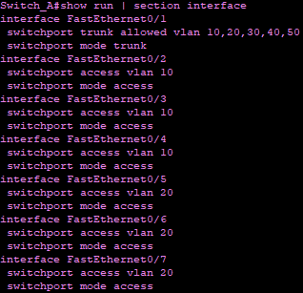
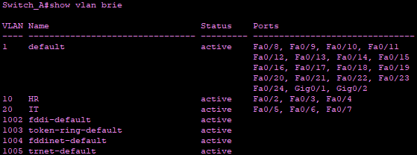
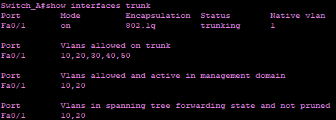

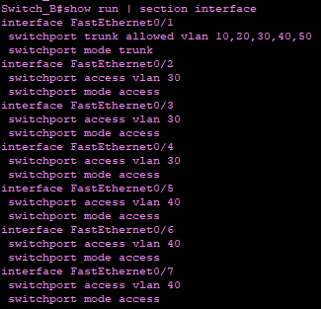
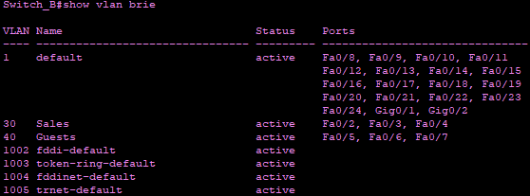
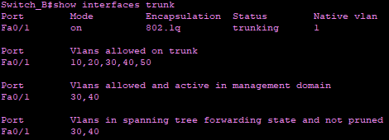
**Switch_B_SecondFloor:**
- VLAN 30 and 40 configuration
- Trunk link to Switch_MAIN

**Switch_C_ThirdFloor:**
- VLAN 50 configuration
- Trunk link to Switch_MAIN
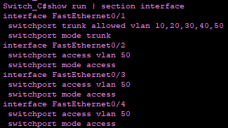
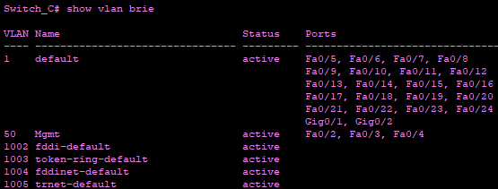
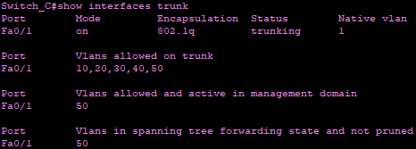

**Switch_MAIN:**
- Receives trunks from all access switches
- Trunk link to Router
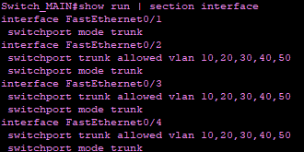
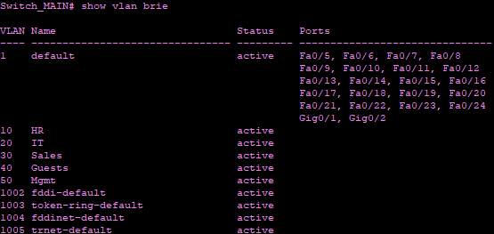
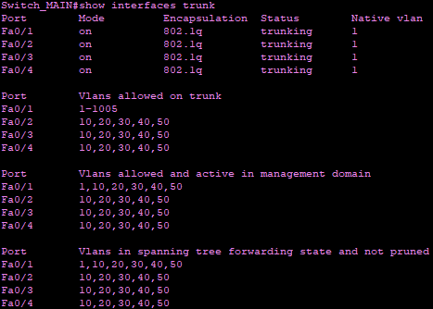

**Router (Router-on-a-Stick + DHCP):**
- Subinterfaces for each VLAN
- DHCP pools for each subnet
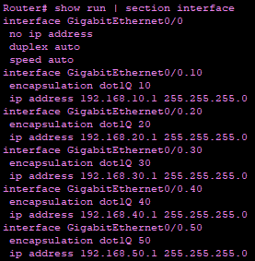
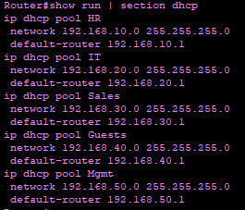

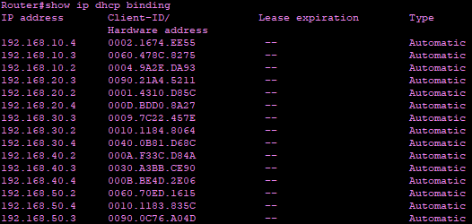

Tests
Communication Tests:
- ping between PCs in different VLANs
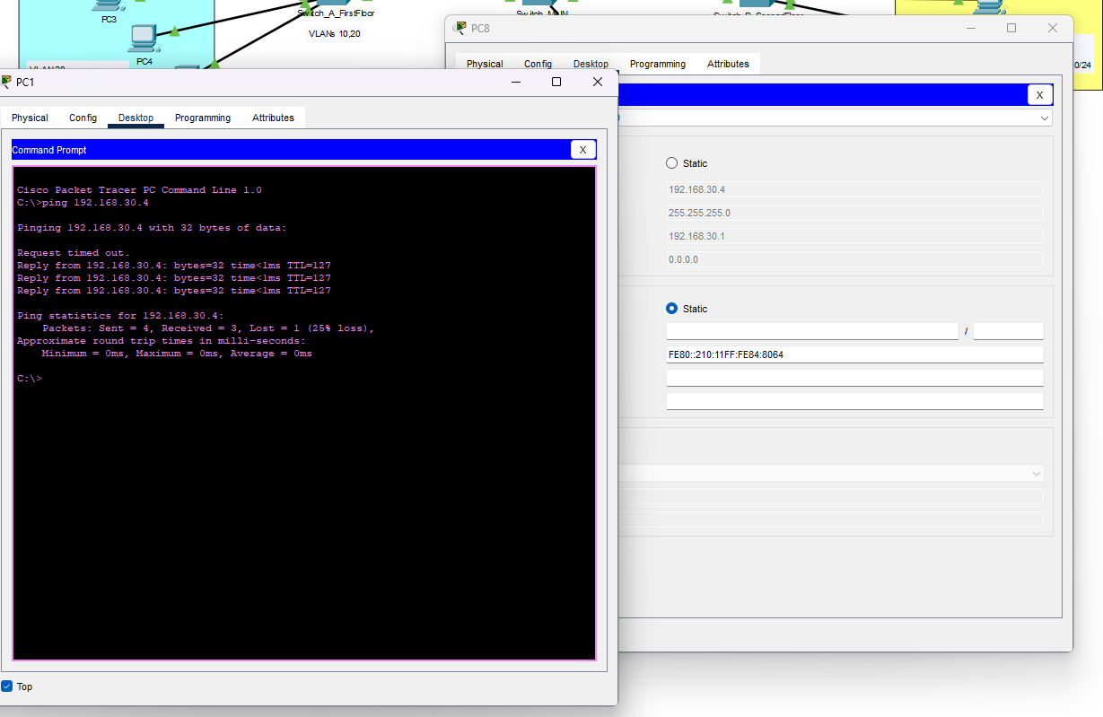

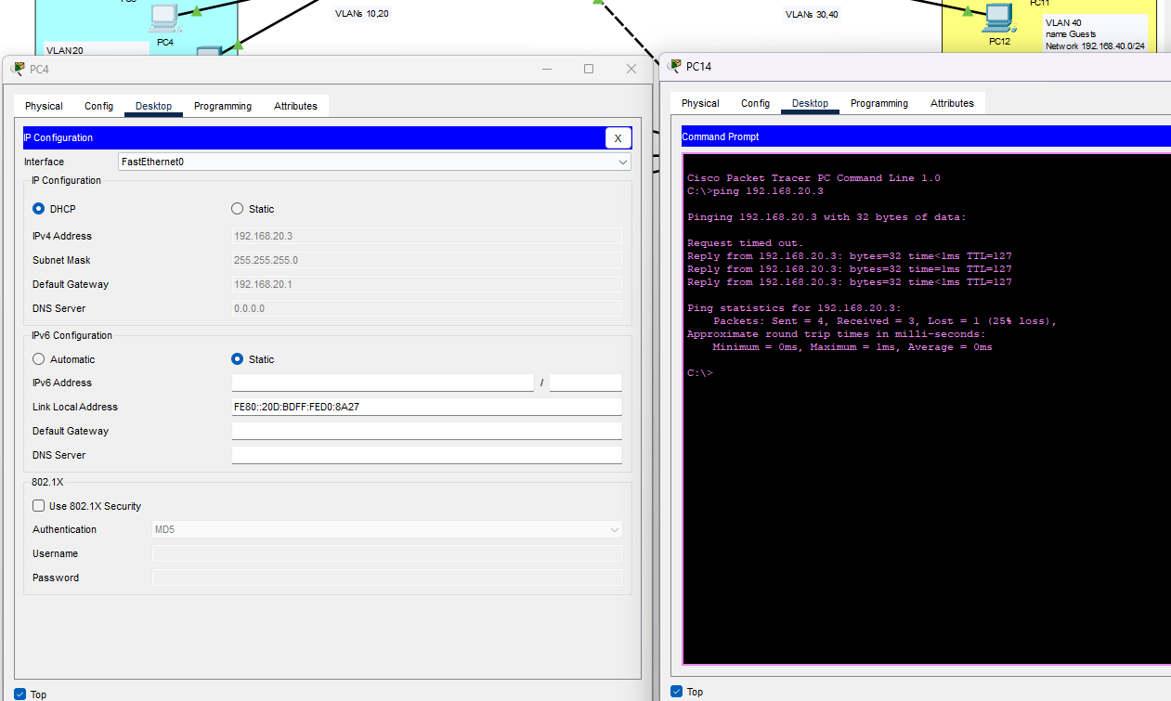

- ipconfig on hosts to confirm correct IP addressing
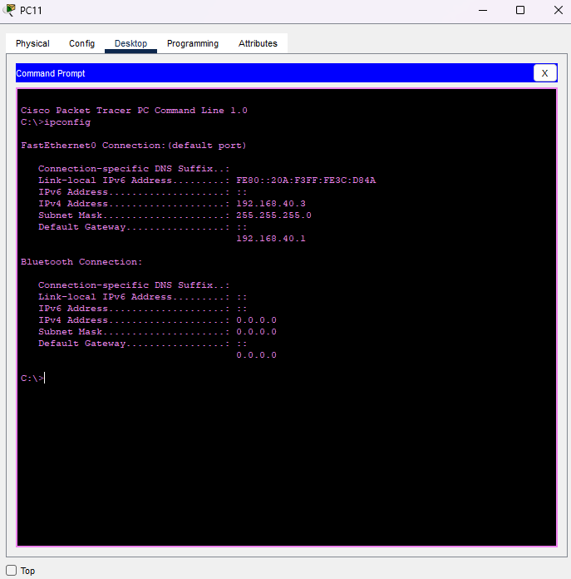
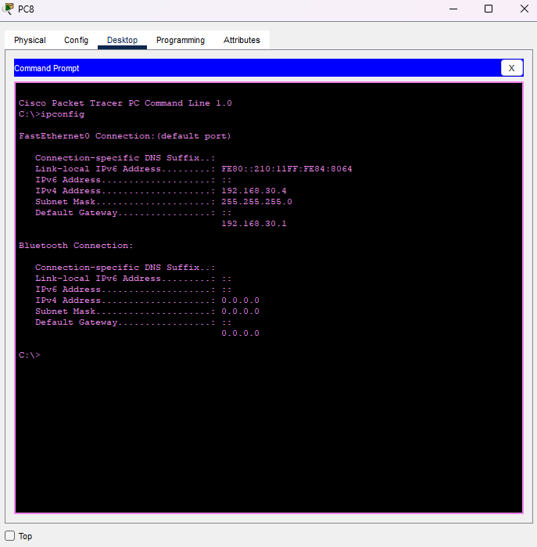

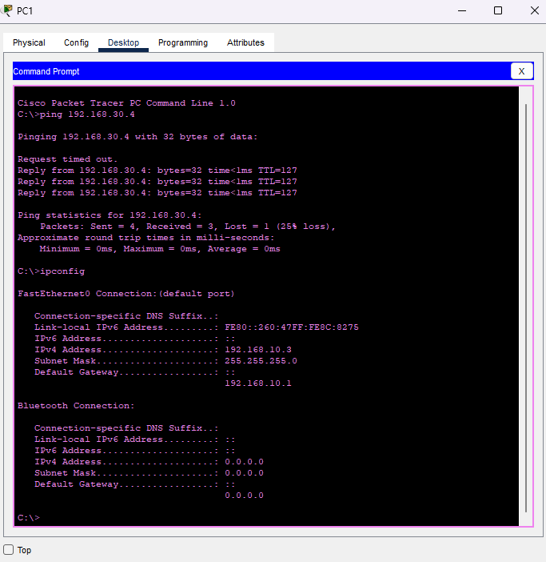
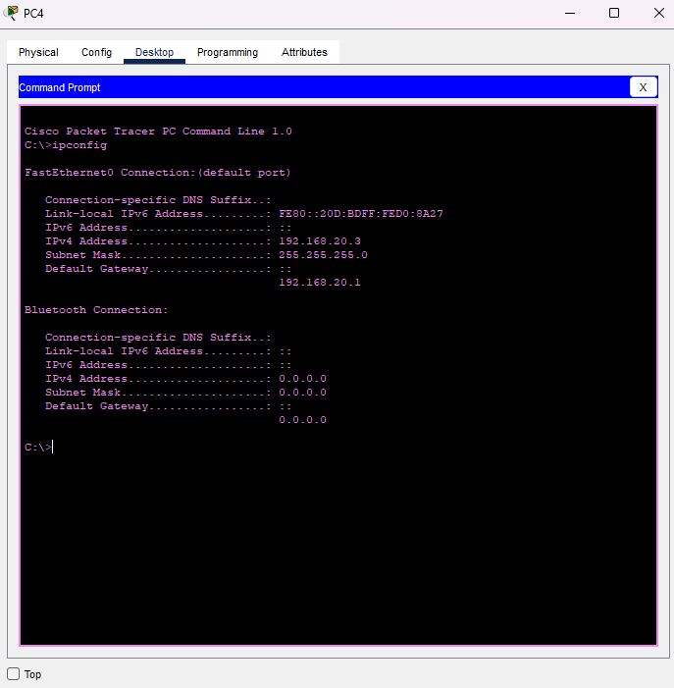

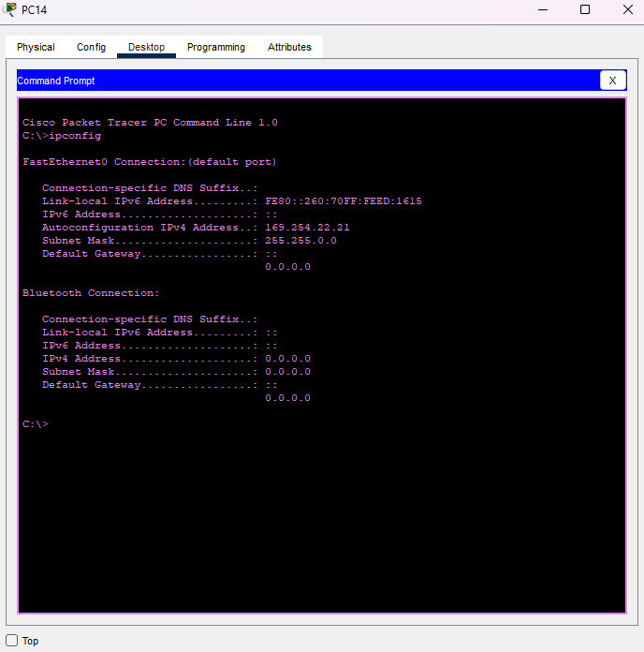

- traceroute between different VLANs
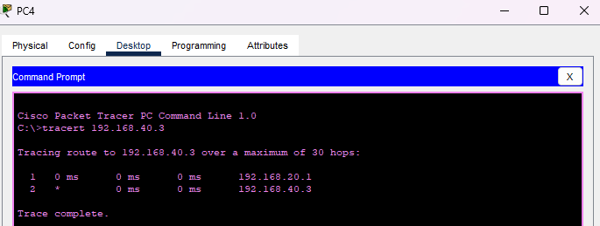

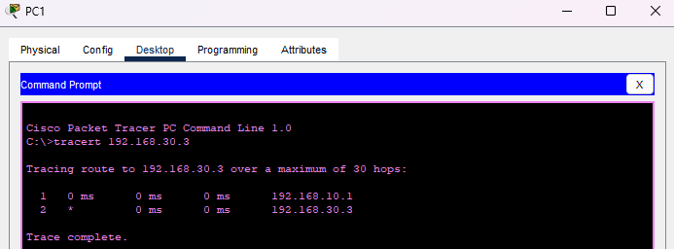

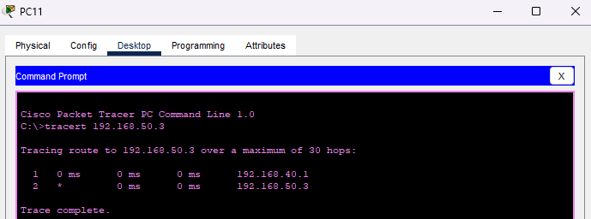

DHCP Packet Analysis

**DHCP DORA**
DHCP Discover
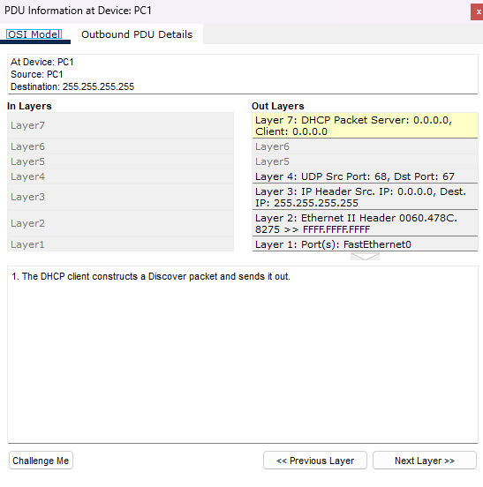

PC1 sends a DHCP Discover packet as a broadcast (0.0.0.0 → 255.255.255.255) to locate any available DHCP server.

DHCP Offer
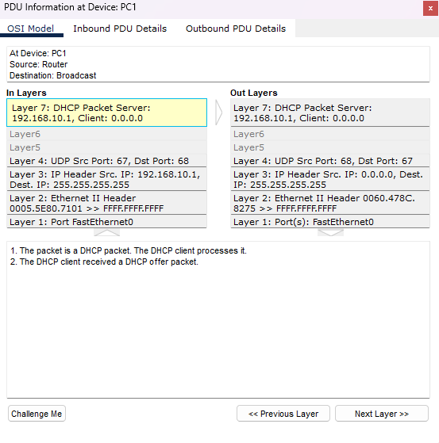

The router (192.168.10.1) responds with a DHCP Offer suggesting an IP address to the client.

DHCP Request
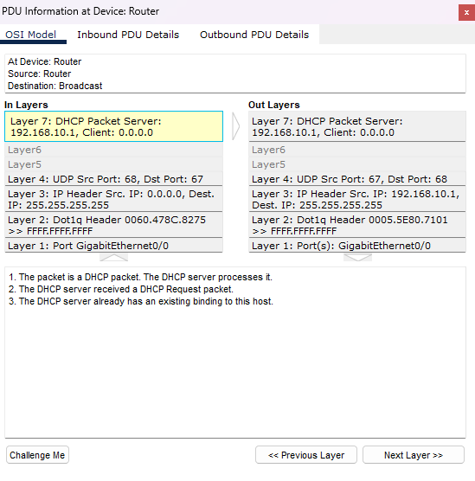

PC1 requests the offered IP address via DHCP Request broadcast.

DHCP Acknowledge (ACK)
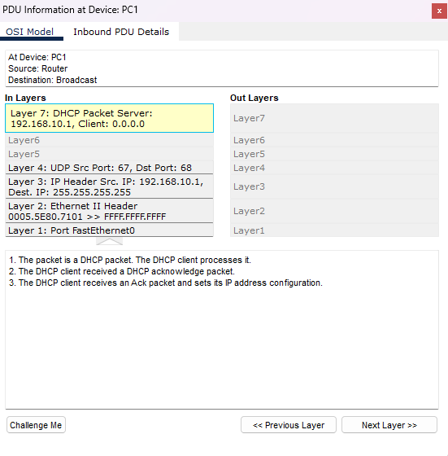

The router confirms the IP assignment with a DHCP Acknowledge packet, completing the DORA process.

Problems and Solutions
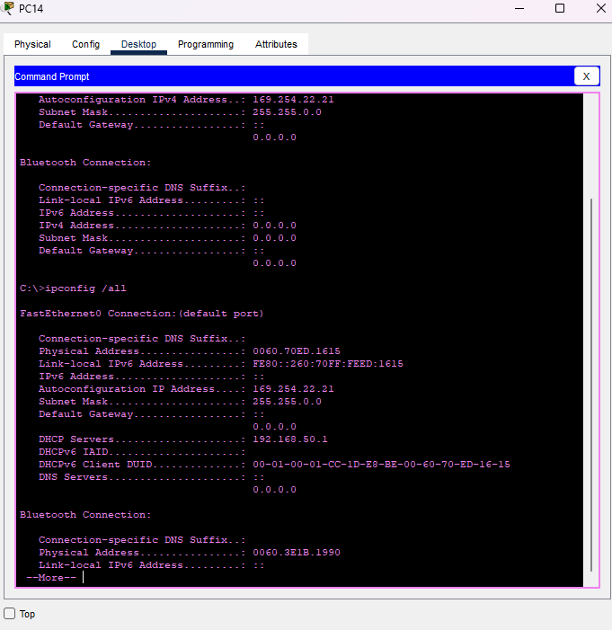
**Problem 1:**
- PCs in VLAN50 did not receive correct IP addresses.

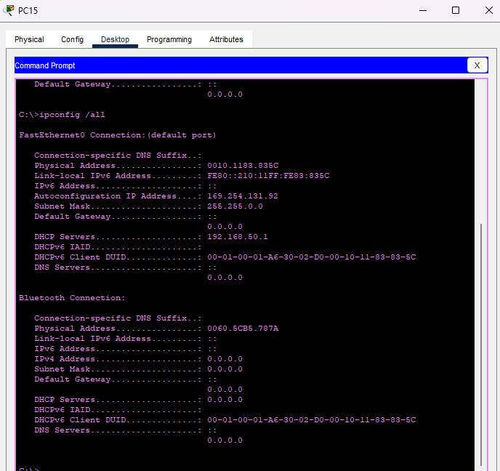

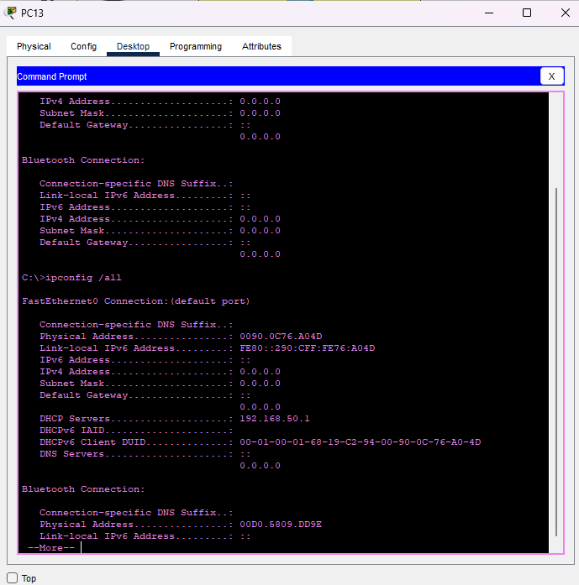

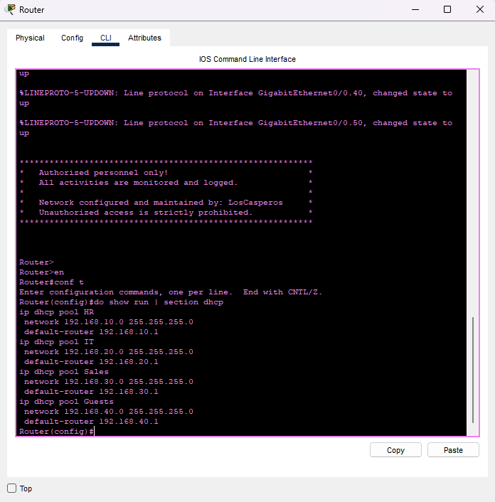
**Solution:**
- Missing DHCP pool for VLAN50. Added the necessary DHCP pool.

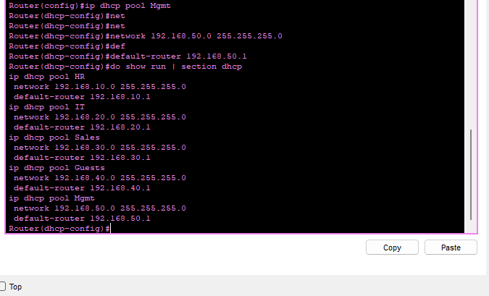

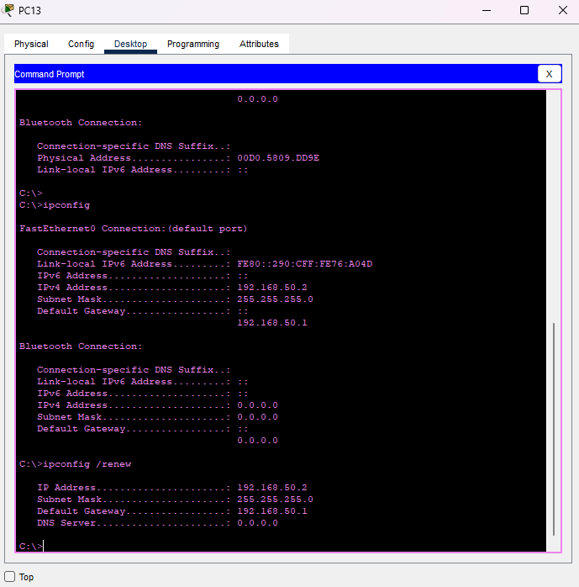
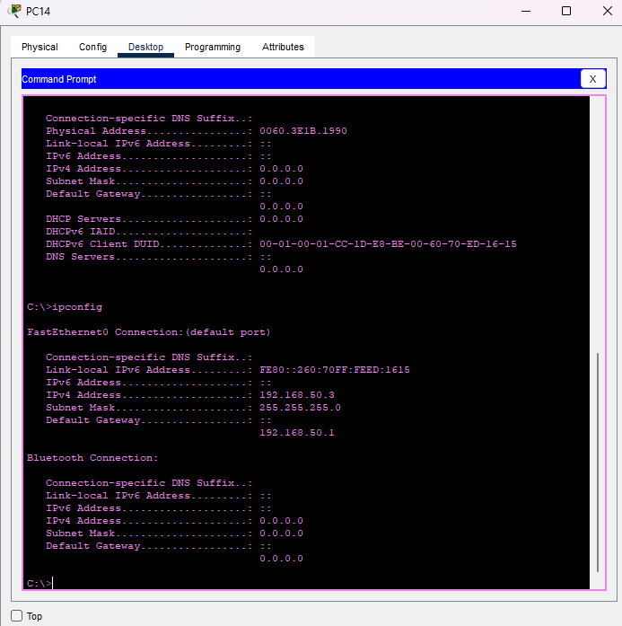
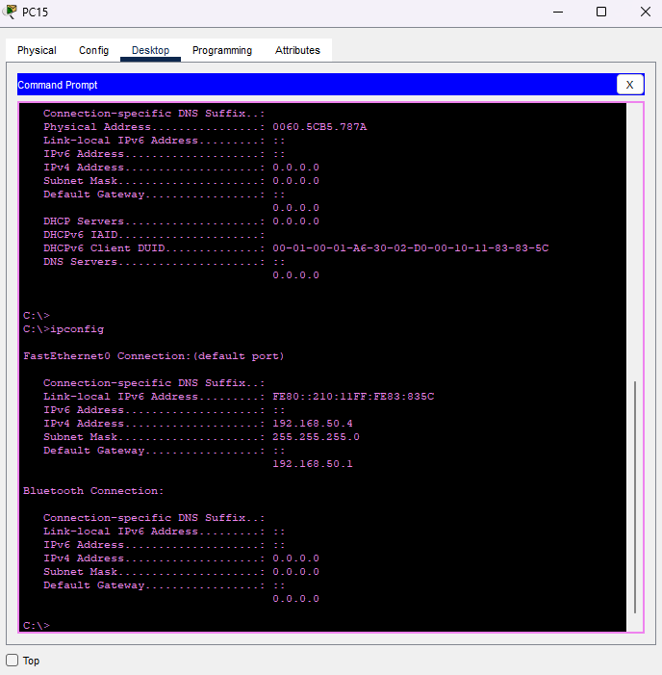

**Problem 2:**
- No communication between VLAN10 and VLAN30.
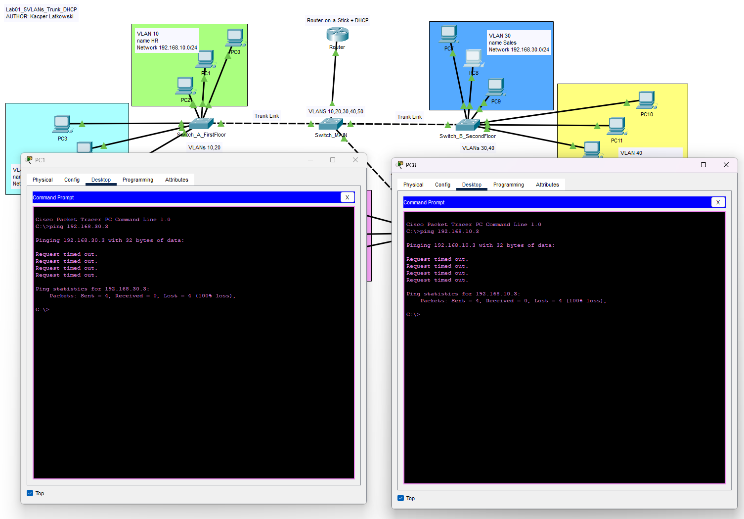
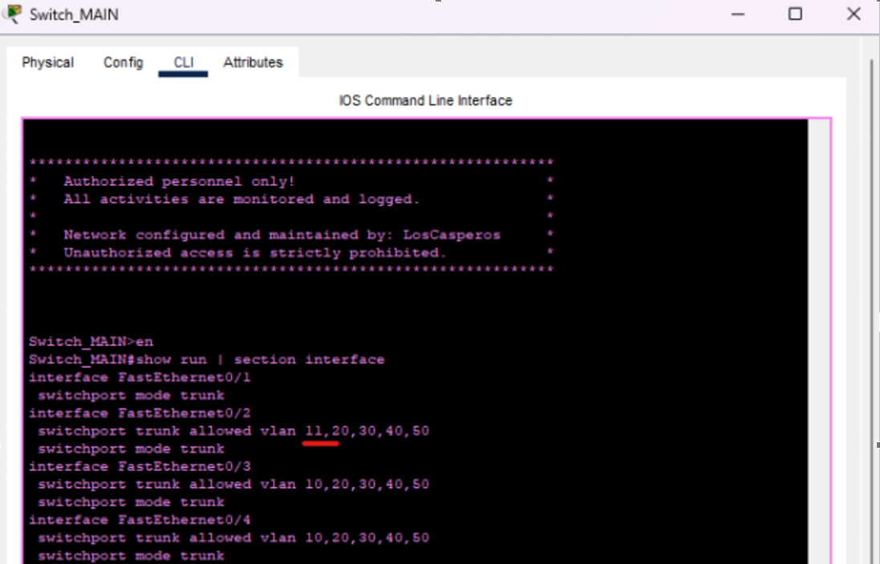
**Solution:**
- Incorrect trunk configuration on Switch_MAIN. Corrected the allowed VLAN list.

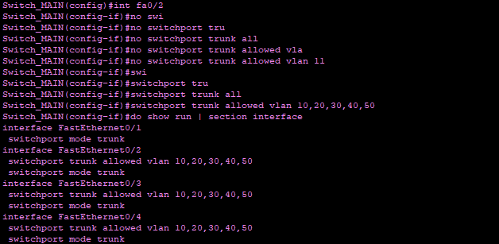

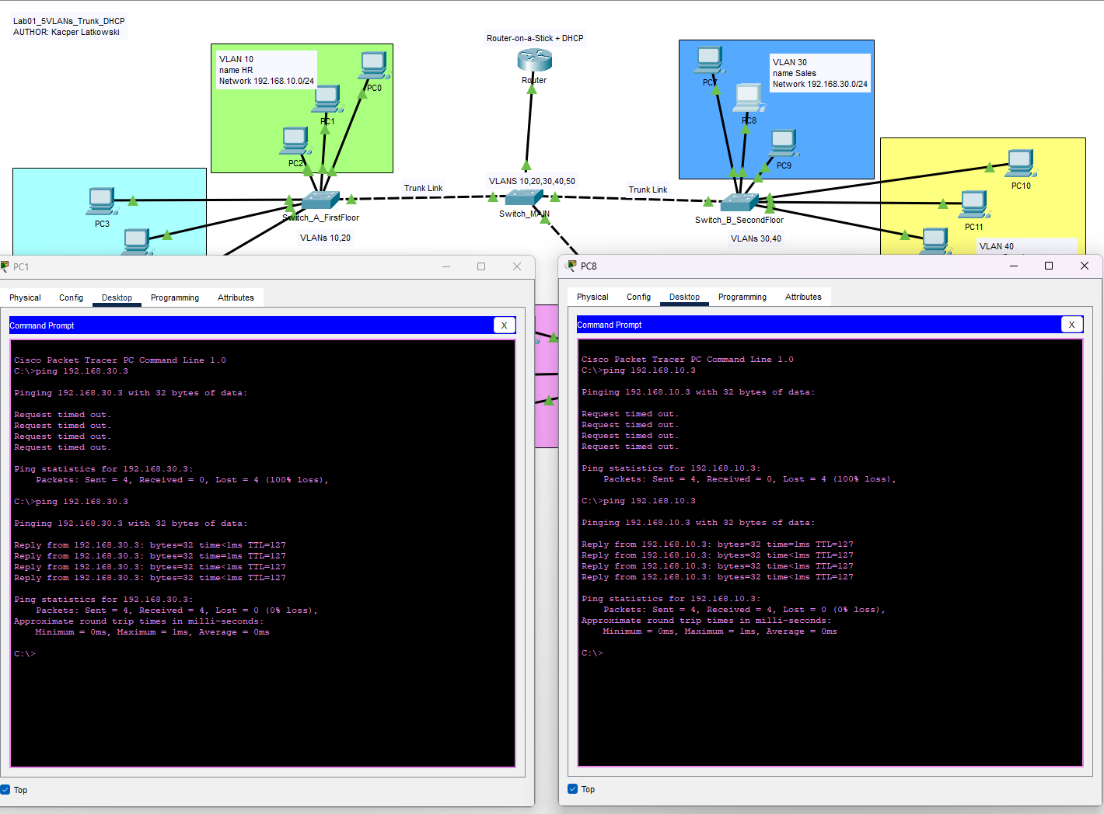

Author: Kacper Latkowski

