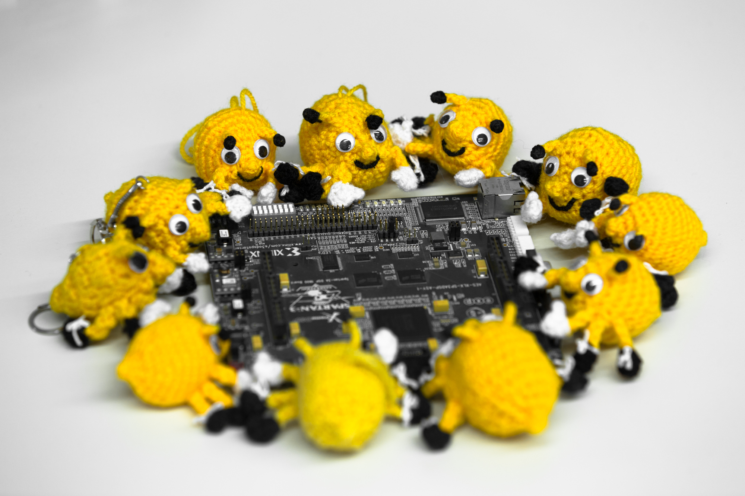
> don’t feed the bugs!
LosFuzzys’ year 2016 in review ...

Global rank: | 38 (of 9909)
Austria rank: | 1 (of 9)
Participated CTFs: | 30
Published Writeups: | 39
Internal Writeups: | 634
Wiki Pages: | 1.021
Trainings (since Sept): | 16
Food orders: | ?
IAIK Special Awards: | 1

All 2016 CTF participations:
33C3 CTF (27. - 29. 12)
SharifCTF 7 (place 2 of 700)
SECCON Online CTF (place 31 of 930)
Juniors CTF (place 1 of 310)
RC3 CTF (place 20 of 663)
Qiwi-Infosec CTF (place 15 of 234)
RuCTFE (place 20 of 131)
Hack The Vote (place 16 of 1030)
EKOPARTY CTF (place 6 of 721)
Hack.lu CTF (place 29 of 174)
HITCON CTF Quals (place 137 of 735)
Hackover CTF (place 9 of 175)
TUM CTF (place 21 of 435)
DefCamp CTF Qualification (place 2 of 116)
CSAW CTF Qualification Round (place 56 of 1274)
ASIS CTF Finals (place 23 of 343)
SECUINSIDE CTF Quals (place 64 of 395)
DEF CON CTF Qualifier (place 252 of 276)
TU CTF (place 42 of 435)
Google Capture The Flag (place 361 of 903)
PlaidCTF (place 519 of 812)
Nuit du Hack CTF Quals (place 69 of 447)
BCTF (place 196 of 588)
BSides Ljubljana CTF (place 1 of 14)
Boston Key Party CTF (place 183 of 764)
Internetwache CTF (place 27 of 647)
Sharif University CTF (place 15 of 447)
HackIM (place 61 of 535)
EFF CTF (place 54 of 100)
Insomni’hack teaser (place 44 of 245)

