> HELLO, WORLD!

We are LosFuzzys!

We are a team of (mostly) students
interested in information security.

We participate in Capture the Flag (CTF) events.
CTFs are information security competitions,
sometimes also called competitive hacking.

Curious? Wanna get to know us? (:
* Visit https://hack.more.systems
* Join our weekly trainings Wednesdays 18:30 @IAIK

Recent CTF Highlights:
we traveled …
Nuit du Hack CTF Finals @ Paris (place 7 of 9)
SUTD Security Showdown Finals @ Singapore (place 2 of 6)
BSides Ljubljana CTF @ Ljubljana (place 1 of ~7)

we attacked & defended …
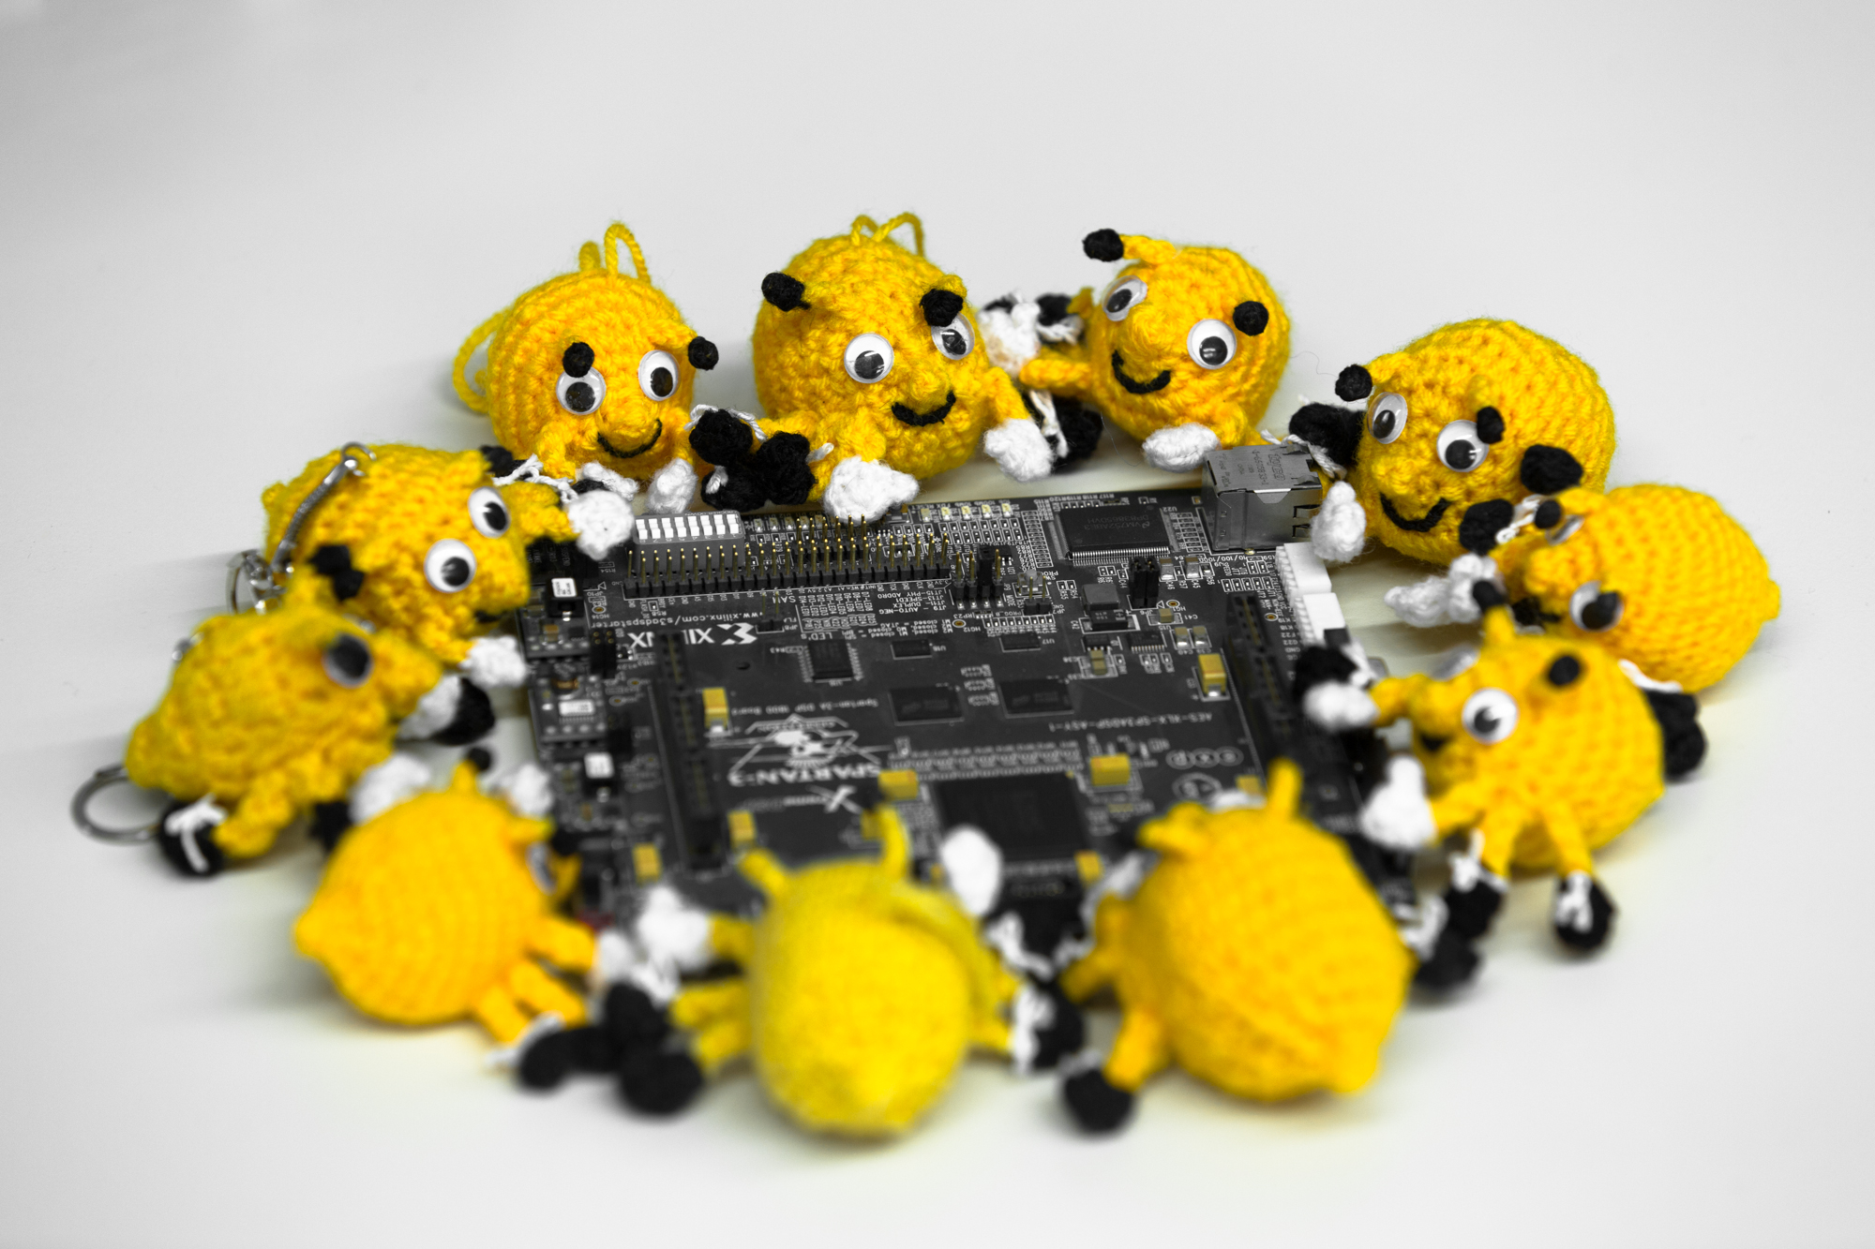
FAUST CTF (place 9 of 50)
UCSB iCTF (place 10 of 317)

and we played some Jeopardy …
SHA2017 CTF (place 35 of 462)
PoliCTF (place 18 of 252)
Google Capture The Flag (place 67 of 1977)
Security Fest (place 20 of 447)
SUTD Security Showdown Quals (place 1 of 9)
Nuit du Hack CTF Quals (place 9 of 378)
Boston Key Party CTF (place 20 of 948)
BSides San Francisco CTF (place 28 of 531)
BITSCTF (place 7 of 275)
AlexCTF (place 19 of 1029)
Insomni’hack teaser (place 36 of 339)

