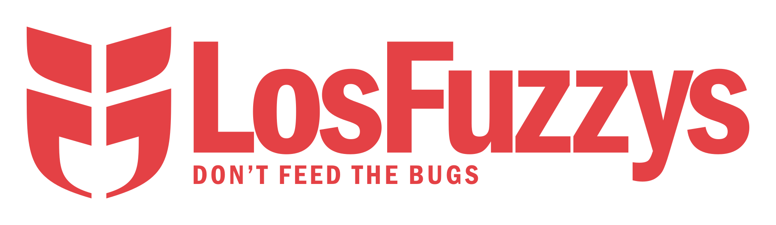

We are a team of (mostly) students
interested in information security.
We participate in Capture the Flag (CTF) events.
CTFs are information security competitions,
sometimes also called competitive hacking.
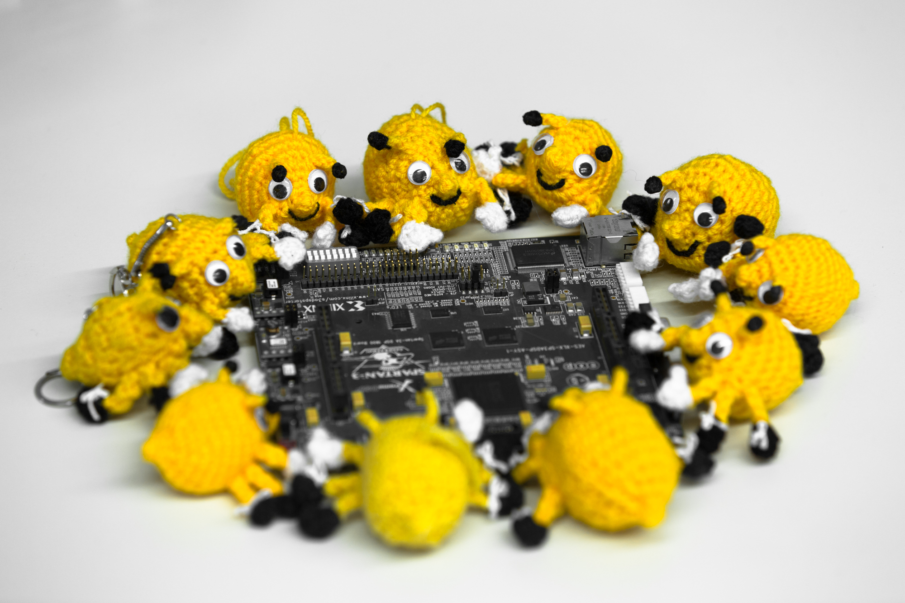

Curious? Wanna get to know us? (:
* Visit https://hack.more.systems
* Join our weekly trainings Wednesdays 18:30 @ IAIK

