> HELLO, WORLD!

We are LosFuzzys!

We are a group of (mostly) students
interested in information security.

We participate in Capture the Flag (CTF) competitions.
CTFs are information security competitions;
sometimes also called competitive hacking.

Curious? Wanna join us?
Visit https://hack.more.systems …

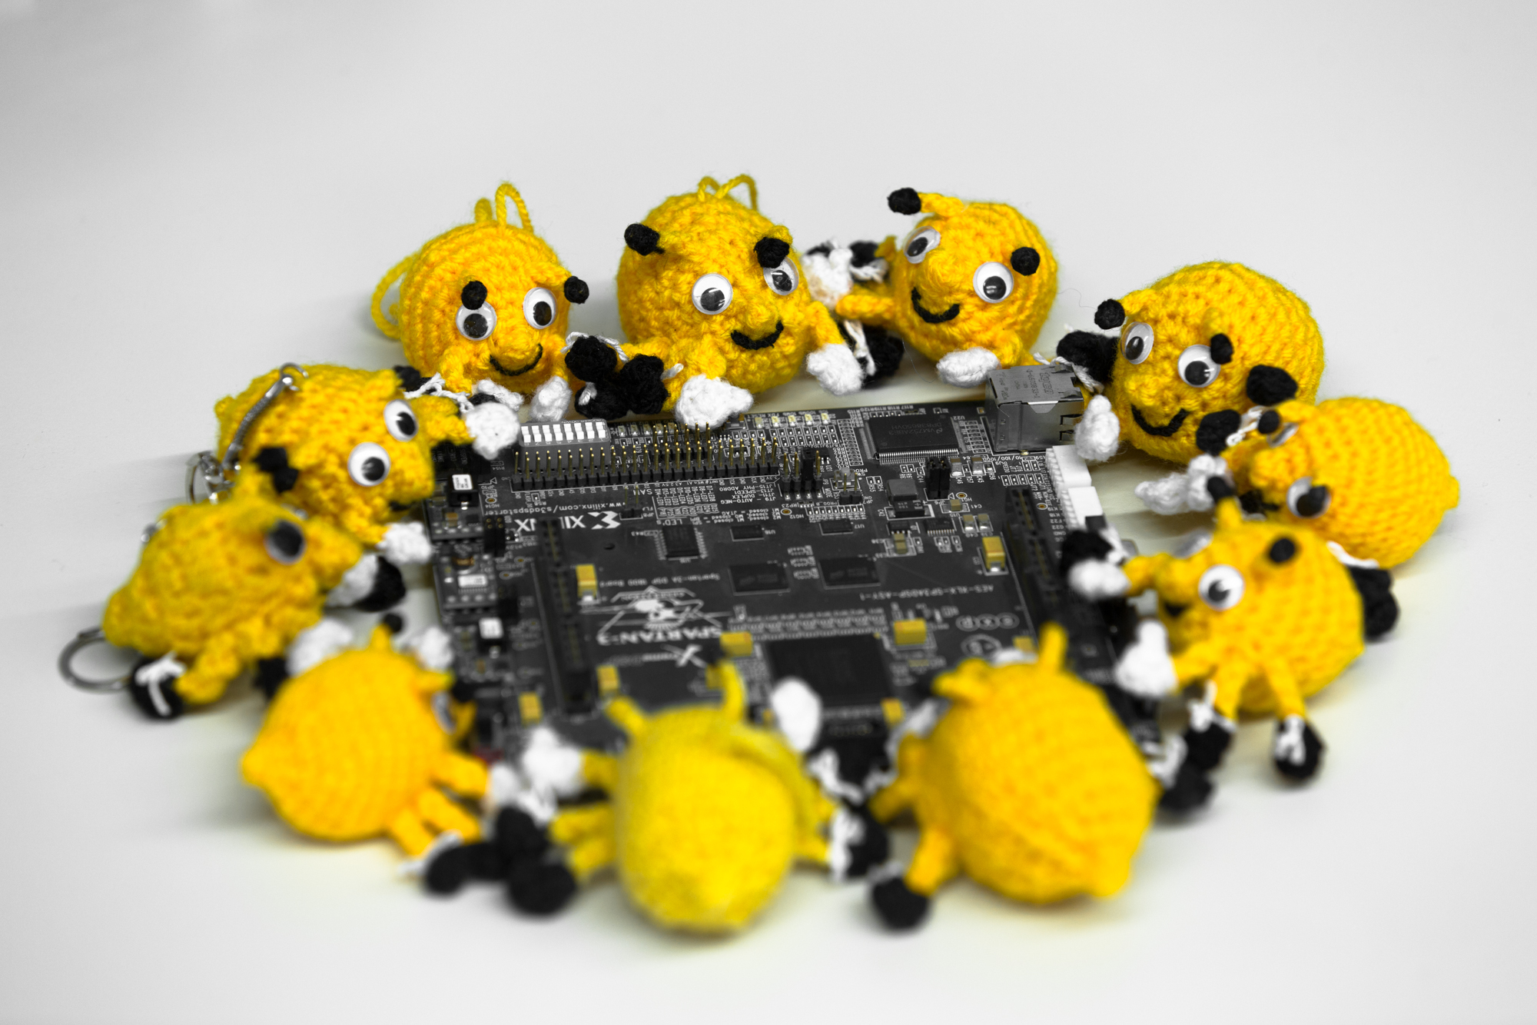
Recent CTF highlights:
Juniors CTF (place 1 of 310)
RC3 CTF (place 20 of 663)
Qiwi-Infosec CTF (place 15 of 234)
RuCTFE (place 20 of 131)
Hack The Vote (place 16 of 1030)
EKOPARTY CTF (place 6 of 721)
Hack.lu CTF (place 29 of 174)
Hackover CTF (place 9 of 175)
TUM CTF (place 21 of 435)
DefCamp CTF Qualification (place 2 of 116)
CSAW CTF Qualification Round (place 56 of 1274)
ASIS CTF Finals (place 23 of 343)
BSides Ljubljana CTF (place 1 of 14)
Internetwache CTF (place 27 of 647)
Sharif University CTF (place 15 of 447)

