> HELLO, WORLD!

We are LosFuzzys!

We are a group of (mostly) students
interested in information security.

We participate in Capture the Flag (CTF) competitions.
CTFs are information security competitions;
sometimes also called competitive hacking.

Curious? Wanna join us?
Visit https://hack.more.systems …

Past CTF participations:
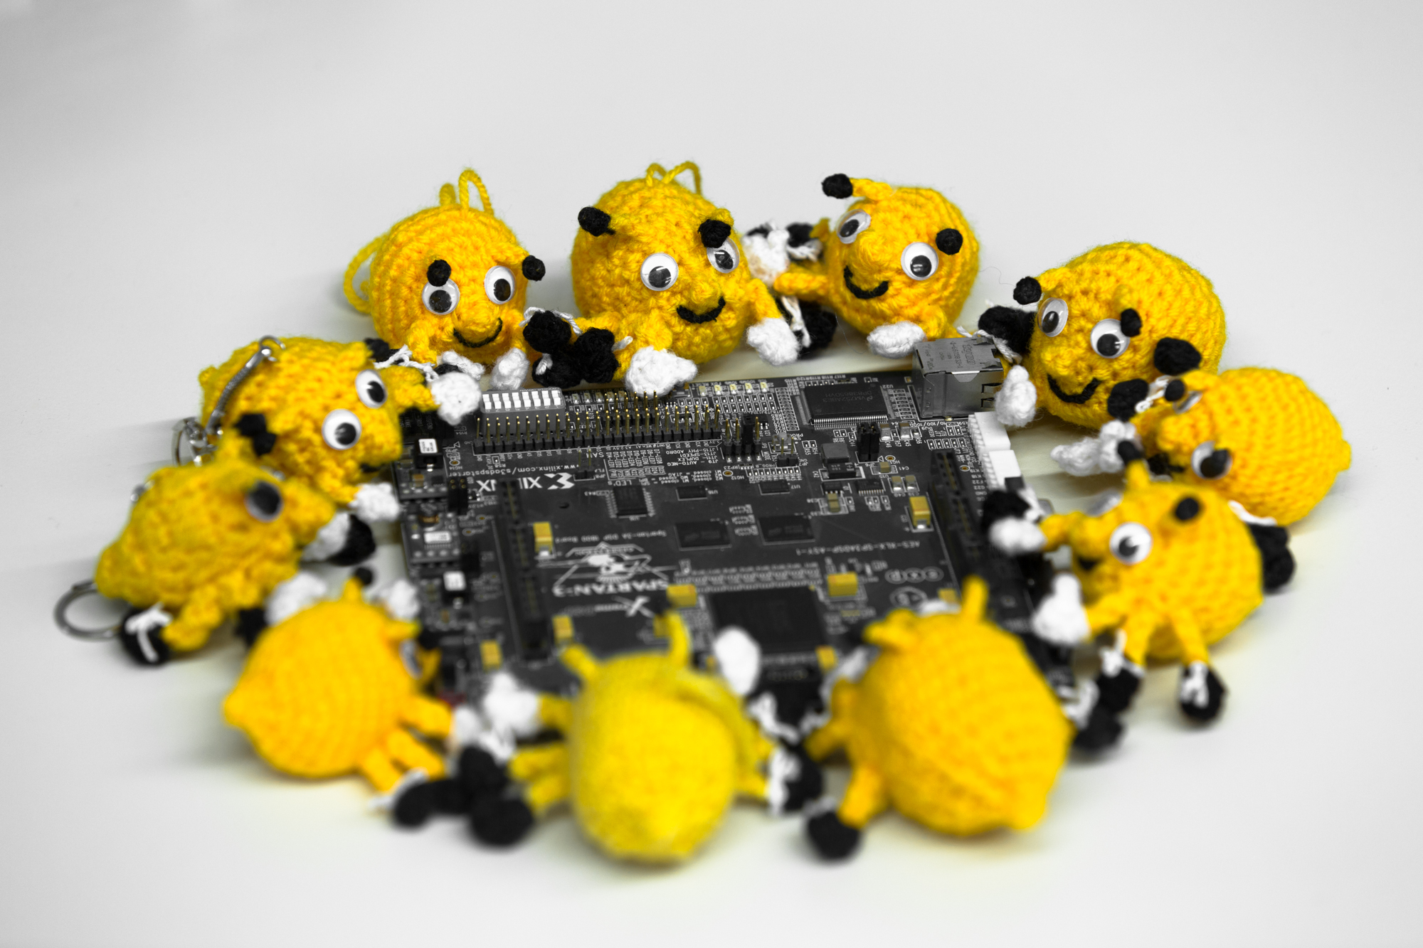
DefCamp CTF Qualification (place 2 of 116)
CSAW CTF Qualification Round (place 56 of 1274)
ASIS CTF Finals (place 23 of 343)
SECUINSIDE CTF Quals (place 64 of 395)
DEF CON CTF Qualifier (place 252 of 276)
TU CTF (place 42 of 435)
Google Capture The Flag (place 361 of 903)
PlaidCTF (place 519 of 812)
Nuit du Hack CTF Quals (place 69 of 447)
BCTF (place 196 of 588)
BSides Ljubljana CTF (place 1 of 14)
Boston Key Party CTF (place 183 of 764)
Internetwache CTF (place 27 of 647)
Sharif University CTF (place 15 of 447)
HackIM (place 61 of 535)
EFF CTF (place 54 of 100)
Insomni’hack teaser (place 44 of 245)

