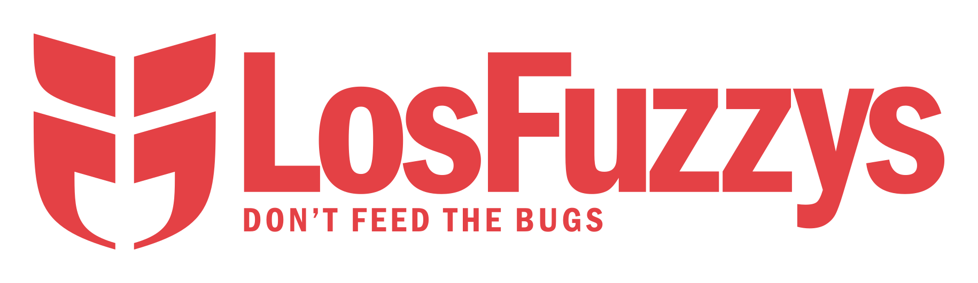
OCTOBER REVERSE | ESREVER REBOTCO

Introduction to Reverse Engineering
Free! – for students, by students!

When? Every Wednesday, 18:15 – ~21:00
Where? @IAIK (Inffeldgasse 16a) ground floor; meet-up at the FuzzyLab (IFEG064)

Meta & Open Session 4. October
a. Overview & Discussion
b. Open Reverse Session: Propose a challenge/topic to look at
Beginner Session 11. October
a. Introduction of LosFuzzys & CTFs
b. Beginner-friendly Reversing Challenges
Reversing Workshop 18. October
a. Basic introduction into IDA
b. Demo challenge (live walkthrough with wolvg)
c. "Real" challenges
Reversing Workshop 25. October
a. Basic introduction of Radare and r4ge
b. Demo challenge (live walkthrough with gast04)
c. "Real" challenges

Questions?
E-Mail we@hack.more.systems

