**drgMaster**

drgMaster performs basic analysis of spike and LFP data acquired by the Restrepo lab. Data are acquired with the Data Translation DT3010 or Intan RHD2000 boards. After reading the header with drta you can perform LFP analysis with drgMaster. In order to perform spike analysis you need to sort spikes using wave_clus. drgMaster will read header and spike information from a jt_times file generated by drta/wave_clus and will read LFP recordings from .dg (DT3010) or .rhd (Intan) files.

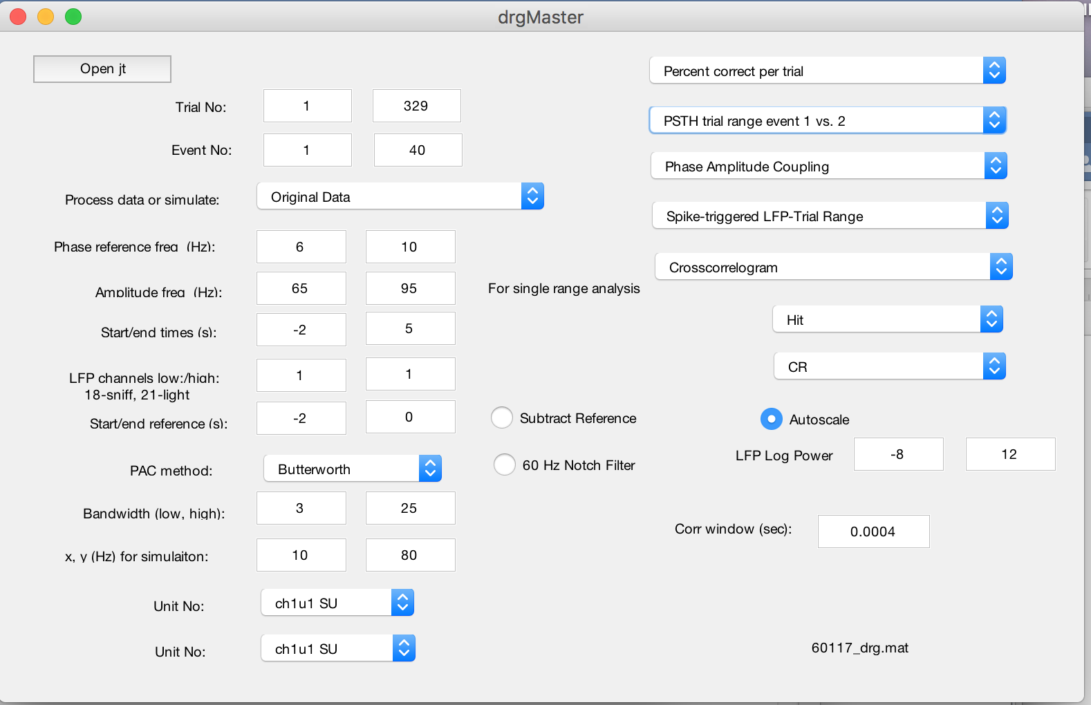

**Analysis of behavior in go-no go tasks**

Phase amplitude coupling. Calculates PAC according to Tort. The amplitude frequency band is set by “Amplitude frq. (Hz)” and the phase reference frequency band is set by “Phase reference freq (Hz)”. The PAC is calculated in the window set by “Start/end time (s)”.

Percent correct per trial. Calculates percent correct (PC) in a window of 20 trials. Blue denotes PC<=65%, red PC>=80%.

**LFP analysis**

**Spike analysis**

PSTH in phase event 1 vs 2

Computes the PSTH convolved with the spike phase histogram generated by “Spike phase in LFP-Trial Range”. You must run Spike phase in LFP-Trial range first. You need to specify: events 1 and 2 (e.g. S+ and S-), Start/end time(s), UnitNo and Amplitude freq (Hz). Make sure that Amplitude freq (Hz) is the same frequency bandwidth used to calculate “Spike phase in LFP-Trial Range”.

**drgPlexToJt**

Generates a jt_times file that can be read using drgMaster using data acquired with Plexon by Anan Li’s. laboratory.

