Game Design Document

Fill up the following document

1. Write the title of your project.

'Generic Adventure Game'

1. What is the goal of the game?

Defeat The Evil Emperor

1. Write a brief story of your game.

'You Are Traveling Between Planets , Its 2096 and Suddenly There is a fault in the Ship you are in You Crash into a Planet Unknown to Many

You were Unconsius when you woke up you were in clean cloths and were tidy to realise that someone helped you.someone came asking for your help to embark on a Dangerous Journy

To Defeat The Cruel Empreror of the Planet there will be many dangers along the way and people telling you not to do but its for a good that will free the planet they also said that

they tried contacting earth about this but the signal weak and their life detection sensors were blocked by a firewall for a whole milenium they were asking for help

and You Say Yes you were given all recources and embark on the mos dangerous jouney yet.

* Characters In This Game PC and NPC-

|  |  |  |
| --- | --- | --- |
| Number | Character Name | What can this character do? |
| 1 | Player(Username By User) | It’s a PC it plays by the rules |
| 2 | Maria | Helps you (at lvl 1) |
| 3 | Lucas | Teaches you how to Play and Helps (lvl 1 – lvl2) |
| 4 | Dash | Trader from who you can buy items form |
| 5 | The River Demon | The First Boss You Encounter at level 4 , Diffcullty : 2.3/5 |
| 6 | Mark | wounded Soulger helps you at the rest for your journey after finding him at level 6 |
| 7 | The Person in the Lost Temple | 2nd Boss in The Game at lvl 7 , Diffculty : 3.4/5(withour soulder) and 2.9/5(With Soulder |
| 8 | Volcano Man | 3rd Boss , Diffculty 4.0/5 , found at lvl 8 |

Helmsmen(Disicon Maker , Makes good Plans (78% Chance of succes) meet at lvl 10)

Emperor Winkin(FINAL BOSS , at lvl 12 , Diffculty 4.7-5/5)

Draw your imagination of this game. What does this game look like?

* Draw the game either on your computer or on paper.
* Add images of the game scenes to show each of the playing and non-playing characters at least once.

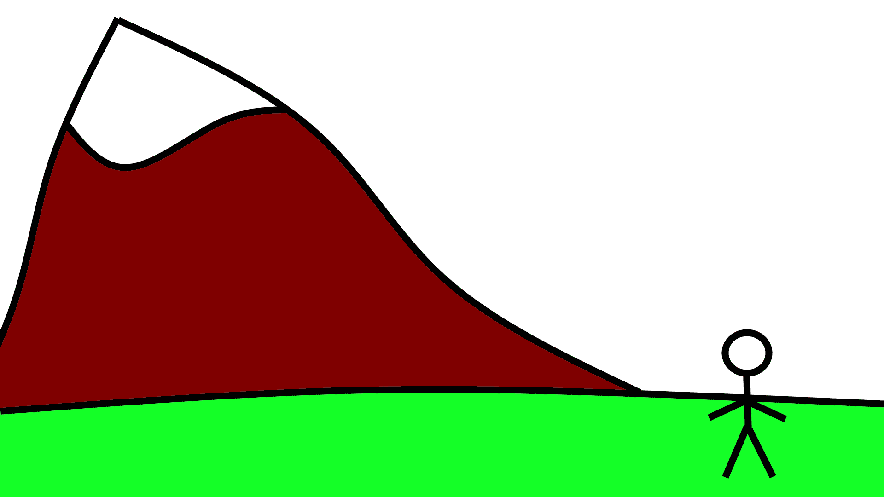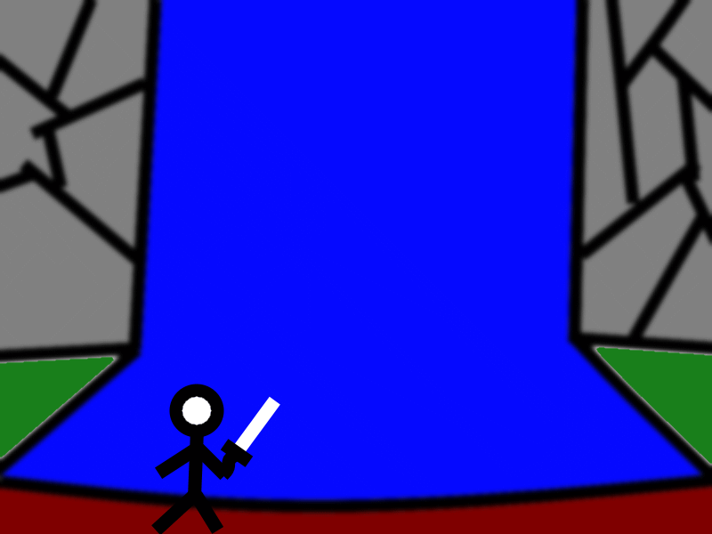

NOTE : This is Just A Rough Estimation of What the Game will look Like and It is Planned To Be Very Basic So It wont be Laggy on Some systems

There are some parts of the Map first is lvl 1 and the 2nd is lvl 4

How do you plan to make your game engaging?

This Game is An Adventure Game so There are Always Places To Explore on a Map.There is also action making it fun.Even Though The Game is Single Player , 2D and Very Basic . The Detail is not what makes a game great but rather the Gameplay.