Table of Contents

User Navigation 2

Understanding the Printer Status Screen 2

Creating an Account 3

Creating a Print Request 4

Admin Navigation 5

Accepting and Denying Print Requests 5

Updating and Deleting Print Requests 6

# User Navigation

## C:\Users\jknud\Downloads\PrinterStatus.PNGUnderstanding the Printer Status Screen

Once you login, the printer status screen (Figure 1) is the first thing you will see. This screen shows information related to the current 3D printers. Each printer is displayed in a gray box, and each box has:

* Printer’s name
* Time left printing
* Amount of prints queued
* Printer status button

The printer status button appears green with “**OPEN**” written on it when the printer is not currently printing. If the printer is printing, but still has time left in the day, the button will appear yellow with “**BUSY**” written on it. If the printer is scheduled out for the day, the button will be red with “**CLOSED**” written on it.

Clicking on this button while it is green will go to the create print request page with the current time set for printing. If the button is clicked while yellow, this will set the date to the next available time for the printer.

If there is more than one printer online, you can scroll down to see each printer. You can also go to the create print request page by clicking the blue plus button at the bottom right-hand corner. To go back to the login screen, simply press the back arrow in the top left-hand corner.

Figure 1 - Printer Status Page

The messages tab is currently being worked on, but will allow the user to message an admin to submit their print request.

## C:\Users\jknud\Downloads\Login.PNGCreating an **Account**

Figure 2 - Register Button

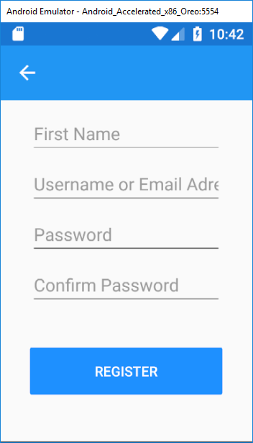To create an account, click on the blue “**Register**” label (Figure 2) at the bottom of the login screen to go to the registration page. On this page there are multiple text boxes for information:

Figure 3 - Registration Page

* First name
* Username or email address
* Password
* Password confirmation

After you enter all the required information, your account will be created. Then you will be redirected to the login screen where you can login using your newly created account.

## Creating a Print Request

Figure 4 - Green Print Request Button

After you login, you can press either one of the printer’s green “**OPEN**” buttons (Figure 4) or the blue plus button at the bottom right (Figure 5), to start creating a print request.

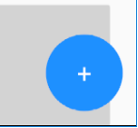

Figure 5 - Blue Print Request Button

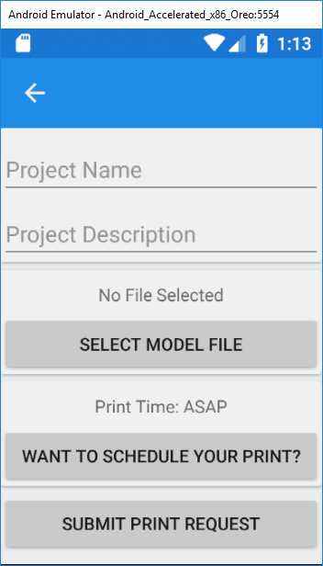

Figure 6 - Print Request Page

Pressing on of those buttons will bring you to the print request page (Figure 6). On this page you will see some required steps:

Project Name: The name for the project you are wanting to print.

Project Description: The description of the project you are wanting to print.

Model File: The 3d model of the print you want created.

Print Time: The time that you want your print to start.

The print time is the only step that is automatically set, which is set to ASAP (As Soon As Possible).

# Admin Navigation

## Accepting and Denying Print Requests

After logging in as admin, you are brought to the admin main page (Figure 7) that is separated into 4 tabs.

Any current requests will be located in the “**Requests**” tab. In the requests tab you can look up any requests using the search bar.

To accept or deny a request, you must click on the project you want to accept/deny and select either “**Accept**” or “**Deny**”. This will move the request to the “Approvals” or “**Denials**” tab. (Correct this instruction)

Figure 7 - Admin Requests Page

## Updating and Deleting Print Requests

If you are logged in as an admin you can update or delete requests on the main admin page. There are 3 tabs you can update/delete requests in; “**Approvals**”, “**Requests**”, and “**Denials**”.

Click on the project you want to update/delete and choose either the “**Update**” or “**Delete**” button. Pressing the “**Update**” button will bring you to the project’s information, in which you can edit. (Correct this instruction)